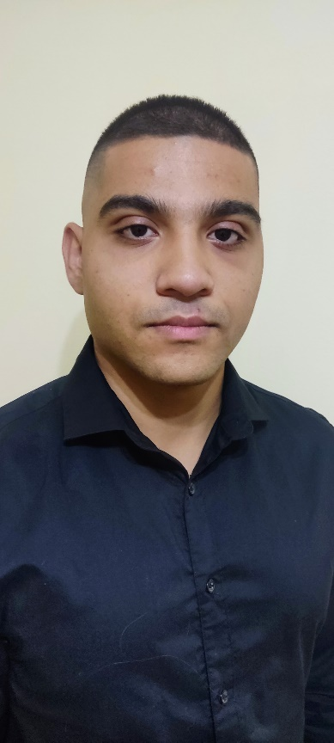

***C#***

***.NET***

***ASP.NET***

***SQL Server / SSMS***

***HTML/CSS***

***JAVA***

***C++***

Kitchen assistant

* Working in dynamic environment.
* Communication and customer service.
* Working in different positions according to the shift staff.

***https://github.com/dimiturjeliyazkov*** ***linkedin.com/in/димитър-желязков-07990525a***

* IT skills and career training

**MON**

Plovdiv

Sep 2018 – Apr 2020

***COURSE***

* Specialty - Software Engineering

**Plovdiv University**

**"Paisii Hilendarski"**

Plovdiv

2020 – Present

* Creating ASP.Net Core Application.
* Working in team using version control system.

**Philly Vibe AD**

Plovdiv

Mar 2021 - Present

**Leet Soft Itd.**

Plovdiv

Internship

Dec 2022 – Jan 2023

***SUMMARY***

***WORK EXPERIENCE***

Third year student - software engineering. I'm interested in .Net and C#. I have participated in various projects (team and individual) during my course and at university. I am a fast learner and ready to take on challenges and learn new things.

I have very good communication skills and know how to work in team. I am highly motivated with a desire to develop in a working environment for a long period of time.

***EDUCATION***

***Englishh***

***Links***

***LANGUAGES***

***SKILLS***

**0885194484**

[**dimiturjeliyazkov222@gmail.com**](mailto:dimiturjeliyazkov222@gmail.com)

**Plovdiv – Bulgaria**

***Dimitur Jeliyazkov***