# Material Summary: Linear Algebra

## Vectors

### Vector Definitions

* "Physics definition"
  + A pointed segment in space
* "Computer science definition"
  + A list of objects (usually numbers)
  + Dimensions = length
* Math definition
  + Encompasses both, and allows even more abstraction: *_*𝑣*_*
  + Vectors can be added and multiplied
    - By numbers and other vectors
  + Similar to how we defined a field
* Another perspective
  + Transformations
  + Actually, things a just a little more complicated…
    - You can look up "tensors" if you're interested
    - We'll talk a little about tensors later

### Vector Components

* The distances to all coordinate axes: *_*𝑣*_*𝑥*_, _*𝑣*_*𝑦*_*
* Equivalent to
* Polar coordinates: $v=\left|\vec{v}\right|, θ$
* Finding components: Pythagoras
* Finding the polar form (magnitude, direction): 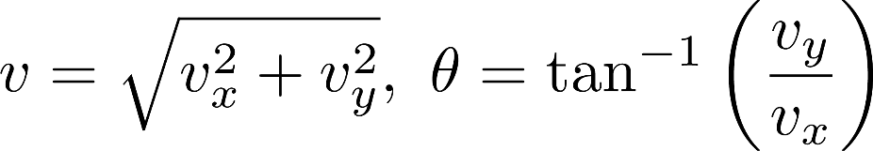
* All these operations generalize to more than 2 dimensions
* We usually denote vectors by *_*𝑣*_* or with bold type: 𝒗
  + Another notation: Latin letters for vectors, Greek letters for numbers
  + Reason: The vector 𝒗 and its length 𝑣 can be easily confused

### Vector Operations

* **Addition**
  + Result:  length = distance from start to end,  direction: start → end
  + In component form: sum all components for every direction
* **Multiplication by a number (scalar)**
  + Result: length = scaled length, direction: same (if scalar *≥0*), opposite otherwise
  + In component form: multiply each component by the number
* **Scalar product of two vectors** 
  + Also called dot product or inner product
  + Result: scalar
  + Definition: 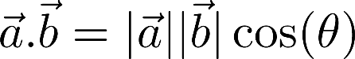
  + Using the vector components: 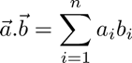
* **Vector product of two vectors**
  + Also called cross product
  + Result: vector, perpendicular to both initial vectors
  + Definition: 
    - $\vec{n}$– normal vector
    - Magnitude: $\left|\vec{a}\right|\left|\vec{b}\right|\sin{(θ)}$ = volume of parallelogram   
      between $\vec{a}$ and $\vec{b}$
    - Direction: coincides with the direction of $\vec{n}$

### Vector Spaces

* A field (usually R or C): 𝐹
* A set of elements (vectors): 𝑉
* Operations
* Addition of two vectors: 𝑤*=*𝑢*+*𝑣
* Multiplication by an element of the field: 𝑤*=*𝜆𝑢
* A "checklist" of eight axioms
* We read this as "vector space (or linear space) 𝑉 over the field 𝐹"
* Examples of vector spaces
  + Coordinate space, e.g., real coordinate space
    - 𝑛-dimensional vectors
  + Infinite coordinate space 
    - Vectors with infinitely many components
  + Polynomial space
    - All polynomials of variable 𝑥 with real coefficients
  + Function space

### Linear Combinations

* Vectors: $v_{1},v_{2},…, v_{n}$
* Numbers (scalars): $λ_{1},λ_{2},…,λ_{n}$
* **Linear combination:** The sum of each vector multiplied by a scalar coefficient



* Why linear? No fancy functions, no vector multiplications
* **Span** (linear hull) of vectors: the set of all their linear combinations
* Linear (in)dependence
  + The vectors $v_{1},…,v_{n}$ are **linearly independent** if the only solution to the equation ${: λ}_{1}v_{1}+λ_{2}v_{2}+⋯+λ_{n}v_{n}=\vec{0}$ is $λ_{1}=0, λ_{2}=0, …,λ_{n}=0$
  + Conversely, they are **linearly dependent** if there is a non-trivial linear combination which is equal to zero
* Example:

