# SoftUni Forum Workshop - Part 1

This application is created as a workshop for the [Angular Couse](https://softuni.bg/trainings/4712/angular-october-2024) @ [Software University](https://softuni.bg)

# Task Requirements

You will be provided with skeleton (**HTML** and **CSS**). When starting the index.html, the following page will appear:

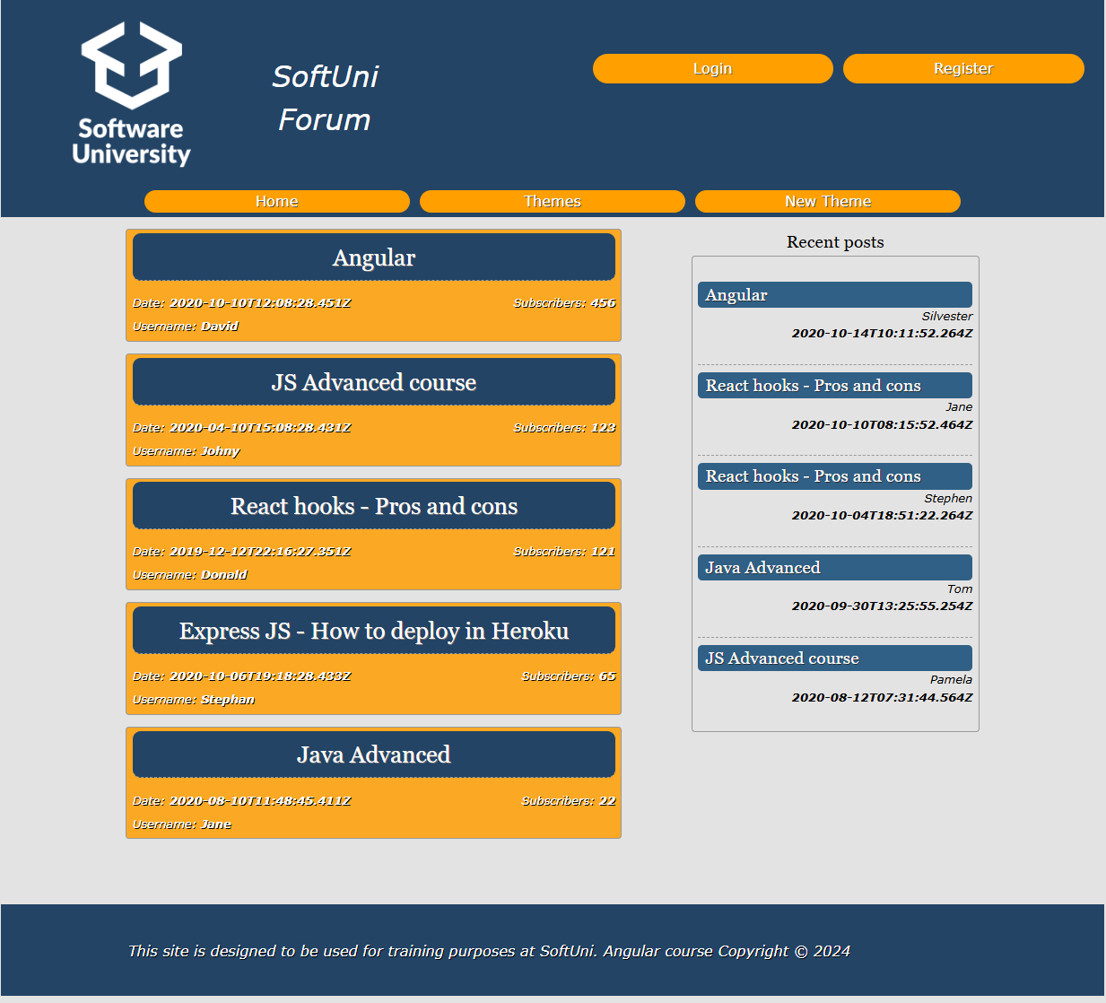

The application is a forum, where each registered user can create a theme or post a comment. For now, your task is to check the given skeleton (HTML and CSS files) and **split them into components**, so each part can be **reusable**. Be careful when you structure the components.

## MongoDB

Before you start with creating a new project in Angular you need to install MongoDB. You can find an installation guide in the provided document:

**MongoDB-Installation-Guide.docx**

After the successful installation your database will be empty, so you can load the provided from us initial data in it as follows:

1. Download the provided folder named "resources".
2. Open the "forum" folder inside "resources" and copy the path:

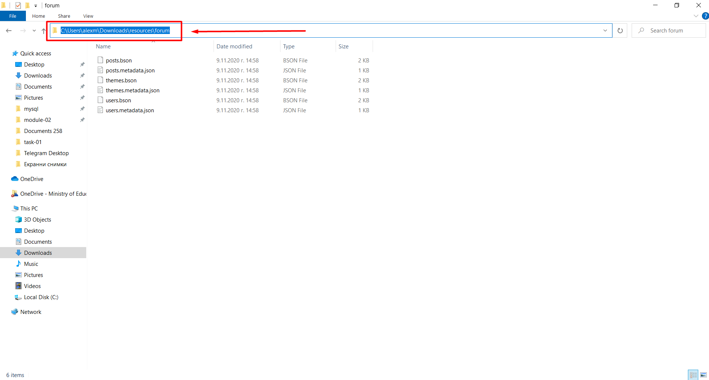

1. Navigate to the mongo tools folder:

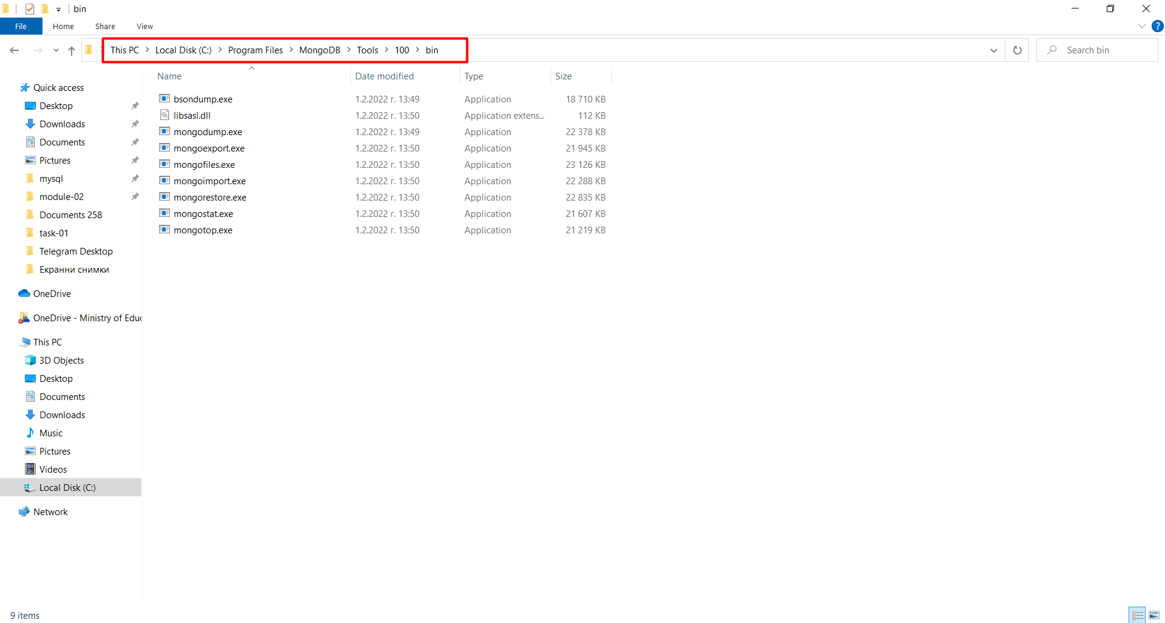

1. Open the command prompt inside of this folder

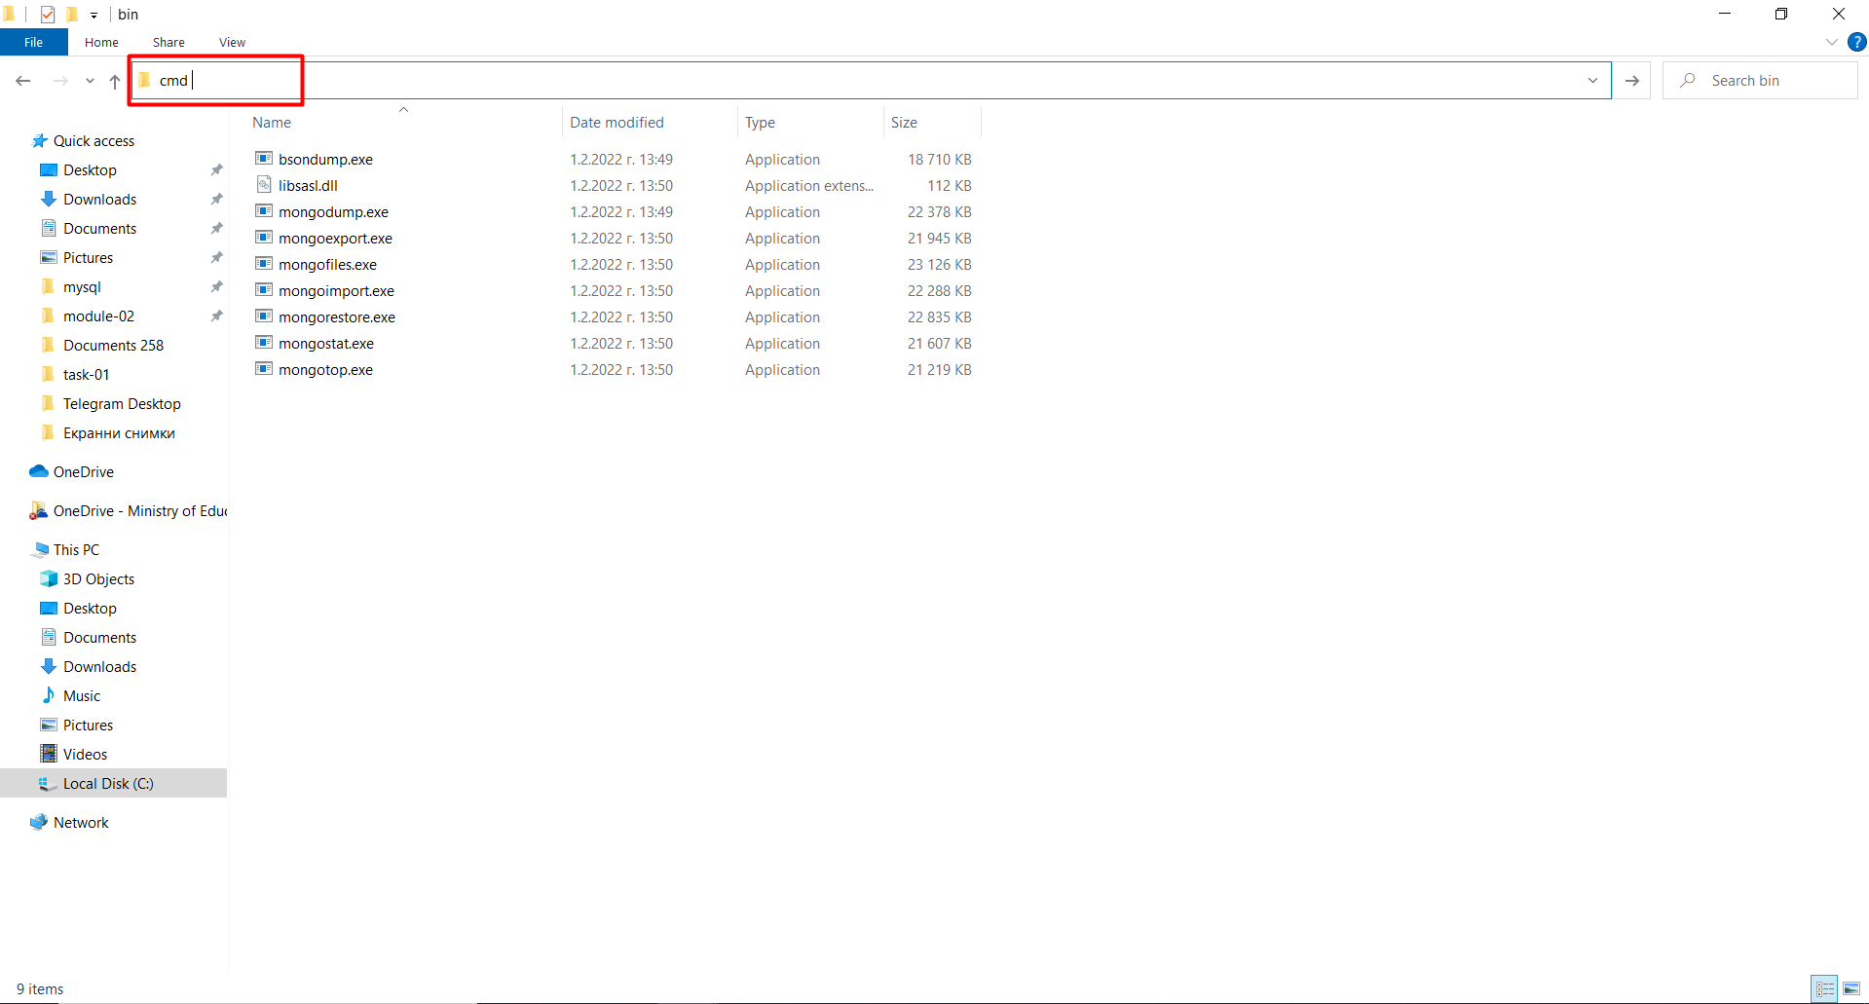

1. In the console write the following command:

**mongorestore -d forum C:\Users\Name\Downloads\resources\forum**

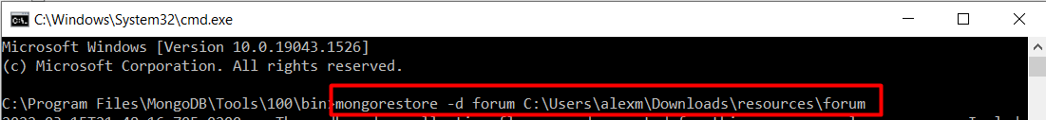

* **Note* C:\Users\Name\Downloads\resources\forum – replace with the path of the folder "forum" in your computer that you copied in the beginning.**
* You will see something like this:

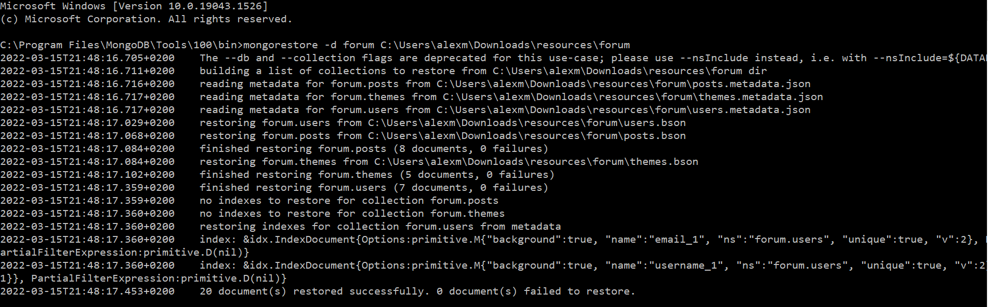

* That's it! You can now find the db in MongoDB Compass if you have installed it:

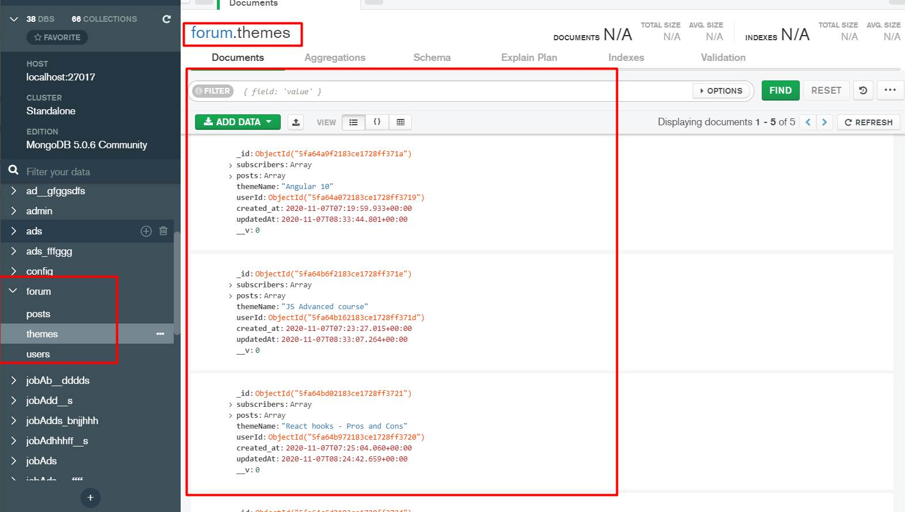

* If you haven't installed MongoDB Compass, you can check the DB in the following way:
* Navigate to the MongoDB server folder

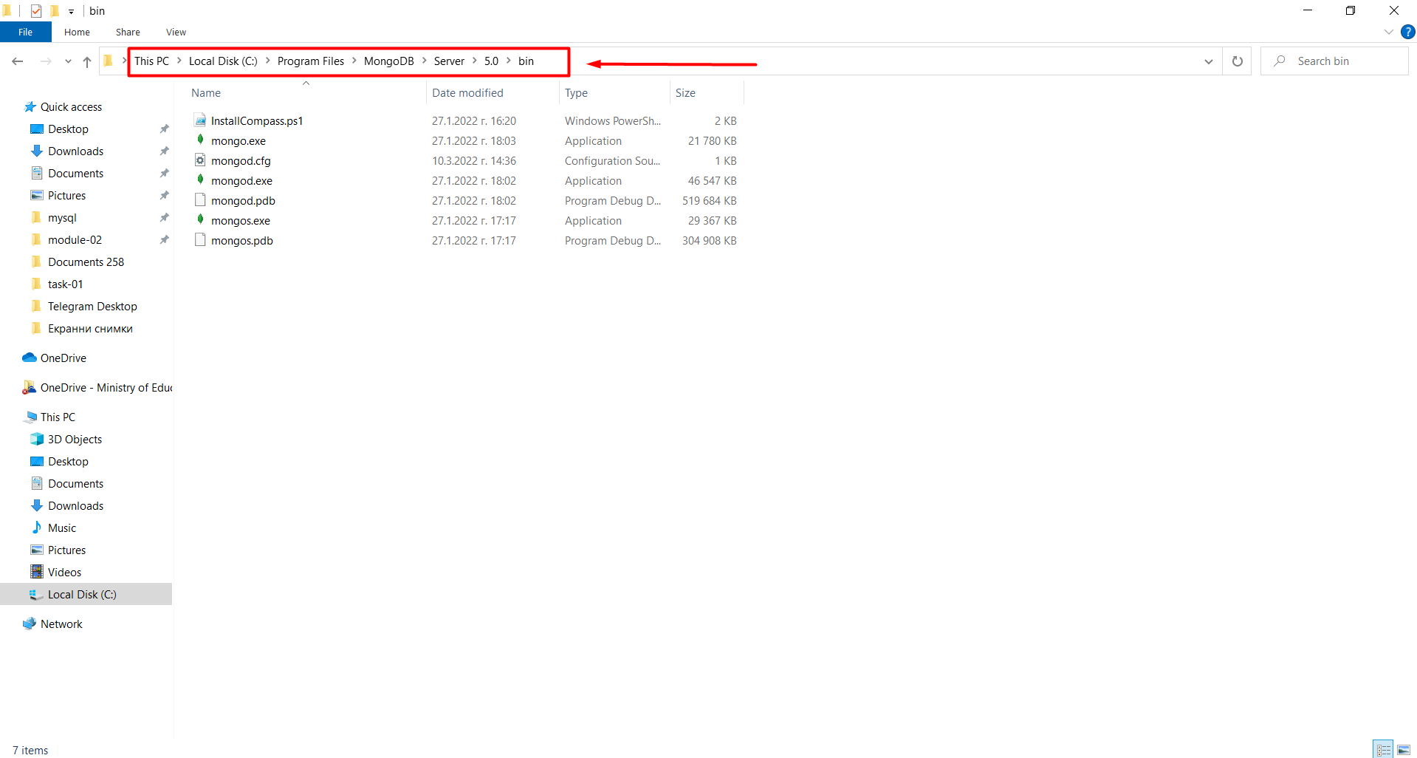

* Open cmd inside of this folder

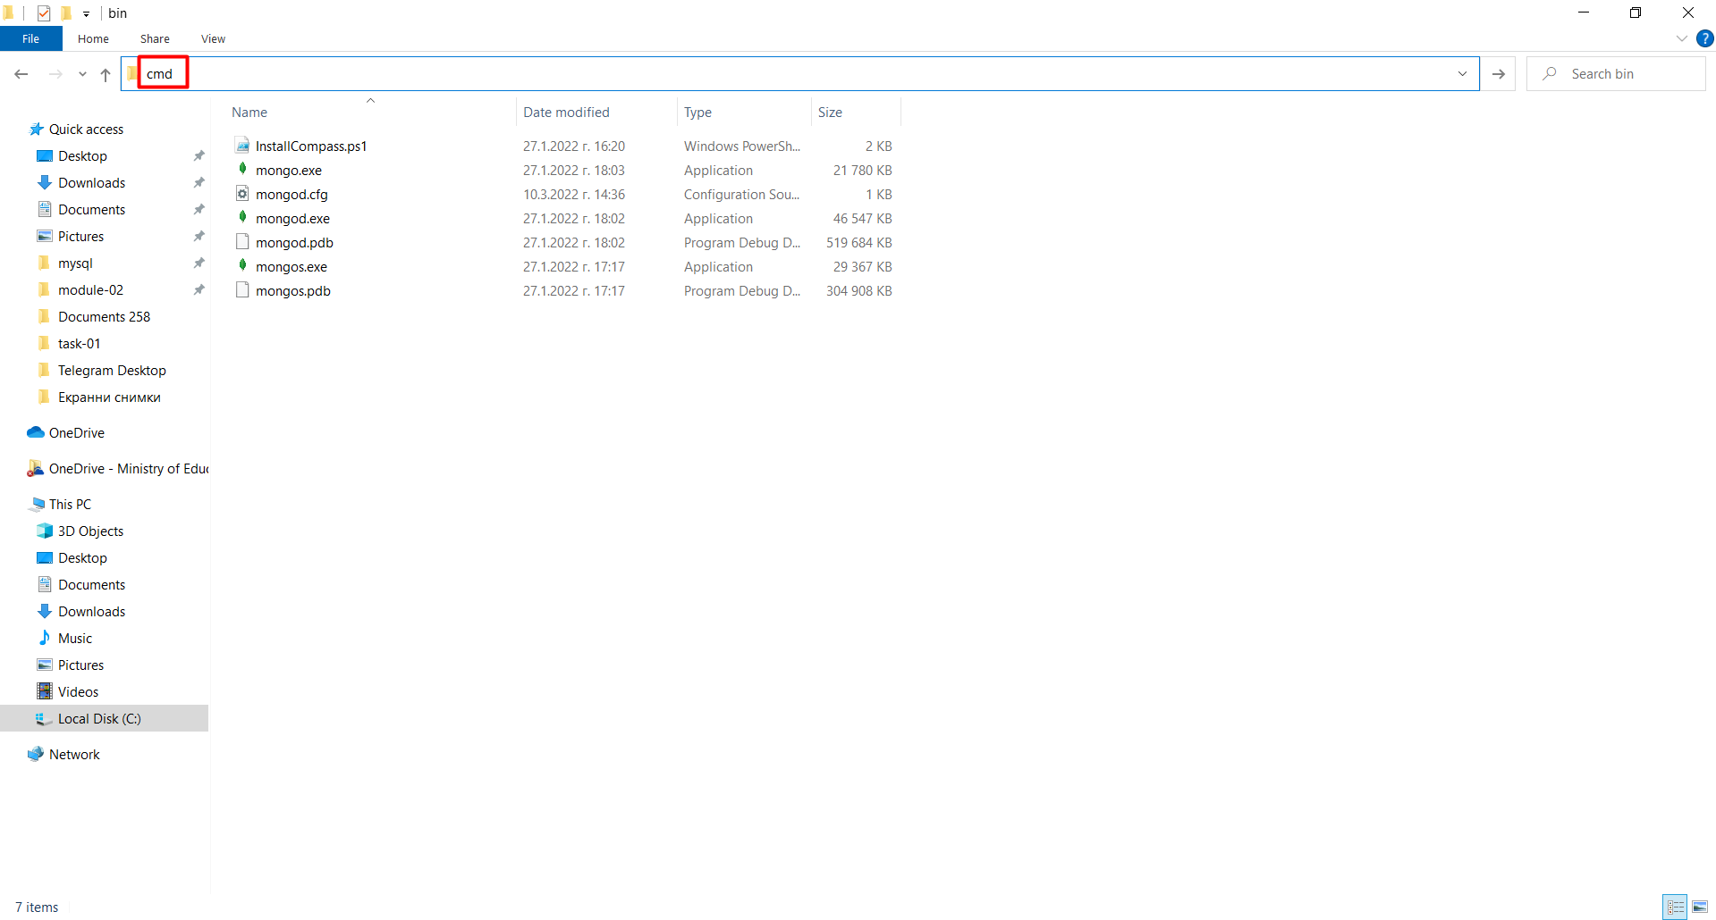

* Run the command "mongo"



* Run the command "show dbs"



* You should be able to find and use the "forum" db

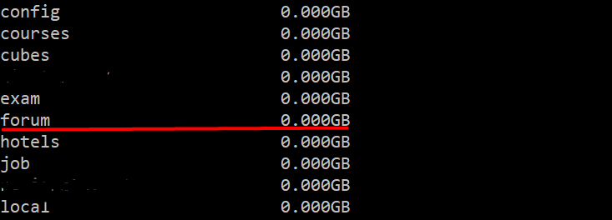

* Install dependencies with the npm install command

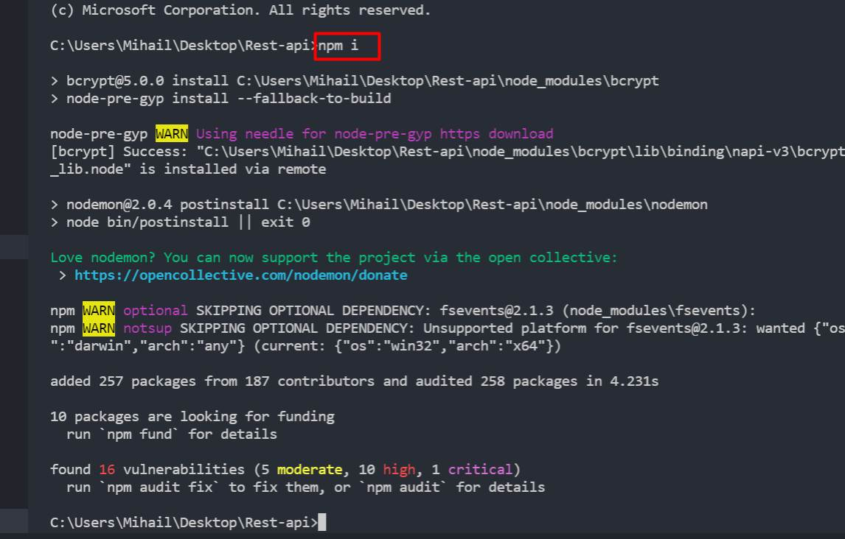

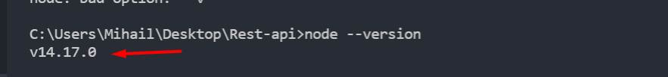

* With this version of node there is no problem to start the server. As it is not necessary to change anything.

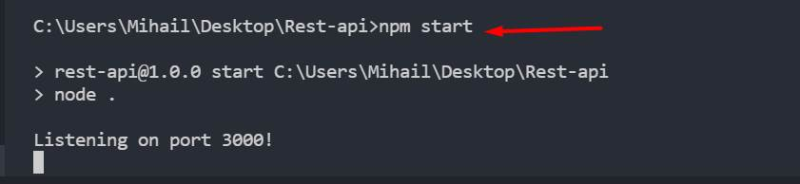

* If you have another version and it gives you an error, go to this configuration file and fix this dbURL:

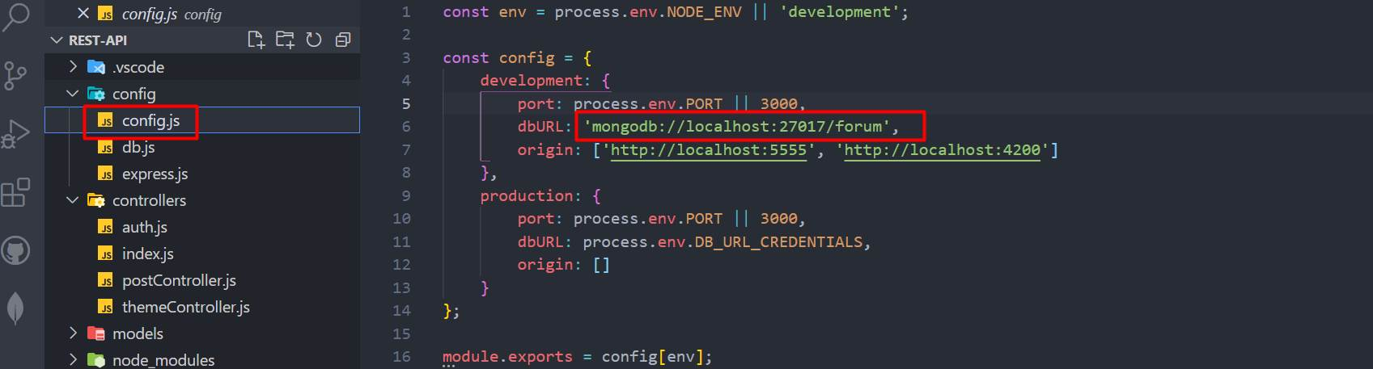

## REST API

You are provided also with **REST API**. To bring life on that API you should first install the dependencies with the command "**npm install**". After that, type the command "**npm start**". In order to fetch the themes, you will have to make a **GET** **request** on "**localhost:3000/api/themes**".

## Logged/Unlogged User

**NOTE: Because we haven't covered authentication yet (how to login and register), you can hardcode it with a variable.**

**Logged out** users see the **Login** and **Register** buttons/links.

## Implementation of the Main Section

After the backend is ready to use, you should **fetch all themes** and **list them** on the home page in the format you saw in the skeleton.

The **themes in the main** section should be **descending sorted by the subscribers**.

Each theme should have a **title**, **date** (when the theme is created), the **username** of the creator, **count of the subscribers** of the theme.

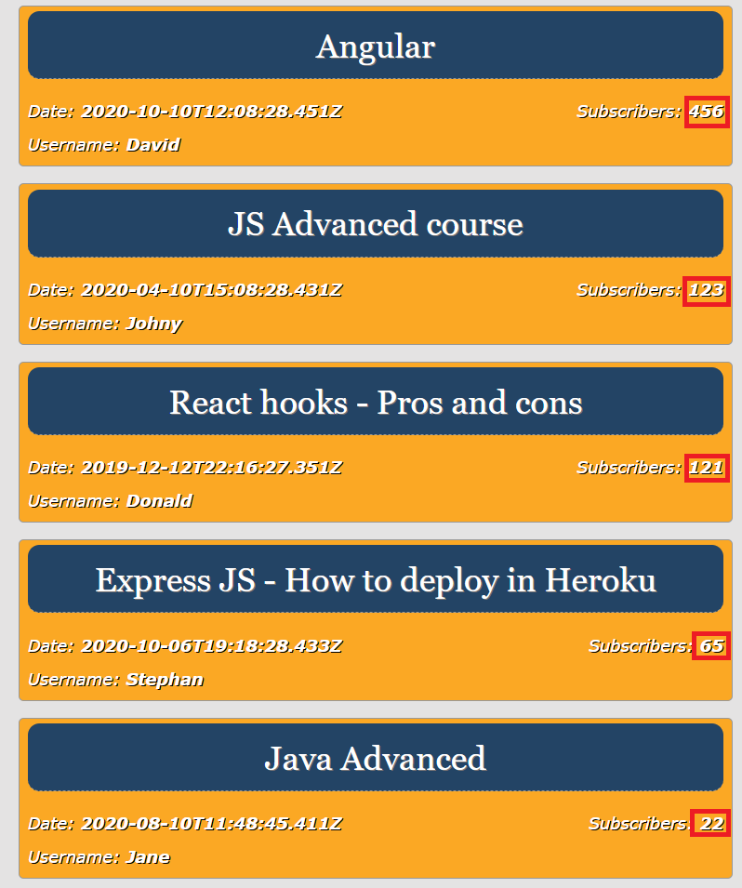

## Implementation of the Aside Section

In the **Recent posts section, only the 5 latest posts** must be shown! **(**[**https://localhost:3000/api/posts?limit=5**](https://localhost:3000/api/posts?limit=5)**)** The posts will be returned from the REST-api **sorted by the time of creation.**

Each component should have a **title (the title of the theme)**, a **username** of the user, whom the last comment in the theme belongs, and the **time** the post was created.

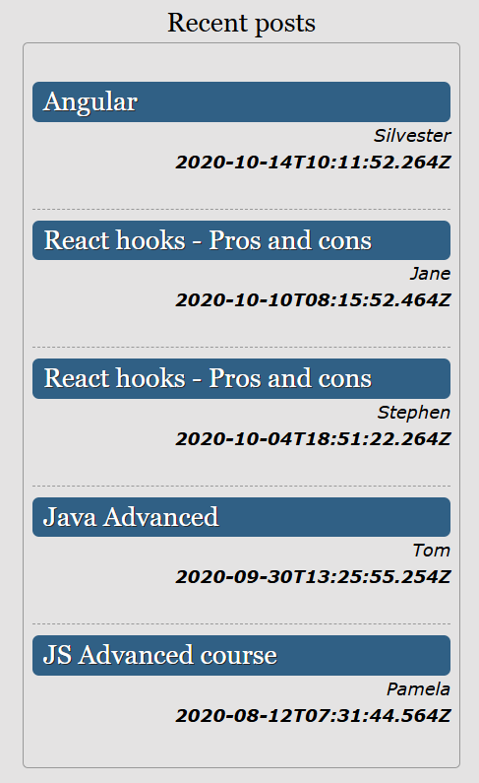

***GOOD LUCK*! 😊**