Installation Instructions for XBRLReportBuilder

1. Let the root folder be called {BIN}.
2. If you have a previous version of the program on your machine, you will recognize it by having three sub folders of {BIN}, called Dispatcher, PreviewBuilder, and SECbuilder.
   1. Execute {BIN}\stopservices.bat.
   2. Execcute {BIN}\uninstallservices.bat
   3. Verify that the services ‘ReportDispatcher’ ‘ReportBuilderSEC’ and ‘ReportBuilderPreview’ have been removed by opening “Services” from Administrative Tools.
3. Unzip XBRLReportBuilder..zip to a directory of your choice on the windows machine where the processes will be run.
4. In folder {BIN}, you will see three subdirectories – Dispatcher, PreviewBuilder, and SECBuilder. There are two report builder engines – PreviewBuilder and SECBuilder. Preview is for users who want to preview their filing before officially filing through SECBuilder. They have identical binaries, but are different in their .config files. You will need to configure both engines using the steps below.
5. Edit file {BIN}\SECBuilder\Aucent.XBRLReportBuilder.BuilderService.exe.config using any plain text editor:
   1. Modify the machine name on the “DispatcherUri” “add key” value. Where {HOST} is usually ‘localhost’, it should read:

<add key="DispatcherUri" value="tcp://{HOST}:9501/ReportDispatcherServer" />

* 1. Modify the “FilingsFolder” “add key” value with the folder of where filings that need to be processed will be placed. This path must exist on your system. We will call the root of these folders {QUEUE}, as for example QUEUE might be c:\ReportBuilder:

<add key="FilingsFolder" value="{QUEUE}\SECBuilder\Filings" />

* 1. Modify the “ProcessingFolder” “add key” value with the folder of where the reports that need to be processed will be saved. This path must exist on your system. It should read:

<add key="ProcessingFolder" value="{QUEUE}\SECBuilder\Processing"/>

* 1. Modify the “ReportsFolder” “add key” value with the folder of where the processed reports will be saved.

<add key="ReportsFolder" value="{QUEUE}\SECBuilder \Reports"/>

* 1. Modify the “ProcessingFrequency” “add key” value with number of seconds the service will wait between checks of the filing folder.

<add key="ProcessingFrequency" value="60"/>

* 1. Review the “DeleteProcessedFilings” “add Key” value. This controls whether filings get deleted from the processing folder. If set to “true”, filings get deleted from the processing folder after output is sent to the reports folder.
     + NOTE that there may be other temporary files generated in C:\Windows\Temp, of the form tmp????.tmp.html, that should be deleted from time to time.
  2. Review the “FinancialRuleFile” “add key” value. These keys allow financial and risk return filings to be controlled by different sets of rules. The default value for financial is “ReportBuilder”.
  3. Note that earlier versions of the engine had keys “ZipFileRetries”, “RiskReturnRuleFile” and “RiskReturnURI” which are now obsolete, and can be deleted from the configuration file if they appear.
  4. Review the “ReportFormat” add key value. The value here is usually “Html”.
  5. Review the “HtmlReportFormat” add key value. The value of this key is usually “Complete”; if you have written a stylesheet to assemble multiple reports into a single file, use “Fragment”.
  6. Review the “RemoteFileCachePolicy: addkey value. “Default” is a safe choice.
  7. Save the file with your changes.

1. Repeat step 4 for the config file found under PreviewBuilder. NOTE that its queues must be in a different location, such as {QUEUE}\PreviewBuilder\Filings, {QUEUE}\PreviewBuilder\Reports, etc.
2. WARNING: Make sure the services window (shown below) is not open when executing the next step.
3. Run {BIN}\InstallServices.bat to execute the install process.
4. Run {BIN}\StartServices.bat to start the dispatcher and report builder services.
   1. If this fails, it is most often because the .config file for the service contains a file path that does not exist. Check the {BIN}\PreviewBuilder\ Aucent.XBRLReportBuilder.BuilderService.exe.config and {BIN}\SECBuilder\ Aucent.XBRLReportBuilder.BuilderService.exe.config files again.
   2. Other reasons for failure include:
      * the {HOST} might not exist or be unreachable
      * The port chosen may already be in use (the service is already installed and running)
      * The ports chosen may be blocked or the service is already installed and running.
   3. On Windows Vista the system will ask whether you want to allow the application access through the firewall; say yes, but then restart the service.
5. Check the services monitor to verify services are running.

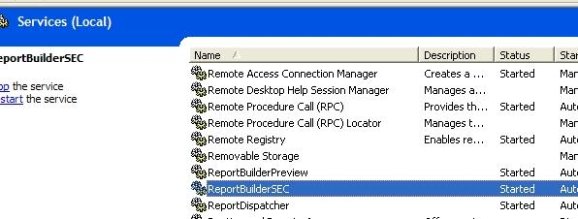

1. Copy XBRL filings (zip files) into either folder {QUEUE}\PreviewBuilder\Filings or {QUEUE}\SECBuilder\Filings.
2. When a service sees the reports in its filings directory, it will move them to the processing folder, once they are processed; the resulting files will be moved to the reports folder.
3. If services need to be stopped, use {BIN}\StopServices.bat.
4. (OPTIONAL) If you have configured output to “Xml” rather than “Html” then copy the content of folders {BIN}\SECBuilder\Resources to the corresponding folder on any web server used to convert the output files of the rendering engine (“R-Files”) into HTML. The content of the “Resources” folders are XSL and CSS style sheets and a Javascript file. These files are identical for the Previewer and the Viewer.

# (OPTIONAL) Local Install of XBRL Taxonomies

**There are no new taxonomies associated with the deployment of rendering engine .**

In order to improve performance and security, these steps will describe how to redirect any calls to external web servers to a local directory so that trips to XBRL.US are minimized. The set of files that could be referenced by an EDGAR filling is in the file

<http://www.sec.gov/info/edgar/edgartaxonomies.xml>

which can be opened using excel; the HTML version of that page is at

<http://www.sec.gov/info/edgar/edgartaxonomies.shtml>

Steps for the US GAAP 2009 taxonomy are illustrative:

1. Go to <http://xbrl.us/taxonomies/Pages/US-GAAP2009.aspx>
2. Click on the the XBRL US Gaap Taxonomy link.
3. Click on the “All Taxonomies” link in the left panel to download the entire taxonomy.
4. Create a directory on the machine where the taxonomy will be stored called “taxonomies.xbrl.us”.
5. Create a directory called “us-gaap” and another one underneath it called “2009”.
6. Unzip the taxonomy to the “2009” folder.
7. Open Internet Information Services (IIS) which can be found under Control Panel/Administrative Tools.
8. Right click on “Default Web Site” and choose “New Virtual Directory.”

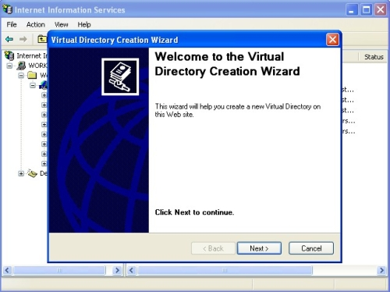

1. For Alias, enter US-GAAP.

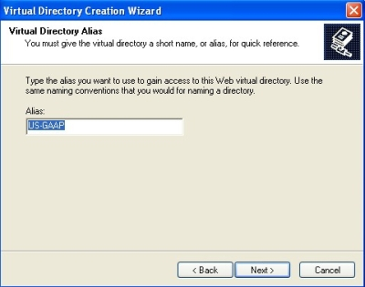

1. For Directory, browse to taxonomies.xbrl.us\us-gaap

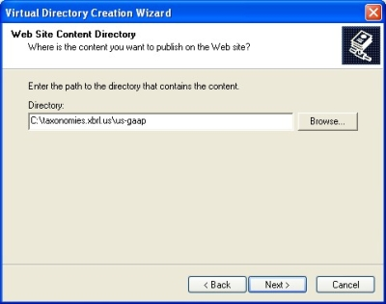

1. For Permissions, select “Read”, “Run Scripts”, and “Execute.”

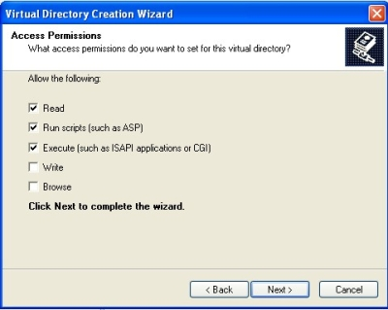

1. End result

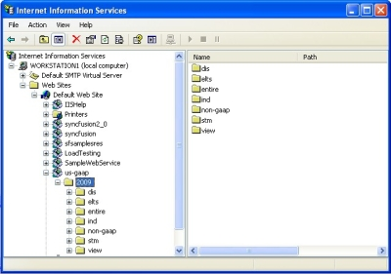

1. Open your hosts file found at C:\WINDOWS\system32\drivers\etc in notepad.
2. You should see a local host entry that looks like this: 127.0.0.1 localhost. Append “taxonomies.xbrl.us” to it so the end result is: 127.0.0.1 localhost taxonomies.xbrl.us
3. To test, open C:\taxonomies.xbrl.us\us-gaap\2009\dis\us-gaap-dis-acec-2009-01-31.xsd in notepad and in the header area next to Copyright (C), insert the word “test”.
4. Open this same file in Internet Explorer by inputting this path <http://xbrl.us/us-gaap/1.0/dis/us-gaap-dis-acec-2008-03-31.xsd>. You should see the word “test” that you typed in step 12.
5. If this does not work, restart IIS by going into IIS, clicking on the computer name and selecting Restart IIS from the Action/All tasks menu option.
6. Repeat these steps for the RR taxonomy. After adding the RR taxonomy, the result should look like this:

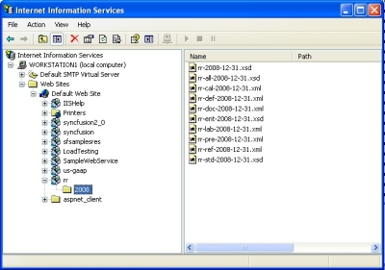

# Processing Rules

The ReportBuilder.rul file found under the Rule_Files directory for both the preview and SEC builder engines controls what rules are applied to the layouts. **Starting with Build 2.2.0.6, these files cannot be changed. If you change them, the service will simply overwrite them with a fixed configuration identical to that used in previous versions of the rendering engine.**

|  |  |
| --- | --- |
| CleanupFlowthroughColumns | Removes columns that contain only “flow-through” elements |
| CleanupFlowThroughReports | Removes reports that contain only “flow-through” elements. |
| InstantAndDuration | Merges columns that contain instant and duration where the duration end date matches the instance date. |
| PreferredLang | Parses the supported languages in the taxonomy looking for en-us. If that language is found, then it is set as the default language for the report. Otherwise the first supported language in the taxonomy is used. |
| ProcessBeginningEndingBalance | In situations where beginning and ending balances are present, this logic will place the ending\beginning balance amount on the correct row rather than adding it to a separate column. |
| PromoteSharedLabels | Labels that are used for every item in the column are promoted to the column header. Labels that are used in every item in the report are promoted to the report header. |
| Rounding | Apply rounding to the report according to the decimal settings used in the filing. |
| Segments | Parses the data in a Report to determine if there is Segmented data that can be displayed in a vertical format.  There are two conditions that could result in data being displayed this way.  1. The Report contains Consolidated and the reporting periods for that data covers all of the reporting periods for each of the Segmented data sets.  2. The Report does not contain Consolidated data, but one of the Segmented data sets contains reporting periods that cover all of the reporting periods for the remaining Segmented data sets. |
| ColumnHeaders | Loops through all of the columns on a Report and formats the header labels using the formats provided in the ColumnHeaders.xml file. |
| EquityStatement | Parses the Columns in an Equity Statement to determine the reporting periods used by the report, and shift the reporting periods to rows on the grid. Then the complete set of elements is repeated for each reporting period leaving only segments on the column. |
| TotalLabel | If the preferred label for the element is totalLabel, then place an underline under each number on the row. |
| CurrencySymbol | Place the currency symbol on the first and last monetary elements in the report. |
| AbstractHeader | Include the preceding abstract from the presentation hierarchy. |
| GenerateExcelFiles | Produce an excel file representation of what is shown in the viewer. Be advised that this will negatively impact performance. |
| GenerateRedlineComparisonFile | N/A |
| ProcessCompleteReports | N/A |
| RemoveLabelColumn | Label column is removed if set to true. This is used for the RR filings. |
| ProcessEmbeddedReports | When set to true, the engine will search for instructions that begin with “~” which provides instructions on which reports are to be embedded. This is used for the RR filings. |
| DisplayDateInUSFormat | Displays dates as MMM DD, YYYY when set to true otherwise YYYY-MM-DD |
| DisplayAsRatio | Displays values that are used with ratio elements as ratios. |
| DisplayZeroAsNone | Displays “none” instead of “0” for certain elements |