

User guide

Mobile App

Browser / App

iOS / Android

from Version 9.x

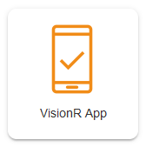

Created by Plan-Vision GmbH

V9.0.1 • 01.01.2022

web: https://plan-vision.com • email: support@plan-vision.com