<https://mchat.nd-sip.sharp.co.jp:8065/>



<https://secure.jp.sharp/sbchsaas/redmine/gsc1/>

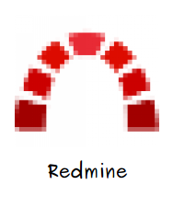

<http://10.24.89.64:4000/main>

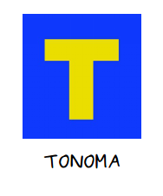

<http://10.74.173.226/mediawiki/index.php/%E4%BB%A3%E7%A0%81%E4%B8%8B%E8%BD%BD%E6%96%B9%E6%B3%95>

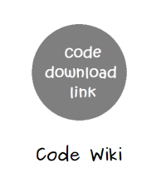

<http://10.74.173.226/mediawiki/index.php/Sharp_CleanRoom%E4%BF%A1%E6%81%AF%E4%BA%A4%E6%8D%A2%E5%B9%B3%E5%8F%B0>

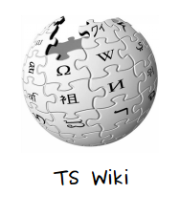

<http://10.24.45.100:50080/>



<http://10.74.185.241:8080/source/>

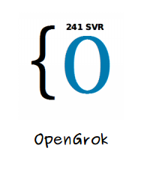

<http://192.168.122.247:8080/source/>

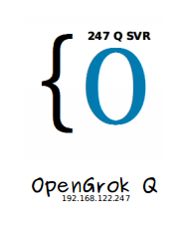

<http://10.24.71.91/gerrit/>

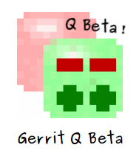

<https://secure.sharp.co.jp/android_review/gerrit/#/>



<http://10.208.60.201/#/>



<http://10.74.185.240/sharp/>

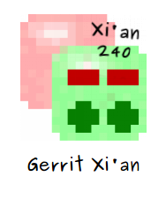

<http://i.thundersoft.com/login/Login.jsp?logintype=1>



<http://10.74.185.200:8080/>



<http://10.24.225.140:8080/>



<https://translate.google.cn/>



<https://createpoint.qti.qualcomm.com/dashboard/public/productkit#public/product-kit/search>



<https://qualcomm-cdmatech-support.my.salesforce.com/home/home.jsp>



<https://feishu.cn/messenger/>



<https://www.baidu.com/>



<http://mail.thundersoft.com/>



<https://shares2.win.sharp.co.jp/>

