PES University — Department of CSE
Lab 1: Requirements Engineering and UML Use-Case Modelling
Problem Statement #43: Feature Flag and Dynamic Config Manager
Domain: Developer Tools and IT Operationss
Name: Anish A Kunder
SRN: PES1UG24AM343

Overview
A central platform for managing feature flags and configuration. Teams can turn features on for a percentage of users, set different values for each environment, and push changes to running applications in real time. Code can be released behind a flag and switched on later without another deployment.

Actors
- Software Engineer — creates and owns feature flags, sets values for non-production environments, and adds the SDK to applications.
- Release Manager — controls production exposure: rollout percentage, targeting rules, and turning a feature off in an emergency.
- Client SDK Application — asks for flag values and stays subscribed to changes.

Contents
1 | Requirements Table — 5 functional requirements (FR-001 to FR-005) and 2 non-functional requirements (NFR-001, NFR-002).
2 | Traceability Matrix — each requirement mapped to the use cases that deliver it.
3 | UML Use-Case Diagram — actors, system boundary, use cases, associations, include and extend.
4 | Use-Case Relationships — written list of the include and extend relationships shown in the diagram.
5 | Use-Case Flow Specification — UC-02, with preconditions, postconditions, main success scenario and one alternate flow.

1. Requirements Table

1.1 Functional Requirements (FR-001 to FR-005)
ID | Type | Description | Priority | Acceptance Criteria | Rationale
FR-001 | Functional | The system shall check a flag's targeting rules for a given user (user ID and attributes such as beta cohort, region or plan) and return the correct on/off state along with the reason for it. | High | Pass: A user inside the 10% rollout group gets the flag enabled, and 10 repeated calls for the same user return the same result.  Fail: A user outside the group gets the flag enabled, or the same user gets different results on repeat calls. | Evaluation must be repeatable. If the result changes between calls, test results become useless and users see the feature flicker on and off.
FR-002 | Functional | The system shall let a Software Engineer create, update and archive feature flags, and shall save a permanent log entry (who, when, environment, old value, new value) for every change made to a flag. | High | Pass: Creating a flag with a key that already exists is rejected and the old flag stays unchanged; an archived flag is no longer sent to SDKs but is still visible in the log.  Fail: A duplicate key is accepted, or a change is saved without a log entry. | One place to define flags avoids duplicate keys across teams, and the log answers who turned a flag on in production during an incident review.
FR-003 | Functional | The system shall let a Release Manager set a rollout percentage (0 to 100, in steps of 1) for each flag in each environment, so that raising the percentage never removes a user who already had the feature. | High | Pass: Raising the rollout from 10% to 25% keeps every earlier user enabled and adds about 15% new users.  Fail: A user who already had the feature loses it when the percentage is raised. | A gradual rollout only works if the group grows steadily. A user who loses a feature midway treats it as a bug and files a support ticket.
FR-004 | Functional | The system shall keep flag values separate for each environment (dev, staging, prod) and shall let an authorised user set an override per environment, with production changes allowed only for the Release Manager role. | Medium | Pass: A flag turned on in staging stays off in prod; a Software Engineer without the Release Manager role is blocked from changing a prod value and the attempt is logged.  Fail: A staging change also changes prod, or a user without the role changes prod. | Changes should move to production only when someone decides to move them. Restricting production access prevents the most common configuration mistakes.
FR-005 | Functional | When a change is saved, the system shall send the updated flag values to all connected client SDKs within 5 seconds over an open connection, and shall also offer polling for clients that cannot keep a connection open. | High | Pass: With 1,000 connected SDKs, at least 95% receive the new value within 5 seconds of the change being saved.  Fail: An SDK keeps serving the old value for longer than 5 seconds with no reconnect attempt. | Turning a feature off is only useful if the change reaches users quickly. Fast updates replace a 30-minute redeploy with a single click.

1.2 Non-Functional Requirements (NFR-001 and NFR-002)
ID | Type | Description | Priority | Acceptance Criteria | Rationale
NFR-001 | Performance and Security | The flag evaluation API must respond in under 15 ms for 99% of requests at 5,000 requests per second. All traffic must use TLS, and client SDK keys must be read-only and limited to one environment. | High | Pass: A load test at peak traffic shows 99% of responses under 15 ms, all traffic encrypted, and a client key unable to create, change or delete any flag.  Fail: Response time goes above 15 ms at peak load, or a client key is able to change a flag. | This API runs on the critical path of every app that uses it, so its delay is added to every page load. Read-only keys limit the damage if a key leaks in a mobile app or web bundle.
NFR-002 | Reliability and Availability | The service must be available 99.95% of the month. If it cannot be reached, the client SDK must keep using the last values it received, and fall back to the default value in code if it has none. An evaluation call must never throw an error into the app or block it. | High | Pass: Shutting the service down for 5 minutes leaves all apps running on their last known values with no errors, and they reconnect on their own once it is back.  Fail: An evaluation call throws an error, blocks the app, or returns nothing during the outage. | Every app depends on this service, so an outage here must not become an outage everywhere. A local cache keeps the tool from becoming the failure it was meant to prevent.

2. Traceability Matrix
Every requirement (FR-001 to FR-005, NFR-001 and NFR-002) is delivered by at least one use case below.
Use Case | Primary Actor | Traces to
UC-01 Manage Feature Flag | Software Engineer | FR-002
UC-02 Configure Rollout and Targeting Rules | Release Manager | FR-003, FR-001
UC-03 Set Environment Override | Software Engineer | FR-004
UC-04 View Audit Log | Software Engineer / Release Manager | FR-002
UC-05 Evaluate Feature Flag | Client SDK Application | FR-001, NFR-001
UC-06 Sync Flags to SDK Clients | Client SDK Application | FR-005
UC-07 Record Audit Log Entry (include) | — | FR-002
UC-08 Trigger Kill Switch (extend) | Release Manager | FR-003, FR-005
UC-09 Resolve User Group (include) | — | FR-001, FR-003
UC-10 Serve Last Known Config (extend) | — | NFR-002

3. UML Use-Case Diagram
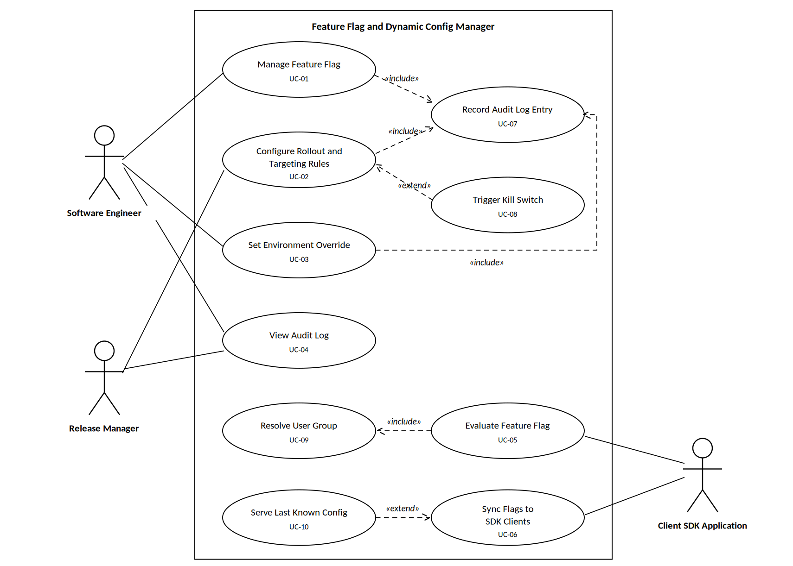
Figure 1: Use-case diagram for the Feature Flag and Dynamic Config Manager

4. Use-Case Relationships

4.1 Include Relationships
Behaviour that always runs as part of the base use case:
- UC-01 Manage Feature Flag includes UC-07 Record Audit Log Entry
- UC-02 Configure Rollout and Targeting Rules includes UC-07 Record Audit Log Entry
- UC-03 Set Environment Override includes UC-07 Record Audit Log Entry
- UC-05 Evaluate Feature Flag includes UC-09 Resolve User Group

4.2 Extend Relationships
Behaviour that runs only in a specific situation:
- UC-08 Trigger Kill Switch extends UC-02 — used when a safety limit is crossed during a rollout.
- UC-10 Serve Last Known Config extends UC-06 — used when the server cannot be reached by the SDK.

4.3 Actors and Their Use Cases
Actor | Use Cases
Software Engineer | UC-01 Manage Feature Flag, UC-03 Set Environment Override, UC-04 View Audit Log
Release Manager | UC-02 Configure Rollout and Targeting Rules, UC-04 View Audit Log, UC-08 Trigger Kill Switch
Client SDK Application | UC-05 Evaluate Feature Flag, UC-06 Sync Flags to SDK Clients

5. Use-Case Flow Specification
UC-02: Configure Rollout and Targeting Rules
Use Case ID | UC-02 | Primary Actor | Release Manager
Use Case Name | Configure Rollout and Targeting Rules | Secondary Actors | Audit Service (UC-07), Client SDK Application (UC-06)
Related Requirements | FR-003 (main), FR-001, FR-005 | Trigger | The Release Manager opens a flag and edits its rollout settings for an environment.
Preconditions and Postconditions
Preconditions | Postconditions
1. The Release Manager is logged in and has the Release Manager role for the target environment.  2. The feature flag already exists (created in UC-01) and is not archived.  3. The target environment (dev, staging or prod) is registered and reachable.  4. The current rollout percentage and rules for the flag are loaded on screen. | On success:  1. The new rollout percentage and rules are saved as the active version for that flag and environment.  2. A log entry with the user, time, environment and old and new values is saved (UC-07).  3. The new values are sent to all connected SDK clients within 5 seconds (UC-06).  4. Every user who already had the feature still has it.  On failure:  The change is rolled back, the previous version stays active, nothing is sent to clients, and the failed attempt is still logged.
Main Success Scenario
# | Actor | Step
1 | Release Manager | Selects a feature flag and the target environment, then chooses Edit Rollout.
2 | System | Shows the current rollout percentage, the targeting rules, and how many users are affected.
3 | Release Manager | Sets the new rollout percentage (for example 10% to 25%) and adds targeting rules if needed.
4 | System | Checks the input: the percentage is a whole number from 0 to 100 and the rule attributes are valid.
5 | System | Works out the new user group (include UC-09) and shows a preview: users added, users kept, users removed.
6 | Release Manager | Reviews the preview and confirms the change.
7 | System | Include UC-07: saves a log entry with the user, time, environment and the old and new values.
8 | System | Saves the change as a new version and makes it active for that environment.
9 | System | Triggers UC-06: sends the new values to all connected SDK clients.
10 | System | Shows a confirmation with the new version number and how many clients have updated.
11 | Release Manager | Checks the rollout dashboard. The use case ends successfully.
Alternate Flow — A1: Safety limit crossed during rollout (extend: UC-08 Trigger Kill Switch)
Branches from step 11 of the main success scenario.
# | Actor | Step
A1.1 | System | Detects that the flag has crossed a safety limit after the rollout (for example error rate above 2%) and alerts the Release Manager.
A1.2 | Release Manager | Opens the alert and chooses Kill Switch on the flag.
A1.3 | System | Asks for a short reason and a confirmation of the environment.
A1.4 | Release Manager | Enters the reason and confirms.
A1.5 | System | Sets the rollout to 0% and returns the flag to its safe default value for that environment.
A1.6 | System | Include UC-07: saves a log entry marked as an emergency action and keeps the old settings so they can be restored.
A1.7 | System | Sends the change to all clients (UC-06) and confirms that at least 95% updated within 5 seconds.
A1.8 | System | Notifies the flag owner and marks the flag as disabled pending investigation.
A1.9 | Release Manager | Confirms on the dashboard. The use case ends with the feature turned off and the old settings saved for a later retry.

