Article Title
First Author¹, Second Author² and Third Author²
¹Affiliation of first author, City, Country (https://orcid.org/0000-0000-0000-0000)
²Affiliation of second author, City, Country (https://orcid.org/0000-0000-0000-0000)
³Affiliation of third author, City, Country (https://orcid.org/0000-0000-0000-0000)

Corresponding author: Name (email)
Submission date: date
Revision date: add all dates for revised submissions
Manuscript type: Letter
Summary character count: (≤ 350 characters)
Letter word count (abstract + main text + captions): (≤ 4500 words)
Methods word count: (≤ 3000 words)
Short title: Short title for headers
Summary: A short summary that is 350 or fewer characters in length. The summary will appear before the manuscript abstract and will appear in the issue's table of contents. Summaries should in general be written in full sentences, though other formats may be considered when they respect the character limit.

Abstract
All submissions to Planetary Research must use the official journal template. By using this template, the authors ensure that all metadata required by the journal are provided, that all elements of the manuscript are present, and that the manuscript is formatted according to the journal's standards. The use of the journal template also ensures that the manuscript can be processed as part of the journal's post-acceptance production pipeline. Manuscript submissions that do not follow the journal's submission guidelines will be systematically rejected without review. The abstract must contain 250 words or less, without line breaks. It should provide a clear understanding of the work without requiring the reader to consult the entire article. The abstract must be self-contained: it should not include references, and any abbreviations or acronyms must be introduced. The abstract should provide the context or background for the study and state the purpose of the study, the basic procedures, and the main findings and conclusions. The authors may remove the licensing statement in the footer of the first page if they desire.

Introduction
Planetary Research provides author templates in both docx and Latex formats. Though we are happy to accept submissions in both formats, we note that our production pipeline will convert all accepted docx manuscripts to Latex. This requires extra time on our part, incurs additional cost, and is more prone to introducing errors, especially with equations. Unlike Latex submissions, we note that we are unable to hyperlink citations in the text to bibliography entries for docx submissions. When it is possible and convenient, we encourage authors to use our Latex template.

Subsections
Sections and subsections have a maximum of three levels and are unnumbered.

Sub-subsection
This is an example of a sub-subsection. Letters should avoid using sub-subsections whenever possible.

Figures
Following the acceptance of an article, the journal will ask for original versions of each figure. The journal accepts the following file formats: jpg, png, tiff, pdf, and svg. Each figure should consist of a single file, and if the figure is composed of several components, it is the author's responsibility to combine these into a single file. Figure captions should start with a short figure title in bold, as in Figure 1.
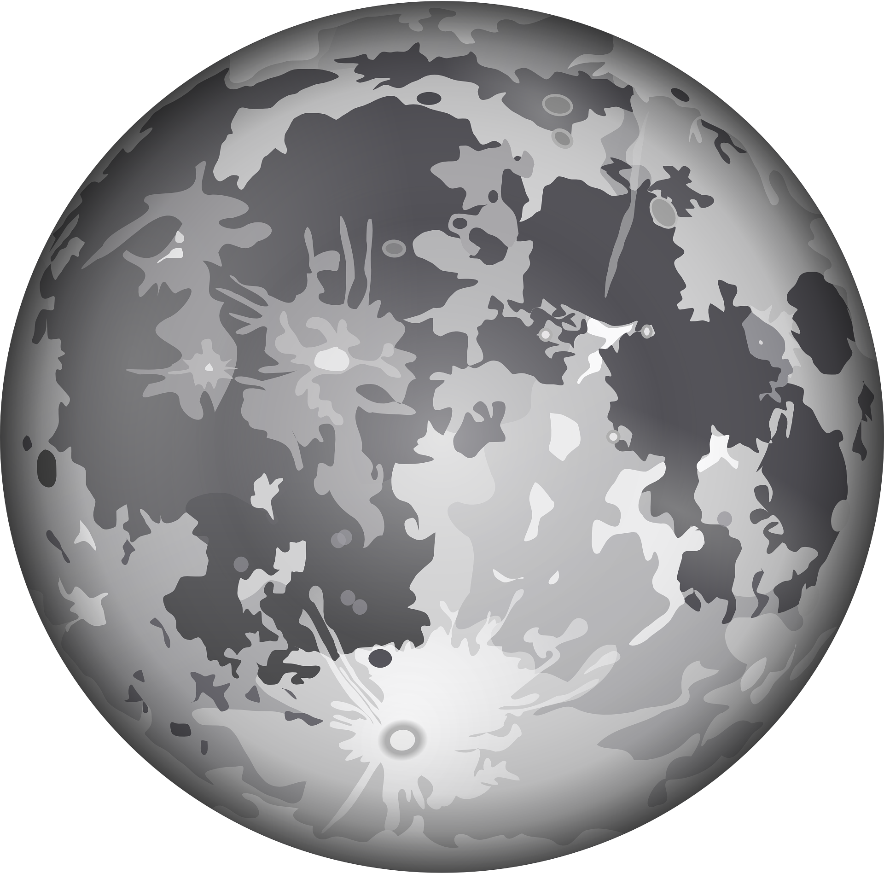
Figure 1 | Figure short title. All lettering (symbols, numbers) in figures must be consistent in style and size across all illustrations and large enough to ensure legibility. Each figure and table must be accompanied by a concise, explanatory caption. Captions must include any necessary credits if portions of the figure are not original. Each figure must correspond to a single, separate file. For further information, see the figures section in the author submission guidelines.
Figures must be sized to fit in the PDF version of the manuscript. Images will appear with widths between 10 and 15 cm, and have a maximum permissible height of 22 cm. The minimum permissible dpi (dots per inch) is 150. In terms of pixels, these dimensions correspond to 590-890×1300. Each figure must contain a caption. If the figure was published previously, the original source must be acknowledged. Furthermore, written permission to reuse the figure must be provided to the journal from the copyright holder if the figure is not distributed under a license permitting reuse.

Tables
Each table must contain a caption. The maximum width of a table cannot exceed the width of the PDF page: The journal does not support landscape mode for large tables, and the font size used for tables in the manuscript cannot be modified (see Table 1).
Table 1. Short title. Example table with placeholder content.
Name | Variable
Dummy parameter A before event | α_{before}
Dummy parameter B before event | β_{before}
Sum of Gaussian differences in A | ΣDoG(∆α)
Normalized Dummy Index | NDI

Equations
Equations can be displayed inline or formatted using equation blocks. Here we demonstrate a few complicated cases involving elastic deformation. For a perfectly elastic medium, $σ^{ij}\left(x,t\right)$ and $ε^{ij}\left(x,t\right)$ denote, respectively, the $\text{\{}i,j\text{\}}$ components of the stress and strain at the point $x$ and at time $t$. For small deformations we can write, to first order,
$$σ^{ij}\left(x,t\right)\text{=}σ_{0}^{ij}\left(x,t\right)\text{+}c_{0}^{ijkl}\left(x\right)ε^{kl}\left(x,t\right),$$ | (1)
where the term $σ_{0}^{ij}\left(x,t\right)$ is called the pre-stress, and the coefficients $c_{0}^{ijkl}\left(x\right)$ are the elastic constants. Equation (1) represents what is known as Hooke’s law. We recommend citing equations by Equation (1) instead of Eq. (1).

References
The journal uses the American Psychological Association (APA) 7th edition style for references and citations (see Table 2).
Table 2. Citation format examples
Textual citation (author in text) | Lesk and Kernighan (1977)
Parenthetical citation | (e.g., Lesk and Kernighan, 1977)
Multiple parenthetical citations | (Knuth, 1984; Lesk and Kernighan, 1977)
For accurate and consistent references, we recommend the use of bibliography manager, such as Zotero. Each reference should be listed in alphabetic order in the References sections at the end of the manuscript and must contain a persistent identifier (such as a DOI) when one is available.

Acknowledgments
Specify contributions that require acknowledgment but that do not warrant authorship. This may include acknowledgments of technical assistance, materials or financial support. When persons are mentioned in the acknowledgments, the corresponding author should request their permission to appear in the text.

Open Science Declarations
Author contributions. List here the details of each of the author's contributions to the work using the Contributor Role Taxonomy (CRediT). These roles include: Conceptualization, Data curation, Formal analysis, Funding acquisition, Investigation, Methodology, Project administration, Resources, Software, Supervision, Validation, Visualization, Writing (original draft), and Writing (review & editing). Only those roles that are appropriate should be specified. These roles are summarized in the journal's authorship policies.
Code availability. Numerical codes must both be findable and accessible according to FAIR principles. Findable means that the code can be located using a persistent identifier, such as a software heritage identifier SWHID, an astrophysics source code library identifier ASCL, or a DOI. The conditions under which the code and software used in a manuscript can be accessed must be described either on the landing page of the code or in the code archive. If the code is restricted and requires credentials to be accessed, the exact conditions under which the credentials can be obtained should be provided. For further information, see the journal's Open Science policies.
Data availability. Any data that were used or generated as part of the study and that are not found in the manuscript and supplement must be uploaded to a public data repository before the article is accepted for publication. The datasets and any accompanying metadata and documentation need to be made available to the reviewers during the peer-review process. For further information, see the journal's Open Science policies.
Funding. All sources of funding for the work must be disclosed. For work funded by a research agency, the following information must be provided: The name of the funding agency, the name of the funding program, the title of the funded project, and the grant number or funding reference.
Competing interests. All manuscripts must declare any real or perceived conflicts of interest. Competing interests may include both financial and non-financial interests such as past or present employment, consulting activity, financing, intellectual property, ownership of financial assets, or advisory roles. In the case where there are no competing interests, one can use the statement: The authors declare that they have no known competing financial interests or personal relationships that could have appeared to influence the work reported in this paper.

References
First author name, First author surname, Second author name, Second author surname and Third author name, Third author surname (year of publication). “Article Title”. In: Journal Name Volume, page range. DOI: doi of the publication.
First author name, First author surname (year of conference). “Communication Title”. In: Name of conference. City, Country of conference, page range when available.
First author name, First author surname (year of publication). “Title of the chapter”. In: Book Title. Edition number (1st, 2nd, …) ed. Publisher.
First author name, First author surname (year of publication). Book Title. Edition number (1st, 2nd, …) ed. Publisher.
Title of website. Available online: URL (accessed on Month Day, Year)

Methods
Methods are an optional section that is used only for the letter format. The methods section must be less than 3000 words in length and contain no tables or figures. The methods section is places after the References section.

