Lab 2 : CSS and Bootstrap
Q1.Design the student bio-data form using button, label, textbox, radio button, table and checkbox using CSS.

Q1.html
<html>
<head>
<title>Student Biodata</title>
<link rel="stylesheet" href="q1.css">
</head>
<body>
<div class="container">
<h2>Student Biodata</h2>
<form>
<table>
<tr>
<td><label for="name">Full Name :</label></td>
<td><input type="text" required></td>
</tr>
<tr>
<td><label for="dob">Date of Birth :</label></td>
<td><input type="date" required></td>
</tr>
<tr>
<td><label for="gender">Gender :</label></td>
<td>
<input type="radio" name="gender" required>
<label for="male">Male</label>
<input type="radio" name="gender" required>
<label for="female">Female</label>
</td>
</tr>
<tr>
<td><label for="address">Address :</label></td>
<td><textarea rows="4" required></textarea></td>
</tr>
<tr>
<td><label for="contact">Contact Number:</label></td>
<td><input type="tel" required></td>
</tr>
<tr>
<td><label for="courses">Select Courses:</label></td>
<td>
<input type="checkbox">
<label for="course1">English</label><br>
<input type="checkbox">
<label for="course2">Mathematics</label><br>
<input type="checkbox">
<label for="course3">Science</label>
</td>
</tr>
<tr>
<td colspan="2">
<button type="submit">Submit</button>
</td>
</tr>
</table>
</form>
</div>
</body>
</html>

q1.css
body{
font-family: Arial, Helvetica, sans-serif;
background-color: lightblue;

}

.container{
width: 60%;
margin: 0 auto;
background-color: aliceblue;
text-align: center;
}

button{
background-color: #4CAF50;
color: white;
padding: 10px 20px;
border: none;
border-radius: 5px;
cursor: pointer;
font-size: 16px;
width: 100%;
margin-top: 10px;
}

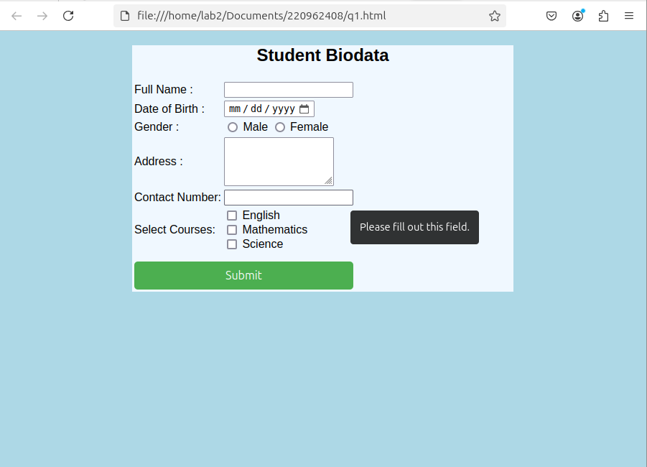

Q3.Create a web page using bootstrap as mentioned. Divide the page in to 2 parts top and
bottom, then divide the bottom into 3 parts and design each top and bottom part using
different input groups, input, badges, buttons and button groups. Make the design more
attractive using bootstrap.

Q2.html
<html>
<head>
<title>Simple Webpage</title>
<link rel="stylesheet" href="q2.css">
</head>

<body>
<div class="container">

<div class="top-section">
<h2>Top Section</h2>
<div class="input-group">
<input type="text" placeholder="Enter your username" id="username">
<button>Submit</button>
</div>
</div>

<div class="bottom-section">
<div class="left">
<h3>Left Section</h3>
<button>Action 1</button>
</div>
<div class="center">
<h3>Center Section</h3>
<button>Click Me</button>
</div>
<div class="right">
<h3>Right Section</h3>
<button>Subscribe</button>
</div>
</div>

</div>
</body>

</html>

q2.css
/* Basic Reset */
* {
margin: 0;
padding: 0;
box-sizing: border-box;
}

/* Body styles */
body {
font-family: Arial, sans-serif;
background-color: #f4f4f4;
padding: 20px;
}

/* Container to center the content */
.container {
max-width: 900px;
margin: 0 auto;
}

/* Top section styling */
.top-section {
background-color: #007bff;
color: white;
padding: 20px;
text-align: center;
margin-bottom: 20px;
}

.top-section h2 {
margin-bottom: 10px;
}

.input-group {
display: flex;
justify-content: center;
align-items: center;
gap: 10px;
}

.input-group input {
padding: 10px;
font-size: 16px;
border: 2px solid #ddd;
border-radius: 5px;
width: 200px;
}

.input-group button {
padding: 10px 20px;
background-color: #28a745;
color: white;
border: none;
border-radius: 5px;
cursor: pointer;
}

/* Bottom section styling */
.bottom-section {
display: flex;
justify-content: space-between;
gap: 20px;
}

.bottom-section > div {
background-color: #ffffff;
border-radius: 8px;
padding: 20px;
box-shadow: 0 4px 8px rgba(0, 0, 0, 0.1);
width: 30%;
text-align: center;
}

.bottom-section h3 {
margin-bottom: 15px;
}

.bottom-section button {
padding: 10px 20px;
background-color: #007bff;
color: white;
border: none;
border-radius: 5px;
cursor: pointer;
}

.bottom-section button:hover {
background-color: #0056b3;
}

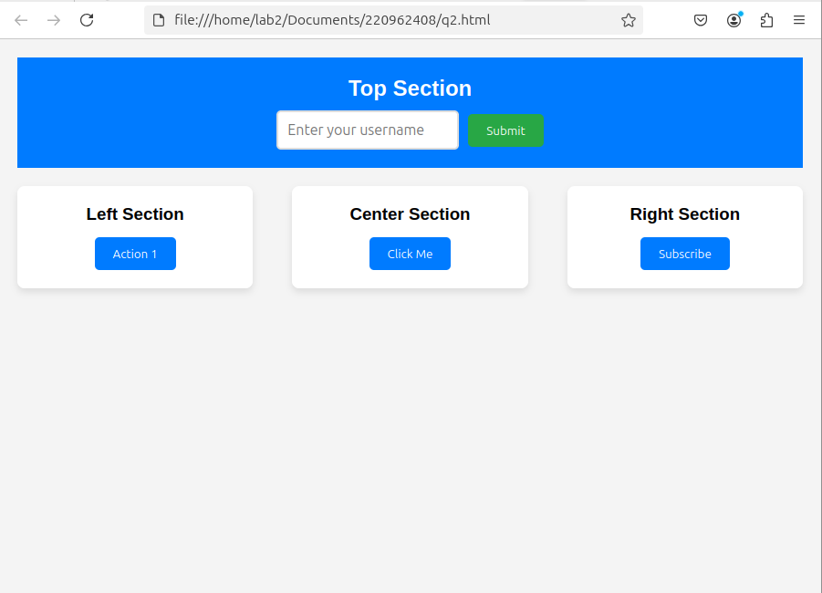

Q4.Design your class timetable using bootstrap table and carousel.

Q4.html

<!DOCTYPE html>
<html lang="en">

<head>
<meta charset="UTF-8">
<meta name="viewport" content="width=device-width, initial-scale=1.0">
<title>Class Timetable</title>
<link href="https://cdn.jsdelivr.net/npm/bootstrap@5.3.0-alpha1/dist/css/bootstrap.min.css" rel="stylesheet">
<link rel="stylesheet" href="q3.css">
</head>

<body>
<div class="container my-4">
<h2 class="text-center">Class Timetable</h2>

<!-- Carousel for Days of the Week -->
<div id="timetableCarousel" class="carousel slide" data-bs-ride="carousel">
<div class="carousel-inner">

<!-- Monday -->
<div class="carousel-item active">
<div class="carousel-caption d-none d-md-block">
<h3>Monday</h3>
</div>
<table class="table table-bordered">
<thead>
<tr>
<th>Time</th>
<th>Class</th>
<th>Room</th>
</tr>
</thead>
<tbody>
<tr>
<td>8:00 AM - 10:00 AM</td>
<td>Mathematics</td>
<td>Room 101</td>
</tr>
<tr>
<td>10:30 AM - 12:30 PM</td>
<td>Physics</td>
<td>Room 102</td>
</tr>
<tr>
<td>1:30 PM - 3:30 PM</td>
<td>Chemistry</td>
<td>Room 103</td>
</tr>
</tbody>
</table>
</div>

<!-- Tuesday -->
<div class="carousel-item">
<div class="carousel-caption d-none d-md-block">
<h3>Tuesday</h3>
</div>
<table class="table table-bordered">
<thead>
<tr>
<th>Time</th>
<th>Class</th>
<th>Room</th>
</tr>
</thead>
<tbody>
<tr>
<td>8:00 AM - 10:00 AM</td>
<td>English</td>
<td>Room 201</td>
</tr>
<tr>
<td>10:30 AM - 12:30 PM</td>
<td>Biology</td>
<td>Room 202</td>
</tr>
<tr>
<td>1:30 PM - 3:30 PM</td>
<td>Computer Science</td>
<td>Room 203</td>
</tr>
</tbody>
</table>
</div>

</div>

<!-- Carousel Controls -->
<button class="carousel-control-prev" type="button" data-bs-target="#timetableCarousel" data-bs-slide="prev">
<span class="carousel-control-prev-icon" aria-hidden="true"></span>
</button>
<button class="carousel-control-next" type="button" data-bs-target="#timetableCarousel" data-bs-slide="next">
<span class="carousel-control-next-icon" aria-hidden="true"></span>
</button>
</div>
</div>

<script src="https://cdn.jsdelivr.net/npm/bootstrap@5.3.0-alpha1/dist/js/bootstrap.bundle.min.js"></script>
</body>

</html>

q4.css

body {
background-color: #f8f9fa;
}

.container {
margin-top: 30px;
}

.carousel-item {
text-align: center;
margin-bottom: 20px;
}

.table th, .table td {
text-align: center;
vertical-align: middle;
}

.carousel-caption h3 {
font-size: 1.8rem;
background-color: rgba(0, 0, 0, 0.5);
padding: 5px;
border-radius: 5px;
color: white;
}

.timetable {
margin-top: 40px;
}

