Lab 2 : CSS and Bootstrap

Q1.Design the student bio-data form using button, label, textbox, radio button, table and checkbox using CSS.

Q1.html

<html>

<head>

<title>Student Biodata</title>

<link rel="stylesheet" href="q1.css">

</head>

<body>

<div class="container">

<h2>Student Biodata</h2>

<form>

<table>

<tr>

<td><label for="name">Full Name :</label></td>

<td><input type="text" required></td>

</tr>

<tr>

<td><label for="dob">Date of Birth :</label></td>

<td><input type="date" required></td>

</tr>

<tr>

<td><label for="gender">Gender :</label></td>

<td>

<input type="radio" name="gender" required>

<label for="male">Male</label>

<input type="radio" name="gender" required>

<label for="female">Female</label>

</td>

</tr>

<tr>

<td><label for="address">Address :</label></td>

<td><textarea rows="4" required></textarea></td>

</tr>

<tr>

<td><label for="contact">Contact Number:</label></td>

<td><input type="tel" required></td>

</tr>

<tr>

<td><label for="courses">Select Courses:</label></td>

<td>

<input type="checkbox">

<label for="course1">English</label><br>

<input type="checkbox">

<label for="course2">Mathematics</label><br>

<input type="checkbox">

<label for="course3">Science</label>

</td>

</tr>

<tr>

<td colspan="2">

<button type="submit">Submit</button>

</td>

</tr>

</table>

</form>

</div>

</body>

</html>

q1.css

body{

font-family: Arial, Helvetica, sans-serif;

background-color: lightblue;

}

.container{

width: 60%;

margin: 0 auto;

background-color: aliceblue;

text-align: center;

}

button{

background-color: #4CAF50;

color: white;

padding: 10px 20px;

border: none;

border-radius: 5px;

cursor: pointer;

font-size: 16px;

width: 100%;

margin-top: 10px;

}

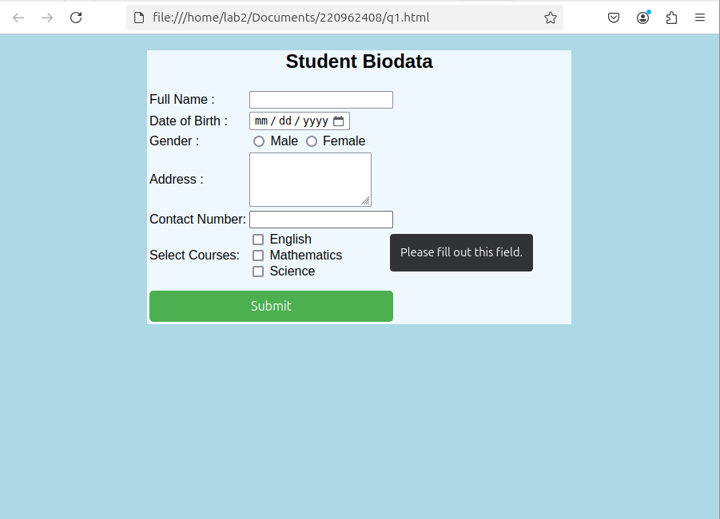

Q3.Create a web page using bootstrap as mentioned. Divide the page in to 2 parts top and

bottom, then divide the bottom into 3 parts and design each top and bottom part using

different input groups, input, badges, buttons and button groups. Make the design more

attractive using bootstrap.

Q2.html

<html>

<head>

<title>Simple Webpage</title>

<link rel="stylesheet" href="q2.css">

</head>

<body>

<div class="container">

<div class="top-section">

<h2>Top Section</h2>

<div class="input-group">

<input type="text" placeholder="Enter your username" id="username">

<button>Submit</button>

</div>

</div>

<div class="bottom-section">

<div class="left">

<h3>Left Section</h3>

<button>Action 1</button>

</div>

<div class="center">

<h3>Center Section</h3>

<button>Click Me</button>

</div>

<div class="right">

<h3>Right Section</h3>

<button>Subscribe</button>

</div>

</div>

</div>

</body>

</html>

q2.css

/\* Basic Reset \*/

\* {

margin: 0;

padding: 0;

box-sizing: border-box;

}

/\* Body styles \*/

body {

font-family: Arial, sans-serif;

background-color: #f4f4f4;

padding: 20px;

}

/\* Container to center the content \*/

.container {

max-width: 900px;

margin: 0 auto;

}

/\* Top section styling \*/

.top-section {

background-color: #007bff;

color: white;

padding: 20px;

text-align: center;

margin-bottom: 20px;

}

.top-section h2 {

margin-bottom: 10px;

}

.input-group {

display: flex;

justify-content: center;

align-items: center;

gap: 10px;

}

.input-group input {

padding: 10px;

font-size: 16px;

border: 2px solid #ddd;

border-radius: 5px;

width: 200px;

}

.input-group button {

padding: 10px 20px;

background-color: #28a745;

color: white;

border: none;

border-radius: 5px;

cursor: pointer;

}

/\* Bottom section styling \*/

.bottom-section {

display: flex;

justify-content: space-between;

gap: 20px;

}

.bottom-section > div {

background-color: #ffffff;

border-radius: 8px;

padding: 20px;

box-shadow: 0 4px 8px rgba(0, 0, 0, 0.1);

width: 30%;

text-align: center;

}

.bottom-section h3 {

margin-bottom: 15px;

}

.bottom-section button {

padding: 10px 20px;

background-color: #007bff;

color: white;

border: none;

border-radius: 5px;

cursor: pointer;

}

.bottom-section button:hover {

background-color: #0056b3;

}

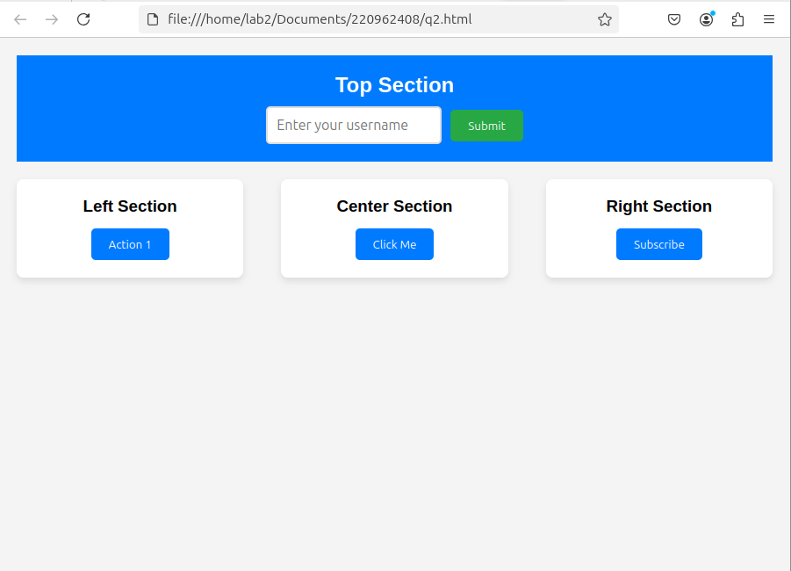

Q4.Design your class timetable using bootstrap table and carousel.

Q4.html

<!DOCTYPE html>

<html lang="en">

<head>

<meta charset="UTF-8">

<meta name="viewport" content="width=device-width, initial-scale=1.0">

<title>Class Timetable</title>

<link href="https://cdn.jsdelivr.net/npm/bootstrap@5.3.0-alpha1/dist/css/bootstrap.min.css" rel="stylesheet">

<link rel="stylesheet" href="q3.css">

</head>

<body>

<div class="container my-4">

<h2 class="text-center">Class Timetable</h2>

<!-- Carousel for Days of the Week -->

<div id="timetableCarousel" class="carousel slide" data-bs-ride="carousel">

<div class="carousel-inner">

<!-- Monday -->

<div class="carousel-item active">

<div class="carousel-caption d-none d-md-block">

<h3>Monday</h3>

</div>

<table class="table table-bordered">

<thead>

<tr>

<th>Time</th>

<th>Class</th>

<th>Room</th>

</tr>

</thead>

<tbody>

<tr>

<td>8:00 AM - 10:00 AM</td>

<td>Mathematics</td>

<td>Room 101</td>

</tr>

<tr>

<td>10:30 AM - 12:30 PM</td>

<td>Physics</td>

<td>Room 102</td>

</tr>

<tr>

<td>1:30 PM - 3:30 PM</td>

<td>Chemistry</td>

<td>Room 103</td>

</tr>

</tbody>

</table>

</div>

<!-- Tuesday -->

<div class="carousel-item">

<div class="carousel-caption d-none d-md-block">

<h3>Tuesday</h3>

</div>

<table class="table table-bordered">

<thead>

<tr>

<th>Time</th>

<th>Class</th>

<th>Room</th>

</tr>

</thead>

<tbody>

<tr>

<td>8:00 AM - 10:00 AM</td>

<td>English</td>

<td>Room 201</td>

</tr>

<tr>

<td>10:30 AM - 12:30 PM</td>

<td>Biology</td>

<td>Room 202</td>

</tr>

<tr>

<td>1:30 PM - 3:30 PM</td>

<td>Computer Science</td>

<td>Room 203</td>

</tr>

</tbody>

</table>

</div>

</div>

<!-- Carousel Controls -->

<button class="carousel-control-prev" type="button" data-bs-target="#timetableCarousel" data-bs-slide="prev">

<span class="carousel-control-prev-icon" aria-hidden="true"></span>

</button>

<button class="carousel-control-next" type="button" data-bs-target="#timetableCarousel" data-bs-slide="next">

<span class="carousel-control-next-icon" aria-hidden="true"></span>

</button>

</div>

</div>

<script src="https://cdn.jsdelivr.net/npm/bootstrap@5.3.0-alpha1/dist/js/bootstrap.bundle.min.js"></script>

</body>

</html>

q4.css

body {

background-color: #f8f9fa;

}

.container {

margin-top: 30px;

}

.carousel-item {

text-align: center;

margin-bottom: 20px;

}

.table th, .table td {

text-align: center;

vertical-align: middle;

}

.carousel-caption h3 {

font-size: 1.8rem;

background-color: rgba(0, 0, 0, 0.5);

padding: 5px;

border-radius: 5px;

color: white;

}

.timetable {

margin-top: 40px;

}

