Lab 3: Javascript

Q1.Write a JavaScript program to perform an online quiz

q1.html

<html>

<head>

<title>Online Quiz</title>

<link rel="stylesheet" href="q1.css">

</head>

<body>

<h1>Can you answer these questions?</h1>

<div class="question" id="q1">

Q1. Who is the president of the United States?<br>

<input type="radio" name="q1">Elon Musk

<input type="radio" name="q1">Donald Trump

<input type="radio" name="q1">Joe Biden

<input type="radio" name="q1">Barack Obama

</div>

<div class="question" id="q2">

Q2. When is the Indian Republic Day celebrated?<br>

<input type="radio" name="q2">26th January

<input type="radio" name="q2">16th February

<input type="radio" name="q2">8th March

<input type="radio" name="q2">20th April

</div>

<div class="question" id="q3">

Q3. What is the full form of MIT?<br>

<input type="radio" name="q3">Manipal Institute of Technology

<input type="radio" name="q3">Massachusetts Institute of Technology

<input type="radio" name="q3">Mahindra Indian Telephones

<input type="radio" name="q3">Madgaon Imperial Tea

</div>

<button onclick="checkAns()" id="btn">Submit</button>

<div id="score"></div>

<script src="q1.js"></script>

</body>

</html>

q1.css

body{

background-color: aliceblue;

}

.question{

border: 2px solid #000;

background-color: lightblue;

}

button {

margin-right: 75px;

margin-top: 8%;

padding: 10px 20px;

background-color: #4f98c2;

color: white;

border: none;

cursor: pointer;

}

button:hover {

color: #4f98c2;

background-color: white;

border: 1 px solid #4f98c2;

}

q1.js

function checkAns() {

let score = 0;

// Check answers for each question

if (document.querySelector('input[name="q1"]:checked') && document.querySelector('input[name="q1"]:checked').nextSibling.textContent.trim() === "Donald Trump") {

score++;

}

if (document.querySelector('input[name="q2"]:checked') && document.querySelector('input[name="q2"]:checked').nextSibling.textContent.trim() === "26th January") {

score++;

}

if (document.querySelector('input[name="q3"]:checked') && document.querySelector('input[name="q3"]:checked').nextSibling.textContent.trim() === "Manipal Institute of Technology") {

score++;

}

// Display the score

document.getElementById("score").innerHTML = "Your score: " + score + "/3";

}

Output:

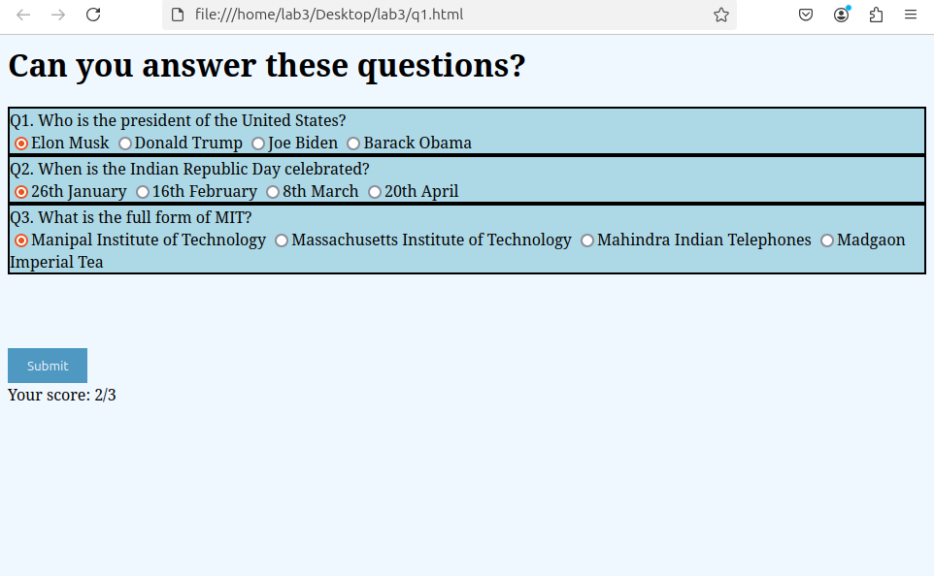

Q2.Write a JavaScript program to Wish a user at different hours of a day. Use

appropriate dialog boxes for wishing the user. Display the dynamic clock on the

web page. Make use of CSS and HTML5 elements for creative and attractive

design.

q2.html

<html>

<head>

<title>Dynamic Greeting</title>

<link rel="stylesheet" href="q2.css">

</head>

<body>

<div id="clock"></div>

<script src="q2.js"></script>

</body>

</html>

q2.css

body {

font-family: Arial, sans-serif;

display: flex;

justify-content: center;

align-items: center;

height: 100vh;

margin: 0;

background-color: #f0f0f0;

}

#clock {

font-size: 48px;

font-weight: bold;

color: #333;

text-align: center;

}

q2.js

function wishUser() {

const hour = new Date().getHours();

let greeting = "";

if (hour < 12) {

greeting = "Good Morning!";

} else if (hour < 18) {

greeting = "Good Afternoon!";

} else {

greeting = "Good Evening!";

}

alert(greeting); // Show a dialog box

}

function updateClock() {

const time = new Date().toLocaleTimeString();

document.getElementById('clock').textContent = time;

}

wishUser(); // Call wish function when page loads

setInterval(updateClock, 1000); // Update the clock every second

Output:

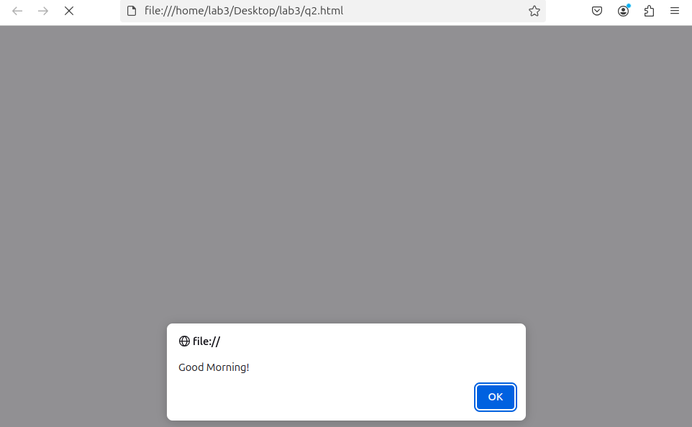

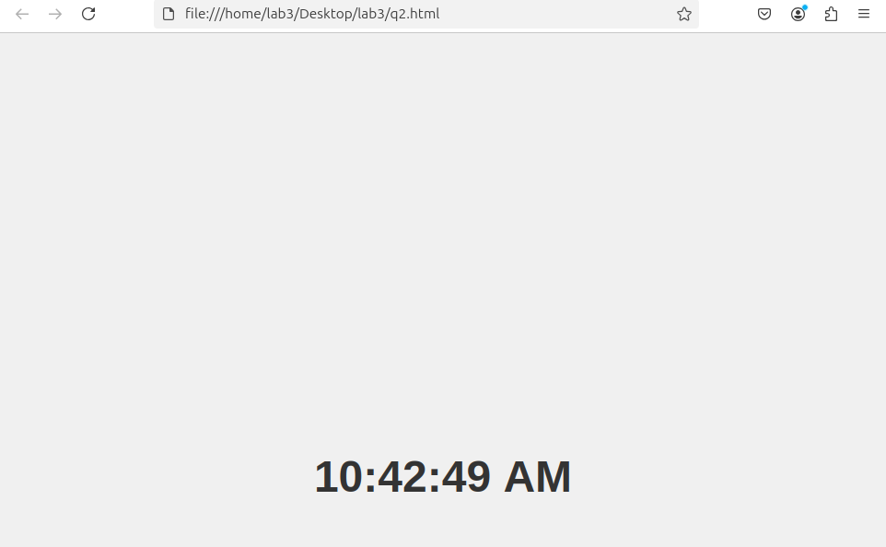

Q3.Write the java script program to display the grade [A, B,C,D] based on the marks

entered by student(take the input into text boxes). Enter the marks of 4 subjects and

calculate the average( using button). If the avg>90 then A, avg>80 then B, if avg>70

then C, if avg>60 then D.

q3.html

<html>

<head>

<title>Grades</title>

<script src="q3.js"></script>

<link rel="stylesheet" href="q3.css">

</head>

<body>

<h1>Get your grade!</h1>

<h3>Enter marks out of 100</h3>

<div class="subject" id="dl">

Deep Learning<br>

<input type="number" min="0" max="100" class="marks">

</div>

<div class="subject" id="pcap">

Parallel Computer Architecture and Programming<br>

<input type="number" min="0" max="100" class="marks">

</div>

<div class="subject" id="eefm">

Engineering Econmics and Financial Management <br>

<input type="number" min="0" max="100" class="marks">

</div>

<div class="subject" id="matlab">

MATLAB for Engineers<br>

<input type="number" min="0" max="100" class="marks">

</div>

<button onclick="calc_avg()">Submit</button>

<h3 id="avg"></h3>

<h3 id="grade"></h3>

</body>

</html>

q3.css

body {

font-family: Arial, sans-serif;

display: flex;

justify-content: center;

align-items: center;

height: 100vh;

margin: 0;

background-color: #f0f0f0;

}

#clock {

font-size: 48px;

font-weight: bold;

color: #333;

text-align: center;

}

q3.js

function calc_avg(){

let sum=0;

const inputs=document.querySelectorAll('.marks');

inputs.forEach(input => {

sum+=parseFloat(input.value);

});

let avg=sum/inputs.length;

document.getElementById('avg').innerText= "Your average is : " + avg;

if(avg>90){

document.getElementById('grade').innerText= "Your grade is : " + "A";

}

else if(avg>80){

document.getElementById('grade').innerText= "Your grade is : " + "B";

}

else if(avg>70){

document.getElementById('grade').innerText= "Your grade is : " + "C";

}

else if(avg>60){

document.getElementById('grade').innerText= "Your grade is : " + "D";

}

}

Output:

