Week 8: Form Processing using Django – Part I

Q1. Develop a web application using Django framework to demonstrate the transfer of multiple parameters between web pages. User should be presented with a dropdown list containing car manufacturers, a text box which takes model name of the manufacturer and a submit button. On submitting the web page, the user is forwarded to a new page. This new page should display the selected car manufacturer name and the model name.

**carinfo/urls.py**

from django.urls import path

from . import views

app_name = 'carinfo'

urlpatterns = [

path('', views.index, name='index'),

path('result/', views.result, name='result'),

]

**carinfo/views.py**

from django.shortcuts import render

def index(request):

# List of car manufacturers for dropdown

car_manufacturers = ['Toyota', 'Ford', 'BMW', 'Tesla', 'Honda']

return render(request, 'carinfo/index.html', {'car_manufacturers': car_manufacturers})

def result(request):

if request.method == "GET":

manufacturer = request.GET.get('manufacturer')

model = request.GET.get('model')

return render(request, 'carinfo/result.html', {'manufacturer': manufacturer, 'model': model})

**carinfo/templates/carinfo/index.html**

<!DOCTYPE html>

<html lang="en">

<head>

<meta charset="UTF-8">

<meta name="viewport" content="width=device-width, initial-scale=1.0">

<title>Select Car</title>

</head>

<body>

<h1>Choose a Car Manufacturer</h1>

<form method="get" action="{% url 'carinfo:result' %}">

<label for="manufacturer">Select Manufacturer:</label>

<select name="manufacturer" id="manufacturer">

{% for manufacturer in car_manufacturers %}

<option value="{{ manufacturer }}">{{ manufacturer }}</option>

{% endfor %}

</select><br><br>

<label for="model">Enter Model Name:</label>

<input type="text" name="model" id="model" required><br><br>

<button type="submit">Submit</button>

</form>

</body>

</html>

**carinfo/templates/carinfo/result.html**

<!DOCTYPE html>

<html lang="en">

<head>

<meta charset="UTF-8">

<meta name="viewport" content="width=device-width, initial-scale=1.0">

<title>Car Model</title>

</head>

<body>

<h1>Car Details</h1>

<p><strong>Manufacturer:</strong> {{ manufacturer }}</p>

<p><strong>Model:</strong> {{ model }}</p>

</body>

</html>

**Output:**

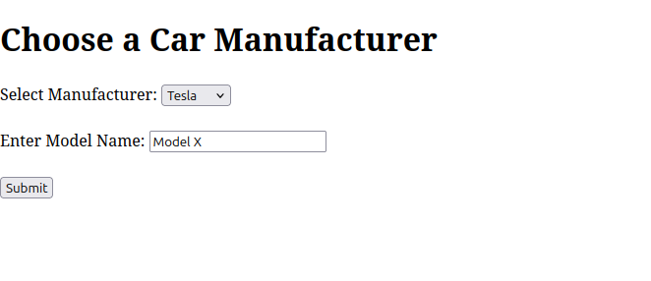

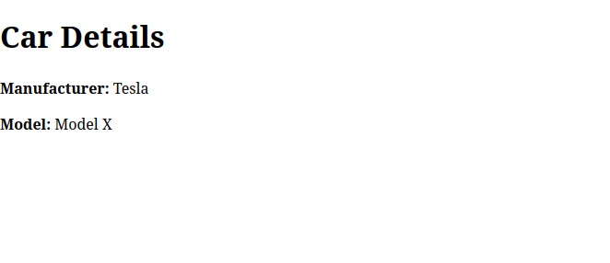

Q2. Create a page firstPage.html with two TextBoxes [Name, Roll], DropDownList

[Subjects], and a button. Create another page secondPage.html with a label and a

button. When the user clicks the button in first Page, he should be sent to the second

page and display the contents passed from first page in the label. The button in second page should navigate the user back to firstPage. Use Django sessions to transfer information.

**session_example/urls.py**

from django.urls import path

from . import views

urlpatterns = [

path('', views.first_page, name='first_page'),

path('second/', views.second_page, name='second_page'),

]

**session_example/views.py**

from django.shortcuts import render, redirect

def first_page(request):

if request.method == 'POST':

# Save data in session

request.session['name'] = request.POST.get('name')

request.session['roll'] = request.POST.get('roll')

request.session['subject'] = request.POST.get('subject')

# Redirect to second page

return redirect('session_example:second_page')

return render(request, 'session_example/firstPage.html')

def second_page(request):

name = request.session.get('name', '')

roll = request.session.get('roll', '')

subject = request.session.get('subject', '')

return render(request, 'session_example/secondPage.html', {

'name': name,

'roll': roll,

'subject': subject,

})

**session_example/templates/session_example/firstPage.html**

<!DOCTYPE html>

<html lang="en">

<head>

<meta charset="UTF-8">

<meta name="viewport" content="width=device-width, initial-scale=1.0">

<title>First Page</title>

</head>

<body>

<h1>Enter Your Details</h1>

<form method="post">

{% csrf_token %}

<label for="name">Name:</label>

<input type="text" name="name" id="name" required><br><br>

<label for="roll">Roll:</label>

<input type="text" name="roll" id="roll" required><br><br>

<label for="subject">Select Subject:</label>

<select name="subject" id="subject">

<option value="Math">Math</option>

<option value="Science">Science</option>

<option value="English">English</option>

</select><br><br>

<button type="submit">Submit</button>

</form>

</body>

</html>

**session_example/templates/session_example/secondPage.html**

<!DOCTYPE html>

<html lang="en">

<head>

<meta charset="UTF-8">

<meta name="viewport" content="width=device-width, initial-scale=1.0">

<title>Second Page</title>

</head>

<body>

<h1>Received Details</h1>

<p><strong>Name:</strong> {{ name }}</p>

<p><strong>Roll:</strong> {{ roll }}</p>

<p><strong>Subject:</strong> {{ subject }}</p>

<br><br>

<a href="{% url 'session_example:first_page' %}"><button>Go Back to First Page</button></a>

</body>

</html>

**Output:**

