WP Lab 9

Q1.Create a Register page and Success page with the following requirements:

i.Register page should contain four input TextBoxes for UserName, Password,

Email id and Contact Number and also a button to submit. Make the username as

compulsory field and other fields as optional.

ii.On button click, Success page is displayed with message "Welcome

{UserName}" and also his Email and Contact Number has to be displayed.

iii. Use secure technique to send details to the Success page (Hint: use csrftoken)

Design a website with two pages.

**user_registration/forms.py**

from django import forms

class RegistrationForm(forms.Form):

username = forms.CharField(max_length=100, required=True, label='Username')

password = forms.CharField(widget=forms.PasswordInput, required=False, label='Password')

email = forms.EmailField(required=False, label='Email')

contact_number = forms.CharField(max_length=15, required=False, label='Contact Number')

**user_registration/urls.py**

from django.urls import path

from . import views

urlpatterns = [

path('register/', views.register, name='register'),

path('success/<str:username>/<str:email>/<str:contact_number>/', views.success, name='success'),

]

**user_registration/views.py**

from django.shortcuts import render, redirect

from .forms import RegistrationForm

def register(request):

if request.method == "POST":

form = RegistrationForm(request.POST)

if form.is_valid():

username = form.cleaned_data.get('username')

email = form.cleaned_data.get('email')

contact_number = form.cleaned_data.get('contact_number')

# Redirect with parameters in the URL

return redirect('success', username=username, email=email, contact_number=contact_number)

else:

form = RegistrationForm()

return render(request, 'user_registration/register.html', {'form': form})

def success(request, username, email, contact_number):

return render(request, 'user_registration/success.html', {

'username': username,

'email': email,

'contact_number': contact_number

})

**user_registration/templates/user_registration/register.html**

<html>

<head><title>Register</title></head>

<body>

<h1>Register</h1>

<form method="post">

{% csrf_token %}

{{ form.as_p }}

<button type="submit">Submit</button>

</form>

</body>

</html>

**user_registration/templates/user_registration/success.html**

<html>

<head><title>Success</title></head>

<body>

<h1>Welcome {{ username }}</h1>

<p>Email: {{ email }}</p>

<p>Contact Number: {{ contact_number }}</p>

</body>

</html>

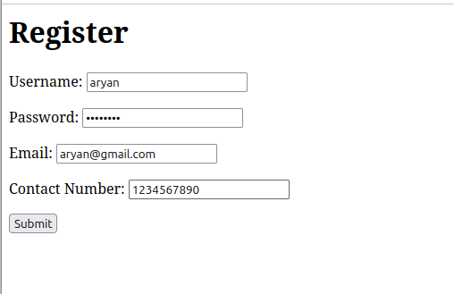**Output:**

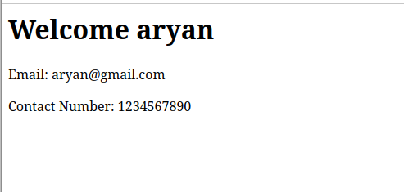

Q2.“How is the book ASP.NET with c# by Vipul Prakashan?” Give the user three choice :

i) Good

ii) Satisfactory

iii) Bad.

Provide a VOTE button. After user votes, present the result in

percentage using labels next to the choices.

**book_vote/models.py**

from django.db import models

class Vote(models.Model):

choice = models.CharField(max_length=20)

count = models.IntegerField(default=0)

def __str__(self):

return self.choice

**book_vote/forms.py**

from django import forms

class VoteForm(forms.Form):

CHOICES = [

('Good', 'Good'),

('Satisfactory', 'Satisfactory'),

('Bad', 'Bad'),

]

vote = forms.ChoiceField(choices=CHOICES, widget=forms.RadioSelect, required=True)

**book_vote/views.py**

from django.shortcuts import render

from .forms import VoteForm

from .models import Vote

def vote(request):

if request.method == "POST":

form = VoteForm(request.POST)

if form.is_valid():

# Get the vote choice from the form

vote_choice = form.cleaned_data['vote']

# Update the vote count for the selected choice

vote, created = Vote.objects.get_or_create(choice=vote_choice)

vote.count += 1

vote.save()

return render(request, 'book_vote/results.html', {'vote': vote_choice})

else:

form = VoteForm()

# Get the total votes and percentage for each choice

total_votes = sum(vote.count for vote in Vote.objects.all())

votes = Vote.objects.all()

percentages = {vote.choice: (vote.count / total_votes * 100) if total_votes else 0 for vote in votes}

return render(request, 'book_vote/vote.html', {'form': form, 'percentages': percentages})

**book_vote/urls.py**

from django.urls import path

from . import views

urlpatterns = [

path('vote/', views.vote, name='vote'),

]

**book_vote/templates/book_vote/vote.html**

<html>

<head><title>Vote for Book</title></head>

<body>

<h1>How is the book "ASP.NET with C# by Vipul Prakashan?"</h1>

<form method="post">

{% csrf_token %}

{{ form.as_p }}

<button type="submit">VOTE</button>

</form>

<h2>Current Vote Percentages:</h2>

<ul>

{% for choice, percentage in percentages.items %}

<li>{{ choice }}: {{ percentage|floatformat:2 }}%</li>

{% endfor %}

</ul>

</body>

</html>

**book_vote/templates/book_vote/results.html**

<html>

<head><title>Vote Results</title></head>

<body>

<h1>Thank you for voting!</h1>

<h2>Your vote: {{ vote }}</h2>

<a href="{% url 'vote' %}">Back to voting</a>

</body>

</html>

**Output:**

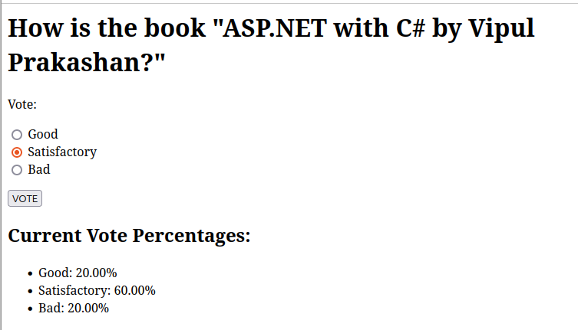

Q3.Create a website with two pages. Page 1 has two TextBoxes (name and total marks) and one ‘Calculate’ Button as shown in the figure. On clicking the ‘Calculate’ Button, CGPA (total marks/50) along with the name should be displayed in the Page 2 . Use Django sessions to store the information.

**cgpa_calculator/forms.py**

from django import forms

class CGPAForm(forms.Form):

name = forms.CharField(max_length=100, label='Name', required=True)

total_marks = forms.IntegerField(label='Total Marks', required=True)

**cgpa_calculator/views.py**

from django.shortcuts import render, redirect

from .forms import CGPAForm

def calculate(request):

if request.method == 'POST':

form = CGPAForm(request.POST)

if form.is_valid():

# Get data from the form

name = form.cleaned_data['name']

total_marks = form.cleaned_data['total_marks']

# Store the data in session

request.session['name'] = name

request.session['total_marks'] = total_marks

return redirect('result')

else:

form = CGPAForm()

return render(request, 'cgpa_calculator/form.html', {'form': form})

def result(request):

# Get the data from session

name = request.session.get('name')

total_marks = request.session.get('total_marks')

# Calculate CGPA (total_marks / 50)

if total_marks is not None:

cgpa = total_marks / 50

else:

cgpa = 0

return render(request, 'cgpa_calculator/result.html', {'name': name, 'cgpa': cgpa})

**cgpa_calculator/urls.py**

from django.urls import path

from . import views

urlpatterns = [

path('calculate/', views.calculate, name='calculate'),

path('result/', views.result, name='result'),

]

**cgpa_calculator/templates/cgpa_calculator/form.html**

<html>

<head><title>CGPA Calculator</title></head>

<body>

<h1>Enter Your Name and Total Marks</h1>

<form method="post">

{% csrf_token %}

{{ form.as_p }}

<button type="submit">Calculate</button>

</form>

</body>

</html>

**cgpa_calculator/templates/cgpa_calculator/result.html**

<html>

<head><title>CGPA Result</title></head>

<body>

<h1>Hello {{ name }}</h1>

<p>Your CGPA is: {{ cgpa }}</p>

<a href="{% url 'calculate' %}">Go back and calculate again</a>

</body>

</html>

**Output:**

