WP Lab Week 5

Q1. Create a web form which allows the teacher to enter the student details like name, date of birth, address, contact number, email id and marks of English, Physics and Chemistry. After filling all the information and on clicking submit button, details

should be added to a textarea displayed on the same page. Display the total

percentage of marks obtained in a label.

q1.html

<!DOCTYPE html>

<html lang="en">

<head>

<meta charset="UTF-8" />

<meta name="viewport" content="width=device-width, initial-scale=1.0" />

<title>Student Information Form</title>

<style>

body {

font-family: 'Segoe UI', Tahoma, Geneva, Verdana, sans-serif;

background-color: #f9f9f9;

margin: 0;

padding: 0;

}

.container {

width: 55%;

margin: 40px auto;

background-color: #ffffff;

padding: 35px;

border-radius: 12px;

box-shadow: 0 8px 16px rgba(0, 0, 0, 0.12);

}

h2 {

text-align: center;

color: #2d2d2d;

font-size: 24px;

margin-bottom: 20px;

}

label {

font-size: 15px;

margin-bottom: 6px;

display: block;

color: #666;

}

input,

textarea {

width: 100%;

padding: 12px;

margin: 8px 0;

border-radius: 6px;

border: 1px solid #ccc;

font-size: 16px;

box-sizing: border-box;

}

input[type="button"] {

background-color: #008cba;

color: white;

border: none;

cursor: pointer;

font-size: 16px;

padding: 12px 25px;

border-radius: 8px;

transition: background-color 0.3s;

}

input[type="button"]:hover {

background-color: #007b8d;

}

#result {

margin-top: 25px;

}

.label {

font-weight: 600;

font-size: 16px;

color: #333;

}

.output {

border: 1px solid #ddd;

padding: 15px;

margin-top: 12px;

background-color: #f8f8f8;

font-size: 16px;

}

#chartContainer {

text-align: center;

margin-top: 30px;

}

canvas {

border-radius: 50%;

background-color: #f1f1f1;

margin: 0 auto;

}

</style>

</head>

<body>

<div class="container">

<h2>Fill Out the Student Details</h2>

<form id="studentForm">

<label for="name">Full Name</label>

<input

type="text"

id="name"

placeholder="Enter your full name"

required

/>

<label for="dob">Date of Birth</label>

<input type="date" id="dob" required />

<label for="address">Address</label>

<textarea

id="address"

placeholder="Enter your address"

rows="4"

required

></textarea>

<label for="contact">Contact Number</label>

<input

type="text"

id="contact"

placeholder="Enter your contact number"

required

/>

<label for="email">Email Address</label>

<input

type="email"

id="email"

placeholder="Enter your email address"

required

/>

<label for="english">Marks in English</label>

<input

type="number"

id="english"

placeholder="Enter marks out of 100"

min="0"

max="100"

required

/>

<label for="physics">Marks in Physics</label>

<input

type="number"

id="physics"

placeholder="Enter marks out of 100"

min="0"

max="100"

required

/>

<label for="chemistry">Marks in Chemistry</label>

<input

type="number"

id="chemistry"

placeholder="Enter marks out of 100"

min="0"

max="100"

required

/>

<input type="button" value="Submit Details" onclick="submitForm()" />

</form>

<div id="result">

<label class="label">Student Information:</label>

<div id="detailsOutput" class="output"></div>

<label class="label">Calculated Percentage:</label>

<div id="percentageOutput" class="output"></div>

</div>

<div id="chartContainer">

<canvas id="percentageChart" width="250" height="250"></canvas>

</div>

</div>

<script>

function submitForm() {

const name = document.getElementById("name").value;

const dob = document.getElementById("dob").value;

const address = document.getElementById("address").value;

const contact = document.getElementById("contact").value;

const email = document.getElementById("email").value;

const english = parseInt(document.getElementById("english").value);

const physics = parseInt(document.getElementById("physics").value);

const chemistry = parseInt(document.getElementById("chemistry").value);

const totalMarks = english + physics + chemistry;

const totalSubjects = 3;

const percentage = (totalMarks / (totalSubjects \* 100)) \* 100;

const detailsOutput = `

Name: ${name}<br>

Date of Birth: ${dob}<br>

Address: ${address}<br>

Contact Number: ${contact}<br>

Email Address: ${email}<br>

English Marks: ${english}<br>

Physics Marks: ${physics}<br>

Chemistry Marks: ${chemistry}<br>

`;

document.getElementById("detailsOutput").innerHTML = detailsOutput;

document.getElementById(

"percentageOutput"

).innerHTML = `Your Percentage: ${percentage.toFixed(2)}%`;

drawPieChart(percentage);

}

function drawPieChart(percentage) {

const ctx = document.getElementById("percentageChart").getContext("2d");

let color;

if (percentage > 80) {

color = "#4CAF50";

} else if (percentage <= 80 && percentage > 40) {

color = "#FFEB3B";

} else {

color = "#F44336";

}

const data = {

labels: ["Percentage"],

datasets: [

{

data: [percentage, 100 - percentage],

backgroundColor: [color, "#e0e0e0"],

borderWidth: 1,

},

],

};

const options = {

responsive: true,

cutoutPercentage: 70,

animation: {

animateRotate: true,

animateScale: true,

},

};

if (window.chart) {

window.chart.destroy();

}

window.chart = new Chart(ctx, {

type: "pie",

data: data,

options: options,

});

}

</script>

<script src="https://cdn.jsdelivr.net/npm/chart.js"></script>

</body>

</html>  
  
Output:

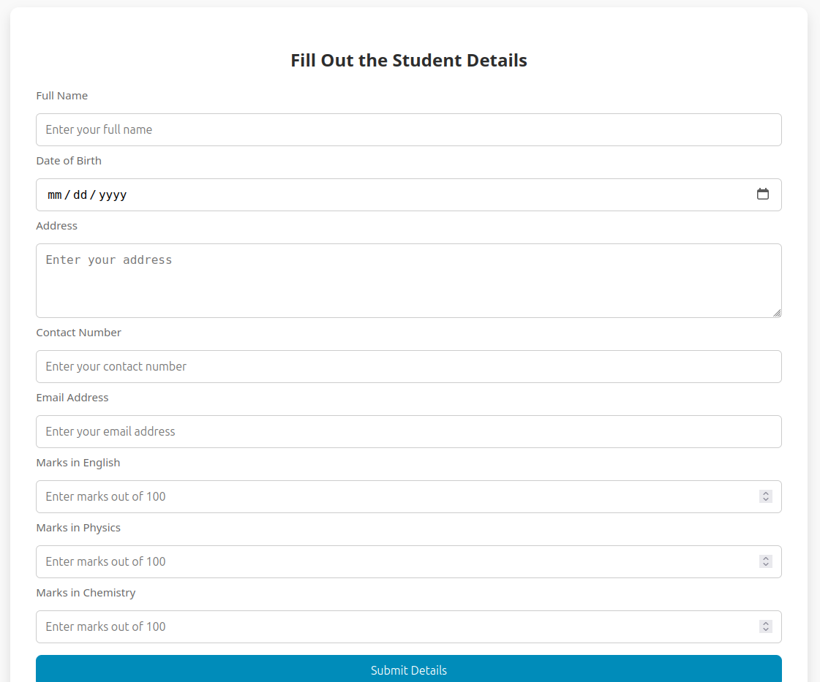

Q2.Create a web form with employee ids in dropdown list. Use a textbox for accepting date of joining. Add a button named “Am I Eligible for Promotion”. On clicking the button, if he has more than 5 years of experience, then display “YES” else “NO” in the label control.

<!DOCTYPE html>

<html lang="en">

<head>

<meta charset="UTF-8" />

<meta name="viewport" content="width=device-width, initial-scale=1.0" />

<title>Employee Promotion Eligibility</title>

<style>

body {

font-family: "Segoe UI", Tahoma, Geneva, Verdana, sans-serif;

background-color: #e9f1f7;

display: flex;

justify-content: center;

align-items: center;

height: 100vh;

margin: 0;

}

.form-container {

background-color: #ffffff;

padding: 35px;

border-radius: 12px;

box-shadow: 0 4px 20px rgba(0, 0, 0, 0.1);

width: 380px;

text-align: center;

}

h2 {

color: #333;

font-size: 26px;

margin-bottom: 20px;

}

label {

font-size: 15px;

color: #555;

margin-bottom: 10px;

display: block;

}

select,

input[type="date"],

button {

width: 100%;

padding: 12px;

margin-bottom: 20px;

border: 1px solid #ccc;

border-radius: 6px;

font-size: 15px;

box-sizing: border-box;

}

button {

background-color: #4caf50;

color: white;

font-size: 16px;

cursor: pointer;

border: none;

transition: background-color 0.3s ease;

}

button:hover {

background-color: #45a049;

}

#result {

font-size: 18px;

font-weight: bold;

color: #333;

}

.error {

color: red;

font-size: 14px;

margin-top: 10px;

}

</style>

</head>

<body>

<div class="form-container">

<h2>Check Your Promotion Eligibility</h2>

<form id="promotionForm">

<label for="employeeId">Select Employee ID:</label>

<select id="employeeId" required>

<option value="">Choose an ID</option>

<option value="101">E101</option>

<option value="102">E102</option>

<option value="103">E103</option>

<option value="104">E104</option>

</select>

<label for="doj">Date of Joining:</label>

<input type="date" id="doj" required />

<button type="button" onclick="checkEligibility()">

Check Eligibility

</button>

<div id="result"></div>

<div class="error" id="error"></div>

</form>

</div>

<script>

function checkEligibility() {

const employeeId = document.getElementById("employeeId").value;

const doj = document.getElementById("doj").value;

const errorElement = document.getElementById("error");

const resultElement = document.getElementById("result");

errorElement.textContent = "";

resultElement.textContent = "";

if (!employeeId || !doj) {

errorElement.textContent =

"Please select both an employee ID and a date of joining.";

return;

}

const joiningDate = new Date(doj);

const currentDate = new Date();

const experience =

currentDate.getFullYear() - joiningDate.getFullYear();

const monthDifference = currentDate.getMonth() - joiningDate.getMonth();

if (

monthDifference < 0 ||

(monthDifference === 0 &&

currentDate.getDate() < joiningDate.getDate())

) {

experience--;

}

if (experience > 5) {

resultElement.textContent = "YES, you are eligible!";

resultElement.style.color = "green";

} else {

resultElement.textContent = "NO, you are not eligible.";

resultElement.style.color = "red";

}

}

</script>

</body>

</html>

