WP Lab Week 4

Q1.Write a web page which contains table with 3 X 3 dimensions (fill some data) and one image. Style the rows with alternate color. Move the table and image together from right to left when button is clicked.

**q1.html**

<html>

<head>

<title>Table and Image</title>

<link rel="stylesheet" href="q1.css">

<script src="https://code.jquery.com/jquery-3.6.0.min.js"></script>

<script src="q1.js"></script>

</head>

<body>

<button id="moveButton">Move Table and Image</button>

<div class="table-container">

<table border="1">

<tbody>

<tr>

<td>1</td>

<td>2</td>

<td>3</td>

</tr>

<tr>

<td>4</td>

<td>5</td>

<td>6</td>

</tr>

<tr>

<td>7</td>

<td>8</td>

<td>9</td>

</tr>

</tbody>

</table>

<img src="table.jpeg">

</div>

</body>

</html>

**q1.css**

table tr:nth-child(odd) {

background-color: lightblue;

}

table tr:nth-child(even) {

background-color: lightcyan;

}

table td {

padding: 10px;

text-align: center;

}

.table-container {

width: auto;

margin: 20px;

position: relative;

}

**q1.js**

$(document).ready(function(){

$("#moveButton").click(function(){

$(".table-container").animate({

left: "-=300px"

}, 2000);

});

});

**Output:**

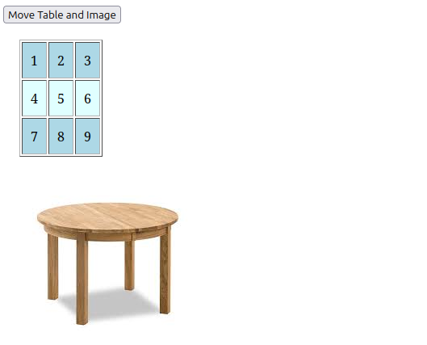

Q2.Design a calculator to perform basic arithmetic operations. Use textboxes and buttons

to design web page.

**q1.html**

<html>

<head>

<title>Calculator</title>

<link rel="stylesheet" href="q2.css">

<script src="https://code.jquery.com/jquery-3.6.0.min.js"></script>

<script src="q2.js"></script>

</head>

<body>

<div class="input">

<input type="number" placeholder="Enter first number">

<input type="number" placeholder="Enter second number">

</div>

<div class="process">

<button id="add">Add</button>

<button id="subtract">Subtract</button>

<button id="multiply">Multiply</button>

<button id="divide">Divide</button>

</div>

<div class="output">

</div>

</body>

</html>

**q2.js**

$(document).ready(function() {

$("button").click(function() {

var num1 = parseFloat($("input:eq(0)").val());

var num2 = parseFloat($("input:eq(1)").val());

if (isNaN(num1) || isNaN(num2)) {

$(".output").text("Please enter valid numbers.");

return;

}

var result;

switch (this.id) {

case "add":

result = num1 + num2;

break;

case "subtract":

result = num1 - num2;

break;

case "multiply":

result = num1 * num2;

break;

case "divide":

if (num2 === 0) {

result = "Cannot divide by zero!";

} else {

result = num1 / num2;

}

break;

}

$(".output").text("Result: " + result);

});

});

**Output:**

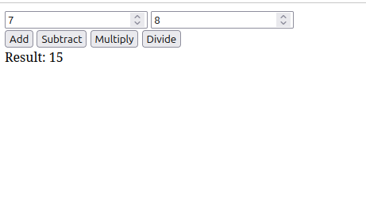

Q3.Create a web page to design a birthday card shown below.

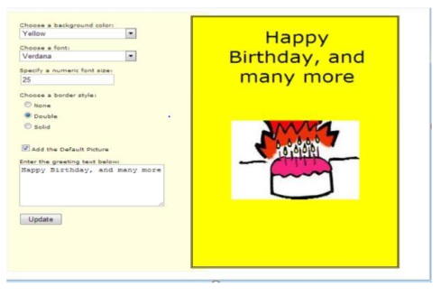

**q3.html**

<!DOCTYPE html>

<html>

<head>

<title>Birthday Card Designer</title>

<link rel="stylesheet" href="q3.css">

<script src="https://code.jquery.com/jquery-3.6.0.min.js"></script>

<script src="q3.js"></script>

</head>

<body>

<div class="container">

<!-- Left half: Input form -->

<div class="input-container">

<label for="bgColor">Background Color:</label>

<select id="bgColor">

<option value="lightblue">Light Blue</option>

<option value="lightgreen">Light Green</option>

<option value="pink">Pink</option>

</select><br><br>

<label for="fontSelect">Font Style:</label>

<select id="fontSelect">

<option value="Arial">Arial</option>

<option value="Courier New">Courier New</option>

<option value="Times New Roman">Times New Roman</option>

</select><br><br>

<label for="fontSize">Font Size:</label>

<input type="number" id="fontSize" value="20"><br><br>

<label>Border Style:</label><br>

<input type="radio" name="border" value="none" checked> None

<input type="radio" name="border" value="solid"> Solid

<input type="radio" name="border" value="double"> Double<br><br>

<label for="picture">Add Picture:</label>

<input type="checkbox" id="picture"><br><br>

<label for="greeting">Greeting Text:</label>

<textarea id="greeting" rows="4" cols="50">Happy Birthday!</textarea><br><br>

<button id="updateCard">Update Card</button>

</div>

<!-- Right half: Card display -->

<div class="card-container" id="cardContainer">

<div class="card">

<div class="card-text" id="cardText">Happy Birthday!</div>

</div>

</div>

</div>

</body>

</html>

**q3.css**

/* Basic reset for the page */

* {

margin: 0;

padding: 0;

box-sizing: border-box;

}

/* Container for the input and card halves */

.container {

display: flex;

height: 100vh;

}

/* Left half: Form for user input */

.input-container {

width: 50%;

padding: 20px;

background-color: #f0f0f0;

}

/* Right half: Card display */

.card-container {

width: 50%;

padding: 20px;

display: flex;

justify-content: center;

align-items: center;

background-color: #fff;

}

.card {

width: 80%;

height: 80%;

border: 2px solid black;

display: flex;

justify-content: center;

align-items: center;

padding: 20px;

position: relative;

}

.card-text {

font-size: 20px;

text-align: center;

font-family: Arial;

}

.card img {

width: 100px;

height: 100px;

position: absolute;

bottom: 20px;

right: 20px;

}

**q3.js**

$(document).ready(function() {

$('#updateCard').click(function() {

// Get user input values

var bgColor = $('#bgColor').val();

var font = $('#fontSelect').val();

var fontSize = $('#fontSize').val();

var border = $("input[name='border']:checked").val();

var picture = $('#picture').is(':checked');

var greetingText = $('#greeting').val();

// Apply changes to the card container

$('#cardContainer').css('background-color', bgColor);

$('#cardText').css({

'font-family': font,

'font-size': fontSize + 'px'

});

// Apply border style

if (border === "none") {

$('.card').css('border', 'none');

} else if (border === "solid") {

$('.card').css('border', '5px solid black');

} else {

$('.card').css('border', '5px double black');

}

// Display picture if checkbox is checked

if (picture) {

$('.card').append('<img src="cake.jpeg" alt="Birthday Picture">');

} else {

$('.card img').remove();

}

// Set the greeting text

$('#cardText').text(greetingText);

});

});

**Output:**

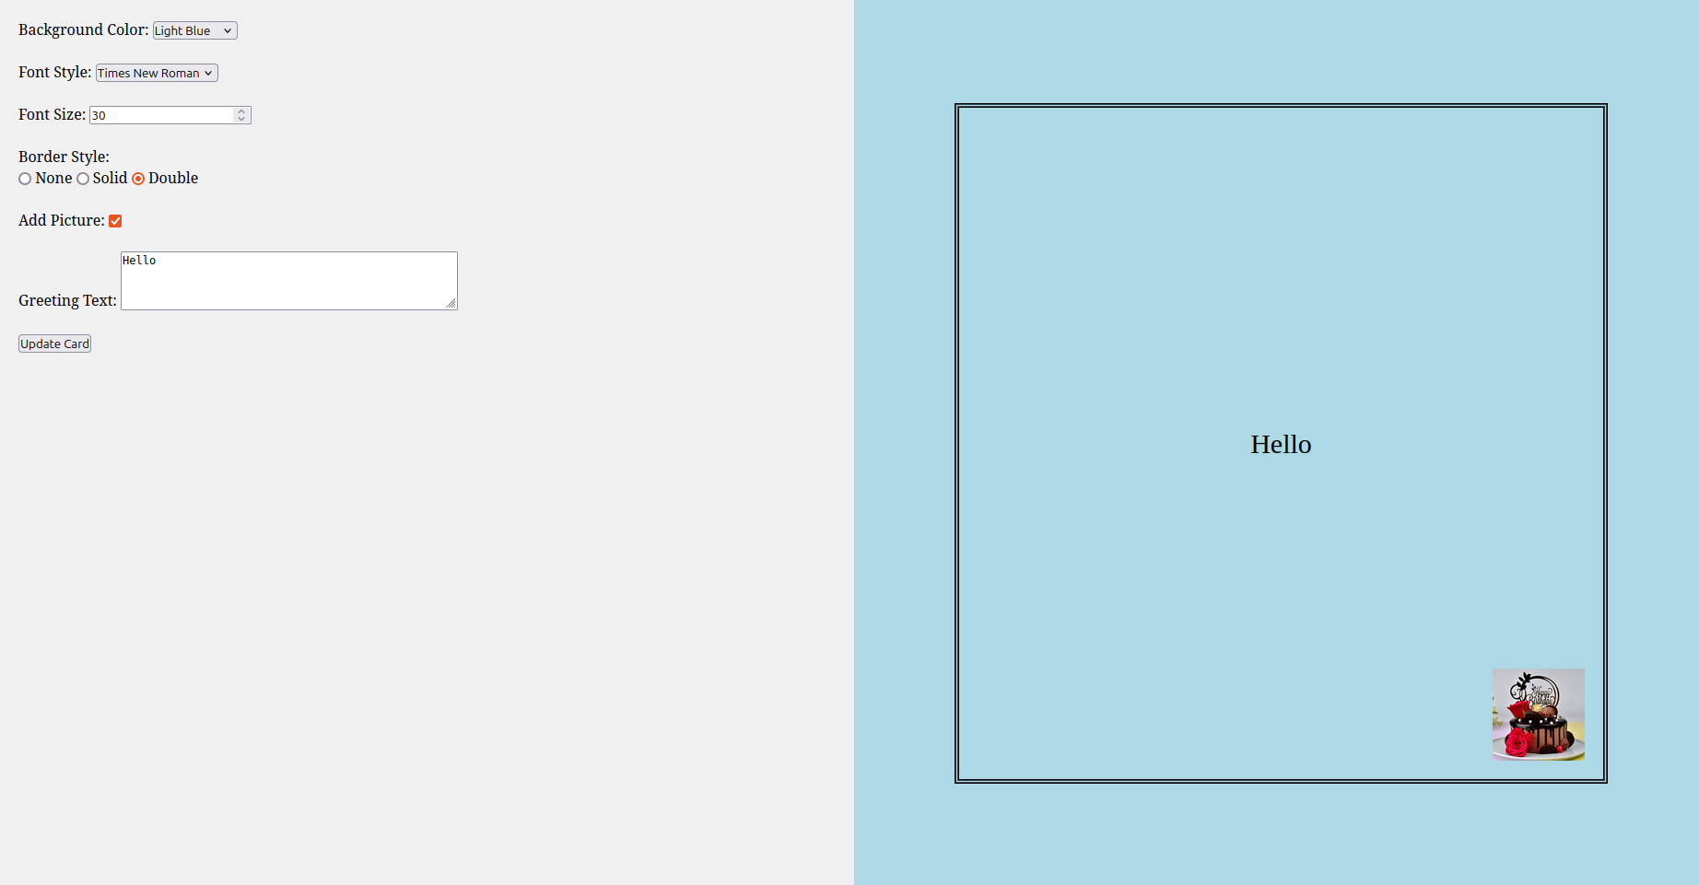

Q4.Design a webpage. The page contains:

• Dropdown list with HP, Nokia, Samsung, Motorola, Apple as items.

• Checkbox with Mobile and Laptop as items. Textbox where you enter quantity.

• There is a button with text as ‘Produce Bill’.

On Clicking Produce Bill button, alert should be displayed with total amount.

**q4.html**

<html>

<head>

<title>Electronics Bill</title>

<script src="https://code.jquery.com/jquery-3.6.0.min.js"></script>

<script src="q4.js"></script>

</head>

<body>

<div class="select_brand">

<select id="brand">

<option value="hp">HP</option>

<option value="nokia">Nokia</option>

<option value="samsung">Samsung</option>

<option value="motorola">Motorola</option>

<option value="apple">Apple</option>

</select>

</div>

<div class="select_device">

<input type="checkbox">Mobile

<input type="checkbox">Laptop

</div>

<div class="quantity">

<input type="number" label="quantity">Enter Quantity

</div>

<button id="bill">Produce Bill</button>

</body>

</html>

**q4.js**

$(document).ready(function() {

$('#bill').click(function() {

var brand = $('#brand').val();

var price = 0;

switch(brand) {

case "hp": price = 500; break;

case "nokia": price = 200; break;

case "samsung": price = 300; break;

case "motorola": price = 250; break;

case "apple": price = 1000; break;

}

if ($('.select_device input[type="checkbox"]:eq(0)').is(':checked')) price += 100; // Mobile

if ($('.select_device input[type="checkbox"]:eq(1)').is(':checked')) price += 700; // Laptop

var quantity = $('.quantity input[type="number"]').val();

var totalAmount = price * quantity;

alert("Total Amount: $" + totalAmount);

});

});

**Output:**

