PlanetLab Implementation of the Slice-Based Facility Architecture

Larry Peterson, Princeton
Soner Sevinc, Princeton
Scott Baker, Arizona
Tony Mack, Princeton
Reid Moran, Princeton
Faiyaz Ahmed, Princeton

Draft Version 0.04

April 7, 2009

This work is supported in part by NSF grants CNS-0540815 and CNS-0631422.
Table of Contents
1 Introduction 3
2 Engineering Decisions 3
3 Usage Scenarios 4
3.1 Vanilla PlanetLab 5
3.2 Alternative Slice Manager 6
3.3 Common Registry 6
3.4 Multiple Aggregates 7
3.5 Full Federation 8
4 Implementation 9
4.1 Certificates, Credentials, and GIDs 9
4.2 RSpec 10
4.3 Tickets 10
4.4 XML-RPC 10
4.5 SFA Interfaces 11
4.5.1 Registry 12
4.5.2 Aggregate Manager 12
4.5.3 Slice Manager 12
4.5.4 Component Manager 12
4.6 Command-Line Interface 13
Appendix 14

Introduction
PlanetLab supports a prototype implementation of the abstractions and interfaces defined in the Slice-based Facility Architecture (SFA) document. This describes outlines a PlanetLab-centric “projection” of the SFA, and provides details about the implementation.
PlanetLab Central (PLC) bundles together an aggregate manager, a slice manager, and a registry server. Individual PlanetLab nodes correspond to components and run a component manger. The PLC aggregate, the PLC slice manager, and the component manager running on each node export the slice interface. The PLC registry server exports the registry interface.
The PlanetLab Consortium serves as a top-level slice and management authority. Sub-authorities correspond to member institutions, as well as federated partners. For example, planetlab.princeton.codeen is the human-readable name for the CoDeeN slice from Princeton, planetlab.vini.nyc.node1 is the HRN for a component in the VINI backbone, and planetlab.eu.inria is the HRN of a slice authority within the PlanetLab Europe sub-authority.

Engineering Decisions
As a working system, PlanetLab has made certain engineering decisions. This section outlines these decisions and their implications on the SFA.
- PlanetLab maintains all authoritative state at PLC. Individual nodes maintain only cached state that must be updated should the node fail and subsequently reboot. This means, for example, that any RedeemTicket or LoanResources operations invoked on a node must be re-invoked whenever the node reboots. Note that each node does have persistent storage that records certain information for the slices it hosts (e.g., the fact that the slice exists and is mapped to a particular virtual machine), but this state may become out-of-date during the time a node is down. Also, the node may be reinstalled, which clears all local state.
- Nodes implicitly delegate control over their resources to PLC (the aggregate), which is responsible for implementing PlanetLab’s resource allocation policy. As a consequence, the GetTicket, CreateSlice, and UpdateSlice operations succeed on PLC, but fail when invoked on individual nodes. Technically, these per-node invocations are return a “no available resources” message in response to requests to allocate resources since they have relinquished the right to allocate their resources to PLC. Individual nodes do, however, support the RedeemTicket and LoanResources operations, so it is possible to get a ticket from PLC and then redeem it on individual nodes. Both PLC and individual nodes support all other operations defined by the slice interface.
- The slice manager running at PLC is configured to know about one or more aggregates. By default, it knows about the local PLC aggregate, but through peering arrangements with other management authorities, it can be configured to provide users with an interface to multiple aggregates. Like an aggregate, the slice manager exports the slice interface, the only difference is that the slice manager does not support the GetTicket operation; slices can be created only using CreateSlice. Users that want to retrieve and redeem tickets must contact individual aggregate managers and their components. A set of helper functions, which runs on the user’s machine and not at PLC, augments the slice interface to provide researchers with a richer interface for manipulating slices.
- Tickets are idempotent. This means no matter how many times one redeems a ticket granting a slice 1Mbps of link bandwidth, for example, the slice is granted only 1Mbps of link bandwidth. In other words, tickets specify absolute resource capacity, rather than relative or incremental capacity. On the other hand, the LoanResources operation does increment a slice’s resource allocation by the amount given in the RSpec.
PlanetLab’s current resource allocation policy is fairly simple. Slices are granted “best effort” resources by default. The policy recognizes only select slices as qualifying for guaranteed resources. One of these corresponds to the Sirius Reservation Service, which subsequently uses the LoanResources operation to grant other slices link and CPU guarantees for one-hour time slots.
PlanetLab supports an extensive O&M interface that goes well beyond anything defined by the SFA. This is a private interface known only to PlanetLab operators. One can view the SFA management interface as a small subset of this PlanetLab-specific O&M interface that is common to all components participating in a federated slice-based facility.

Usage Scenarios
This section walks through a sequence of usage scenarios showing how we expect PlanetLab to evolve to take advantage of the SFA to support both federation and third-party user services. Throughout this section, we use the notation outlined in Figure 3.1.
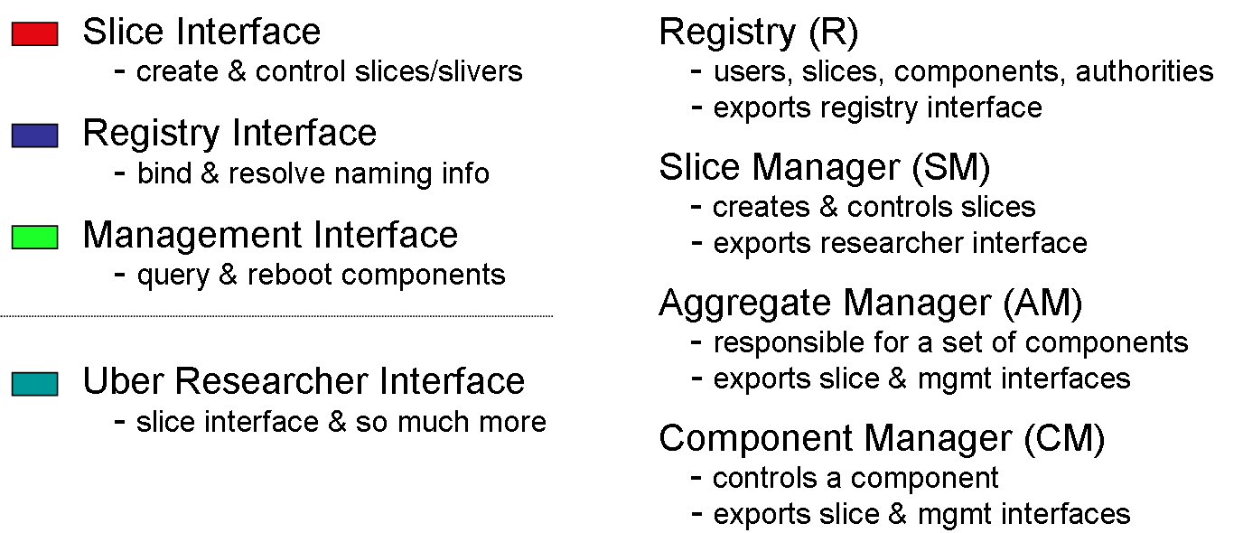
Figure 3.1: Notation used throughout this section, including both interfaces and managers.
For the purpose of this discussion, we introduce an uber researcher interface, which provides a high-level interface (possibly GUI-based) that researchers interact with to set up, control, and tear down their slices. This interface is not one of the standard SFA-defined interfaces, although it likely extends the slice interface. For example, it might allow users to manipulate graphical representations of their slices, it might iteratively discover and acquire resources, and it might help users steer the experiments running in those slices. In the current implementation, the researcher interface corresponds to a combination of the slice interface exported by the slice manager and the set of helper functions running on the researcher’s desktop.
Note that with the exception of the first scenario (vanilla PlanetLab), this section outlines the planned evolution of PlanetLab, not the state of affairs today. The subsequent scenarios correspond to configurations currently supported in PlanetLab, but using PlanetLab-specific interfaces rather than the SFA-defined interfaces.

Vanilla PlanetLab
The first scenario, depicted in Figure 3.2, corresponds to a simple deployment of PlanetLab, in which a trivial slice manager (SM), an aggregate manager (AM), and a registry (R) are all bundled in PLC, with each node running a component manager (CM). In all the examples presented throughout this section, we focus on the slice-related records in the registry. Component-related records are also recorded in the registry, but we do not illustrate how these records are used in the following discussion. (Currently, PLC manipulates these records on behalf the constituent components, with PLC and the components communicating using a private interface.)
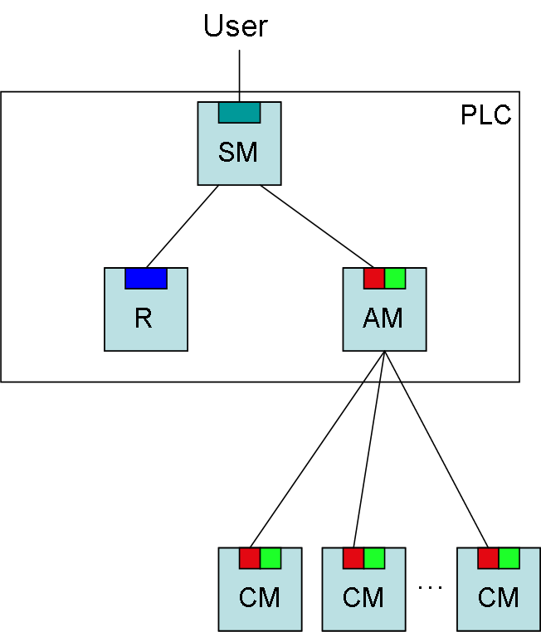
Figure 3.2: Vanilla PlanetLab, with bundled slice manager, registry, and aggregate manager.
In this example, users interact with the slice manager (using either a GUI or a programmatic interface) to create and control their slices. The slice manager contacts the registry to retrieve the necessary credentials, and then invokes the slice interface on the aggregate to create and control the slice. As is the common case in PlanetLab, the aggregate (rather than end users) interacts with the individual nodes. Note that the current implementation of PLC uses a private interface to interact with the individual components (although the components also export the slice interface to other clients).

Alternative Slice Manager
We can augment the simple scenario by allowing users to interact with alternative slice managers; in the example shown in Figure 3.3, one provided by Emulab. In general, users may employ any number of different slice managers, not just the simple one provided by PLC.
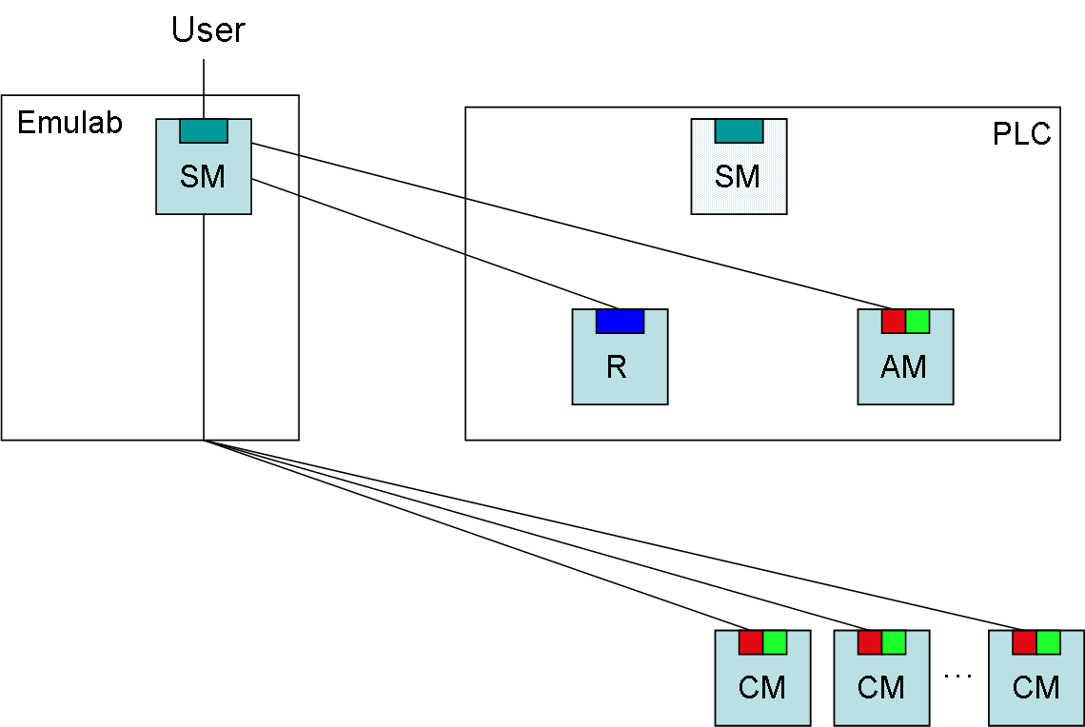
Figure 3.3: PlanetLab nodes accessed from an alternative slice manager.
In this scenario, the Emulab slice manager contacts the PlanetLab registry to retrieve the necessary credentials. It then contacts the PlanetLab aggregate manager to retrieve a ticket for each slice it wants to instantiate. The Emulab slice manager then directly contacts the PlanetLab nodes to redeem these tickets, and later, to control the slices on those nodes. Because each node only caches slice-related state, the Emulab slice manager is responsible for ensuring that the slices it instantiates persist across node failures.

Common Registry
In another possible interaction between Emulab and PlanetLab, the Emulab slice manager may choose to trust users registered with PlanetLab—retrieving their credentials from the PlanetLab registry—but otherwise instantiate the slice purely on Emulab nodes. This allows Emulab to create experiments for PlanetLab users without requiring those users to separately registering with Emulab. This scenario is illustrated in Figure 3.4.
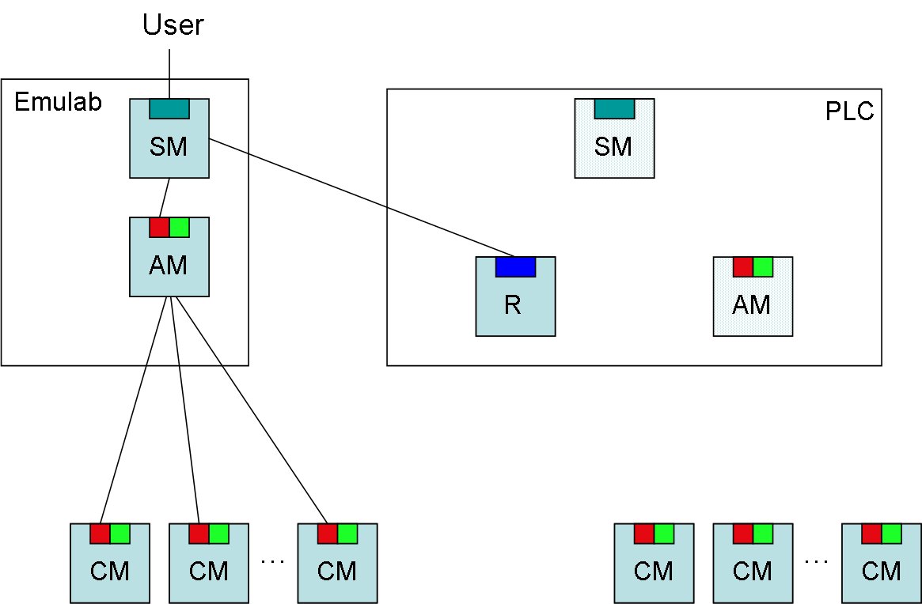
Figure 3.4: Another testbed (Emulab) taking advantage of users and slices registered in the PlanetLab registry.

Multiple Aggregates
The scenario depicted in Figure 3.5 spans multiple aggregates—PlanetLab and VINI—each responsible for its own set of components. That is, VINI and PlanetLab are distinct management authorities, each responsible for a distinct aggregate of components. In this case, VINI does not operate its own registry or slice manager, and PlanetLab’s slice manger presents users with a unified view of all the components available on both systems, hiding the fact that its global view spans multiple aggregates.
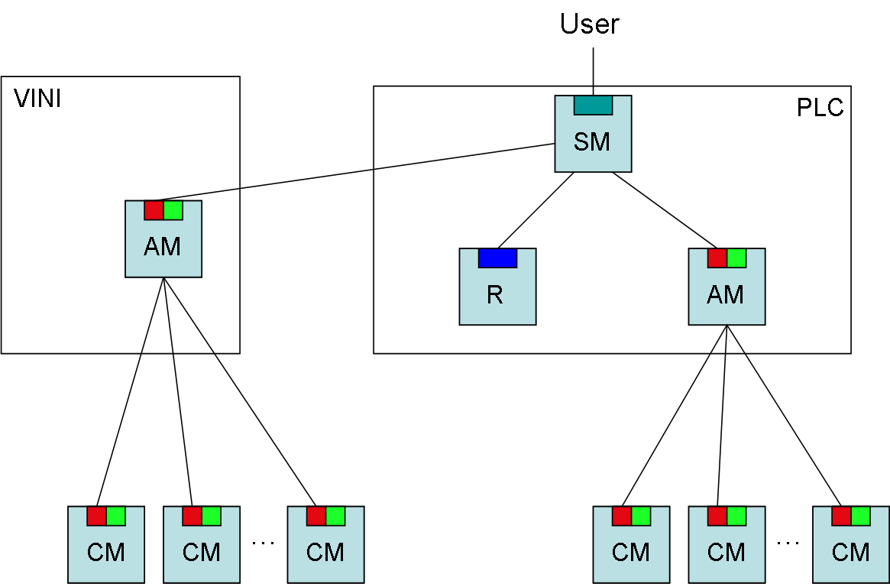
Figure 3.5: VINI and PlanetLab represent independent aggregates (and corresponding management authorities), unified by a single slice manager.
To create a slice, the PlanetLab SM would need to contact both available aggregate managers to learn about the available components. It would then present these components to the user in an SM-specific way. Once the user selects the set of components to be included in his or her slice, the SM would call the Registry to retrieve the necessary credentials, and then invoke the CreateSlice operation on the respective aggregates to create the cross-aggregate slice.
In this scenario, as well as the one described in the next section, the SM plays the role of an aggregate of aggregates. When viewed from this perspective, it makes sense that the SM exports the slice interface, just like any other aggregate (i.e., the uber researcher interface is a superset of the slice interface). Note that there are two candidate aggregates that we plan to include in an early demonstration of this capability—VINI and Measurement Lab (M-Lab).

Full Federation
Our final scenario, shown in Figure 3.6, involves symmetric federation between two autonomous aggregates, one representing PlanetLab Europe (PLE) and the other representing the rest of PlanetLab (PLC). Both systems support their own slice manager, registry servers, aggregate manager, and set of components. As in the previous scenario, users interact with their “local” SM, which creates and manages slices spanning both aggregates.
Although not explicitly depicted in the figure, the PLC registry points to the PLE registry. That is, registry records for the top-level PlanetLab authority, including the record for the EU sub-authority, are maintained in the PLC registry, while records associated with the EU sub-authority are maintained in the PLE registry server.
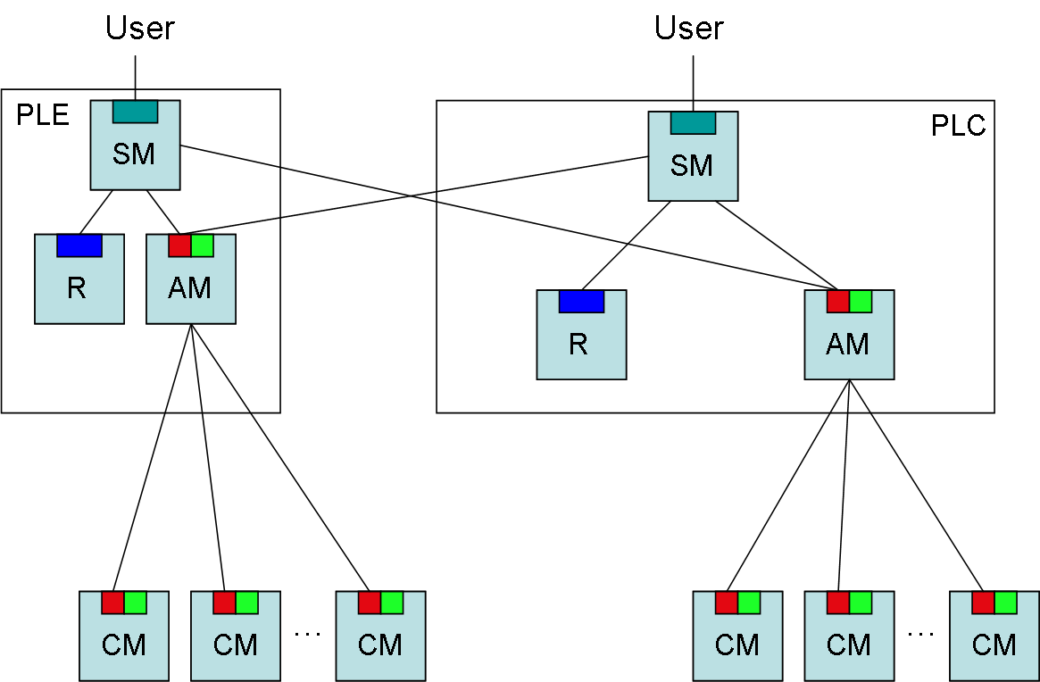
Figure 3.6: Peer testbeds (PLC and PLE) federate their aggregates.
Note that there are four candidate peers that we plan to include in an early demonstration of this capability—PlanetLab Europe (PLE), PlanetLab Japan (PLJ), PlanetLab Korea (PLK), and PlanetLab Brazil (PLB).

Implementation
We have implemented a module, called geniwrapper, that exports the set of interfaces defined by the SFA. The geniwrapper module is distributed as part of the MyPLC software package, and is independently available at http://svn.planet-lab.org.
The module defines the following sets of classes:
PLC-based classes that implement the registry, slice, and management interfaces exported by the Aggregate Manager (AM), Slice Manager (SM), and Registry (R). Instantiations of these classes are co-located with PLC. An implementation of these classes is contained in the /geni directory of the module.
Component-based classes that implement the slice and management interfaces exported by the Component Manger (CM). Instantiations of these classes are co-located with the node manager of each node. An implementation of these classes is contained in the /component directory of the module.
Utility classes that implement GIDs, credentials, and tickets, as well as an underlying secure remote invocation mechanism. An implementation of these classes is contained in the /geni/util directory of the module.
RSpec class is generated from an Ecliplse Modeling Framework (EMF) data model contained in the /rspec/model directory of the module.
The module also includes command-line programs that researchers can use to invoke operations on the SM, AM, CM, and Registry servers. These programs are contained in the /cmdline directory of the module. One of these commands, sfi, is described later in this section.

Certificates, Credentials, and GIDs
A Certificate class extends pyOpenSSL's native X.509 certificate class by adding a parent field, thereby supporting certificate chains. When loaded from a file or a string, a sequence of certificates is interpreted as a parent chain. When saved to a file or string, the caller can choose whether or not to save the chain of parent certificates.
The geniwrapper module also defines GID and Credential classes that extend this Certificate class. They add support for GID-specific and credential-specific tuples, respectively. The GID class sets the subject-public-key field of the certificate to the PublicKey in the GID, and the subject-alt-name field of the certificate to the UUID and HRN in the GID. UUIDs are generated according to RFC4122 (version 4). The authority that is responsible for the object denoted by the GID signs the certificate. Similarly, the Credential class stores the entire (GIDCaller, GIDObject, LifeTime, Privileges, Delegate) 5-tuple in the subject-alt-name field. Both GIDs and credentials currently use 1024-bit RSA as their public key algorithm and SHA1 as their signature algorithm.

RSpec
The definition of the RSpec class is still evolving. Our approach is to define a data model for resource specifications in the Eclipse Modeling Framework (EMF), and then generate RSpec-related code from this model. The file /rspec/model/planetlab.xsd contains the (current) schema generated from the EMF model. This schema is then used to generate a parser and verifier for an XML representation of RSpecs.

Tickets
Similar to GIDs and credentials, a Ticket class extends the Certificate class. The implementation deviates somewhat from the definition given in the SFA document. A ticket is defined by the 5-tuple (GIDCaller, GIDObject, Attributes, RSpec, Delegate), where GIDCaller is the GID of the principal performing the operation; GIDObject is the GID of the slice to which the ticket is bound; Attributes is the set of PlanetLab attributes (tag/value pairs) that do not correspond to resources (e.g., keys contains the SSH keys for the users affiliated with the slice, vsys specifies privileged operation the slice may invoke, and initscript defines the script that runs when the slice boots); and RSpec specifies the set of resources bound to the slice.
As described in the Section 2, PlanetLab allows callers to get tickets from the Aggregate Manager running at PLC, and redeem tickets at the Component Manager running on each node. Individual nodes do not respond to local calls to GetTicket.

XML-RPC
Secure remote invocation is based on XML-RPC running on top of HTTPS, where the underlying SSL layer is implemented using pyOpenSSL. Both the client and server specify their private and public keys when opening an SSL socket, and upon successful connection establishment, each knows the other's public key (by convention, this key is stored in an X.509 certificate). The GeniClient and GeniServer classes implement the underlying client and server, respectively (both are in the /geni/util directory).
The next step of XML-RPC is to dispatch the incoming call to the specified operation, where the first argument to each operation is a credential. The GeniServer class provides a decode_authentication method to verify that this credential gives the caller the right to invoke the corresponding operation. For example, the following code snippet is used by all SFA operations:
def sfa_operation(self, cred_str, ...other arguments...):
self.decode_authentication(cred_str, "sfa_operation")
...
The decode_authentication routine is defined as follows:
##
# Decode the credential provided by the caller. Several checks
# are performed to ensure that the credential is valid, and that
# the CallerGID included in the credential matches the caller
# (client) that is connected to the HTTPS connection.

def decode_authentication(self, cred_string, operation):
# extract relevant fields from the credential
self.client_cred = Credential(string = cred_string)
self.client_gid = self.client_cred.get_gid_caller()
self.object_gid = self.client_cred.get_gid_object()

# make sure client_gid is not blank
if not self.client_gid:
raise MissingCallerGID(self.client_cred.get_subject())

# make sure pubkey of peer matches pubkey in client_gid
peer_cert = self.server.peer_cert
if not peer_cert.is_pubkey(self.client_gid.get_pubkey()):
raise ConnectionKeyGIDMismatch(
self.client_gid.get_subject())

# make sure client is allowed to perform the operation
if not self.client_cred.can_perform(operation):
raise InsufficientRights(operation)

# make sure credential is signed (recursively) by parents
if self.trusted_cert_list:
self.client_cred.verify_chain(self.trusted_cert_list)
if self.client_gid:
self.client_gid.verify_chain(self.trusted_cert_list)
if self.object_gid:
self.object_gid.verify_chain(self.trusted_cert_list)
where verify_chain recursively walks through the chain of certificates, making sure that each parent signed the certificate of each child. At each level of recursion, verify_chain makes sure that the parent's HRN is a prefix of the child's HRN. The calls to verify_chain at the end of decode_authentication conservatively verify the credential, the client's GID, and the object's GID.

SFA Interfaces
The geniwrapper module implements classes for each of the major objects described in the SFA: Registry (co-located with PLC), Aggregate Manager (co-located with PLC), Slice Manager (co-located with PLC), and Component Manager (co-located with each node). This section briefly describes the implementation of each.
Note that all managers (servers) need not to be activated on all instantiations. For example, the standard PLC instantiation includes a Registry (for all authorities, slices, users and components managed by this PLC), an AM (for the aggregate of nodes managed by this PLC), and an SM (which provides users with an interface to the set of aggregates that peer with this PLC). On the other hand, a VINI or M-Lab instantiation runs only an AM. The /geni/plc command is executed to start up the desired set of servers, and depending on the command-line arguments, instantiates the requested combination of a Registry object, an Aggregate object, and a SliceMgr object.
Also note that while the geniwrapper module is usually bundled with the MyPLC distribution, it can be accessed in isolation, for example, to provide a starting point for building a stand-alone AM or CM. When used in this way, the PlanetLab-specific code would be replaced with software that knows how to control the devices and networks of interest. That is, the developer would be using only the secure remote invocation machinery implemented by geniwrapper.

Registry
The Registry class exports exactly the registry interface defined by the SFA, where the Record class defines a registry record; it includes the 4-tuple (Name, GID, Type, Info). The class is implemented on top of the PlanetLab database, where the Info field contains the following three sub-fields: pointer, pl_info, and geni_info. The first sub-field is a pointer into the PlanetLab database, its exact representation depending on the record Type (e.g., if Type==user, then the pointer is a person_id that indexes PlanetLab's persons table). The pl_info and geni_info sub-fields represent two different views of the information maintained by the registry for the named object. The pl_info sub-field is a cache of information read from the PlanetLab database about the named object, and the geni_info sub-field a mapping of that information into “SFA canonical form.” Today that mapping is implemented by the identity function. In the near term, we plan to generate code to parse and verify registry records from an EMF-based schema, just we do today for RSpecs.

Aggregate Manager
The Aggregate class exports exactly the slice interface defined by the SFA. It is implemented on top of PlanetLab’s PLCAPI, and as such, is used to create, terminate, and control slices on a PlanetLab-wide basis. It can also be used to retrieve a ticket that is subsequently passed to the CM running on any PlanetLab node managed by this instance of PLC. Note that there is a different Aggregate class for each supported aggregate. For example, the VINI-specific aggregate understands how to act on the topology-related information in an RSpec.

Slice Manager
The SliceMgr class exports the slice interface, and in turn, calls the slice interface on the set of aggregates with which this instance of PLC peers. The SM calls each peer AM to learn the set of available components (and subsequently displays the union of these lists to users), and later calls the appropriate AMs to instantiate a slice on the components managed by that AM. The SM maintains a database of all slices created by behalf of users, including a record of where those slices have been instantiated to it can “pass through” slice control operations. The SM does not support the ticket-related calls; clients that want to retrieve a ticket must directly contact an AM.

Component Manager
The Component class exports exactly the slice interface defined by the SFA. It is implemented on top of PlanetLab’s Node Manager (NM) interface available on each node. Currently, slice control operations invoked on a CM are successful only if the slice was created using a ticket. Control of slices instantiated by invoking CreateSlice on the PLC aggregate must go through the PLC aggregate.

Command-Line Interface
Users invoke the sfi command to manage their slices. sfi is configured to interact with a “home” registry and slice manager to implement those commands. sfi does not directly interact with any aggregates.
sfi manages a set of credentials on behalf of the user, and uses them when invoking various slice or registry operations. The set of credentials include a “user” credential (used to view information in the registry), a “slice” credential for each slice that the user belongs to (used to create, control, and terminate the slice), and if the user also serves as PI for a research organization, an “authority” credential (used to register nodes, slices, and users in the registry).
In addition to sfi, we are developing a set of tools that make it easy for users to manipulate RSpecs and registry records, the two key file formats employed by sfi. (sfi uses a working directory, ~/.sfi by convention, in which it stores credentials, RSpecs, and registry records.) These tools are still under development, but /cmdline/editRecord.py is an example of a simple tool that can be used to edit a file that stores a registry record.

Appendix: User Tools
This appendix describes the available user-level tools and commands using a Unix manual-like template.
NAME
sfi – Slice Facility Interface
SYNOPSIS
sfi [options] command [command-options] [command-args]
DESCRIPTION
Provides a Unix command-line interface to a federation of PlanetLab-based networks that export the programmatic interfaces of the Slice Facility Architecture (SFA). sfi is configured to invoke operations on a “home” registry and slice manager. It manages a set of credentials on behalf of the user, and uses them when invoking various slice or registry operations. The set of include a “user” credential (used to view information in the registry), a “slice” credential for each slice that the user belongs to (used to create, control, and terminate the slice), and if the user also serves as PI for a research organization, an “authority” credential (used to register nodes, slices, and users in the registry).
A typical mode of operation is to retrieve a registry record (it can be saved as an XML file), edit the record file locally, and then use this modified record file to update the registry. Similarly, a user can retrieve a default rspec from the slice manager (it can be saved as an XML file), edit the rspec file locally, and then use this modified rspec file to create or update a slice.
COMMANDS
list – list registry records belonging to a named authority; if the –t option is present, limit the output to the selected record type

sfi list [command-options] name
-h, --help show help message
-t TYPE, --type=TYPE (user|slice|ma|sa|node|aggregate)
-o FILE, --file=FILE output XML to file rather than standard output

show – output named registry record(s); if the –t option is present, limit the output to the selected record type

sfi show [command-options] name
-h, --help show help message
-t TYPE, --type=TYPE (user|slice|ma|sa|node|aggregate)
-o FILE, --file=FILE output XML to file rather than standard output

remove – remove named record(s) from registry; if the –t option is present, remove only the record of the selected type

sfi remove [command-options] name
-h, --help show help message
-t TYPE, --type=TYPE (user|slice|ma|sa|node|aggregate)

add – add record in named file to registry

sfi add [command-options] record
-h, --help show help message

update – update registry with record in named file

sfi update [command-options] record
-h, --help show help message

slices – list all slices available via slice manager

sfi slices [command-options]
-h, --help show help message

resources – output rspec for resources bound to the named slice; if no slice name is given, output the default rspec accepted by the slice manager; if the –f option is present, print only DNS names or IP addresses for nodes identified in the rspec

sfi resources [command-options][name]
-f FORMAT, --format=FORMAT (dns|ip)
-o FILE, --file=FILE output XML to file rather than standard output
-h, --help show help message

create – create named slice according to the rspec in given file; if slice already exists, update slice according to the rspec; a PI must have already created a registry record for the slice before a user is allowed to invoke create on that slice

sfi create [command-options] name rspec
-h, --help show help message

delete – delete named slice
sfi delete [command-options] name
-h, --help show help message

reset – reset named slice
sfi reset [command-options] name
-h, --help show help message

start – start named slice

sfi start [command-options] name
-h, --help show help message

stop – stop named slice

sfi stop [command-options] name
-h, --help show help message
OPTIONS
-h, --help show help message
-r URL, --registry=URL root registry server
-s URL, --slicemgr=URL slice manager
-d PATH, --dir=PATH working directory (~/.sfi by default)
-u HRN, --user=HRN user name
-a HRN, --auth=HRN authority name
-v, --verbose verbose mode
FILES
~/.sfi – default working directory where credentials are collected
Registry records (argument record in the above synopsis) and resource specifications (argument rspec in the above synopsis ) are saved to and read from XML files.
ENVIRONMENT VARIABLES
SFI_USER=HRN user name
SFI_AUTH=HRN authority name
SFI_SM=URL slice manager
SFI_REGISTRY=URL root registry server
For example
SFI_USER=plc.princeton.llp
SFI_AUTH=plc.princeton
SFI_SM=http://128.112.139.90:12347/
SFI_REGISTRY=http://128.112.139.90:12345/

NAME
getRecord, setRecord – get and set fields in registry record
SYNOPSIS
getRecord [name]
setRecord [command-args]
DESCRIPTION
With no arguments, getRecord reads a registry record (an XML file) from standard input, and pretty prints the record to standard output, one field (name/value pair) per line. With an argument, getRecord outputs only the named field.
setRecord reads a registry record (an XML file) from standard input and writes a registry record (an XML file) to standard output. The command takes a set of command line arguments, each of the form name=value, where name identifies a field in the record and value corresponds to the value of that field. For each such argument, setRecord modifies the input record by setting the named field to the corresponding value. Note that the value may be given by a comma-separated list of values; e.g., name=value1,value2,value3. Also, since the value already present in the inputted record may be a set/list, the syntax name+=value and name-=value is used to append to and remove from that set (rather than replace the set with the given value). Finally, setRecord always outputs a valid registry record, even if the inputted record is even empty. Thus, giving setRecord an empty file via standard input is a way to generate a default registry record suitable for further modification, although any unset values will be empty.

NAME
getNode, setNode – get and set node fields in resource specification (rspec)
SYNOPSIS
getNode [option]
setNode [option] FILE
DESCRIPTION
getNode reads an rspec (an XML file) from standard input, and writes the list of nodes contained in the rspec to standard output.
setNode reads an rspec (an XML file) from standard input, modifies the list of nodes embedded in the rspec to correspond to those read from argument FILE, and writes the modified rspec (an XML file) to standard output. Argument FILE contains a list of nodes, one per line.
OPTIONS
-f ip, --format=ip use IP addresses to identify nodes;
by default, DNS names are used
-a NAME, --aggregate=NAME perform get/set relative to named aggregate

For example
setNode –a plc.eu ./nodelist < oldrspec.xml > newrspec.xml
adds the list of nodes contained in file ./nodelist to the PlanetLab Europe aggregate in the inputted rspec, leaving the nodes specified for any other aggregates embedded in the rspec unchanged.

The GENI literature refers to a Clearinghouse, which can be viewed as a bundle of related software packages—e.g., an aggregate manager and registry server—and a “trust anchor.” PLC can be viewed as an example GENI Clearinghouse on both counts.
The .xsd file also contains EMF-specific information that geniwrapper ignores.

