**Training Data Set Creation**

The training data set used for this analysis is shown below (first 5 lines):

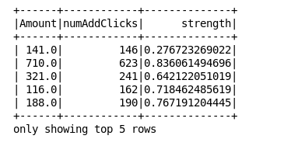

Dimensions of the training data set (rows x columns) : 44 x 3

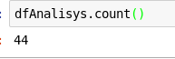

# of clusters created: 3

I'm going to try with 3 clusters.