**Graph Analytics**

**Modeling Chat Data using a Graph Data Model**

Our principal nodes are Users, Teams, Team Chat Sessions and Chat items. A User could create new chat. All the chats are part of a team chat session. A Chat item could respond to an other chat item or maybe Mention to a user. All users could join or leaves a chat session. Finally all chat sessions are owned by a Team.

**Creation of the Graph Database for Chats**

Describe the steps you took for creating the graph database. As part of these steps

1. Write the schema of the 6 CSV files

chat_create_team_chat.csv

userid,teamid,TeamChatSessionID,timestamp

chat_item_team_chat.csv

userid,teamchatsessionid,chatitemid,timestamp

chat_join_team_chat

userid,TeamChatSessionID,teamstamp

chat_leave_team_chat.csv

userid,teamchatsessionid,timestamp

chat_mention_team_chat.csv

ChatItem,userid,timeStamp

chat_respond_team_chat.csv

chatid1,chatid2,timestamp

1. Explain the loading process and include a sample LOAD command

LOAD CSV FROM "file:///chat_create_team_chat.csv" as row

MERGE (u:User {id: toInteger(row[0])})

MERGE (t:Team {id: toInteger(row[1])})

MERGE (c:TeamChatSession {id: toInteger(row[2])})

MERGE (u)-[:CreatesSession{timeStamp: row[3]}]->(c)

MERGE (c)-[:OwnedBy{timeStamp: row[3]}]->(t)

LOAD CSV FROM "file:///chat_join_team_chat.csv" as row

MERGE (u:User {id: toInteger(row[0])})

MERGE (c:TeamChatSession {id: toInteger(row[1])})

MERGE (u)-[:joins{timeStamp: row[2]}]->(c)

LOAD CSV FROM "file:///chat_leave_team_chat.csv" as row

MERGE (u:User {id: toInteger(row[0])})

MERGE (c:TeamChatSession {id: toInteger(row[1])})

MERGE (u)-[:Leaves{timeStamp: row[2]}]->(c)

LOAD CSV FROM "file:///chat_mention_team_chat.csv" as row

MERGE (u:User {id: toInteger(row[1])})

MERGE (ch:ChatItem {id: toInteger(row[0])})

MERGE (ch)-[:Mentioned{timeStamp: row[2]}]->(u)

LOAD CSV FROM "file:///chat_respond_team_chat.csv" as row

MERGE (ch1:ChatItem {id: toInteger(row[0])})

MERGE (ch2:ChatItem {id: toInteger(row[1])})

MERGE (ch1)-[:ResponseTo{timeStamp: row[2]}]→(ch2)

1. Present a screenshot of some part of the graph you have generated. The graphs must include clearly visible examples of most node and edge types. Below are two acceptable examples. The first example is a rendered in the default Neo4j distribution, the second has had some nodes moved to expose the edges more clearly. Both include examples of most node and edge types.

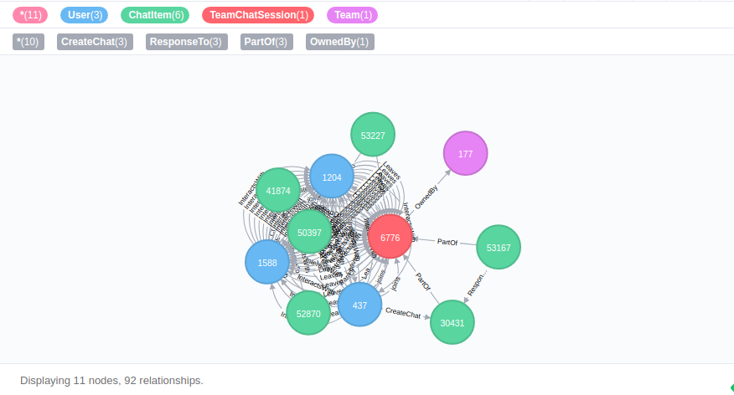

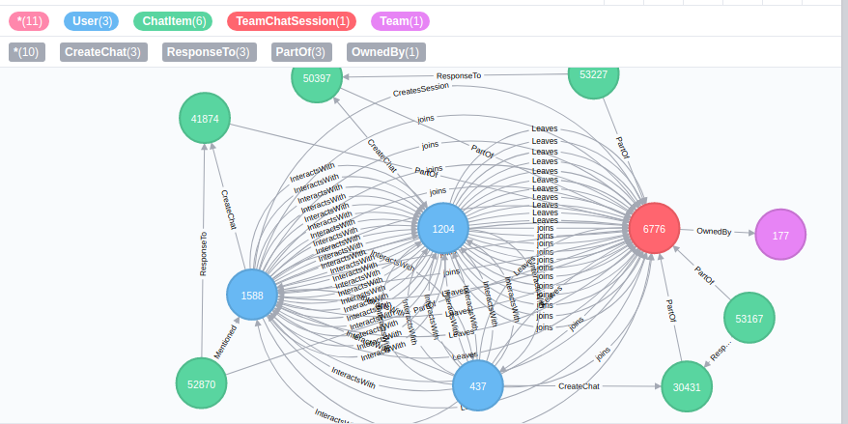

**Finding the longest conversation chain and its participants**

Report the results including the length of the conversation (path length) and how many unique users were part of the conversation chain. Describe your steps. Write the query that produces the correct answer.

**Length of the conversation: 9**

MATCH p =(a)-[:ResponseTo*]->(b)

return length(p)

order by length(p) desc

limit 1

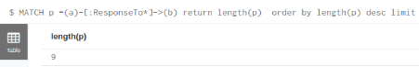

**Conversation**

MATCH p =(a)-[:ResponseTo*]->(b)

return p

order by length(p) desc

limit 1

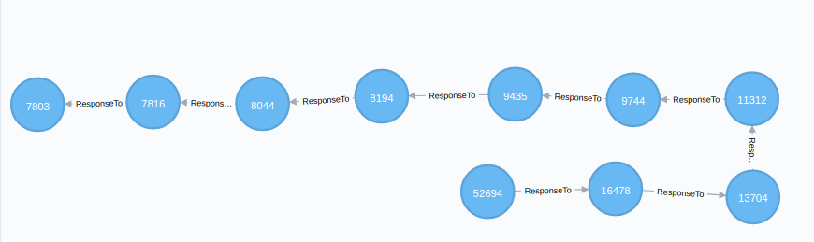

**Distinct Users: 5**

MATCH p =(a)-[:ResponseTo*]->(b)

with p

order by length(p) desc limit 1

match p1=(x)-[:CreateChat]->(y)

where y in nodes(p)

return count(distinct x)

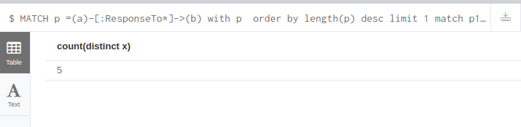

**Analyzing the relationship between top 10 chattiest users and top 10 chattiest teams**

Describe your steps from Question 2. In the process, create the following two tables. You only need to include the top 3 for each table. Identify and report whether any of the chattiest users were part of any of the chattiest teams.

Chattiest User  
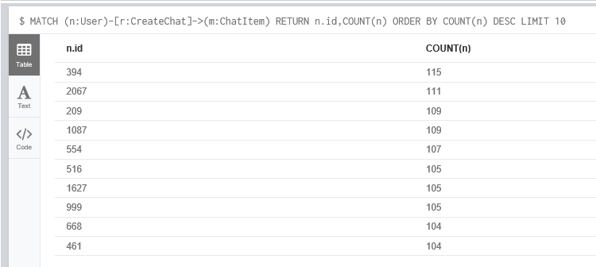

Chattiest Team  
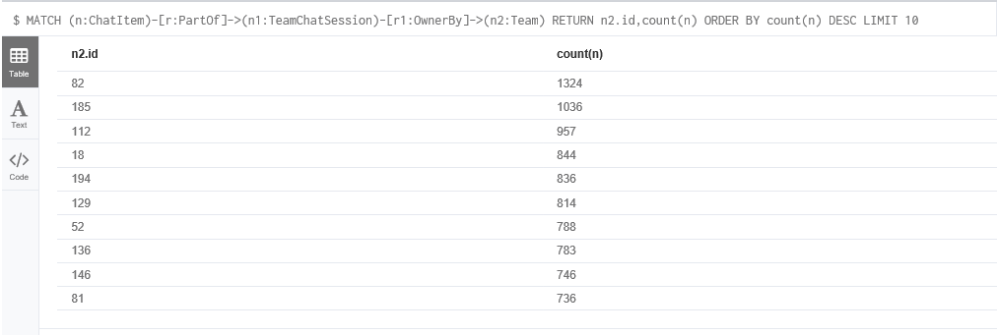

**Chattiest Users**

|  |  |
| --- | --- |
| **Users** | **Number of Chats** |
| 394 | 115 |
| 2067 | 111 |
| 209 | 109 |
| 1087 | 109 |
| 554 | 107 |
| 516 | 105 |
| 1627 | 105 |
| 999 | 105 |
| 668 | 104 |
| 461 | 104 |

**Chattiest Teams**

|  |  |
| --- | --- |
| **Teams** | **Number of Chats** |
| 82 | 1324 |
| 185 | 1036 |
| 112 | 957 |
| 18 | 844 |
| 194 | 836 |
| 129 | 814 |
| 52 | 788 |
| 136 | 783 |
| 146 | 746 |
| 81 | 736 |

Finally, present your answer, i.e. whether or not any of the chattiest users are part of any of the chattiest teams.

**The Chattiest User id 999 is part of Team id 52 which is also among top 10 Chattiest Teams.**

**How Active Are Groups of Users?**

Describe your steps for performing this analysis. Be as clear, concise, and as brief as possible. Finally, report the top 3 most active users in the table below.

1. Created InteractWith Edge between the users based on Mentioned Edge  
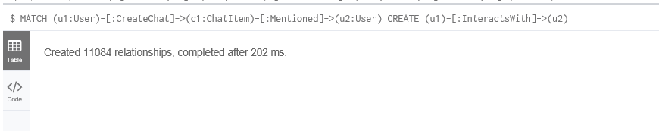  
2.Created InteractWith Edge between the users based on ResponseTo Edge  
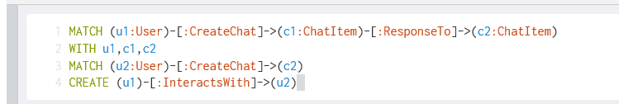  
3. Delete the Self Loops Edges of InteractWith  
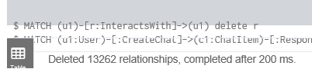

**Most Active Users (based on Cluster Coefficients)**

|  |  |
| --- | --- |
| **User ID** | **Coefficient** |
| 209 | 0.95 |
| 554 | 0.90 |
| 1087 | 0.80 |