**Technical Appendix**

**Catch the Pink Flamingo Analysis**

**Produced by: Pablo Langa Blanco**

Acquiring, Exploring and Preparing the Data

Data Exploration

Data Set Overview

The table below lists each of the files available for analysis with a short description of what is found in each one.

|  |  |  |
| --- | --- | --- |
| **File Name** | **Description** | **Fields** |
| ad-clicks.csv | This table has accumulated all clicks of the users on an advertisement in the app | **timestamp**: the timestamp when the event occurs.  **txId**: a unique id for the click, its a primary key  **userSessionid**: the id of the user session, its a foreing key from the table User_sessions  **teamid**: the current team id, its a foreing key from the table Team  **userid**: the user id of the user who made the click, its a foreing key from the table User  **adId**: the id of the ad clicked on. This id must be in other table wich have the id of the adds.  **adCategory**: the category/type of ad clicked on. This attribute is an enumerated type. |
| buy-clicks.csv | This table have one row for each purchase in the app | **timestamp**: the timestamp when the event occurs  **userSessionId**: the id of the user session for the user who made the purchase. its a foreing key from the table User_sessions  **team**: the current team id of the user who made the purchase, its a foreing key from the table Team (teamId)  **userId**: the user id of the user who made the purchase, its a foreing key from the table User  **buyId**: the id of the item purchased, its a primary key  **price**: the price of the item purchased |
| users.csv | This table contains the players of the game | **timestamp**: when user first played the game.  **userId**: the user id assigned to the user. its a primary key. Numeric Id  **nick**: the nickname chosen by the user.  **twitter**: the twitter handle of the user.  **dob**: the date of birth of the user. In this format AAAA­MM­DD  **country**: the two­letter country code where the user lives. |
| team.csv | This table contains all the teams in the game. | **teamId**: the id of the team, its a primary key. Numeric Id  **name**: the name of the team **teamCreationTime**: the timestamp when the team was created  **teamEndTime**: the timestamp when the last member left the team  **strength**: a measure of team strength, roughly corresponding to the success of a team  **currentLevel**: the current level of the team |
| team-assignments.csv | Each row contains when a user join a team. When one user join a new team it indicates that leave the last team. | **timestamp**: when the user joined the team.  **team**: the id of the team, foreing key  **userId**: the id of the user, foreing key  **assignmentId**: a unique id for this assignment, primary key. |
| level-events.csv | This table contains all the level events, when a team start an event on when finish it. | **timestamp**: when the event occurred.  **eventId**: a unique id for the event, primary key  **teamId**: the id of the team, foreing key  **teamLevel**: the level started or completed. Its grater than 0  **eventType**: the type of event, either start or end. Enumerated value. |
| user-session.csv | Each line in this file describes a user session, which denotes when a user starts and stops playing  the game. Additionally, when a team goes to the next level in the game, the session is ended for  each user in the team and a new one started. | **timestamp**: a timestamp denoting when the event occurred.  **userSessionId**: a unique id for the session. Primary key  **userId**: the current user's ID. Foreing key  **teamId**: the current user's team. Foreing key  **assignmentId**: the team assignment id for the user to the team. Foreing key  **sessionType**: whether the event is the start or end of a session. Enumerated type  **teamLevel**: the level of the team during this session. Positive integer  **platformType**: the type of platform of the user during this session. |
| game-clicks.csv | A line is added to this file each time a user performs a click in the game. | **timestamp**: when the click occurred.  **clickId**: a unique id for the click. Primary key  **userId**: the id of the user performing the click. Foreing key  **userSessionId**: the id of the session of the user when the click is performed. Foreing key  **isHit**: denotes if the click was on a flamingo (value is 1) or missed the flamingo (value is 0)  **teamId**: the id of the team of the user, Foreing key  **teamLevel**: the current level of the team of the user |

Aggregation

|  |  |
| --- | --- |
| Amount spent buying items | 21407 |
| Number of unique items available to be purchased | 6 |

* A histogram showing how many times each item is purchased:

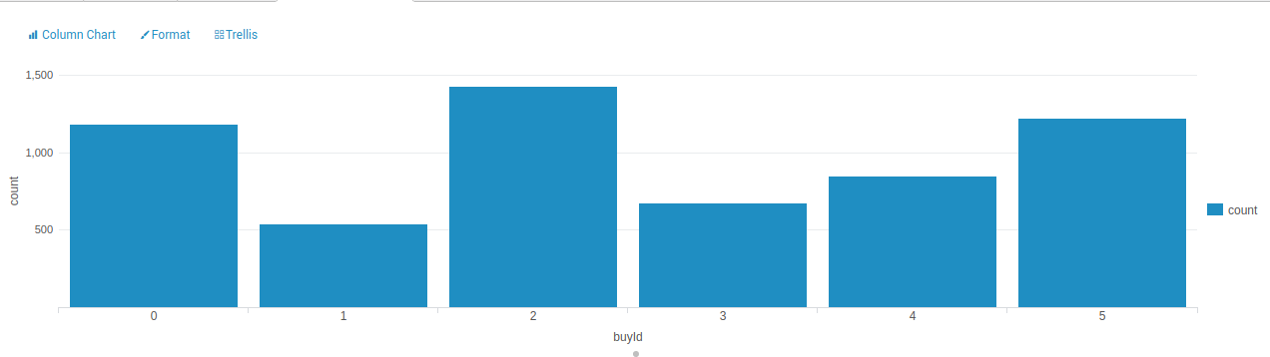 the item 2 is the top shell item

* A histogram showing how much money was made from each item:

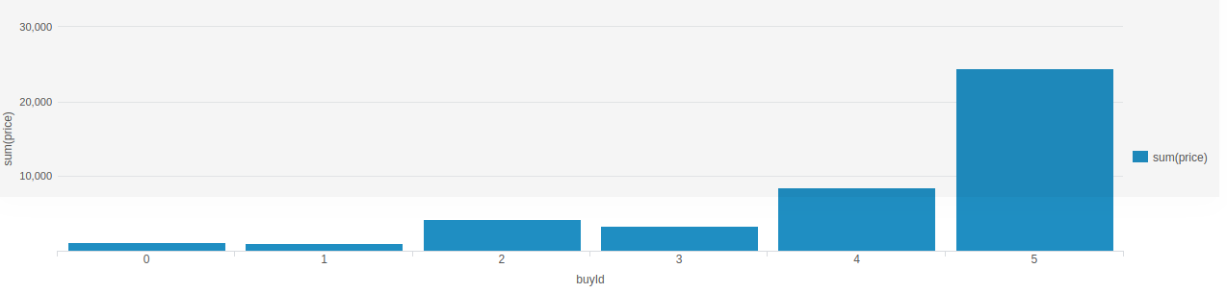The item 5 is the top of how much money spent the players

Filtering

A histogram showing total amount of money spent by the top ten users (ranked by how much money they spent).

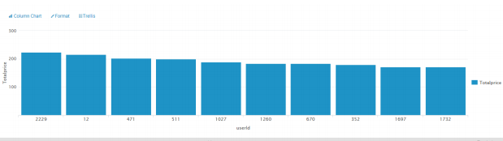

The following table shows the user id, platform, and hit-ratio percentage for the top three buying users:

|  |  |  |  |
| --- | --- | --- | --- |
| **Rank** | **User Id** | **Platform** | **Hit-Ratio (%)** |
| 1 | 2229 | iphone | 11.59% |
| 2 | 12 | iphone | 13.06% |
| 3 | 471 | iphone | 14.50% |

Data Classification Analysis

**Data Preparation**

Analysis of combined_data.csv

Sample Selection

|  |  |
| --- | --- |
| **Item** | **Amount** |
| # of Samples | 4619 |
| # of Samples with Purchases | 1411 |

Attribute Creation

A new categorical attribute was created to enable analysis of players as broken into 2 categories (HighRollers and PennyPinchers). A screenshot of the attribute follows:

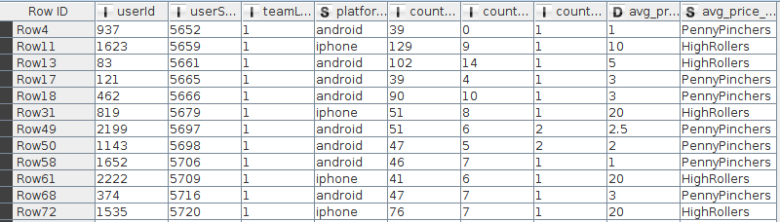

The new attribute avg_price_binned uses the avg_price attribute to classify the instances. When the value of avg_prive is less than 5 it classify the instance as “PennyPinchers”. And when it is grater than 5 as “HighRollers”

The creation of this new categorical attribute was necessary because it will be the target attribute that we are going to use in the next steps to train the decision tree.

Attribute Selection

The following attributes were filtered from the dataset for the following reasons:

|  |  |
| --- | --- |
| **Attribute** | **Rationale for Filtering** |
| usserSesionId | Its excluded because its not a significance value, its only the Id to identify the session |
| avg_price | Its excluded because the target attribute its created from this attribute |

**Data Partitioning and Modeling**

The data was partitioned into train and test datasets.

The first partition data set was used to create the decision tree model.

The trained model was then applied to the second partition dataset.

This is important because we need to test our model in data set different from the training data set to see how is it behaving in different data with the same distribution.

When partitioning the data using sampling, it is important to set the random seed because we want to be able to reproduce the same results in each execution.

A screen-shot of the resulting decision tree can be seen below:

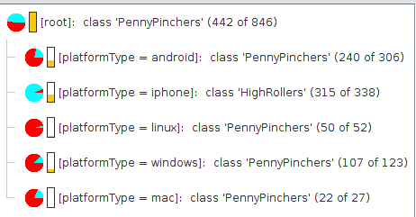

**Evaluation**

A screenshot of the confusion matrix can be seen below:



As seen in the screenshot above, the overall accuracy of the model is 0.871

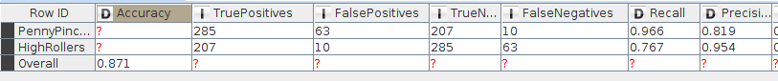

* 285 “PennyPinchers” was correctly predicted
* 207 “HighRollers” was correctly predicted.
* 63 instances was predicted as “PennyPinchers” and they are “HighRollers”
* 10 instances was predicted as “HighRollers” and they are “PennyPinchers”

**Analysis Conclusions**

The final KNIME workflow is shown below:

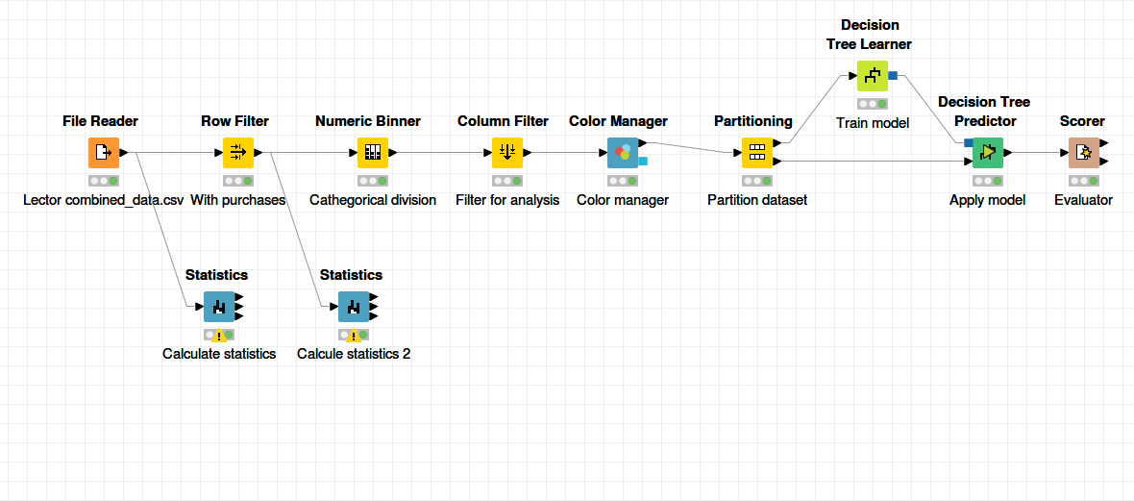

What makes a HighRoller vs. a PennyPincher?

Based in the decision results the principal attribute is the platform type. The iphone user trend to be high rollers and the users of the oder platmorms trend to be Penny Pinchers.

|  |
| --- |
| **Specific Recommendations to Increase Revenue** |
| 1. We need to focus our efforts to increase iphone users. We could make publicity of our game oriented in this platform. |
| 2. We want to the no iphone platforms users spent more money in our game. We could personalize some characteristics of our game, like an andoid flamingo to increase the interests of this platform users. |

Clustering Analysis

**Attribute Selection**

|  |  |
| --- | --- |
| **Attribute** | **Rationale for Selection** |
| Strength | The Strength of the team of team.csv. I want to know how this attribute is related with the purchases |
| Amount | This attribute is the sum of the price spent by a team. Its interesting because is the parameter we want to increase or we want to know how its related with other parameters of the team (from buy-clicks.csv) |
| NumAddClicks | This attribute is the count of the click in the adds by the teams (from ad-clicks.csv). Its interesting because it could be related with the amount spent |

**Training Data Set Creation**

The training data set used for this analysis is shown below (first 5 lines):

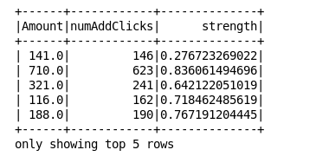

Dimensions of the training data set (rows x columns) : 44 x 3

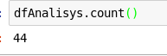

# of clusters created: 3

I'm going to try with 3 clusters.

**Cluster Centers**





|  |  |
| --- | --- |
| **Cluster #** | **Cluster Center** |
| Cluster 1 | [-0.73, -0.61, 0.89] |
| Cluster 2 | [1.05, 1.10, 0.09] |
| Cluster 3 | [-0.36, -0.52, -0.93] |

These clusters can be differentiated from each other as follows:

Cluster 1 is different from the others in that… Has a high strength, very low number of addClicks an Amount spent

Cluster 2 is different from the others in that… Has a medium strength, very hihg number of addClicks an Amount spent

Cluster 3 is different from the others in that… Has a low strength, low number of addClicks an Amount spent

**Recommended Actions**

|  |  |
| --- | --- |
| **Action Recommended** | **Rationale for the action** |
| Incentive team with medium strength | We have seen that the teams with medium strength are the team that have spent more money and clicked more adds, its important to incentive this teams to play |
| Put adds in strategic zone | We have seen than the amount spent is directly related with the addClicks. We could put the adds in strategic zones of the game to encourage the team to click it. |

Graph Analytics Analysis

**Modeling Chat Data using a Graph Data Model**

Our principal nodes are Users, Teams, Team Chat Sessions and Chat items. A User could create new chat. All the chats are part of a team chat session. A Chat item could respond to an other chat item or maybe Mention to a user. All users could join or leaves a chat session. Finally all chat sessions are owned by a Team.

**Creation of the Graph Database for Chats**

Describe the steps you took for creating the graph database. As part of these steps

* Write the schema of the 6 CSV files

chat_create_team_chat.csv

userid,teamid,TeamChatSessionID,timestamp

chat_item_team_chat.csv

userid,teamchatsessionid,chatitemid,timestamp

chat_join_team_chat

userid,TeamChatSessionID,teamstamp

chat_leave_team_chat.csv

userid,teamchatsessionid,timestamp

chat_mention_team_chat.csv

ChatItem,userid,timeStamp

chat_respond_team_chat.csv

chatid1,chatid2,timestamp

* Explain the loading process and include a sample LOAD command

LOAD CSV FROM "file:///chat_create_team_chat.csv" as row

MERGE (u:User {id: toInteger(row[0])})

MERGE (t:Team {id: toInteger(row[1])})

MERGE (c:TeamChatSession {id: toInteger(row[2])})

MERGE (u)-[:CreatesSession{timeStamp: row[3]}]->(c)

MERGE (c)-[:OwnedBy{timeStamp: row[3]}]->(t)

LOAD CSV FROM "file:///chat_join_team_chat.csv" as row

MERGE (u:User {id: toInteger(row[0])})

MERGE (c:TeamChatSession {id: toInteger(row[1])})

MERGE (u)-[:joins{timeStamp: row[2]}]->(c)

LOAD CSV FROM "file:///chat_leave_team_chat.csv" as row

MERGE (u:User {id: toInteger(row[0])})

MERGE (c:TeamChatSession {id: toInteger(row[1])})

MERGE (u)-[:Leaves{timeStamp: row[2]}]->(c)

LOAD CSV FROM "file:///chat_mention_team_chat.csv" as row

MERGE (u:User {id: toInteger(row[1])})

MERGE (ch:ChatItem {id: toInteger(row[0])})

MERGE (ch)-[:Mentioned{timeStamp: row[2]}]->(u)

LOAD CSV FROM "file:///chat_respond_team_chat.csv" as row

MERGE (ch1:ChatItem {id: toInteger(row[0])})

MERGE (ch2:ChatItem {id: toInteger(row[1])})

MERGE (ch1)-[:ResponseTo{timeStamp: row[2]}]→(ch2)

* Present a screenshot of some part of the graph you have generated. The graphs must include clearly visible examples of most node and edge types. Below are two acceptable examples. The first example is a rendered in the default Neo4j distribution, the second has had some nodes moved to expose the edges more clearly. Both include examples of most node and edge types.

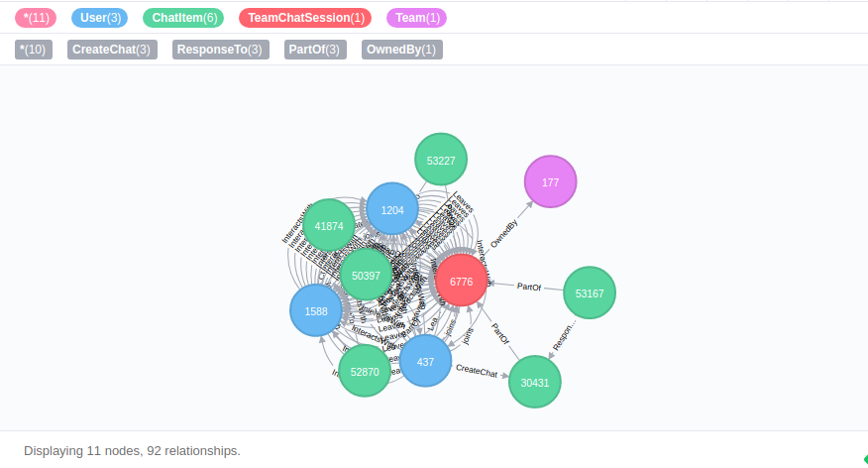

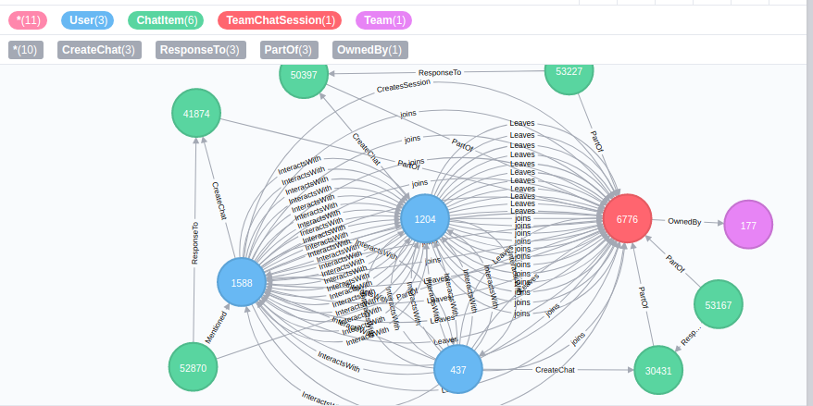

**Finding the longest conversation chain and its participants**

Report the results including the length of the conversation (path length) and how many unique users were part of the conversation chain. Describe your steps. Write the query that produces the correct answer.

**Length of the conversation: 9**

MATCH p =(a)-[:ResponseTo*]->(b)

return length(p)

order by length(p) desc

limit 1

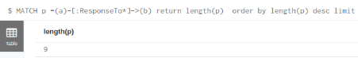

**Conversation**

MATCH p =(a)-[:ResponseTo*]->(b)

return p

order by length(p) desc

limit 1

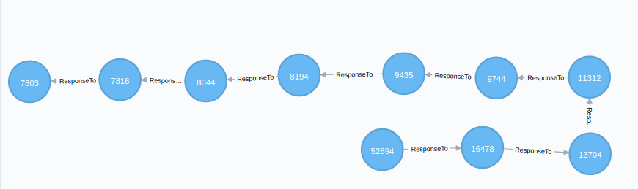

**Distinct Users: 5**

MATCH p =(a)-[:ResponseTo*]->(b)

with p

order by length(p) desc limit 1

match p1=(x)-[:CreateChat]->(y)

where y in nodes(p)

return count(distinct x)

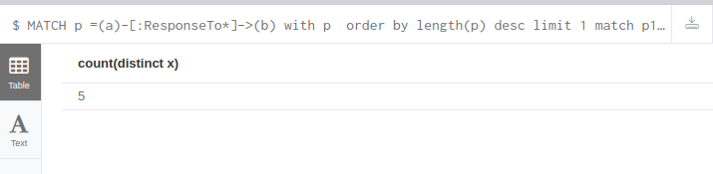

**Analyzing the relationship between top 10 chattiest users and top 10 chattiest teams**

Describe your steps from Question 2. In the process, create the following two tables. You only need to include the top 3 for each table. Identify and report whether any of the chattiest users were part of any of the chattiest teams.

Chattiest User  
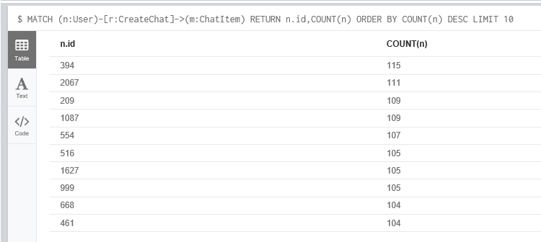

Chattiest Team  
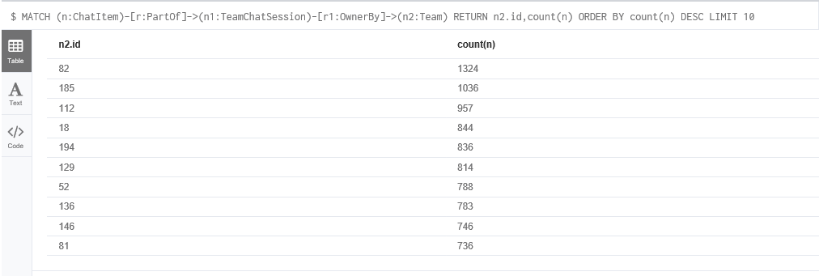

**Chattiest Users**

|  |  |
| --- | --- |
| **Users** | **Number of Chats** |
| 394 | 115 |
| 2067 | 111 |
| 209 | 109 |
| 1087 | 109 |
| 554 | 107 |
| 516 | 105 |
| 1627 | 105 |
| 999 | 105 |
| 668 | 104 |
| 461 | 104 |

**Chattiest Teams**

|  |  |
| --- | --- |
| **Teams** | **Number of Chats** |
| 82 | 1324 |
| 185 | 1036 |
| 112 | 957 |
| 18 | 844 |
| 194 | 836 |
| 129 | 814 |
| 52 | 788 |
| 136 | 783 |
| 146 | 746 |
| 81 | 736 |

Finally, present your answer, i.e. whether or not any of the chattiest users are part of any of the chattiest teams.

**The Chattiest User id 999 is part of Team id 52 which is also among top 10 Chattiest Teams.**

**How Active Are Groups of Users?**

Describe your steps for performing this analysis. Be as clear, concise, and as brief as possible. Finally, report the top 3 most active users in the table below.

1. Created InteractWith Edge between the users based on Mentioned Edge  
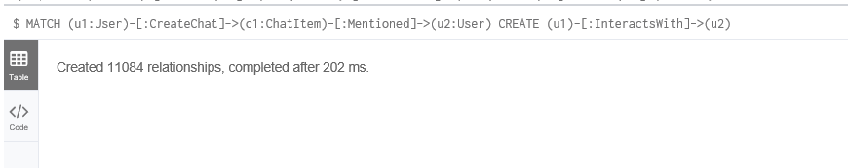  
2.Created InteractWith Edge between the users based on ResponseTo Edge  
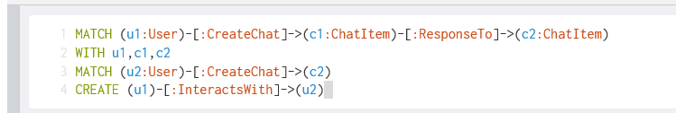  
3. Delete the Self Loops Edges of InteractWith  
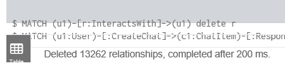

**Most Active Users (based on Cluster Coefficients)**

|  |  |
| --- | --- |
| **User ID** | **Coefficient** |
| 209 | 0.95 |
| 554 | 0.90 |
| 1087 | 0.80 |

**Recommended Actions**

Finally, make recommendations to Eglence, Inc. and include examples of how your findings support them. Include this information in Slide 6 of your final presentation.