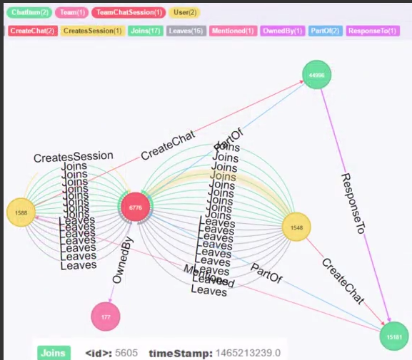

LOAD CSV FROM "file:///chat_create_team_chat.csv" as row
MERGE (u:User {id: toInteger(row[0])})
MERGE (t:Team {id: toInteger(row[1])})
MERGE (c:TeamChatSession {id: toInteger(row[2])})
MERGE (u)-[:CreatesSession{timeStamp: row[3]}]->(c)
MERGE (c)-[:OwnedBy{timeStamp: row[3]}]->(t)

LOAD CSV FROM "file:///chat_join_team_chat.csv" as row
MERGE (u:User {id: toInteger(row[0])})
MERGE (c:TeamChatSession {id: toInteger(row[1])})
MERGE (u)-[:joins{timeStamp: row[2]}]->(c)

LOAD CSV FROM "file:///chat_leave_team_chat.csv" as row
MERGE (u:User {id: toInteger(row[0])})
MERGE (c:TeamChatSession {id: toInteger(row[1])})
MERGE (u)-[:Leaves{timeStamp: row[2]}]->(c)

LOAD CSV FROM "file:///chat_mention_team_chat.csv" as row
MERGE (u:User {id: toInteger(row[1])})
MERGE (ch:ChatItem {id: toInteger(row[0])})
MERGE (ch)-[:Mentioned{timeStamp: row[2]}]->(u)
LOAD CSV FROM "file:///chat_respond_team_chat.csv" as row
MERGE (ch1:ChatItem {id: toInteger(row[0])})
MERGE (ch2:ChatItem {id: toInteger(row[1])})
MERGE (ch1)-[:ResponseTo{timeStamp: row[2]}]→(ch2)

MATCH (n) RETURN count(*)
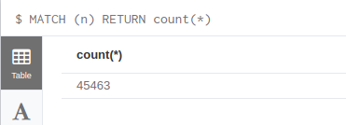

MATCH (c1)-[r]->(c2) return count(r)
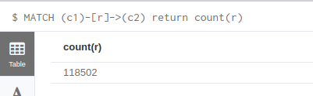

MATCH p =(a)-[:ResponseTo*]->(b)
return length(p)
order by length(p) desc
limit 10

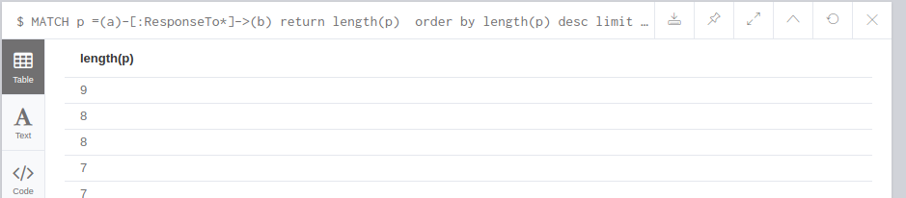

MATCH p =(a)-[:ResponseTo*]->(b)
return p
order by length(p) desc
limit 1
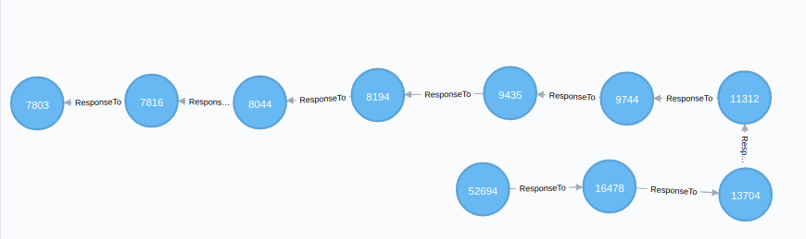

MATCH p =(a)-[:ResponseTo*]->(b)
with p
order by length(p) desc limit 1
match p1=(x)-[:CreateChat]->(y)
where y in nodes(p)
return count(distinct x)
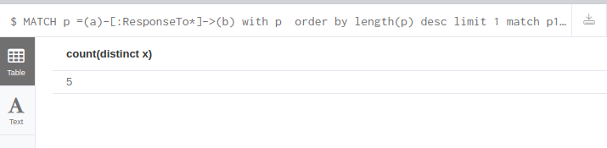

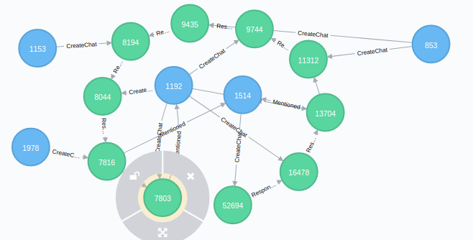

Match (x:User)-[ch:CreateChat]->(:ChatItem)
return x.id,count(ch)
order by count(ch) desc
limit 10

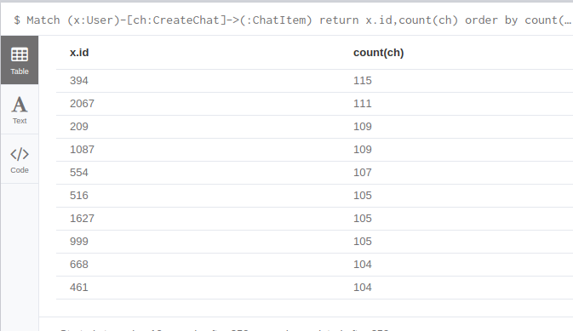

Match (ch:ChatItem)-[:PartOf]->(:TeamChatSession)-[:OwnedBy]->(T:Team)
return T.id,count(ch)
order by count(ch) desc
limit 10

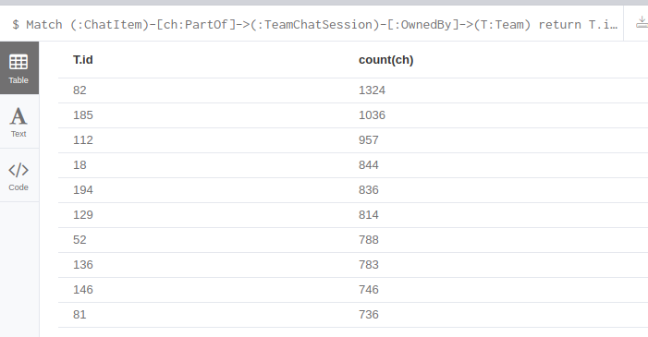

Match (U:User)-[:joins]->(:TeamChatSession)-[:OwnedBy]->(T:Team)
where (T.id = 82 or T.id = 185 or T.id = 112) and
(U.id = 394 or U.id = 2067 or U.id = 209)
return U,T

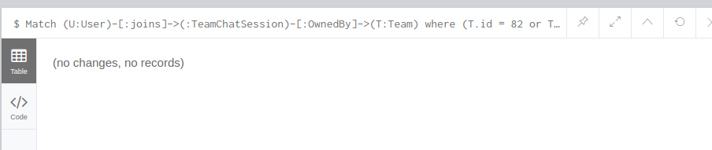

match p = (u1:User)-[:CreateChat]->(:ChatItem)-[:Mentioned]->(u2:User) create (u1)-[:InteractsWith]→(u2)

Match (u1:User)-[:CreateChat]->(:ChatItem)-[:ResponseTo]->(:ChatItem)<-[:CreateChat]-(u2:User) create (u1)-[:InteractsWith]→(u2)

Match (u)-[r:InteractsWith]->(u) delete r

match (u:User)-[:InteractsWith]-(u1:User)
where u.id=394 or u.id=2067 or u.id=209
with u,collect(distinct u1.id) as neighbors ,count(distinct u1) as n
match (x:User),(y:User)
where x.id in neighbors and y.id in neighbors
return u.id, n, count(case when (x:User)-[:InteractsWith]-(y:User) then 1 else 0 end) as r
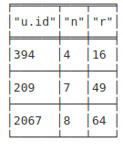

16/4*3 = 1.33
49/7*6 = 1.16
64/8*7 = 1.14

