Under xampp:=

<http://localhost/z_radical/z_ccm/training/assignment1/html/z.html>

C:\xampp\htdocs\z_radical\z_ccm\training\assignment1\

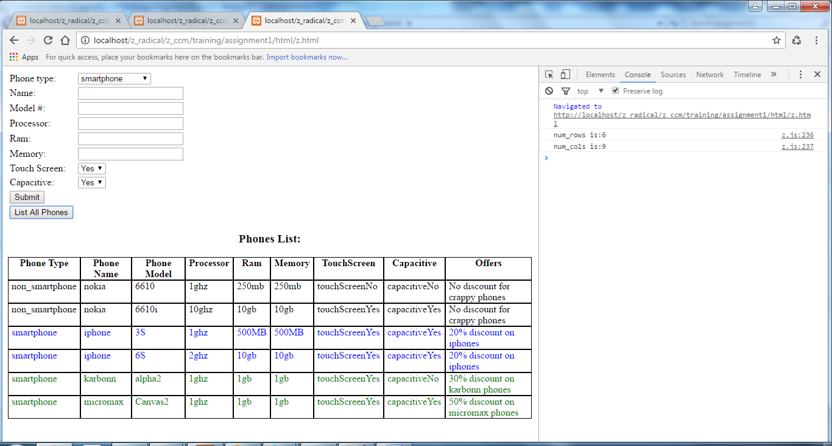

1. Also available on [www.plnkr.co](http://www.plnkr.co)

PLunker url for this is:-- <http://plnkr.co/edit/WWKwx2xGEwLTX8DxyDmu?p=preview>

Plunkr Screenshots:- (plz do refer readme.md on the plunker link above)

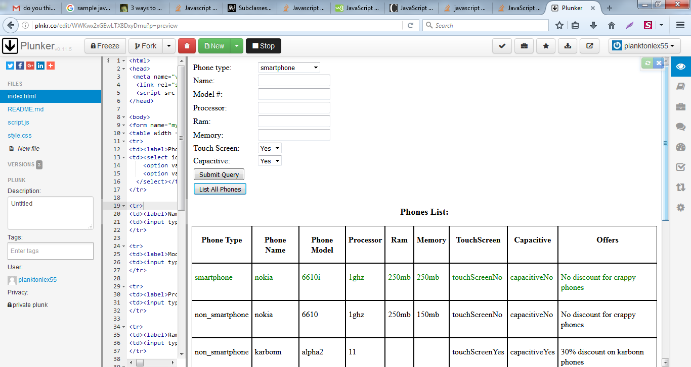

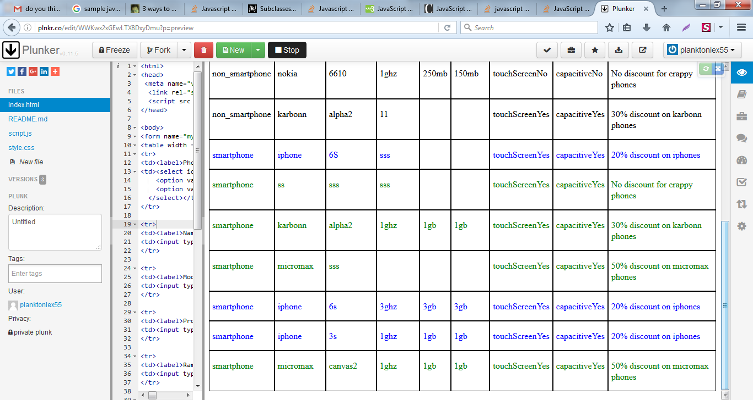

Legend:-

Smartphones are colored, iphones are in blue, rest r in green

Non Smartphones are NOT colored.