Mathematics AC V9 | Year 5
Unit 3
SA 5 – Representing and ordering fractions and decimals

- Shade the diagrams to show the fractions.
$$\frac{1}{4}$$ |  |  |  |  | $$\frac{3}{4}$$
- Which fraction is greater:$\frac{1}{4}$ or $\frac{3}{4}$?
- Shade the diagrams to show the decimals.
0.40 |  |  |  |  |  |  |  |  |  |  | 0.04
- Which decimal is greater: 0.40 or 0.04?
- Show the decimals on the place value charts.
- 56 hundredths |  |  |  | - One and 5 hundredths
Ones | Tenths | Hundredths |  | Ones | Tenths | Hundredths
- Seven and 63 hundredths
Ones | Tenths | Hundredths
- Order these decimals from smallest to greatest.
2.21 0.02 2.22 1.25 1.02 0.50
- Label these decimals above the number line on Sheet — Number line.

- Label these fractions below the number line on Sheet — Number line.
2 $\frac{1}{10}$, 1 $\frac{2}{5}$, $\frac{14}{10}$, $\frac{5}{10}$, 2 $\frac{3}{10}$, $\frac{6}{5}$
- Jill ordered and represented fractions on a number line. Is Jill correct? How do you know?
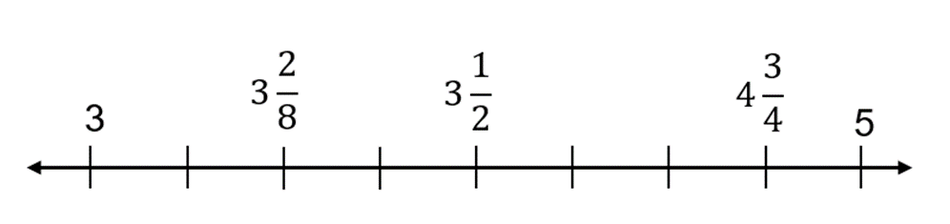
10. Look at the results of the 50 m freestyle swimming race. Swimmers with a time faster than $39\frac{1 }{2}$ seconds go to the regional final. Who will go to the regional final? Show your working out.
Lane | Name | Time (seconds)
1 | Sarah | 39.45
2 | Mana | 39.55
3 | Sam | 39.58
4 | Darcy | 39.6
5 | Piper | 39.05
6 | Ali | 39.01
11. Georgie needs $2\frac{4 }{10}$ metres of the same-coloured fabric to make a costume. She has the following lengths of fabric:
2$\frac{1}{5}$ metres  of green fabric | 2$\frac{1}{2}$ metres  of red fabric | 2$\frac{3}{5}$ metres  of blue fabric
What could Georgie use? Show your working out.

12. Calculate the following:

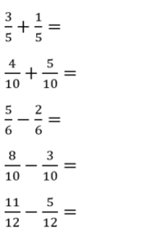
Sheet
Number line
