Grolly Watering System - TECHNICAL DESIGN

System is assembled in a plastic/metal box and consists of hardware:
  - solenoid valves for watering lines (SVWL= 0 to 4)
  - solenoid valve or water pump for water intake
  - main high pressure watering pump
  - circulation pump
  - fertilizer dosing pumps (FDP = 0 to 4)

Grolly Base Basic config for Grolly system

For the basic config there are 3 solenoid valves on watering lines and 2 dosing pumps for fertilizers. Circulation pump is connected to T8 MOSFET of Cadi mainboard (140210) going to PC8 of STM32F100 uC. The main high pressure watering pump is switched on/off with extra driver controlled by PC0 output of controller.

Grolly electrical connectors
There are 2 metal connectors (GX16-8) on the Grolly wall to connect 2 water level sensors (WLS). At least one of them is used to control the level in Mixing tank.
Another WLS could be connected for controlling another – buffer tank for filtered water. The buffer tank incoming supply will be controlled using external valve, wired to the pins of the same WLS connector.
There are two more metal connectors for external temperature and humidity sensors

Cadi electrical connectors
There are connectors, that wire together the Cadi box and Grolly devices. These connectors are located on the wall of Cadi box, installed inside Grolly.
There are 3 connectors:
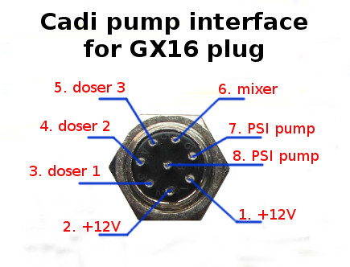
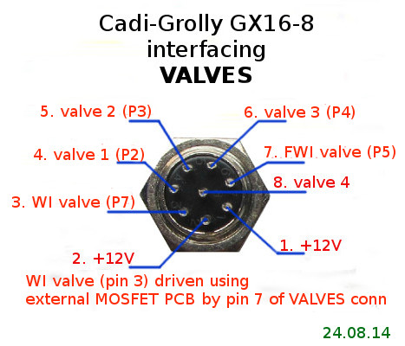
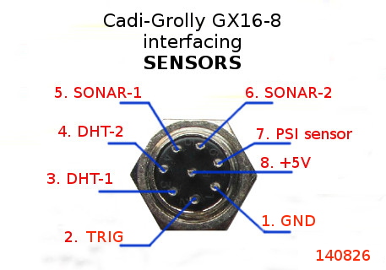

PUMP GX16-8 connector wiring to Cadi v2 Mainboard
PIN 1: +12V
PIN 2: +12V
PIN 3: Drain of T5
PIN 4: Drain of T6
PIN 5: Drain of T7
PIN 6: Drain of T8
PIN 7: Drain of extra driver 1 (driven by PC0 pin of STM32 controller)
PIN 8: Drain of extra driver 1 (same)

VALVE GX16-8 connector wiring to Cadi v2 Mainboard
PIN 1: +12V
PIN 2: +12V
PIN 3: P7 WI valve driven by external MOSFET valve (PIN 7 of VALVES_ plug, previously used as feedback for ball valve)
PIN 4: P2 - Drain of T1
PIN 5: P3 – Drain of T2
PIN 6: P4 - Drain of T3
PIN 7: P5 - Drain of T4
PIN 8: Drain of Extra Driver 3 (driven by PIN9 (previously known as feedback)). Optional

SENSORS GX16-8 connector wiring to Cadi v2 Mainboard
PIN 1: N/C
PIN 2: P7 – TRIG for Sonars
PIN 3: P2 - DHT1 data wire
PIN 4: P3 - DHT2 data wire
PIN 5: P9 - SONAR1 echo
PIN 6: P7 - SONAR2 echo
PIN 7: pH/EC connector PIN3 – PSI sensor
PIN 8: +5V

Grolly external devices interface panel
This is a row of metal GX16 connectors.
Grolly has ability to connect external distance meters (sonars) and temperature&humidity sensors. The Water Intake valve also connected here.

External SONAR connectors' pinout (GX16-8 connector)
pin8: +5V
pin5: echo
pin2: trig
pin1:GND

External DHT sensor connectors' pinout (GX16-8 connector)
pin8: +5V
pin3: data
pin1:GND

WI valve connector
pin1:+12V
pin3:GND

Grolly fertilizer mixing tank
When Grolly wants to mix the feeding solution, it does it in a separate volume. This is good idea to put the tank on top of Grolly, so the minimum gravity pressure will push the water into the watering pump and fertilizer mixing circuit. This helps for proper operation of Grolly.

Grolly watering pump
When the water is ready to be sent towards plants, Grolly opens one of the watering line valves and starts pumping the water with high pressure watering pump.

Grolly circulation pump
Used when the solution in the mixing tank should be mixed, recirculated for a while. For example, when adding the fertilizer, this pump should run for a while to mix the fertilizer properly, before adding the next one.

Grolly Power
Grolly systems have a power source, converting incoming 220V into 12V. Minimum current capacity recommended to use is 15Amps (180W).

