**Site**

The study was carried out in March 2024 at the Paracou field site located near Sinnamary in French Guiana (5.274, 52.928 W) and managed by the Centre International de Recherche Agronomique (CIRAD, <https://paracou.cirad.fr/>). The climate at Paracou is classified as tropical, with an average temperature of 26°C and an annual rain of 3100 mm. The dry season occurs from mid-August to mid-November with usually less than 100 mm of rain per month. The site is located in an old-growth tropical forest. As part of the “Amazonian Landscapes in Transition” project (<https://anr.fr/Project-ANR-21-CE32-0009>), all the trees above 1 cm in diameter at breast height are identified and spatially localized in a 16-area plot.

**Species and leaf sampling**

27 species were selected with an average DBH of 3 cm (min = 1 cm, max = 6.7 cm). Among them, 11 species were understory specialists, and 15 were saplings of tall species that can reach the canopy top once mature. The tall species include typical pioneer species (e.g. *Jacaranda copaia, Pourouma melilonii*) and typical old-growth forest species (e.g. *Bocoa prouacensis*). Between one and three trees were selected for each species. One leaf per tree was selected for gas exchange, reflectance, and leaf elemental composition analysis. The leaf was sampled between 2 m and 4 m in height and accessed by a light scaffolding if the leaf couldn’t be measured by extending the LICOR chamber tripod to its maximum height and bending the stem. All the leaves were deeply shaded. We avoided very young or very old senescing leaves after visual inspection of the leaf appearance and position on the branch.

**Gas exchange measurements**

Gas exchange measurements were made with a LICOR 6800 equipped with a 6 cm2 leaf chamber (6800-01A). The incident leaf irradiance inside the chamber was set at 800 µmol m-2 s-1. This irradiance saturates the photosynthesis rate of understory trees (Verryckt et al., 2020), as we confirmed by light curve measurements. The CO2 concentration of the air entering the chamber was set at 435 ppm with a 700 µmol s-1 flow rate. The air temperature inside the chamber was set at 29°C. We waited a minimum of 20 minutes until the photosynthesis rate and conductance reached a steady state before recording the data for one minute. This data can be used to estimate the photosynthetic capacity of the leaves using the One-Point method (De Kauwe *et al.*, 2016; Burnett *et al.*, 2019). Measurements were performed from 8 am to 4 pm (Figure 1). Each leaf was identified with a label so they could be found later for measuring the leaf dark respiration (*R*dark). At night, i.e. after 7:30 pm and before 1 am, the leaf gas exchange was measured by setting the air temperature at 27°C, the CO2 concentration at 435 ppm, the flow rate at 300 µmol s-1, and by switching off the leaf incident light. One minute of data was recorded to estimate *R*dark once the CO2 assimilation rate and stomatal conductance were constant on a 4-minute window (usually in 10 minutes).

Most gas exchange measurements were performed *in-situ* (n = 65) in intact branches. Some measurements were also performed in cut branches on rainy days (n = 6). Ex-situ measurements were performed after cutting branches in the morning and re-cutting the stem under water. The leaves were wet (rain) when they were cut so the transpiration was minimal.

After the leaf dark respiration measurements, the leaf was cut, put into a dark plastic bag in the dark, and sent to the field station for reflectance measurement.

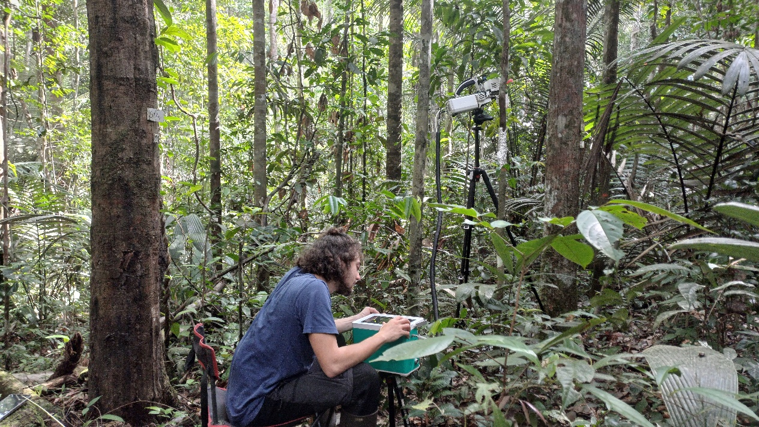

Figure 1 Gas exchange measurement of understory trees.

**Leaf optical hyperspectral Reflectance**

Leaf reflectance was measured with an ASD FieldSpec 3 Junior spectrometer equipped with an ASD contact leaf clip. A white reference was measured before each leaf reflectance measurement. 3 spectra were measured on each leaf. The bias between the visible, near infrared and short wave infrared spectrometer sensors (at 1000 and 1831 nm) were corrected using the ViewSpecPro “Splice correction” method. The 3 spectra per leaf were averaged to constitute one full range reflectance spectrum (350 nm to 2500 nm) for each leaf.

**Leaf elemental composition**

The fresh leaf area was estimated using a flatbed scanner (Epson Perfection V800). Once scanned, the leaves were dried at 65°C. Finally, their dry mass was measured with a precision scale and their leaf mass per surface area (LMA) was calculated using the fresh leaf area and its dry mass. Leaf elemental composition was measured by the Silva lab (Nancy, France) with the Unicube elemental analyzer (Elementar, Langenselbold, Germany).

**Acknowledgments**

The Paracou Forest Research Station in French Guiana is managed and supported by CIRAD, UMR EcoFoG (https://paracou.cirad.fr), and benefits from the financial support of a French "Investissement d'Avenir" program (Labex CEBA ANR-10-LABX-25-01).

The author(s) would like to thank SILVATECH (Silvatech, INRAE, 2018. Structural and functional analysis of tree and wood Facility, doi: 10.15454/1.5572400113627854E12) from UMR 1434 SILVA, 1136 IAM, 1138 BEF and 4370 EA LERMAB from the research center INRAE Grand-Est Nancy for it contribution to leaf elemental composition measurements. SILVATECH facility is supported by the French National Research Agency through the Laboratory of Excellence ARBRE (ANR-11-LABX-0002-01)."