# Materials and Methods

## Site Description

The study was conducted in 2024 at two field sites and focused on two species: barley (*Hordeum vulgare*), a grass, and Manna Gum (*Eucalyptus viminalis*), an evergreen broadleaved tree. The first dataset, involving *E. viminalis*, was collected at the University of New England SMART Farm Innovation Centre in Kirby, Armidale, NSW (30.52 °S, 151.67 °E; 980 m.a.s.l). Armidale has a cool temperate climate, with an average annual rainfall of 791.2 mm and average maximum and minimum temperatures of 20.3 and 7.1 °C, respectively. The second dataset, focused on *H. vulgare*, was obtained from the Wagga Wagga Agricultural Institute, in Wagga Wagga, NSW (35.16°S, 147.46°E; 212 m.a.s.l). Wagga Wagga experiences mild, moderate conditions with significant rainfall throughout the year. Mean annual rainfall in Wagga Wagga is 572 mm with average maximum and minimum temperatures of 22.2 and 9.1°C, respectively (Climate statistics from the Australian Bureau of Meteorology).

## Experimental Design and Sampling

Eucalyptus viminalis was managed to produce diverse seed lots for future revegetation efforts, while various genotypes of Hordeum vulgare were cultivated to assess the OzBarley diversity panels. Both experiments were arranged in a row × column/range design, with E. viminalis planted in 7 rows. The H. vulgare experiment comprised 57 rows and 12 ranges, with each block containing 19 rows. A total of 198 E. viminalis plants, representing 66 families (1 to 10 plants per family), and 212 genotypes of H. vulgare (639 plots) were selected for dark respiration measurements. Sampling for E. viminalis took place over two days in April 2024, while H. vulgare was sampled over five days in September 2024.

Prior to fieldwork, plant identification numbers were generated and printed on labels, which were affixed to Ziploc bags and envelopes for collecting plant materials. A field tour file was also prepared, detailing the rows, ranges, and plots to be sampled each day. This systematic approach was consistently followed throughout the sampling period. The measurement of plant traits occurred in two phases: field and laboratory. The field phase involved hyperspectral scans of intact leaves (detailed procedures for each measurement will be provided later). In the laboratory phase, leaf samples were collected after hyperspectral scanning to measure Rdark-O2.

## List of Measurements Taken

This dataset includes the following measurements for E. viminalis and H. vulgare:

1. Leaf Hyperspectral Reflectance
2. Dark Respiratory Oxygen Release (*R*dark-O2)
3. Leaf Mass Area (LMA)

## Measurements of leaf spectral reflectance

Reflectance data were collected from the adaxial surface of the first fully expanded leaves (the flag leaf in barley) using an ASD FieldSpec4 Spectroradiometer (Analytical Spectral Devices, Malvern Panalytical, United Kingdom) (Fig. 1) equipped with a leaf clip attached to a fiber optic cable. The leaf clip was modified with a mask to reduce the aperture to 1.264 cm² (1.15 × 1.4 cm), suitable for both barley and eucalyptus leaves. To prevent leaf damage and avoid external light entering through the edges, a 3 mm thick black circular gasket was attached to the mask. This methodology, previously used in Coast et al. (2019a) and Silva-Perez et al. (2018), generates hyperspectral model predictions for temperature-normalized rates of *V*cmax, *R*dark-O2, leaf mass per area, and leaf nitrogen concentration in wheat. The same approach was used here to generate reflectance data for the relevant traits.

Hyperspectral reflectance measurements (% light reflectance in the 350–2500 nm range) were performed between 9:00 am and 12:00 pm, just before destructive leaf sampling for further analysis. The 9:00 am start time ensured that leaves were dry, reducing the risk of measurement errors. A white reference was used to calibrate reflectance of the sensor lamp at the start of each sampling session and repeated every 10 - 15 measurements to check for any instrumental errors. Calibration of the white reference spectra took between 30 seconds and 1 minute. Reflectance measurement took approximately 1 minute per leaf sample. After measuring the reflectance spectrum, the leaf was immediately detached from the plant, near the ligule, and kept in moist ziplock bags in the dark for subsequent measurement of *R*dark-O2. These bagged samples were stored temporarily in cooler boxes with ice packs until they could be analyzed for *R*dark-O2 in the laboratory.

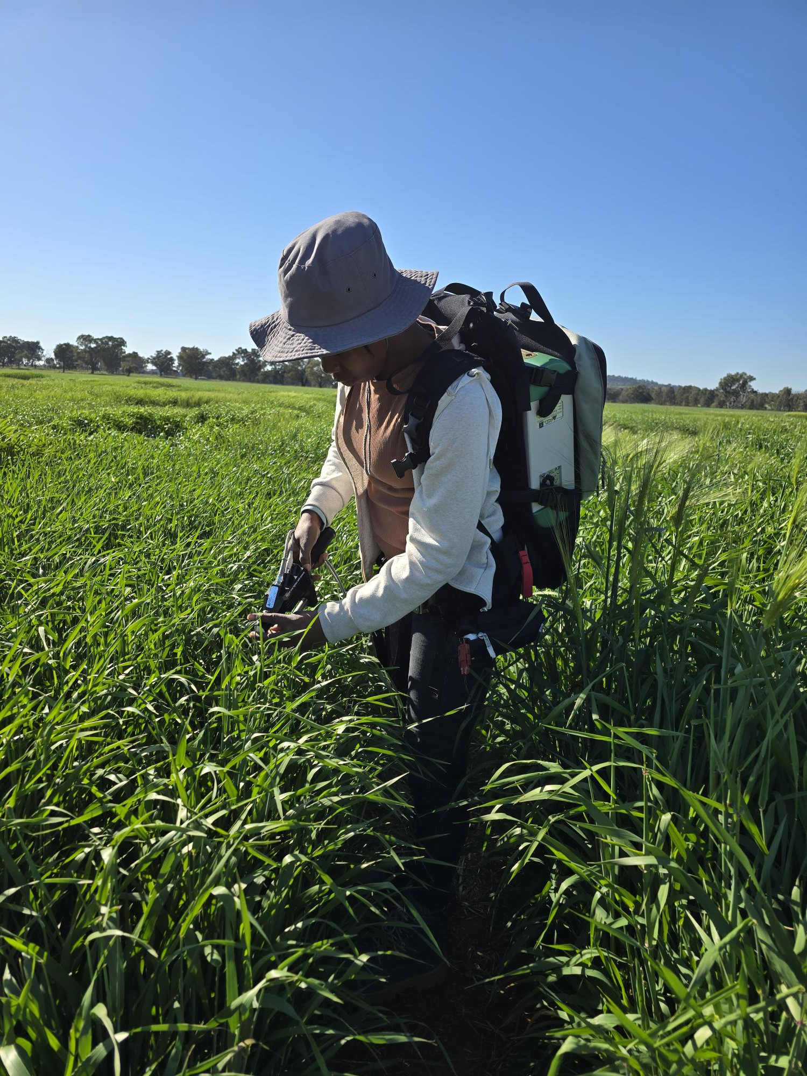

#### Figure 1: Measurement of leaf spectral reflectance using ASD FieldSpec4 Spectroradiometer

## Measurements of leaf *R*dark-O2

A high-throughput fluorophore based system (Seed Respiratory Analyser (SRA), LemnaTec GmbH, Aachen, Germany) was used to measure dark respiration oxygen uptake (*R*dark-O2), following the method described by Coast et al. (2019b) and Scafaro et al. (2017). Measurements were taken from the same leaf that had been used for hyperspectral scanning. A minimum of one leaf disc, 0.8 cm in diameter, was taken from the middle section of the leaf. Each disc was placed in empty tubes (1 or 2 ml in volume) containing 100 µL of distilled water and sealed with specialized SRA caps. Additionally, six blank tubes (containing no water or gas) and six tubes filled with 100% nitrogen gas were prepared for machine calibration.

*R*dark-O2 measurements were conducted at 25° C. The SRA was covered with black cloths, and the room kept in darkness to prevent light interference with *R*dark measurement. The SRA works by emitting an LED excitation pulse onto an O2-sensitive fluorophore embedded in the lid of the sealed tube, with the resulting fluorescence signal detected by a fiber-optic sensor, measuring O2 uptake inside the tube. The system can handle up to 768 samples per run, with each run lasting at least 2 hours.

The output includes approximately five stable data points on respiratory oxygen consumption, expressed as an O2 percentage relative to the calibration tubes. However, the data from the first 30 minutes to 1 hour were excluded due to instability, as respiratory activity tends to fluctuate rapidly during this time. Using the ideal gas law, the raw output (O2 % relative to the air calibration tube) was converted into absolute *R*dark in moles of O2 per second, based on the equation provided in Scafaro et al. (2017).

#### ImageFigure 2: Laboratory set-up and use of the SRA machine to determine Rdark-O2

### Estimation of leaf mass per area.

Leaf mass per area (LMA) was estimated based on excised leaf discs used for determining rate of Rdark. After dark respiration measurement, leaves were oven-dried at 65 °C for 5-7 days until a constant dry weight was achieved using Drum Heater Large Capacity (Up to +150ºC) (LABEC Laboratory Equipment Pty. Ltd, Marrickville, NSW, Australia). Afterwards, the samples were weighed using Wedderburn precision scale (Ingleburn NSW, Australia), and the LMA was calculated using the leaf area and its dry weight.

# References

Coast, O., Shah, S., Ivakov, A., Gaju, O., Wilson, P. B., Posch, B. C., Bryant, C. J., Negrini, A. C. A., Evans, J. R., Condon, A. G., Silva-Pérez, V., Reynolds, M. P., Pogson, B. J., Millar, A. H., Furbank, R. T., and Atkin, O. K. (2019a). Predicting dark respiration rates of wheat leaves from hyperspectral reflectance. *Plant Cell and Environment* **42**, 2133-2150.

Coast, O., Shah, S., Ivakov, A., Gaju, O., Wilson, P. B., Posch, B. C., Bryant, C. J., Negrini, A. C. A., Evans, J. R., Condon, A. G., Silva-Pérez, V., Reynolds, M. P., Pogson, B. J., Millar, A. H., Furbank, R. T., and Atkin, O. K. (2019b). Predicting dark respiration rates of wheat leaves from hyperspectral reflectance. *Plant Cell & Environment* **42**, 2133-2150.

Scafaro, A. P., Negrini, A. C. A., O’Leary, B., Rashid, F. A. A., Hayes, L., Fan, Y., Zhang, Y., Chochois, V., Badger, M. R., Millar, A. H., and Atkin, O. K. (2017). The combination of gas-phase fluorophore technology and automation to enable high-throughput analysis of plant respiration. *Plant Methods* **13**, 16.

Silva-Perez, V., Molero, G., Serbin, S. P., Condon, A. G., Reynolds, M. P., Furbank, R. T., and Evans, J. R. (2018). Hyperspectral reflectance as a tool to measure biochemical and physiological traits in wheat. *Journal of Experimental Botany* **69**, 483-496.