Materials and methods

Site
The experiment was conducted in controlled-environment facilities (glasshouses) at the University of New England (UNE) Armidale, New South Wales, Australia (latitude 30.48°S, longitude 151.63°E, elevation 1021.5 m).

Plant material and leaf sampling
Big truss forming tomato (Endeavour and Riviera) and snacking type tomato (Angelle Max and Ternetto) cuttings collected from Costa Tomato Exchange, Guyra, NSW, were used for this study. The plants were established in hydroponic system similar to those at Costa tomato glasshouses. The experiment was set up in two bays of the glasshouse of the Agronomy department of UNE. Weather stations were installed in each of the bay for recording the daily meteorological data. Glasshouse temperatures were maintained between 27 °C during day and 18 °C during night using ventilation and cooling fans. Relative humidity (RH) will be maintained at 60-65% during day and at 70% at night time. These high RH levels were achieved by installing humidifiers in each bay.
Each glasshouse bay was setup hydroponic channels supporting four rockwool slabs. Each slab held three plants. Therefore, a total of 24 plants were maintained per glasshouse bay. The plants were grown at ambient CO₂ levels. The pH of the nutrient solution was adjusted to 6.5 ± 0.2 and the electrical conductivity (EC) value were maintained at 3-4 µS cm⁻¹.

Dark adapted respiration (R_{dark}) measurements:
Gas exchange measurements were made with a LICOR 6400XT equipped with a 2 cm² leaf chamber. The CO₂ concentration of the air entering the chamber was set at 400 ppm with a 500 µmol s⁻¹ flow rate. The air temperature inside the chamber was set at 25 °C and RH of 60%. The third and second fully expanded leaf from the top shoot axis were used for measuring respiration in the dark (R_{dark}) and reflectance. Leaf R_{dark} measurement were taken on leaves that had been dark-adapted for at least 30 min.

Leaf hyperspectral reflectance measurements:
All leaves used for dark respiration measurements were tagged and subsequently assessed for hyperspectral reflectance using an SVC Spectroradiometer HR-1024i (Spectra Vista Corporation, Poughkeepsie, NY, USA) with a leaf clip attached to an optic cable. The spectroradiometer captured a spectral range from 350 to 2500 nm for each leaf. A white reference was taken before the leaf reflectance measurements and repeated after every 10-15 readings. The hyperspectral reflectance measurements were taken between 12:30 pm and 2:00 pm, with a single measurement recorded per leaf. The data was then processed using the SVC desktop software.

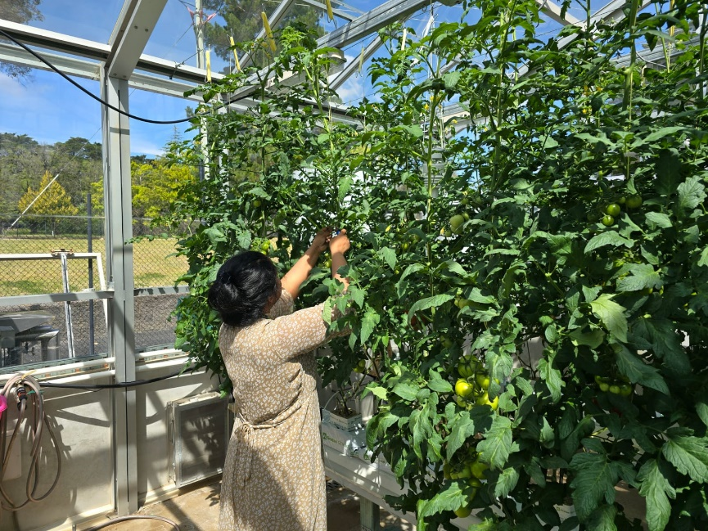

Figure 1: Tagging the leaves for dark respiration measurements and hyperspectral measurements

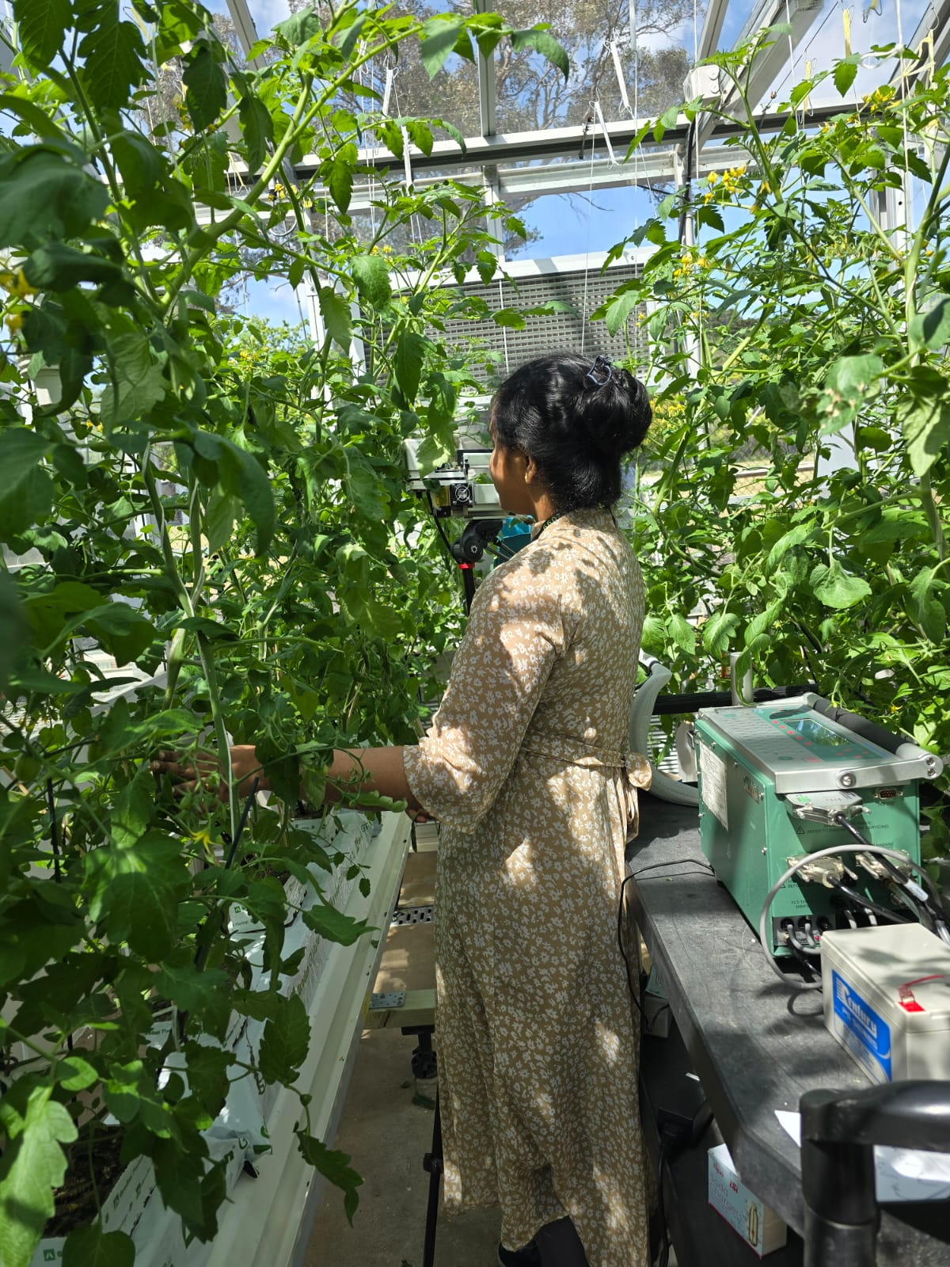

Figure 2: Measurements of leaf R_{dark}-CO₂ basis using LICOR 6400XT

