CIS 302

A JavaScript Calculator

Add the GitHub Page Link

<https://webcoredesigns.github.io/>

Add a screenshot of the Calculator using the given codes

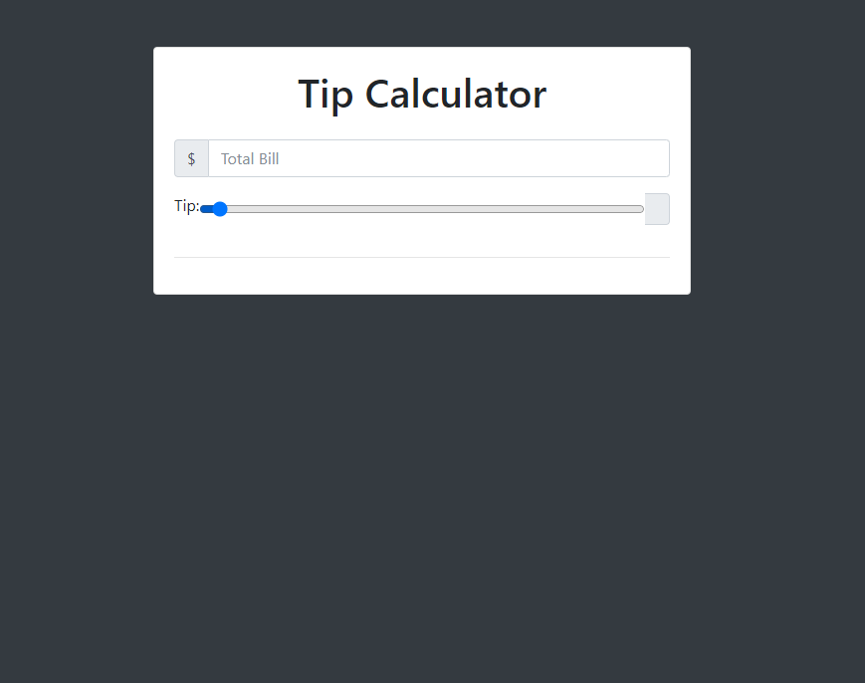

Add a screenshot of your version of the Calculator

