# ConnectRVA 2045 – Sentiment Analysis from Public Comments

## Input data overview –

(Subset screenshot)

Data was scraped off available online pdf and stored in excel file.

## Sentiment Analysis –

* Zero shot classification used. (Classification on the go)
* 3 categories of Sentiments were assigned on the basis of the column “Comments” which comprised of people’s comments on the new project proposals, a 4th category of Sentiment was added for error cases –

Categories of Sentiments

'Support but Skeptical',

'Full Support',

'Strictly Against',

'Classification Error'

* Achieved an average confidence score of 0.77 for labelling sentiments on 760 responses. (A measure of confidence. Not a measure of accuracy)

## Visualizations –

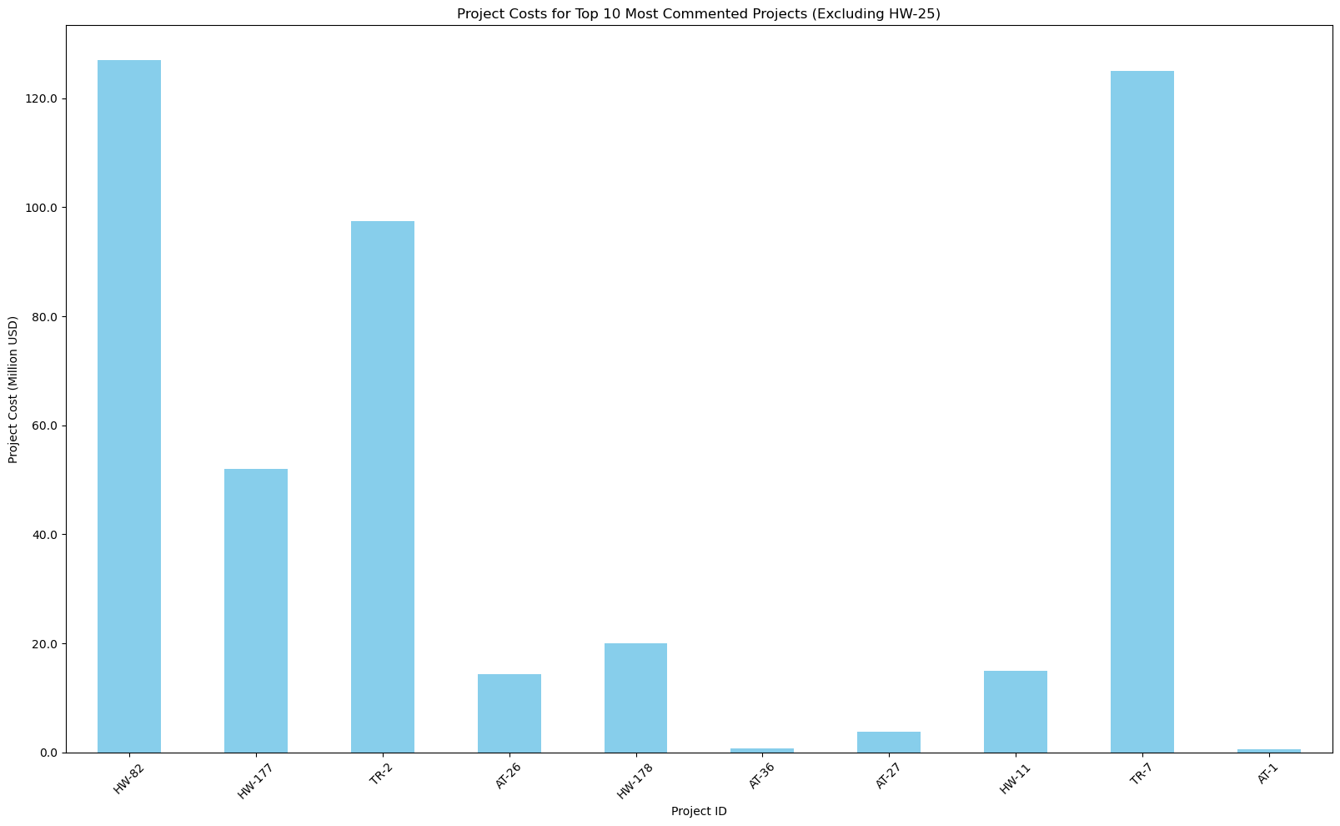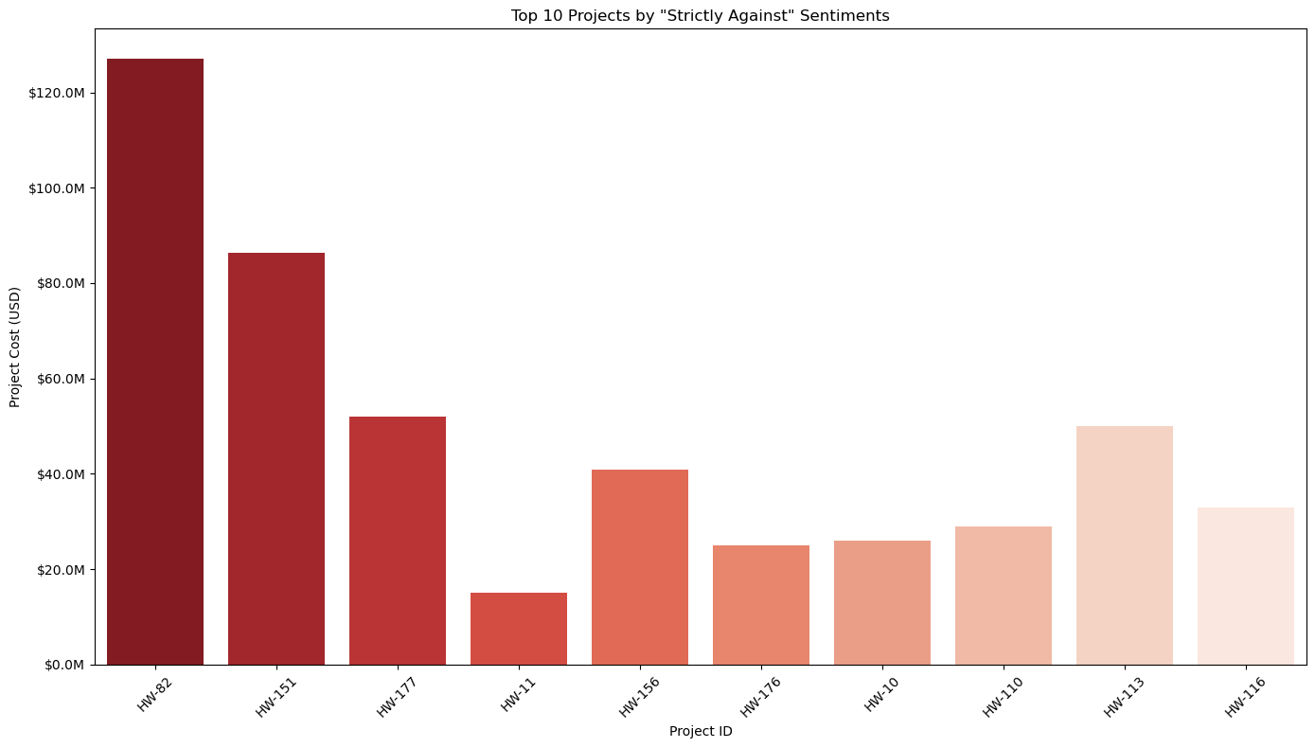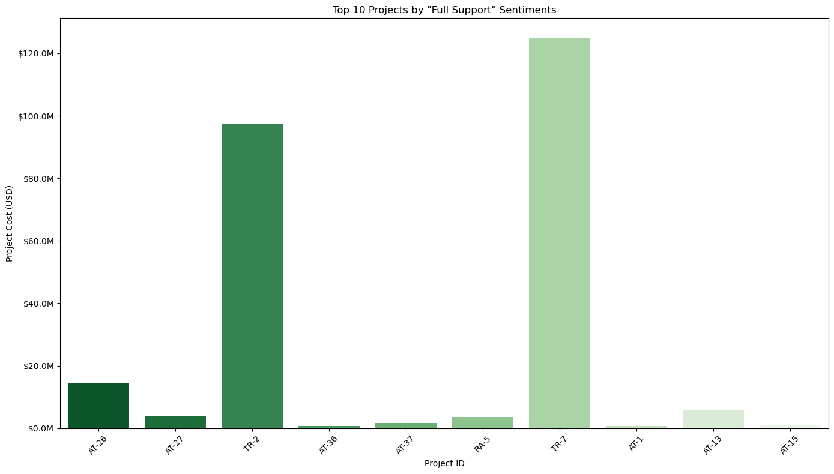

## Creating Sentiment Buttons using Pie Plots -

Example 1 -

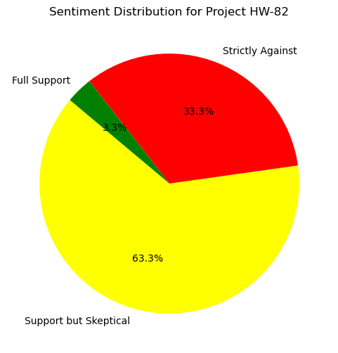

This is out of total comments received for that project ID – “HW-82” in this case.

Example 2 –

* These pie plots were created for all the projects showing a grid as in the image below, looking more like sentiment buttons.
* This was originally one long image but is here chopped up into smaller pieces to fit on individual pages on MS Word.
* Shows overall sentiments by each project ID.
* The distribution is calculated by measuring the Percentage of comments in each sentiment out of total comments received for that project ID.

