Application Note
Table of contents
1 Makefile 5
1.1 Target 7
1.1.1 all 7
1.1.2 gpio 7
1.1.3 hwmon 7
1.1.4 bypass 7
1.1.5 clean 7
1.1.6 release 7
1.1.7 changelog 8
1.2 Debug Flag 8
2 Library 9
2.1 libpch.c 10
int gpio_setup_addr(unsigned long int *gpio_use_sel_addr, \ 10
void gpio_enable(unsigned long int gpio_use_sel_addr, int gpio) 11
unsigned long int gpio_get(unsigned long int gp_lvl_addr, int gpio) 12
void gpio_set(unsigned long int gp_lvl_addr, int gpio, int value) 12
void gpio_dir_in(unsigned long int gp_io_sel_addr, int gpio) 12
void gpio_dir_out(unsigned long int gp_io_sel_addr, \ 13
2.2 libsio.c 13
void sio_enter(char *chip) 13
void sio_exit(void) 14
int sio_read(int reg) 14
void sio_write(int reg, int val) 14
int sio_read_reg(int index, int address) 15
void sio_write_reg(int index, int address) 15
void sio_select(int ldnum) 15
void sio_gpio_enable(int ldnum) 15
void sio_logical_device_enable(int bit) 16
int sio_gpio_get(int gpio) { 16
void sio_gpio_dir_in(int gpio) 17
void sio_gpio_dir_out(int gpio, int value) 17
unsigned int sio_ilpc2ahb_read(int lr, int hr) 17
void sio_ilpc2ahb_write(unsigned char val_w, unsigned int lw, unsigned int hw) 18
void sio_ilpc2ahb_setup(void) 19
3 GPIO loopback test 20
3.1 Introduction 20
3.2 GPIO register 20
3.2.1 PCH 20
3.2.1.1 GPIO_USE_SEL – GPIO Use Select Register 21
3.2.1.2 GP_IO_SEL – GPIO Input/Output Select Register 22
3.2.1.3 GP_LVL – GPIO Level for Input or Output Register 23
3.2.2 Nuvoton SuperIO 23
3.2.2.1 GPIO7 Group 24
3.2.2.2 Active GPIO7 Group 24
3.2.2.3 Setup the direction for GPIO7 Group 25
3.2.2.4 Setup data for GPIO7 Group 25
3.3 Programming 26
static int gpio_set_then_read(int gpio_out, int gpio_in, int value) 27
static int sio_gpio_calculate(int gpio) 28
static int sio_gpio_set_then_read(int gpio_out, int gpio_in, int value) 28
int main(int argc, char *argv[]) 29
4 Hardware Monitor 32
4.1 AST1300 32
4.1.1 Enter and exit SIO 32
4.1.2 Select and enable iLPC2AHB(logic device D) 32
4.1.3 Setup SIO iLPC2AHB length 32
4.1.4 iLPC2AHB address 33
4.1.5 Read/Write trigger of iLPC2AHB 33
4.1.6 Read/Write the data of iLPC2AHB 34
4.1.8 Data Register 34
4.1.9 Read temperature via PECI 35
4.1.10 Read temperature via I2C 36
4.1.10.1 I2C clock 37
4.1.10.2 Channel number and device address 37
4.1.10.3 Enable I2C channel 37
4.1.10.4 Fire to engine and read temperature data 38
4.1.11 Tacho controller 38
4.1.12 ADC controller 39
4.2 Nuvoton 40
4.2.1 Base address of hardware monitor register 40
4.2.2 Bank select 41
4.2.3 Temperature 42
4.2.4 Fan speed 44
4.2.5 Voltage 45
4.3 Fintek 46
4.3.1 Base address of hardware monitor 46
4.3.2 Temperature 47
4.3.3 Fan speed 47
4.3.4 Voltage 48
4.4 Programming 49
int main(int argc, unsigned char *argv[]) 52
void init_peci(void) 59
unsigned int read_hwmon_base_address(void) 60
void bank_select(unsigned int address, unsigned int bank) 61
int type_list(struct sensor *sensors) 61
int ast_type_list(struct sensor *sensors) 62
float read_temperature(unsigned int address, int plus, struct sensor *sensors) 62
float read_fan_speed(unsigned int address, int plus, struct sensor *sensors) 62
float read_voltage1(unsigned int address, int plus, struct sensor *sensors) 63
float read_voltage2(unsigned int address, int plus, struct sensor *sensors) 63
float read_voltage3(unsigned int address, int plus, struct sensor *sensors) 63
float read_ast_temperature_peci(unsigned int index, ...) 63
float read_ast_temperature_i2c(unsigned int index, ...) 64
float read_ast_fan(unsigned int index, ...) 65
float read_ast_voltage(unsigned int index, ...) 66
float read_ast_voltage1(unsigned int index, ...) 67
void pin_list(char *chip_model, struct sensor *sensors) 68
void usage(void) 78
5 Bypass 79
5.1 Select and configure the CPLD 79
5.1.1 Setup the PAIR 79
5.1.2 Setup the CFG 80
5.1.3 Trigger 80
5.2 GPIO 81
5.3 Programming 81
int main(int argc, char *argv[]) 83
int check_arguments(char *argv[], int *pair, int *on, int *off, int *wdt) 86
int read_config(char *filename, struct cpld_cfg *cpld, \ 86
int ast_get_gpio_offset(char *gpio, struct gpio_groups *gg) 89
int ast_gpio_init(struct ast_cpld_cfg *cpld, struct gpio_groups *gg) 89
void ast_pair_setup(int value, unsigned long int data_offset, int offset) 91
void ast_cfg_setup(int value, unsigned long int data_offset, int offset) 92
void ast_cpld_trigger(unsigned long int data_offset, int offset) 92
int ast_bypass_setup(int pair, int cfg, struct ast_cpld_cfg *cpld, \ 93
void set_gpio(int gpio, int value) 95
void pair_setup(int pair, struct cpld_cfg *cpld) 96
void cfg_setup(int pair, int on, int off, int wdt, struct cpld_cfg *cpld) 97
void cpld_trigger(int pair, struct cpld_cfg *cpld) 97
void bypass_setup(int pair, int on, int off, int wdt, struct cpld_cfg *cpld) 98
void sio_pair_setup(int pair, struct cpld_cfg *cpld) 98
void sio_cfg_setup(int pair, int on, int off, int wdt, struct cpld_cfg *cpld) 99
void sio_cpld_trigger(int pair, struct cpld_cfg *cpld) 100
void sio_bypass_setup(int pair, int on, int off, int wdt, struct cpld_cfg *cpld) 100
int f71889ad_get_gpio_dir_index(int gpio) 100
void f71889ad_gpio_dir_out(int gpio, int value) 101
void usage(void) 102

- Makefile

# compiler
CC = gcc

# include directory
INCLUDE = ${PWD}/

# directory
CONFDIR = ${PWD}/conf
SCRIPTDIR = ${PWD}/script
RELEASEDIR = ${PWD}/release
LP_RELEASE_DIR = $(RELEASEDIR)/loopback
BP_RELEASE_DIR = $(RELEASEDIR)/bypass
HWMON_RELEASE_DIR = $(RELEASEDIR)/hwmon

# files
GPIO = gpio-loopback
HWMON = hwmon
BYPASS = bypass
WDT = wdt
LIBPCH = libpch.c
LIBSIO = libsio.c
BIN = $(GPIO) $(HWMON) $(BYPASS) $(WDT)
CHANGELOG = Changelog

# objects
GPIO_OBJS = libpch.o libsio.o
HWMON_OBJS = libsio.o
BP_OBJS = libpch.o libsio.o
WDT_OBJS = libsio.o

GIT = $(shell which git > /dev/null 2>&1; echo $$?)

# CFLAGS
DEBUG ?= 0
ifeq ($(DEBUG), 1)
CFLAGS += -DDEBUG
else
CFLAGS += -DNDEBUG
endif

CFLAGS += -I$(INCLUDE)

# targets
all: gpio hwmon bypass changelog release

gpio: $(GPIO_OBJS) $(GPIO).c
$(CC) $(CFLAGS) $(GPIO_OBJS) $(GPIO).c -o $(GPIO)

hwmon: $(HWMON_OBJS) $(HWMON).c
$(CC) $(CFLAGS) $(HWMON_OBJS) $(HWMON).c -o $(HWMON)

bypass: $(BP_OBJS) $(BYPASS).c
$(CC) $(CFLAGS) $(BP_OBJS) $(BYPASS).c -o $(BYPASS)

wdt: $(WDT_OBJS) $(WDT).c
$(CC) $(CFLAGS) $(WDT_OBJS) $(WDT).c -o $(WDT)

libpch.o: $(LIBPCH)
$(CC) $(CFLAGS) -c $(LIBPCH)

libsio.o: $(LIBSIO)
$(CC) $(CFLAGS) -c $(LIBSIO)

.PHONY: changelog
changelog:
ifeq ($(GIT), 1)
@echo "git not found, please install git first."
else
git log > $(CHANGELOG)
endif

.PHONY: release
release:
mkdir -p $(RELEASEDIR)
cp -rf $(CONFDIR)/* $(RELEASEDIR)
cp -rf $(SCRIPTDIR)/* $(RELEASEDIR)
if [ -f $(GPIO) ]; then cp -rf $(GPIO) $(LP_RELEASE_DIR); fi
if [ -f $(BYPASS) ]; then cp -rf $(BYPASS) $(BP_RELEASE_DIR); fi
if [ -f $(HWMON) ]; then cp -rf $(HWMON) $(HWMON_RELEASE_DIR); fi
if [ -f $(WDT) ]; then cp -rf $(WDT) $(BP_RELEASE_DIR); fi

.PHONY: clean
clean:
rm -rf *.o $(BIN) $(RELEASEDIR)/* $(CHANGELOG)

  - Target
So far, this makefile support three test programs, gpio loopback, hardware monitor and bypass, execute “make TARGET_NAME”, then it will build the corresponding target. The following sector shows what will be done for each target.

    - all
Just execute “make”, and it will build all targets.
$ make

    - gpio
Build GPIO loopback test program.
$ make gpio

    - hwmon
Build hardware monitor test program.
$ make hwmon

    - bypass
Build bypass test program.
$ make bypass

    - clean
Remove all file that create by make.
$ make clean

    - release
Copy test program, configuration files and script to release directory.
$ make release

    - changelog
Create changelog.
$ make changelog

  - Debug Flag
Add “DEBUG=1” when building, and then DBG() function will print the messages. The default value for DEBUG flags is 0.

$ make gpio DEBUG=1

- Library

There are too many duplicate code in original test programs, and we use low-level port I/O functions(inb, outb... etc) to control the hardware, so it’s not easy to read and to understand what the codes do.

For example, it’s not easy to understand what the following codes do without any comment:

b = inb_p(GPIO_BASE_ADDR + GPIO_USE_SEL1 + offset);
b |= (0x1 << bit);
outb_p(b, GPIO_BASE_ADDR + GPIO_USE_SEL1 + offset);

b = inb_p(GPIO_BASE_ADDR + GP_IO_SEL1 + offset);
b &= ~(0x1 << bit);
outb_p(b, GPIO_BASE_ADDR + GP_IO_SEL1 + offset);

b = inb_p(GPIO_BASE_ADDR + GP_LVL1 + offset);
b &= ~(0x1 << bit);
b |= (0x1 << bit);
outb_p(b, GPIO_BASE_ADDR+GP_LVL1 + offset);

In order to improve the readability of the codes, we can wrap above codes into two functions:

void gpio_enable(unsigned long int gpio_ use_sel_addr, int gpio)
{
unsigned long int buf;

buf = inl_p(gpio_use_sel_addr);\
buf |= (0x1 << gpio);
outl_p(buf, gpio_use_sel_addr);
}

void gpio_dir_out(unsigned long int gp_io_sel_addr, int gpio, \
int value)
{
unsigned long int buf;

buf = inl_p(gp_io_sel_addr);
buf &= ~(0x1 << gpio);
outl_p(buf, gp_io_sel_addr);

buf = inl_p(gp_lvl_addr);
buf &= ~(0x1 << gpio);
buf |= (value << gpio);
outl_p(buf, gp_lvl_addr);
}

Now, it’s easier to understand what the codes do from the name of the function, i.e, when gpio_dir_out has been called, it will setup the direction to out and pull signal to the input value.

After wrapping, we move these functions into another file, and compile it as a library(libXYZ.o). So, if any other program needs to enable gpio or setup the gpio, it can call these functions directly without rewrite the code again.

  - libpch.c
The functions in this file are use to control PCH. In most cases, you can understand what the function does from its name, please read the comment(blue color) for detail.

#include <stdio.h>
#include <stdlib.h>
#include <sys/io.h>
#include <libpch.h>
#include <sitest.h>

/* re-assign the gpio number */

int gpio_setup_addr(unsigned long int *gpio_use_sel_addr, \
unsigned long int *gp_io_sel_addr, \
unsigned long int *gp_lvl_addr, \
int gpio, unsigned long int base_addr)
{
int new_gpio;

if (gpio >= 0 && gpio <= 31) {
*gpio_use_sel_addr = GPIO_USE_SEL1_ADDR(base_addr);
*gp_io_sel_addr = GP_IO_SEL1_ADDR(base_addr);
*gp_lvl_addr = GP_LVL1_ADDR(base_addr);
new_gpio = gpio;
} else if (gpio >= 32 && gpio <= 63) {
*gpio_use_sel_addr = GPIO_USE_SEL2_ADDR(base_addr);
*gp_io_sel_addr = GP_IO_SEL2_ADDR(base_addr);
*gp_lvl_addr = GP_LVL2_ADDR(base_addr);
new_gpio = gpio - 32;
} else {
*gpio_use_sel_addr = GPIO_USE_SEL3_ADDR(base_addr);
*gp_io_sel_addr = GP_IO_SEL3_ADDR(base_addr);
*gp_lvl_addr = GP_LVL3_ADDR(base_addr);
new_gpio = gpio - 64;
}

return new_gpio;
}

/* Set GPIO to use as a GPIO, no native function */

void gpio_enable(unsigned long int gpio_use_sel_addr, int gpio)
{
unsigned long int buf;

buf = inl_p(gpio_use_sel_addr); /* Read the original value */
buf |= (0x1 << gpio); /* Set the bit to 1 for GPIO mode */
outl_p(buf, gpio_use_sel_addr); /* Output the value */
}

unsigned long int gpio_get(unsigned long int gp_lvl_addr, int gpio)
{
unsigned long int buf;

buf = inl_p(gp_lvl_addr);
buf = (buf >> gpio);
buf &= 0x1;

return buf;
}

void gpio_set(unsigned long int gp_lvl_addr, int gpio, int value)
{
unsigned long int buf;

buf = inl_p(gp_lvl_addr); /* Read the original value */
buf &= ~(0x1 << gpio); /* Set the bit to 0 for low level */
buf |= (value << gpio); /* Set the bit to 1 for high level */
outl_p(buf, gp_lvl_addr); /* Output the value */
DBG("Set GPIO Level to %d\n", value);
}

void gpio_dir_in(unsigned long int gp_io_sel_addr, int gpio)
{
unsigned long int buf;

buf = inl_p(gp_io_sel_addr); /* Read the original value */
DBG("buf = %x, gpio = %d\n", buf, gpio);
buf |= (0x1 << gpio); /* Set the bit to 1 for input */
DBG("buf = %x, gpio = %d\n", buf, gpio);
outl_p(buf, gp_io_sel_addr); /* Output the value */
}

void gpio_dir_out(unsigned long int gp_io_sel_addr, \
unsigned long int gp_lvl_addr, int gpio, int value)
{
unsigned long int buf;

buf = inl_p(gp_io_sel_addr); /* Read the original value */
DBG("buf = %x, gpio = %d\n", buf, gpio);
buf &= ~(0x1 << gpio); /* Set the bit to 0 for output */
DBG("buf = %x, gpio = %d\n", buf, gpio);
outl_p(buf, gp_io_sel_addr); /* Output the value */

buf = inl_p(gp_lvl_addr); /* Read the original value */
buf &= ~(0x1 << gpio); /* Set the bit to 0 for low level */
buf |= (value << gpio); /* Set the bit to 1 for high level */
outl_p(buf, gp_lvl_addr); /* Output the value */
DBG("Set GPIO[%d] Level to %s\n", gpio, value ? "HIGH" : "LOW");
}

  - libsio.c
The functions in this file are use to control SuperIO. Please read the comment(blue color) for detail.
#include <stdio.h>
#include <stdlib.h>
#include <string.h>
#include <sys/io.h>
#include <libsio.h>
#include <sitest.h>

/* Enter the Extended Function Mode */

void sio_enter(char *chip)
{
if (strncmp("AST1300", chip, 7) == 0) {
outb_p(0xA5, EFER);
outb_p(0xA5, EFER);
DBG("chip = %s, EFER = %x, EFDR = %x\n", chip, EFER, EFDR);
} else {
outb_p(0x87, EFER);
outb_p(0x87, EFER);
DBG("chip = %s, EFER = %x, EFDR = %x\n", chip, EFER, EFDR);
}
}

/* Exit the Extended Function Mode */

void sio_exit(void)
{
outb_p(0xAA, EFER);
}

int sio_read(int reg)
{
int b;

outb_p(reg, EFER); /* Sent index to EFER */
b = inb_p(EFDR); /* Get the value from EFDR */
return b; /* Return the value */
}

void sio_write(int reg, int val)
{
outb_p(reg, EFER); /* Sent index at EFER */
outb_p(val, EFDR); /* Send val_w at FEDR */
}

/* Read value from register of SuperIO */

int sio_read_reg(int index, int address)
{
outb_p(index, address);
return inb_p(address + 1);
}

/* Write value to register of SuperIO */

void sio_write_reg(int index, int address)
{
outb_p(index, address);
}

/* ldsel_reg: Logical Device Select
* ldnum: Logical Device Number */

void sio_select(int ldnum)
{
DBG("SIO_LDSEL_REG = %x, ldnum = %x\n", SIO_LDSEL_REG, ldnum);
outb_p(SIO_LDSEL_REG, EFER);
outb_p(ldnum, EFDR);
}

void sio_gpio_enable(int ldnum)
{
int b;

/* CR 30h of Logical Device Number 9 is enable register for GPIO1~7 */
sio_select(ldnum);

/* Active GPIO7 Group */
/* Read the value of CR 30h of Logical device 9 */
b = sio_read(SIO_ENABLE_REG);
DBG("b = %x\n", b);
b |= SIO_GPIO7_ENABLE; /* Set bit7 to 1 to enable GPIO7 Group */
/* Write the value at CR 30h of Logical device 9 */
sio_write(SIO_ENABLE_REG, b);
}

void sio_logical_device_enable(int bit)
{
int b;

/* Read the value from CR 30h of Logical Device register */
b = sio_read(SIO_ENABLE_REG);
DBG("read from CR30h = %x\n", b);
b |= (0x1 << bit); /* Set bitN to 1 to enable Logical Device */
DBG("write %x to CR30h\n", b);
/* Write the value to CR 30h of Logical device */
sio_write(SIO_ENABLE_REG, b);
}

int sio_gpio_get(int gpio) {
return ((sio_read(SIO_GPIO7_DATA_REG) >> gpio) & 0x1);
}

void sio_gpio_set(int gpio, int value)
{
int b;

b = sio_read(SIO_GPIO7_DATA_REG);
b &= ~(0x1 << gpio); /* clear */
b |= (value << gpio);
sio_write(SIO_GPIO7_DATA_REG, b);
}

void sio_gpio_dir_in(int gpio)
{
int b;

b = sio_read(SIO_GPIO7_DIR_REG);
b |= (0x1 << gpio); /* set 1 for input */
sio_write(SIO_GPIO7_DIR_REG, b);
}

void sio_gpio_dir_out(int gpio, int value)
{
int b;

/* direction */
b = sio_read(SIO_GPIO7_DIR_REG);
b &= ~(0x1 << gpio); /* clear to 0 for output */
sio_write(SIO_GPIO7_DIR_REG, b);

/* data */
sio_gpio_set(gpio, value);
}

/*
* For AST1300
*/

unsigned int sio_ilpc2ahb_read(int lr, int hr)
{
unsigned int b;
unsigned int mod;

mod = lr % 4; /* Address must be multiple of 4 */
lr = lr - mod;

/*
* Setup address
* 0xF0: SIO iLPC2AHB address bit[31:24]
* 0xF1: SIO iLPC2AHB address bit[23:16]
* 0xF2: SIO iLPC2AHB address bit[15:8]
* 0xF3: SIO iLPC2AHB address bit[7:0]
*/
sio_write(0xF0, hr >> 8);
sio_write(0xF1, hr & 0xFF);
sio_write(0xF2, lr >> 8);
sio_write(0xF3, lr & 0xFF);

/* Read to trigger SIO iLPC2AHB write command */
sio_read(0xFE);

/*
* Read data
* 0xF4: SIO iLPC2AHB data bit[31:24]
* 0xF5: SIO iLPC2AHB data bit[23:16]
* 0xF6: SIO iLPC2AHB data bit[15:8]
* 0xF7: SIO iLPC2AHB data bit[7:0]
*/
b = sio_read(0xF7 - mod); /* Get the value */

DBG("b = %x\n", b);
return b;
}

void sio_ilpc2ahb_write(unsigned char val_w, unsigned int lw, unsigned int hw)
{
/*
* Setup address
* 0xF0: SIO iLPC2AHB address bit[31:24]
* 0xF1: SIO iLPC2AHB address bit[23:16]
* 0xF2: SIO iLPC2AHB address bit[15:8]
* 0xF3: SIO iLPC2AHB address bit[7:0]
*/
sio_write(0xF0, hw >> 8);
sio_write(0xF1, hw & 0xFF);
sio_write(0xF2, lw >> 8);
sio_write(0xF3, lw & 0xFF);

/*
* Write data
* 0xF4: SIO iLPC2AHB data bit[31:24]
* 0xF5: SIO iLPC2AHB data bit[23:16]
* 0xF6: SIO iLPC2AHB data bit[15:8]
* 0xF7: SIO iLPC2AHB data bit[7:0]
*/
sio_write(0xF7, val_w);

/* Write 0xCF to trigger SIO iLPC2AHB write command */
sio_write(0xFE, 0xCF);
}

void sio_ilpc2ahb_setup(void)
{
unsigned int b;

/* select logical device iLPC2AHB */
sio_select(SIO_LPC2AHB_LDN);
/* enable iLPC2AHB */
sio_logical_device_enable(SIO_LPC2AHB_EN);
/* Set Length to 1 Byte */
b = sio_read(0xF8);
b &= ~(0x03);
sio_write(0xF8, b);
}
/* For AST1300 end */

- GPIO loopback test

  - Introduction
GPIOs from Intel PCH:
S0101 has a JGPIO header(it can be find in Engineer SPEC), and its GPIO signals are from PCH.
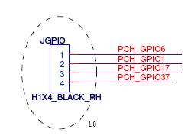

GPIOs from Nuvoton SuperIO:
S0361 has a JP2 header(it can be find in Engineer SPEC and schematic diagram), and its GPIO signals are from NCT6776F.

  - GPIO register
    - PCH
Refer to Cougar Point datasheet, the following table shows the GPIO registers. GPIO register can be access via GPIOBASE + Offset, where GPIOBASE is 0x500 or 0x1C00 for Sandy/Ivy Bridge or Haswell(it can be get from BIOS engineer). Note, Cougar Point has 3 parts (Select 1, 2 and 3) for GPIO registers. The maximum number of GPIO signal for each part is 32.
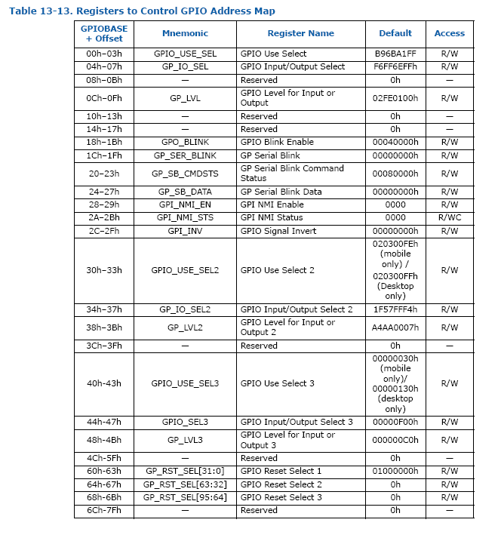
      - GPIO_USE_SEL – GPIO Use Select Register
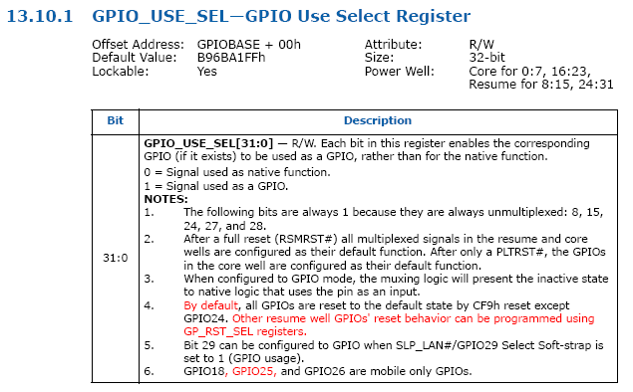
Each bit in this register enables corresponding GPIO(if exists) to be used as a GPIO, rather than for native function.
0: native function
1: GPIO

gpio_enable function in libpch.c to set GPIO_USE_SEL[n] to 1, please refer to sector 3.3 Programming in this chapter for more detail.

void gpio_enable(unsigned long int gpio_use_sel_addr, int gpio)

      - GP_IO_SEL – GPIO Input/Output Select Register
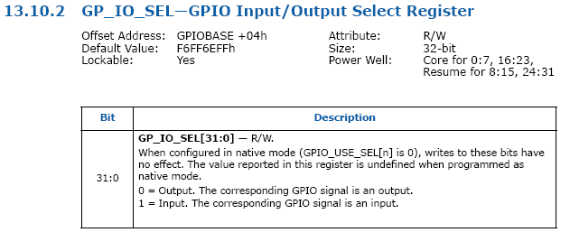
When configured in native mode(GPIO_USE_SEL[n] is 0), writes to these bits have no effect. The value reported in this register is undefined when programmed as native mode.
0: Output
1: Input

      - GP_LVL – GPIO Level for Input or Output Register
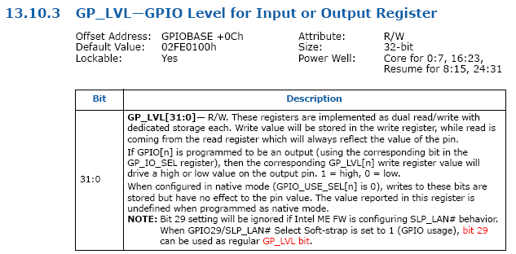
If GPIO[n] is programmed to be an output(using the corresponding bit in the GP_IO_SEL register), then corresponding GP_LVL[n] write register value will drive a high or low value on the output pin.
1: high
0: low

Function void gpio_dir_out(unsigned long int gp_io_sel_addr, unsigned long int gp_lvl_addr, int gpio, int value) or void gpio_dir_in(unsigned long int gp_io_sel_addr, int gpio) in libpch.c can set the gpio to output and drive a high or low value, please refer to sector 3.3 Programming in this chapter for more detail.

    - Nuvoton SuperIO
To program the NCT6776F / NCT6776D configuration registers, the following configuration procedures must be followed in sequence:
(1). Enter the Extended Function Mode.
Please refer to void sio_enter(char *chip).

(2). Configure the configuration registers.
Please refer to int sio_read(int reg) and void sio_write(int reg, int val).

(3). Exit the Extended Function Mode.
Please refer to void sio_exit(void ).

      - GPIO7 Group
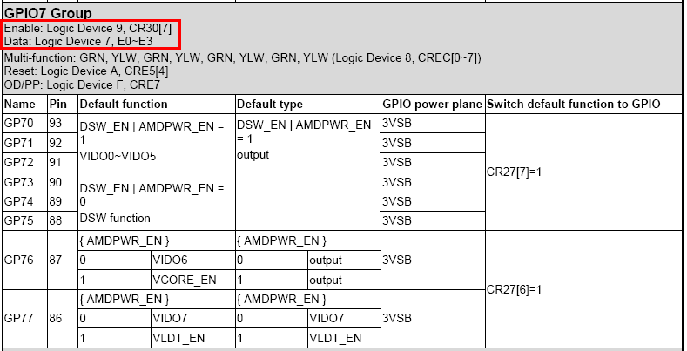

S0361 use GPIO7 from NCT6776F, refer to the NCT6776F datasheet(above table), GPIO7 can be enable on Logic Device 9, CR30[7], and access its data on Logic Device 7, E0~E3.

      - Active GPIO7 Group
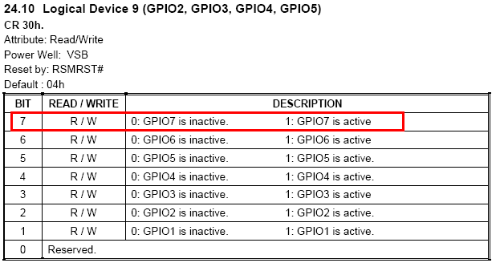

Set bit 7 to 1 to active GPIO7.

sio_gpio_enable can set bit 7 to 1 to enable GPIO7, please refer to void sio_gpio_enable(int ldnum) and sector 3.3 Programming in this chapter for more detail.

      - Setup the direction for GPIO7 Group
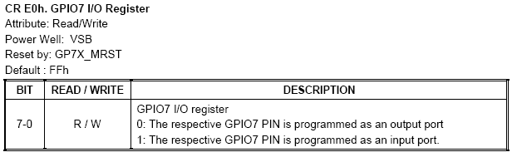

There are 8 bits in this register, bit 0 for GPIO70, and bit 6 for GPIO76.

      - Setup data for GPIO7 Group
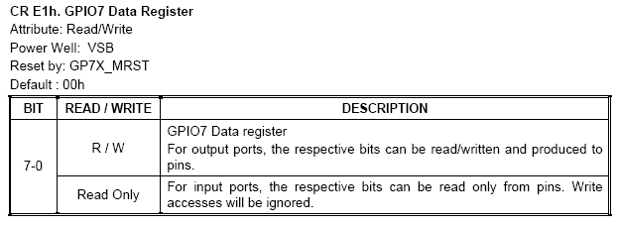

If GPIO7[n] is programmed to be an output(using the corresponding bit in the GPIO7 I/O register), then write value to corresponding GPIO Data register will drive a high or low value on the output pin.

For more detail, please refer to void sio_gpio_dir_in(int gpio), void sio_gpio_dir_out(int gpio, int value) and sector 3.3 Programming in this chapter.

  - Programming
gpio-loopback.c, source code for gpio loopback. Please read the comment (blue color) for detail.

#include <sys/types.h>
#include <sys/stat.h>
#include <fcntl.h>
#include <stdio.h>
#include <stdlib.h>
#include <string.h>
#include <unistd.h>
#include <sys/io.h>
#include <errno.h>
#include <sitest.h>
#include <libpch.h>
#include <libsio.h>

static int gpio_set_then_read(int gpio_out, int gpio_in, int value);
static int sio_gpio_set_then_read(int gpio_out, int gpio_in, int value);
static int sio_gpio_calculate(int gpio);

unsigned long int base_addr;

/* Set gpio_out direction to output and read from gpio_in */

static int gpio_set_then_read(int gpio_out, int gpio_in, int value)
{
unsigned long int gpio_use_sel_addr, gp_io_sel_addr, gp_lvl_addr;
int new_gpio;

/* Set gpio_out direction to output and pull low or high. */
new_gpio = gpio_setup_addr(&gpio_use_sel_addr, &gp_io_sel_addr, \
&gp_lvl_addr, gpio_out, base_addr);
gpio_enable(gpio_use_sel_addr, new_gpio);
gpio_dir_out(gp_io_sel_addr, gp_lvl_addr, new_gpio, value);

DBG("gpio_sel_addr = %x, gp_lvl_addr =%x\n", gp_io_sel_addr, gp_lvl_addr);
/* Set gpio_in direction to input and read data. */
new_gpio = gpio_setup_addr(&gpio_use_sel_addr, &gp_io_sel_addr, \
&gp_lvl_addr, gpio_in, base_addr);
gpio_enable(gpio_use_sel_addr, new_gpio);
gpio_dir_in(gp_io_sel_addr, new_gpio);
DBG("gpio_sel_addr = %x, gp_lvl_addr =%x\n", gp_io_sel_addr, gp_lvl_addr);

printf("GPIO[%d] output %d to GPIO[%d] test ", gpio_out, value, gpio_in);
if (gpio_get(gp_lvl_addr, new_gpio) == value) {
printf("PASS!\n");
return 0;
} else {
printf("FAIL!\n");
return -1;
}
}

static int sio_gpio_calculate(int gpio)
{
if (gpio >= 70 && gpio <= 77)
return (gpio - 70);
else {
ERR("GPIO number incorrect.\n");
exit(-1);
}
}

static int sio_gpio_set_then_read(int gpio_out, int gpio_in, int value)
{
int new_gpio;

/* Enable GPIO7 group */
sio_gpio_enable(SIO_GPIO_EN_REG);
/* Select GPIO7 */
sio_select(SIO_GPIO7_LDN);

new_gpio = sio_gpio_calculate(gpio_out);
sio_gpio_dir_out(new_gpio, value);

new_gpio = sio_gpio_calculate(gpio_in);
sio_gpio_dir_in(new_gpio);

printf("GPIO[%d] output %d to GPIO[%d] test ", gpio_out, value, gpio_in);
if (sio_gpio_get(new_gpio) == value) {
printf("PASS!\n");
return 0;
} else {
printf("FAIL\n");
return -1;
}
}

int main(int argc, char *argv[])
{
int i, total, pin1, pin2;
FILE *fp;
char str[10];

/*
* Change I/O privilege level to all access. For Linux only.
* If has error, show error message.
*/
if (iopl(3)) {
perror(NULL);
exit(1);
}

if (argc != 2) {
printf("Usage: COMMAND FILE_NAME\n");
exit(-1);
}

if ((fp = fopen(argv[1], "r")) == NULL) {
ERR("Fail to open <%s>, please enter the correct file name.\n", argv[1]);
printf("Usage: COMMAND FILE_NAME\n");
exit(-1);
}

/* Skip the header */
fscanf(fp, "%*[^\n]\n", NULL);
fscanf(fp, "%*[^\n]\n", NULL);
fscanf(fp, "%*[^\n]\n", NULL);
fscanf(fp, "%*[^\n]\n", NULL);

/* Read chip set and gpio base addr */
fscanf(fp, "%s %x", str, &base_addr);

if (strcmp("SIO", str) == 0) {
EFER = base_addr;
EFDR = base_addr + 1;
}

DBG("str = %s, base_addr = %x, EFER = %x, EFDR = %x\n", \
str, base_addr, EFER, EFDR);

fscanf(fp, "%d\n", &total);

DBG("total = %d\n", total);

for (i = 0; i < total; i += 2) {
fscanf(fp, "%d %d", &pin1, &pin2);
printf("Testing GPIO[%d] and GPIO[%d]...\n", pin1, pin2);

if (strcmp("PCH", str) == 0) { /* test gpio via PCH */
if (gpio_set_then_read(pin1, pin2, GPIO_LOW) == -1)
exit(1);
if (gpio_set_then_read(pin1, pin2, GPIO_HIGH) == -1)
exit(1);
if (gpio_set_then_read(pin2, pin1, GPIO_LOW) == -1)
exit(1);
if (gpio_set_then_read(pin2, pin1, GPIO_HIGH) == -1)
exit(1);
} else { /* test gpio via SIO */
sio_enter(argv[1]);
if (sio_gpio_set_then_read(pin1, pin2, GPIO_LOW) == -1)
exit(1);
if (sio_gpio_set_then_read(pin1, pin2, GPIO_HIGH) == -1)
exit(1);
if (sio_gpio_set_then_read(pin2, pin1, GPIO_LOW) == -1)
exit(1);
if (sio_gpio_set_then_read(pin2, pin1, GPIO_HIGH) == -1)
exit(1);
sio_exit();
}
}

fclose(fp);

return 0;
}

- Hardware Monitor

  - AST1300
AST1300 has its own firmware, the test program only read hardware monitor data via iLPC2AHB from its SRAM.

    - Enter and exit SIO

Write 0xA5 to 0x2E twice to enter SIO and write 0xAA to exit SIO. Please refer to void sio_enter(char *chip) and void sio_exit(void ).

    - Select and enable iLPC2AHB(logic device D)

There are 5 logical device corresponding to 5 individual functinos: SUART1 (logical device 2), SUART2 (logical device 3), Keyboard Controller (logical device 5), GPIO (logical device 7), and iLPC2AHB (logical device D). Each logical device has its own configuration register above index 0x30. Write logic device number(0x0D, iLPC2AHB) to offset 0x07, and then set bit0 to 1 on offset 0x30. Please refer to void sio_ilpc2ahb_setup(void), void sio_logical_device_enable(int bit) and void sio_select(int ldnum).

    - Setup SIO iLPC2AHB length

Setup SIO iLPC2AHB length at offset 0xF8 of logic device D. Please refer to void sio_ilpc2ahb_setup(void).

    - iLPC2AHB address
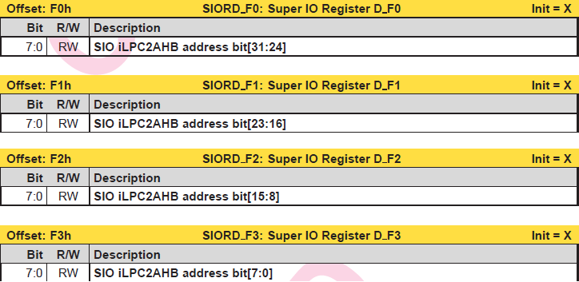
Setup the iLPC2AHB address at offset 0xF0, 0xF1, 0xF2 and 0xF3. If you want to read fan speed, the base address for tachometer’s data is 0x1E721500, so write 0x00 to 0xF3, 0x15 to 0xF2, 0x72 to 0xF1 and 0x1E to 0xF0. Please refer to unsigned int sio_ilpc2ahb_read(int lr, int hr). And for more detail about the base address of hardware monitor data, please refer to AST1300 firmware SEPC.

    - Read/Write trigger of iLPC2AHB

Read offset 0xFE to trigger read command and write 0xCF at 0xFE to trigger write command. Please refer to unsigned int sio_ilpc2ahb_read(int lr, int hr).

    - Read/Write the data of iLPC2AHB

Read/Write the data at offset 0xF4, 0xF5, 0xF6 and 0xF7 of iLPC2AHB. If the data is 0x12345678, write 0x78 to 0xF7, 0x56 to 0xF6, 0x34 to 0xF5 and 0x12 to 0xF4.

    - Read/Write iLPC2AHB with 1byte length
When read 1byte length from iLPC2AHB. The address of iLPC2AHB must be multiple of 4.

For example, when read the data from 0x1E760001. Must write 0x1E760000 at iLPC2AHB address, then read the data of 0x1E760003 from index 0xf6 of Logic Device D.

It does not have this limitation when write the data with 1byte length.

    - Data Register

AST1300 use PECI and I2C to read temperature, but PECI and I2C controller register doesn’t has data register to store data. After setting up the PECI and I2C controller, we have to read the data from Data Register(0x1E722000).

Read 4.1.9 and 4.1.10 for more detail about how to read temperature via PECI and I2C.

    - Read temperature via PECI

The base address of PECI is 0x1E721C00, refer to AST1300 firmware SPEC for more detail.

First, initial and setup the PECI(see function void init_peci(void)), then read terperature data at offset 0x00 of 0x1E722000(Data Register), see function float read_ast_temperature_peci(unsigned int index, ...) for more detail.

    - Read temperature via I2C

AST1300 has 9 I2C channels, and the termperature sensor could be connet to any channel, it depends on hardware design, please ask hardware or BIOS engineer for channel number and device address. On S0381, there are 2 temperature sensors connected to I2C channel 7 and device address is 0x90 and 0x98.

Before reading temperature, we have to initial the I2C controller.

      - I2C clock
Set the I2C clock to 100Hz.

      - Channel number and device address
Set channel number to 7 and device address to 0x90 or 0x98.

      - Enable I2C channel

      - Fire to engine and read temperature data
Set bit0 to 1 to fire the I2C engine.
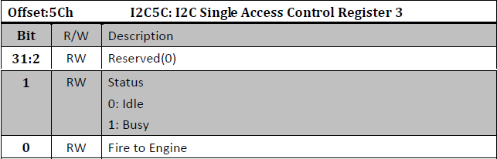

Read the temperature data from Data Register.

Please refer to float read_ast_temperature_i2c(unsigned int index, ...) for more detail.

    - Tacho controller
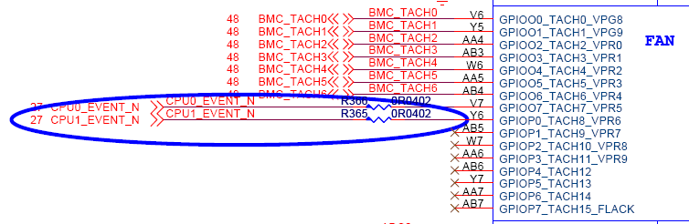

AST1300 firmware provide a simple way to read fan speed, just read data from offset 0x08 to 0x44 of TACHO controller(0x1E721500). See float read_ast_fan(unsigned int index, ...) for more detail.

    - ADC controller
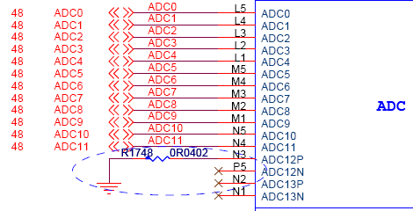
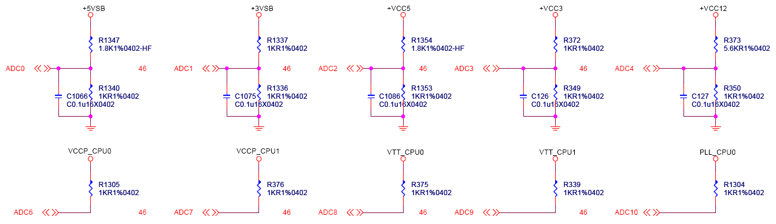
According to AST1300 firmware SPEC, the voltage could be read from ADC Controller(0x1E721600).
Voltage = (Channel Raw Data / 2048) * Ratio

The Ratio is depends on circuit design, different project has different Ratio, sometimes it different between channel and channel, ask BIOS to get the correct Ratio.

See float read_ast_voltage(unsigned int index, ...) and float read_ast_voltage1(unsigned int index, ...) for more detail.

  - Nuvoton
    - Base address of hardware monitor register

The base address of the Address Port and Data Port is specified in registers CR[60h] and CR[61h] of Logical Device B, the hardware monitor device. CR[60h] is the high byte, and CR[61h] is the low byte. The Address Port and Data Port are located at the base address, plus 5h and 6h, respectively. For example, if CR[60h] is 02h and CR[61h] is 90h, the Address Port is at 0x295h, and the Data Port is at 0x296h.

See unsigned int read_hwmon_base_address(void) for more detail.

    - Bank select
Due to the number of internal register, it is necessary to separate the register sets into “banks” specified by register 4Eh. The structure of the internal registers is shown in the following figure.

See void bank_select(unsigned int address, unsigned int bank) for more detail.

    - Temperature
Check the schematic to get what temperature sensor does the mother board used.

S0361(with NCT6776F) use CPUTIN(Temperature Sensor 2) and SYSTIN(Temperature Sensor 4).

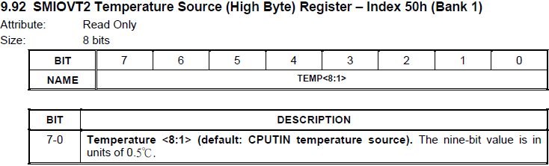

S0981(with NCT6779D) also use CPUTIN and SYSTEN.
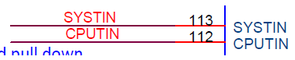

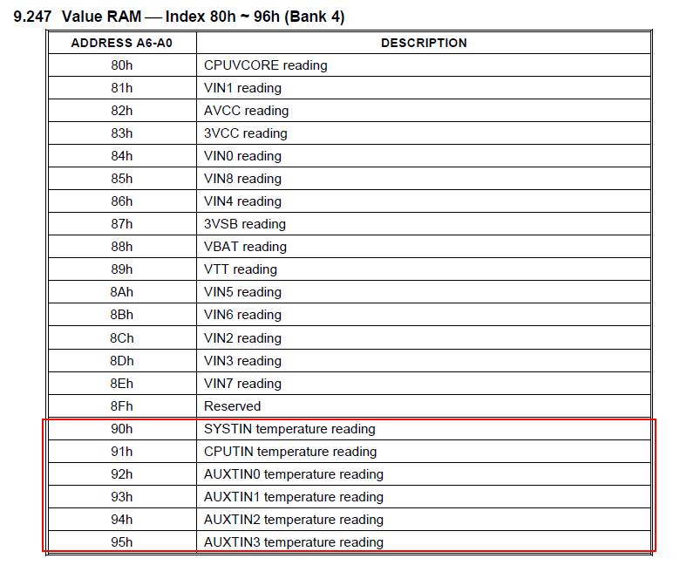
See float read_temperature(unsigned int address, int plus, struct sensor *sensors) for more detail.

    - Fan speed
Check the schematic and find how many tachometer does the mother board used.

S0361(with NCT6776F) has 2 fan and it use CPUFANIN and SYSFANIN.

Read the data from index 0x56 and 0x57, and the system fan speed is ((HIGH-BYTE << 8) | LOW-BYTE). See float read_fan_speed(unsigned int address, int plus, struct sensor *sensors) for more detail.
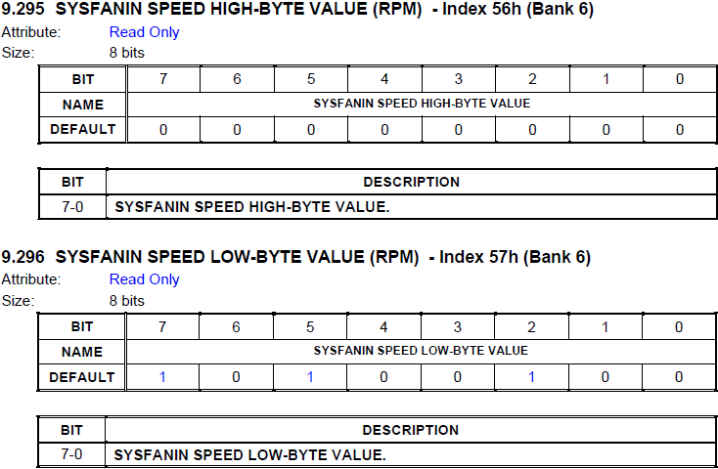

See float read_fan_speed(unsigned int address, int plus, struct sensor *sensors) for more detail.

    - Voltage
NCT6776F / NCT6776D has 9 voltage reading:

NCT6779D has 15 voltage reading:

The data format for voltage detection is an eight-bit value, and each unit represents an interval of 8 mV.
Detected Voltage = Reading * 0.008 V

Input voltages greater than 2.048 V should be reduced by an external resistor divider to keep the input voltages in the proper range. For example, input voltage V0 (+12 V) should be reduced before it is connected to VIN0 according to the following equation:
$$V_{0}≤2.048, VIN0=V_{0}×\frac{R2}{R1+R2}×0.008$$
$$V_{0}>2.048, VIN0=V_{0}×0.008$$

Sometimes, the circuit design will make the voltage can’t be calculated by above 2 formulas, please ask BIOS engineer for how to calculate the voltage.

See float read_voltage1(unsigned int address, int plus, struct sensor *sensors), float read_voltage2(unsigned int address, int plus, struct sensor *sensors) and float read_voltage3(unsigned int address, int plus, struct sensor *sensors) for more detail.

  - Fintek
    - Base address of hardware monitor
The base address of the Address Port and Data Port is specified in registers CR[60h] and CR[61h] of Logical Device 4, the hardware monitor device. CR[60h] is the high byte, and CR[61h] is the low byte. The Address Port and Data Port are located at the base address, plus 5h and 6h, respectively. For example, if CR[60h] is 02h and CR[61h] is 90h, the Address Port is at 0x295h, and the Data Port is at 0x296h. For F71889 series SuperIO, the base address is Address Port, base address + 1 is Data Port.

See unsigned int read_hwmon_base_address(void) for more detail.

    - Temperature
The Fintek SuperIO has a PECI and 3 temperature sensors to detect temperature. Please check the schematic of mother board to get what temperature sensors are connected.
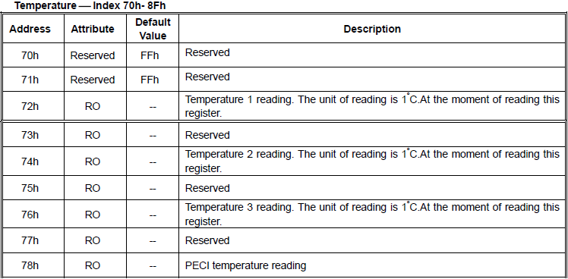

See float read_temperature(unsigned int address, int plus, struct sensor *sensors) for more detail.

    - Fan speed
Inputs are provided by the signals from fans equipped with tachometer outputs. The level of these signals should be set to TTL level, and maximum input voltage cannot be over 5V. If the input signals from the tachometer outputs are over the 5V, the external trimming circuit should be added to reduce the voltage to obtain the input specification. The normal circuit and trimming circuits are shown as follows:

Determine the fan counter according to:
$$Count=\frac{1.5×{10}^{6}}{RPM}$$

In other words, the fan speed counter (12 bit resolution) has been read from register, the fan speed can be evaluated by the following equation.
$$RPM=\frac{1.5×{10}^{6}}{Count}$$

As for fan, it would be best to use 2 pulses (4 phases fan) tachometer output per round. So the parameter “Count” under 5 bit filter is 4096~64 and RPM is 366~23438 based on above equation. If using 8 phases fan, RPM would be from 183~11719.

Notes: For S0121, the fan speed will be 366RPM if there is no installed fan. Please set the fan speed to 0, when read 366RPM.

Please check the datasheet of Fintek SuperIO and check the schematic to find how many tachometers does the mother board used.
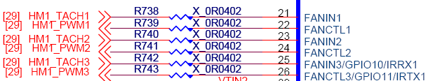

See float read_fan_speed(unsigned int address, int plus, struct sensor *sensors) for more detail.

    - Voltage
For the 8-bit ADC has the 8mv LSB, the maximum input voltage of the analog pin is 2.048V. Therefore the voltage under 2.048V (ex:1.5V) can be directly connected to these analog inputs. The voltage higher than 2.048V should be reduced by a factor with external resistors so as to obtain the input range. Only 3Vcc is an exception for it is main power of the F71889A. Therefore 3Vcc can directly connect to this chip’s power pin and need no external resistors. There are two functions in this pin with 3.3V. The first function is to supply internal analog power of the F71889A and the second function is that voltage with 3.3V is connected to internal serial resistors to monitor the +3.3V voltage. The internal serial resistors are two 150K ohm, so that the internal reduced voltage is half of +3.3V.

The voltage divided formula is shown as follows:
$$V_{0}≤2.048, VIN0=V_{0}×\frac{R2}{R1+R2}×0.008$$
$$V_{0}>2.048, VIN0=V_{0}×0.008$$

See float read_voltage1(unsigned int address, int plus, struct sensor *sensors), float read_voltage2(unsigned int address, int plus, struct sensor *sensors) and float read_voltage3(unsigned int address, int plus, struct sensor *sensors) for more detail.

  - Programming
hwmon.c, source code for hardware monitor. Please read the comment (blue color) for detail.

#include <sys/types.h>
#include <sys/stat.h>
#include <fcntl.h>
#include <stdio.h>
#include <stdlib.h>
#include <stdarg.h>
#include <string.h>
#include <unistd.h>
#include <sys/io.h>
#include <errno.h>

#include <sitest.h>
#include <libsio.h>

/* Refer to AST 1300 firmware spec. ver.063 */
#define LOW_ADC_BASE_ADDR 0x1600
#define HIGH_ADC_BASE_ADDR 0x1E72

#define LOW_DATA_BASE_ADDR 0x2000
#define HIGH_DATA_BASE_ADDR 0x1E72

#define LOW_I2C_BASE_ADDR 0x1700
#define HIGH_I2C_BASE_ADDR 0x1E72

#define LOW_TACHO_BASE_ADDR 0x1500
#define HIGH_TACHO_BASE_ADDR 0x1E72

#define LOW_PECI_BASE_ADDR 0x1C00
#define HIGH_PECI_BASE_ADDR 0x1E72

/* The base address is 0x1E720000 */
#define HIGH_CTL_BASE_ADDR 0x1E72

/*
* Define the struct for Sensor.
* Type 0: Temperature; 1: FAN Speed; 2: Voltage > 0 and < 2.048V;
* 3: Voltage >2.048V
* Name: Sensor Name
* Index: The index of the register in Super IO
* Bank: The bank of the register in Super IO
* Par1 and Par2: For Fan speed, Par1 is a value when no fan installed,
* the program will set the speed to 0 if the speed is Par1.
* For Voltage (Type 3), Par1 is R1, Par2 is R2
* Low and Up: The range of the sensors, if over range,
* the program will show Over range.
*/
struct sensor {
int type;
char name[30];
char pin_name[5];
unsigned int index;
int bank;
float par1;
float par2;
float low_limit;
float high_limit;
float min;
float max;
float multiplier;
};

void bank_select(unsigned int address, unsigned int bank);
void init_peci(void );

unsigned int read_hwmon_base_address(void );

float read_temperature(unsigned int address, int plus, struct sensor *sensors);
float read_fan_speed(unsigned int address, int plus, struct sensor *sensors);
float read_voltage1(unsigned int address, int plus, struct sensor *sensors);
float read_voltage2(unsigned int address, int plus, struct sensor *sensors);
float read_voltage3(unsigned int address, int plus, struct sensor *sensors);

float read_ast_temperature_peci(unsigned int index, ...);
float read_ast_temperature_i2c(unsigned int index, ...);
float read_ast_fan(unsigned int index, ...);
float read_ast_voltage(unsigned int index, ...);
float read_ast_voltage1(unsigned int index, ...);

void usage(void);

int type_list(struct sensor *sensors);
int ast_type_list(struct sensor *sensors);
void pin_list(char *chip_model, struct sensor *sensors);

char chip_model[10];

int main(int argc, unsigned char *argv[])
{
FILE *fp;
char *buf;
unsigned int hw_base_addr, offset;
int i = 0, j = 0, count = 0, result = 0, time, plus;
float b = 0;

/* read sensor functions initialize, for SIO */
float (*read_sio_sensor[])(unsigned int address, int plus , \
struct sensor *sensors) = {
read_temperature,
read_fan_speed,
read_voltage1,
read_voltage2,
read_voltage3
};

/* read sensor functions initialize, for AST1300 */
float (*read_ast_sensor[])(unsigned int index, ...) = {
read_ast_temperature_peci,
read_ast_temperature_i2c,
read_ast_fan,
read_ast_voltage,
read_ast_voltage1
};

/* change I/O privilege level to all access. For Linux only. */
if (iopl(3)) {
perror(NULL);
exit(1);
}

/* If the parameter is wrong, use the usage message */
if (argc != 3) {
usage();
exit(-1);
}

time = atoi(argv[2]);

fp = fopen(argv[1], "r");

if ( fp == NULL) {
ERR("Fail to open <%s>, please enter the correct file name.\n", argv[1]);
exit(-1);
}

/* Skip the header */
fscanf(fp, "%*[^\n]\n", NULL);
fscanf(fp, "%*[^\n]\n", NULL);
fscanf(fp, "%*[^\n]\n", NULL);
/* Remember the offset, read from this position later. */
offset = ftell(fp);
DBG("offset = %d\n", offset);
/* Skip 4th line. */
fscanf(fp, "%*[^\n]\n", NULL);

/* Count how many data we need to read. */
while (!feof(fp)) {
fscanf(fp, "%*[^\n]\n", NULL);
count++;
}
DBG("count = %d\n", count);

fseek(fp, offset, SEEK_SET);

struct sensor sensors[count];

fscanf(fp, "%[^,], %x\n", chip_model, &EFER);
EFDR = EFER + 1;
DBG("chip_model = %s, EFER = %x\n", chip_model, EFER);

if (strncmp("AST", chip_model, 3) == 0) {
while (!feof(fp)) {
fscanf(fp, "%[^,], %[^,], %f, %f, %f, %f, %f\n", \
&sensors[j].name, &sensors[j].pin_name, \
&sensors[j].par1, &sensors[j].par2, \
&sensors[j].low_limit, &sensors[j].high_limit, \
&sensors[j].multiplier);

DBG("name = %s, pin_name = %s, par1 = %f, par2 = %f, " \
"low_limit = %f, high_limit = %f, multiplier = %f\n", \
sensors[j].name, sensors[j].pin_name, sensors[j].par1, \
sensors[j].par2, sensors[j].low_limit, sensors[j].high_limit, \
sensors[j].multiplier);

pin_list(chip_model, &sensors[j]);
sensors[j].type = ast_type_list(&sensors[j]);
DBG("sensors[%d].type = %d\n", j, sensors[j].type);

DBG("name = %s, type = %d, index = %x, par1 = %f, par2 = %f, " \
"low_limit = %f, high_limit = %f, multiplier = %f\n", \
sensors[j].name, sensors[j].type, sensors[j].index, \
sensors[j].par1, sensors[j].par2, sensors[j].low_limit, \
sensors[j].high_limit, sensors[j].multiplier);

j++;
}
} else {
while (!feof(fp)) {
fscanf(fp, "%[^,], %d, %f, %f, %f, %f, %f\n", \
&sensors[j].name, &sensors[j].index, &sensors[j].par1, \
&sensors[j].par2, &sensors[j].low_limit, \
&sensors[j].high_limit, &sensors[j].multiplier);

DBG("name = %s, par1 = %f, par2 = %f, low_limit = %f, " \
"high_limit = %f, multiplier = %f\n", \
sensors[j].name, sensors[j].par1, sensors[j].par2, \
sensors[j].low_limit, sensors[j].high_limit, \
sensors[j].multiplier);

pin_list(chip_model, &sensors[j]);
sensors[j].type = type_list(&sensors[j]);

DBG("name = %s, type = %d, index = %x, par1 = %f, par2 = %f, " \
"low_limit = %f, high_limit = %f, multiplier = %f\n", \
sensors[j].name, sensors[j].type, sensors[j].index, \
sensors[j].par1, sensors[j].par2, sensors[j].low_limit, \
sensors[j].high_limit, sensors[j].multiplier);

j++;
}
}

fclose(fp);

/* Enter the Extended Function Mode */
sio_enter(chip_model);
if (strncmp("AST", chip_model, 3) == 0) {
/*
* Always access AST1300 with SuperIO protocol, so do not exit
* Entended Function Mode.
*/
sio_ilpc2ahb_setup();
init_peci();
} else {
/* Read HW monitor base address */
hw_base_addr = read_hwmon_base_address();
sio_exit();
}

if (strncmp("NCT", chip_model, 3) == 0 || \
strncmp("W83", chip_model, 3) == 0) {
plus = 5;
} else if (strncmp("F71889", chip_model, 6) == 0) {
plus = 0;
} else if (strncmp("F7186", chip_model, 5) == 0) {
plus = 5;
}

/* Disable the buffer of STDOUT */
setbuf(stdout, NULL);

/* The loop for Test time */
for (i = 0; i < time; i++) {

#ifndef DEBUG
system("clear");
printf("Sensors Current Minimum Maximum Status\n");
printf("--------------------------------------------------------------------------");
#endif

/*
* Read the sensors and show the current value and record the min/max
* value.
*/
for (j = 0; j < count; j++) {
if (strncmp("AST", chip_model, 3) == 0) {
DBG("j = %d, type = %d, index = %x, par1 = %f, par2 = %f\n",
j, sensors[j].type, sensors[j].index, \
sensors[j].par1, sensors[j].par2);

b = read_ast_sensor[sensors[j].type](sensors[j].index, \
sensors[j].par1, \
sensors[j].multiplier);

DBG("b = %f\n", b);
} else {
DBG("hw_base_addr = %x, j = %d, type = %d, index = %x, " \
"bank = %d, par1 = %f, par2 = %f\n",
hw_base_addr, j, sensors[j].type, sensors[j].index, \
sensors[j].bank, sensors[j].par1, sensors[j].par2);

if (strncmp("NCT", chip_model, 3) == 0 || \
strncmp("W83", chip_model, 3) == 0) {
bank_select(hw_base_addr, sensors[j].bank); /* Set Bank */
}

b = read_sio_sensor[sensors[j].type](hw_base_addr, plus, \
&sensors[j]);
DBG("b = %f\n", b);
}

#ifndef DEBUG
/* Show Sensor name */
asprintf(&buf, "tput cup %d 0", j + 2);
system(buf);
free(buf);
printf("%s", sensors[j].name);

/* Show Current value */
asprintf(&buf, "tput cup %d 30", j + 2);
system(buf);
free(buf);
printf("%.3f", b);

/* Initial the Min and Max value at the first time */
if (i == 0) {
sensors[j].max = b;
sensors[j].min = b;
} else { /* Change the Min and Max value if the current value is */
if (b > sensors[j].max)
sensors[j].max = b;

if (b < sensors[j].min)
sensors[j].min = b;
}

/* Show minimum value */
asprintf(&buf, "tput cup %d 42", j + 2);
system(buf);
free(buf);
printf("%.3f", sensors[j].min);

/* Show maximum value */
asprintf(&buf, "tput cup %d 54", j + 2);
system(buf);
free(buf);
printf("%.3f", sensors[j].max);

/* Show Status */
asprintf(&buf, "tput cup %d 66", j + 2);
system(buf);
free(buf);

if ((sensors[j].min >= sensors[j].low_limit) && \
(sensors[j].max <= sensors[j].high_limit)) {
printf("PASS");
} else {
printf("Fail!!");
result = 1;
}
#endif
}

sleep(1);
}

if (strncmp("AST", chip_model, 3) == 0)
sio_exit();

printf("\n\n");

return result;
}

void init_peci(void)
{
unsigned int data;

/* Enable PECI, Negotiation Timing = 0x40, Clock divider = 2 */
sio_ilpc2ahb_write(0x02, LOW_PECI_BASE_ADDR + 0x00, HIGH_PECI_BASE_ADDR);
sio_ilpc2ahb_write(0x40, LOW_PECI_BASE_ADDR + 0x01, HIGH_PECI_BASE_ADDR);
sio_ilpc2ahb_write(0x01, LOW_PECI_BASE_ADDR + 0x02, HIGH_PECI_BASE_ADDR);
sio_ilpc2ahb_write(0x00, LOW_PECI_BASE_ADDR + 0x03, HIGH_PECI_BASE_ADDR);

/* Read length = 2, Write length = 1, CPU address = 0x30 */
sio_ilpc2ahb_write(0x30, LOW_PECI_BASE_ADDR + 0x04, HIGH_PECI_BASE_ADDR);
sio_ilpc2ahb_write(0x01, LOW_PECI_BASE_ADDR + 0x05, HIGH_PECI_BASE_ADDR);
sio_ilpc2ahb_write(0x02, LOW_PECI_BASE_ADDR + 0x06, HIGH_PECI_BASE_ADDR);
sio_ilpc2ahb_write(0x00, LOW_PECI_BASE_ADDR + 0x07, HIGH_PECI_BASE_ADDR);

/* Write Command Code (0x01) into write Register */
sio_ilpc2ahb_write(0x01, LOW_PECI_BASE_ADDR + 0x0C, HIGH_PECI_BASE_ADDR);
sio_ilpc2ahb_write(0x00, LOW_PECI_BASE_ADDR + 0x0D, HIGH_PECI_BASE_ADDR);
sio_ilpc2ahb_write(0x00, LOW_PECI_BASE_ADDR + 0x0E, HIGH_PECI_BASE_ADDR);
sio_ilpc2ahb_write(0x00, LOW_PECI_BASE_ADDR + 0x0F, HIGH_PECI_BASE_ADDR);

/* Fire Engine */
sio_ilpc2ahb_write(0x01, LOW_PECI_BASE_ADDR + 0x08, HIGH_PECI_BASE_ADDR);

/* Check the status is Idle or Busy */
data = 2;
while (data != 0) {
usleep(10000);
data = sio_ilpc2ahb_read(LOW_PECI_BASE_ADDR + 0x08, HIGH_PECI_BASE_ADDR);
data &= 0x02;
}
}

/*
* Read HW monitor base address
* The base address of the Address Port and Data Port is specified in registers
* CR[60h] and CR[61h] of Logical Device B, the hardware monitor device.
* CR[60h] is the high byte, and CR[61h] is the low byte. The Address Port
* and Data Port are located at the base address, plus 5h and 6h, respectively.
* For example, if CR[60h] is 02h and CR[61h] is 90h, the Address Port is at
* 0x295h, and the Data Port is at 0x296h
*/

unsigned int read_hwmon_base_address(void)
{
unsigned int addr, high_addr, low_addr;

if (strncmp("NCT", chip_model, 3) == 0 || \
strncmp("W83", chip_model, 3) == 0) {
sio_select(0x0B); /* Select Logical device B */
} else { /* For Fintek */
sio_select(0x04); /* Logical device number 4 */
}

sio_logical_device_enable(SIO_HWMON_EN);

/* Read the value of CR 60h of Logical device */
high_addr = (sio_read(SIO_HW_BASE_REG) << 8);
/* Read the value of CR 61h of Logical device */
low_addr = sio_read(SIO_HW_BASE_REG + 1);
addr = high_addr | low_addr;
DBG("high_addr = %x, low_addr = %x, addr = %x\n", \
high_addr, low_addr, addr);

return addr;
}

void bank_select(unsigned int address, unsigned int bank)
{
unsigned char data;
int plus = 5;

outb_p(EFER, address + plus); /* Bank select */
data = inb_p(address + plus + 1);

if (strcmp("NCT6776F", chip_model) == 0 || \
strncmp("W83", chip_model, 3) == 0) {
data &= ~(0x7); /* Clear bit0~2 */
} else if (strcmp("NCT6779D", chip_model) == 0) {
data &= ~(0x0F); /* Clear bit0~3 */
}

data |= (bank); /* Set Bank */
outb_p(data, address + plus + 1);
}

int type_list(struct sensor *sensors)
{
if (sensors->multiplier != 0) {
return 4;
} else if (sensors->par2 == 0) {
if (sensors->high_limit < 20) {
return 2;
} else if (sensors->high_limit < 110 && sensors->high_limit >= 20) {
return 0;
} else {
return 1;
}
} else {
return 3;
}
}

int ast_type_list(struct sensor *sensors)
{
return (sensors->multiplier != 0 ? 4 : sensors->type);
}

float read_temperature(unsigned int address, int plus, struct sensor *sensors)
{
return (sio_read_reg(sensors->index, address + plus) + sensors->par1);
}

float read_fan_speed(unsigned int address, int plus, struct sensor *sensors)
{
int data;

data = sio_read_reg(sensors->index, address + plus);
DBG("data = %d\n", data);
data = data << 8;
DBG("data = %d\n", data);
data |= sio_read_reg(sensors->index + 1, address + plus);
DBG("data = %d\n", data);

if (strncmp("F718", chip_model, 4) == 0) {
data = 1500000 / data;
}

return (data == sensors->par1) ? 0 : data;
}

float read_voltage1(unsigned int address, int plus, struct sensor *sensors)
{
return ((float) sio_read_reg(sensors->index, address + plus) * 0.008);
}

float read_voltage2(unsigned int address, int plus, struct sensor *sensors)
{
int data;
float result;

data = sio_read_reg(sensors->index, address + plus);

DBG("address = %x, index = %x, par1 = %f, par2 = %f, data = %d\n", \
address, sensors->index, sensors->par1, sensors->par2, data);

result = ((float) data) * ((float) (sensors->par1 + sensors->par2)) / \
((float) sensors->par2) * 0.008;

return result;
}

float read_voltage3(unsigned int address, int plus, struct sensor *sensors)
{
DBG("multiplier = %f\n", sensors->multiplier);
return ((float) sio_read_reg(sensors->index, address + plus) * \
sensors->multiplier / 1000.0);
}

float read_ast_temperature_peci(unsigned int index, ...)
{
unsigned int data_l = 0;
unsigned int data_h = 0;
unsigned int data = 0;
int low_addr;
int high_addr;

low_addr = LOW_DATA_BASE_ADDR + index;
high_addr = HIGH_DATA_BASE_ADDR;

DBG("high_addr = %x, low_addr = %x\n", high_addr, low_addr);

data_l = sio_ilpc2ahb_read(low_addr, high_addr);
data_h = sio_ilpc2ahb_read(low_addr + 1, high_addr);
data = data_l | (data_h << 8);

return ((float) data);
}

float read_ast_temperature_i2c(unsigned int index, ...)
{
unsigned int data_l = 0;
unsigned int data_h = 0;
unsigned int data = 0;
int low_addr;
int high_addr;
float result;
int Hz = 100000;

low_addr = LOW_I2C_BASE_ADDR;
high_addr = HIGH_I2C_BASE_ADDR;

/* Write I2C Channel 7 clock to 100KHz */
sio_ilpc2ahb_write((Hz & 0xFF), low_addr + 0x48, high_addr);
sio_ilpc2ahb_write(((Hz >> 8) & 0xFF), low_addr + 0x49, high_addr);
sio_ilpc2ahb_write(((Hz >> 16) & 0xFF), low_addr + 0x4A, high_addr);
sio_ilpc2ahb_write(((Hz >> 24) & 0xFF), low_addr + 0x4B, high_addr);

/* Set I2C to read, Device Address and Channel number */
sio_ilpc2ahb_write(0x07, low_addr + 0x54, high_addr);
sio_ilpc2ahb_write(index, low_addr + 0x55, high_addr);
sio_ilpc2ahb_write(0x00, low_addr + 0x56, high_addr);
sio_ilpc2ahb_write(0x00, low_addr + 0x57, high_addr);

/* Enabled I2C Channel 7 */
data = sio_ilpc2ahb_read(low_addr + 0x00, high_addr);
data |= 0x40;
sio_ilpc2ahb_write(data, low_addr + 0x00, high_addr);

/* Fire to Engine */
data = sio_ilpc2ahb_read(low_addr + 0x5C, high_addr);
data |= 0x01;
sio_ilpc2ahb_write(data, low_addr + 0x5C, high_addr);

usleep(1000000); /* Need the wait time for next reading */

data_l = 2; /* Check the status is Idle or Busy */
while (data_l != 0) {
usleep(10000);
data_l = sio_ilpc2ahb_read(low_addr + 0x5C, high_addr);
data_l &= 0x02;
}

/* Read I2C data */
result = (sio_ilpc2ahb_read(LOW_DATA_BASE_ADDR, HIGH_DATA_BASE_ADDR));

return result;
}

float read_ast_fan(unsigned int index, ...)
{
unsigned int data_l = 0;
unsigned int data_h = 0;
unsigned int data = 0;
int low_addr;
int high_addr;

low_addr = LOW_TACHO_BASE_ADDR + index;
high_addr = HIGH_TACHO_BASE_ADDR;

data_l = sio_ilpc2ahb_read(low_addr, high_addr);
data_h = sio_ilpc2ahb_read(low_addr + 1, high_addr);
data = data_l | (data_h << 8);

return ((float) data);
}

float read_ast_voltage(unsigned int index, ...)
{
unsigned int data_l = 0;
unsigned int data_h = 0;
unsigned int data = 0;
int low_addr;
int high_addr;
float par1, result;
va_list args;

low_addr = LOW_ADC_BASE_ADDR + index;
high_addr = HIGH_ADC_BASE_ADDR;
data_l = sio_ilpc2ahb_read(low_addr, high_addr);
data_h = sio_ilpc2ahb_read(low_addr + 1, high_addr);
data_h &= 0x03;
data = data_l | (data_h << 8);

va_start(args, index);
par1 = va_arg(args, double);
va_end(args);

/* Ask BIOS to get the ratio */
result = (((float) data) * ((float) par1) * 25 / 1023 / 100);

return result;
}

float read_ast_voltage1(unsigned int index, ...)
{
unsigned int data_l = 0;
unsigned int data_h = 0;
unsigned int data = 0;
int low_addr;
int high_addr;
float multiplier;
va_list args;

low_addr = LOW_ADC_BASE_ADDR + index;
high_addr = HIGH_ADC_BASE_ADDR;
data_l = sio_ilpc2ahb_read(low_addr, high_addr);
data_h = sio_ilpc2ahb_read(low_addr + 1, high_addr);
data_h &= 0x03;
data = data_l | (data_h << 8);

va_start(args, index);
multiplier = va_arg(args, double);
multiplier = va_arg(args, double);
va_end(args);

/* Ask BIOS to get the ratio */
return (((float) data) * multiplier / 1024);
}

/* TODO: need to find a better way to do this... */

void pin_list(char *chip_model, struct sensor *sensors)
{
int pin = sensors->index;

if (strcmp("NCT6776D", chip_model) == 0 || strcmp("NCT6776F", chip_model) == 0) {
switch(pin) {
case 1:
sensors->index = 0x23;
sensors->bank = 0;
break;
case 46:
sensors->index = 0x50;
sensors->bank = 5;
break;
case 99:
sensors->index = 0x51;
sensors->bank = 5;
break;
case 103:
sensors->index = 0x25;
sensors->bank = 0;
break;
case 104:
sensors->index = 0x24;
sensors->bank = 0;
break;
case 105:
sensors->index = 0x21;
sensors->bank = 0;
break;
case 106:
sensors->index = 0x22;
sensors->bank = 0;
break;
case 107:
sensors->index = 0x20;
sensors->bank = 0;
break;
case 109:
sensors->index = 0x26;
sensors->bank = 0;
break;
case 124:
sensors->index = 0x58;
sensors->bank = 6;
break;
case 126:
sensors->index = 0x56;
sensors->bank = 6;
break;
case 110:
sensors->index = 0x50;
sensors->bank = 1;
break;
case 111:
sensors->index = 0x2B;
sensors->bank = 6;
break;
}
} else if (strcmp("NCT6779D", chip_model) == 0) {
switch(pin) {
case 3:
sensors->index = 0xC4;
sensors->bank = 4;
break;
case 4:
sensors->index = 0xC6;
sensors->bank = 4;
break;
case 99:
sensors->index = 0x88;
sensors->bank = 4;
break;
case 104:
sensors->index = 0x84;
sensors->bank = 4;
break;
case 105:
sensors->index = 0x81;
sensors->bank = 4;
break;
case 106:
sensors->index = 0x8C;
sensors->bank = 4;
break;
case 107:
sensors->index = 0x8D;
sensors->bank = 4;
break;
case 109:
sensors->index = 0x80;
sensors->bank = 4;
break;
case 111:
sensors->index = 0x86;
sensors->bank = 4;
break;
case 112:
sensors->index = 0x20;
sensors->bank = 7;
break;
case 113:
sensors->index = 0x90;
sensors->bank = 4;
break;
case 114:
sensors->index = 0x8A;
sensors->bank = 4;
break;
case 115:
sensors->index = 0x8B;
sensors->bank = 4;
break;
case 116:
sensors->index = 0x8E;
sensors->bank = 4;
break;
case 124:
sensors->index = 0xC2;
sensors->bank = 4;
break;
case 126:
sensors->index = 0xC0;
sensors->bank = 4;
break;
}
} else if (strncmp("W83", chip_model, 3) == 0) {
switch (pin) {
case 28:
sensors->index = 0x23;
sensors->bank = 0;
break;
case 61:
sensors->index = 0x50;
sensors->bank = 5;
break;
case 74:
sensors->index = 0x51;
sensors->bank = 5;
break;
case 95:
sensors->index = 0x22;
sensors->bank = 0;
break;
case 96:
sensors->index = 0x26;
sensors->bank = 0;
break;
case 97:
sensors->index = 0x25;
sensors->bank = 0;
break;
case 99:
sensors->index = 0x21;
sensors->bank = 0;
break;
case 100:
sensors->index = 0x20;
sensors->bank = 0;
break;
case 102:
sensors->index = 0x50;
sensors->bank = 2;
break;
case 103:
sensors->index = 0x50;
sensors->bank = 1;
break;
case 104:
sensors->index = 0x27;
sensors->bank = 0;
break;
case 111:
sensors->index = 0x54;
sensors->bank = 6;
break;
case 112:
sensors->index = 0x50;
sensors->bank = 6;
break;
case 119:
sensors->index = 0x52;
sensors->bank = 6;
break;
}
} else if (strncmp("F718", chip_model, 4) == 0) {
sensors->bank = 0;
switch (pin) {
case 21:
sensors->index = 0xA0;
break;
case 23:
sensors->index = 0xB0;
break;
case 25:
sensors->index = 0xC0;
break;
case 89:
sensors->index = 0x76;
break;
case 90:
sensors->index = 0x74;
break;
case 91:
sensors->index = 0x72;
break;
case 93:
sensors->index = 0x26;
break;
case 94:
sensors->index = 0x25;
break;
case 95:
sensors->index = 0x24;
break;
case 96:
sensors->index = 0x23;
break;
case 97:
sensors->index = 0x22;
break;
case 98:
sensors->index = 0x21;
break;
}

if (strncmp("F7186", chip_model, 5) == 0) {
switch(pin) {
case 4:
case 37:
sensors->index = 0x20;
break;
case 58:
sensors->index = 0x7E;
break;
case 68:
sensors->index = 0x27;
break;
case 86:
sensors->index = 0x28;
break;
}
}

if (strncmp("F71889", chip_model, 5) == 0) {
switch(pin) {
case 1:
case 35:
sensors->index = 0x20;
break;
case 44:
sensors->index = 0x78;
break;
case 65:
sensors->index = 0x27;
break;
case 82:
sensors->index = 0x28;
break;
}
}
} else if (strcmp("AST1300", chip_model) == 0) {
if (strcmp(sensors->pin_name, "AA21") == 0) { /* PECI */
if (strcmp(sensors->name, "TEMP_CPU0") == 0)
sensors->index = 0x50;
else if (strcmp(sensors->name, "TEMP_CPU1") == 0)
sensors->index = 0x54;
else if (strcmp(sensors->name, "TEMP_CPU0_VR") == 0) {
sensors->index = 0x5C;
} else {
ERR("Sensor name should be TEMP_CPU0 or TEMP_CPU1 or TEMP_CPU0_VR\n");
exit(-1);
}
sensors->type = 0;
} else if (strcmp(sensors->pin_name, "D1") == 0) { /* I2C */
sensors->type = 1;
if (strcmp(sensors->name, "TEMP_BMC") == 0)
sensors->index = 0x90; /* device addres 0x90 */
else if (strcmp(sensors->name, "TEMP_ENV") == 0)
sensors->index = 0x98; /* device addres 0x90 */
else {
ERR("Sensor name should be TEMP_BMC or TEMP_ENV\n");
exit(-1);
}
/* Tachometer, Channel 0 ~ 15 */
} else if (strcmp(sensors->pin_name, "V6") == 0) {
sensors->index = 0x08;
sensors->type = 2;
} else if (strcmp(sensors->pin_name, "Y5") == 0) {
sensors->index = 0x0C;
sensors->type = 2;
} else if (strcmp(sensors->pin_name, "AA4") == 0) {
sensors->index = 0x10;
sensors->type = 2;
} else if (strcmp(sensors->pin_name, "AB3") == 0) {
sensors->index = 0x14;
sensors->type = 2;
} else if (strcmp(sensors->pin_name, "W6") == 0) {
sensors->index = 0x18;
sensors->type = 2;
} else if (strcmp(sensors->pin_name, "AA5") == 0) {
sensors->index = 0x1C;
sensors->type = 2;
} else if (strcmp(sensors->pin_name, "AB4") == 0) {
sensors->index = 0x20;
sensors->type = 2;
} else if (strcmp(sensors->pin_name, "V7") == 0) {
sensors->index = 0x24;
sensors->type = 2;
} else if (strcmp(sensors->pin_name, "Y6") == 0) {
sensors->index = 0x28;
sensors->type = 2;
} else if (strcmp(sensors->pin_name, "AB5") == 0) {
sensors->index = 0x2C;
sensors->type = 2;
} else if (strcmp(sensors->pin_name, "W7") == 0) {
sensors->index = 0x30;
sensors->type = 2;
} else if (strcmp(sensors->pin_name, "AA6") == 0) {
sensors->index = 0x34;
sensors->type = 2;
} else if (strcmp(sensors->pin_name, "AB6") == 0) {
sensors->index = 0x38;
sensors->type = 2;
} else if (strcmp(sensors->pin_name, "Y7") == 0) {
sensors->index = 0x3C;
sensors->type = 2;
} else if (strcmp(sensors->pin_name, "AA7") == 0) {
sensors->index = 0x40;
sensors->type = 2;
} else if (strcmp(sensors->pin_name, "AB7") == 0) {
sensors->index = 0x44;
sensors->type = 2;
}
/* ADC0 ~ ADC11 */
else if (strcmp(sensors->pin_name, "L5") == 0) {
sensors->index = 0x08;
sensors->type = 3;
} else if (strcmp(sensors->pin_name, "L4") == 0) {
sensors->index = 0x0C;
sensors->type = 3;
} else if (strcmp(sensors->pin_name, "L3") == 0) {
sensors->index = 0x10;
sensors->type = 3;
} else if (strcmp(sensors->pin_name, "L2") == 0) {
sensors->index = 0x14;
sensors->type = 3;
} else if (strcmp(sensors->pin_name, "L1") == 0) {
sensors->index = 0x18;
sensors->type = 3;
} else if (strcmp(sensors->pin_name, "M5") == 0) {
sensors->index = 0x1C;
sensors->type = 3;
} else if (strcmp(sensors->pin_name, "M4") == 0) {
sensors->index = 0x20;
sensors->type = 3;
} else if (strcmp(sensors->pin_name, "M3") == 0) {
sensors->index = 0x24;
sensors->type = 3;
} else if (strcmp(sensors->pin_name, "M2") == 0) {
sensors->index = 0x28;
sensors->type = 3;
} else if (strcmp(sensors->pin_name, "M1") == 0) {
sensors->index = 0x2C;
sensors->type = 3;
} else if (strcmp(sensors->pin_name, "N5") == 0) {
sensors->index = 0x30;
sensors->type = 3;
} else if (strcmp(sensors->pin_name, "N4") == 0) {
sensors->index = 0x34;
sensors->type = 3;
}
}
}

/* If parameter is wrong, it will show this message */

void usage(void)
{
printf("Usage : hwmon <FILE NAME> <TIMES>\n"
" i.e: ./hwmon S0361.conf 10\n");
}

- Bypass

Bypass/Passthrough is controlled by CPLD, and we can use GPIO to control CPLD. The following table is the CPLD control table, PAIR_X and CFG_X are GPIOs.

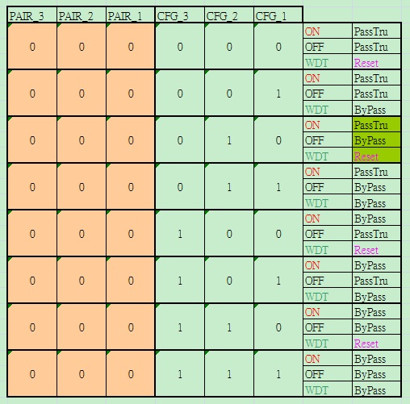

  - Select and configure the CPLD
    - Setup the PAIR
Setup the value of PAIR_1, PAIR_2 and PAIR_3 to select which CPLD you want to control. One CPLD contorlls one pair LAN ports.

For example, S0361 has one pair LAN ports for Bypass/Passthrough function, so it only has one CPLD controller, you need to setup the PAIR to 0(PAIR_3 to 0, PAIR_2 to 0 and PAIR_3 to 0). 06E3 has two pairs LAN ports for Bypass/Passthrough function, so it has two CPLD controller, you can setup the PAIR to 0 to control frist CPLD controller and setup the PAIR to 1 to control second CPLD controller.

For the other setting, please refer to the following table. Also see void ast_pair_setup(int value, unsigned long int data_offset, int offset), void pair_setup(int pair, struct cpld_cfg *cpld) and void sio_pair_setup(int pair, struct cpld_cfg *cpld) for more detail.

PAIR_1 | PAIR_2 | PAIR_3 | PAIR(CPLD)
0 | 0 | 0 | 1
0 | 0 | 1 | 2
0 | 1 | 0 | 3
0 | 1 | 1 | 4
1 | 0 | 0 | 5
1 | 0 | 1 | 6
1 | 1 | 0 | 7
1 | 1 | 1 | 8

Note: S0961 use different GPIOs to control different pair LAN ports, pair1/2 use the same GPIOs, pair3/4 use the same GPIOs and pair 5/6 use the same GPIOs. See void sio_pair_setup(int pair, struct cpld_cfg *cpld) for more detail.

    - Setup the CFG

Setup the CFG to configure the status of CPLD.
- CFG_1 is the action of Watch Dog Timer, 0 is Reset, 1 is Bypass.
- CFG_2 is the action when power off, 0 is Passthrough, 1 is Bypass.
- CFG_3 is the action when power on, 0 is Passthrough, 1 is Bypass.

See void ast_cfg_setup(int value, unsigned long int data_offset, int offset), void cfg_setup(int pair, int on, int off, int wdt, struct cpld_cfg *cpld) and void sio_cfg_setup(int pair, int on, int off, int wdt, struct cpld_cfg *cpld) for more detail.

    - Trigger

Sendbit is a Native-edge-trigger(Falling-edge-trigger) signal, after setting PAIR and CFG, pull Sendbit from High to Low to trigger CPLD. CPLD will load the settings and do the action. According to the SPEC of CPLD, the wait time must be equal or more than 100ms.

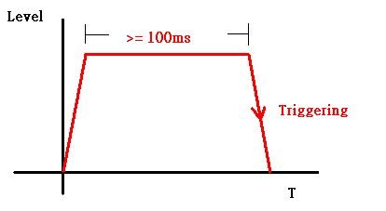

See void ast_cpld_trigger(unsigned long int data_offset, int offset), void cpld_trigger(int pair, struct cpld_cfg *cpld) and void sio_cpld_trigger(int pair, struct cpld_cfg *cpld) for more detail.

  - GPIO
Please refer to Chapter 3 GPIO loopback test for how to configure the GPIO.

  - Programming
bypass.c, source code for bypass. Please read the comment (blue color) for detail.

#include <stdio.h>
#include <stdlib.h>
#include <string.h>
#include <unistd.h>
#include <sys/io.h>
#include <errno.h>

#include <sitest.h>
#include <libsio.h>
#include <libpch.h>

#define LOW_GPIO_BASE_ADDR 0x0000 /* Refer to AST Datasheet page 416 */
#define HIGH_GPIO_BASE_ADDR 0x1E78

#define PAIR_GPIO_NUM 3
#define AST_GPIO_NUM 19
#define CPLD_DELAY 200000 /* micro second */

struct cpld_cfg
{
int pair_g[12];
int cfg_g[9];
int sendbit[3];
};

struct ast_cpld_cfg
{
char pair_g[12][3];
char cfg_g[3][3];
char sendbit[3];
};

struct gpio_groups
{
char name;
unsigned long int data_offset;
unsigned long int dir_offset;
};

void usage(void);

void set_gpio(int gpio,int value);
void pair_setup(int pair, struct cpld_cfg *cpld);
void cfg_setup(int pair, int on, int off, int wdt, struct cpld_cfg *cpld);
void cpld_trigger(int pair, struct cpld_cfg *cpld);
void bypass_setup(int pair,int on, int off, int wdt, struct cpld_cfg *cpld);

void sio_pair_setup(int pair, struct cpld_cfg *cpld);
void sio_cfg_setup(int pair, int on, int off, int wdt, struct cpld_cfg *cpld);
void sio_cpld_trigger(int pair, struct cpld_cfg *cpld);
void sio_bypass_setup(int pair,int on, int off, int wdt, struct cpld_cfg *cpld);
int f71889ad_get_gpio_dir_index(int gpio);
void f71889ad_gpio_dir_out(int gpio, int value);

int ast_get_gpio_offset(char *pair_g, struct gpio_groups *gg);
int ast_gpio_init(struct ast_cpld_cfg *cpld, struct gpio_groups *gg);
void ast_pair_setup(int value, unsigned long int data_offset, int offset);
void ast_cfg_setup(int value, unsigned long int data_offset, int offset);
void ast_cpld_trigger(unsigned long int data_offset, int offset);
int ast_bypass_setup(int pair, int cfg, struct ast_cpld_cfg *cpld, \
struct gpio_groups *gg);

int check_arguments(char *argv[], int *, int *, int *, int *);
int read_config(char *, struct cpld_cfg *, struct ast_cpld_cfg *, char *);

unsigned long int gpio_base_addr;
static int total_pair_pin_num;
static int total_cfg_pin_num = 3;

int main(int argc, char *argv[])
{
unsigned char b;
int pair, on, off, wdt, cfg;
char chip[10];
struct cpld_cfg *cpld;
struct ast_cpld_cfg *ast_cpld;

if (argc < 6) {
usage();
exit(-1);
}

if (check_arguments(argv, &pair, &on, &off, &wdt)) {
ERR("Incorrect arguments!\n");
usage();
exit(-1);
}

cpld = malloc(sizeof(struct cpld_cfg));
ast_cpld = malloc(sizeof(struct ast_cpld_cfg));

if (read_config(argv[1], cpld, ast_cpld, chip)) {
ERR("Fail to open <%s>, please enter the correct file name.\n", argv[1]);
free(cpld);
exit(-1);
}

DBG("pair = %d, on = %d, off = %d, wdt = %d\n", pair, on, off, wdt);

/* change I/O privilege level to all access. For Linux only. */
if (iopl(3)) {
perror(NULL);
exit(1);
}

if (strcmp(chip, "PCH") == 0) {
bypass_setup(pair, on, off, wdt, cpld);
} else if (strncmp(chip, "F71", 3) == 0 || strncmp(chip, "AST", 3) == 0) {
/* Assign EFER and EFDR for SuperIO */
EFER = gpio_base_addr;
EFDR = gpio_base_addr + 1;

/* Enter the Extended Function Mode */
sio_enter(chip);

if (strncmp(chip, "AST", 3) == 0) {
sio_ilpc2ahb_setup();

struct gpio_groups gg[AST_GPIO_NUM] = {
{'A', 0x00, 0x04}, {'B', 0x01, 0x05}, \
{'C', 0x02, 0x06}, {'D', 0x03, 0x07}, \
{'E', 0x20, 0x24}, {'F', 0x21, 0x25}, \
{'G', 0x22, 0x26}, {'H', 0x23, 0x27}, \
{'I', 0x70, 0x74}, {'J', 0x71, 0x75}, \
{'K', 0x72, 0x76}, {'L', 0x73, 0x77}, \
{'M', 0x78, 0x7C}, {'N', 0x79, 0x7D}, \
{'O', 0x7A, 0x7E}, {'P', 0x7B, 0x7F}, \
{'Q', 0x80, 0x84}, {'R', 0x81, 0x85}, \
{'S', 0x82, 0x86}
};

if (ast_gpio_init(ast_cpld, gg))
ERR("ast_gpio_init fail.\n");

/*
* ast_bypass_setup(..., int cfg, ...),
* cfg = wdt | off << 1 | on << 2
* cfg_g[0] --> CFG1: WDT, 0 for Reset , 1 for Bypass.
* cfg_g[1] --> CFG2: OFF, 0 for Pass Through, 1 for Bypass.
* cfg_g[2] --> CFG3: ON , 0 for Pass Through, 1 for Bypass.
*/
if (ast_bypass_setup(pair, wdt | off << 1 | on << 2, ast_cpld, gg))
ERR("ast_bypass_setup fail.\n");
} else if (strncmp(chip, "F71", 3) == 0) {
sio_select(FINTEK_GPIO_LDN);
sio_bypass_setup(pair, on, off, wdt, cpld);
} else {
ERR("this program doesn't support <%s> yet.", chip);
}

sio_exit();
} else {
ERR("%s is illegal name.\n", chip);
}

return 0;
}

int check_arguments(char *argv[], int *pair, int *on, int *off, int *wdt)
{
int i;

if (atoi(argv[2]) < 1 || atoi(argv[2]) > 8) {
ERR("Pair should >= 1 and <= 8\n");
return 1;
}

for (i = 3; i <= 5; i++) {
if (atoi(argv[i]) < 0 || atoi(argv[i]) > 1) {
ERR("PWRON/PWROFF/WDT should be 0 or 1\n");
return 1;
}
}

*pair = atoi(argv[2]);
*on = atoi(argv[3]);
*off = atoi(argv[4]);
*wdt = atoi(argv[5]);

return 0;
}

int read_config(char *filename, struct cpld_cfg *cpld, \
struct ast_cpld_cfg *ast_cpld, char *chip)
{
FILE *fp;
int i;
char number[3][3];

fp = fopen(filename, "r");

if (fp == NULL)
return 1;

DBG("filename: %s\n", filename);

if (strncmp(filename, "S0961", 5) == 0)
total_pair_pin_num = 9;
else
total_pair_pin_num = 3;

/* Skip the header */
for (i = 0; i < 5; i++)
fscanf(fp, "%*[^\n]\n", NULL);

fscanf(fp, "%[^,], %x\n", chip, &gpio_base_addr);
DBG("chip: %s, gpio_base_addr = %x\n", chip, gpio_base_addr);

if (strncmp(chip, "AST", 3) == 0) {
free(cpld);
fscanf(fp, "%[^,], %[^,], %[^\n]\n", ast_cpld->pair_g[0], \
ast_cpld->pair_g[1], ast_cpld->pair_g[2]);
fscanf(fp, "%[^,], %[^,], %[^\n]\n", ast_cpld->cfg_g[0], \
ast_cpld->cfg_g[1], ast_cpld->cfg_g[2]);
fscanf(fp, "%s", ast_cpld->sendbit);

#ifdef DEBUG
DBG("\n");
printf("================GPIOs================\n");
for (i = 0; i < total_pair_pin_num; i++)
printf("%s ", ast_cpld->pair_g[i]);
printf("\n");
for (i = 0; i < total_pair_pin_num; i++)
printf("%s ", ast_cpld->cfg_g[i]);
printf("\n");
for (i = 0; i < total_pair_pin_num / 3; i++)
printf("%s ", cpld->sendbit);
printf("=====================================\n");
#endif
} else {
free(ast_cpld);

if (strncmp(filename, "S0961", 5) == 0) {
fscanf(fp, "%d, %d, %d, %d, %d, %d, %d, %d, %d\n", \
&cpld->pair_g[0], &cpld->pair_g[1], &cpld->pair_g[2], \
&cpld->pair_g[3], &cpld->pair_g[4], &cpld->pair_g[5], \
&cpld->pair_g[6], &cpld->pair_g[7], &cpld->pair_g[8]);
fscanf(fp, "%d, %d, %d, %d, %d, %d, %d, %d, %d\n", \
&cpld->cfg_g[0], &cpld->cfg_g[1], &cpld->cfg_g[2], \
&cpld->cfg_g[3], &cpld->cfg_g[4], &cpld->cfg_g[5], \
&cpld->cfg_g[6], &cpld->cfg_g[7], &cpld->cfg_g[8]);
fscanf(fp, "%d, %d, %d\n", &cpld->sendbit[0], &cpld->sendbit[1], \
&cpld->sendbit[2]);
} else {
fscanf(fp, "%d, %d, %d\n", &cpld->pair_g[0], &cpld->pair_g[1], \
&cpld->pair_g[2]);
fscanf(fp, "%d, %d, %d\n", &cpld->cfg_g[0], &cpld->cfg_g[1], \
&cpld->cfg_g[2]);
fscanf(fp, "%d\n", &cpld->sendbit[0]);
}

#ifdef DEBUG
DBG("\n");
printf("================GPIOs================\n");
for (i = 0; i < total_pair_pin_num; i++)
printf("%d ", cpld->pair_g[i]);
printf("\n");
for (i = 0; i < total_pair_pin_num; i++)
printf("%d ", cpld->cfg_g[i]);
printf("\n");
for (i = 0; i < total_pair_pin_num / 3; i++)
printf("%d ", cpld->sendbit[i]);
printf("\n");
printf("=====================================\n");
#endif
}

fclose(fp);

return 0;
}

int ast_get_gpio_offset(char *gpio, struct gpio_groups *gg)
{
int offset;

DBG("gpio = %s\n", gpio);
for (offset = 0; offset < AST_GPIO_NUM; offset++) {
if (strncmp(gpio, &gg[offset].name, 1) == 0)
break;
}

if (offset == AST_GPIO_NUM)
return -1;
else
return offset;
}

/*
* ast_gpio_init(), initial GPIOs and set the direction to output.
*/

int ast_gpio_init(struct ast_cpld_cfg *cpld, struct gpio_groups *gg)
{
unsigned char data;
int i, ret, offset;

/* Setup GPIOs for Pair */
for (i = 0; i < total_pair_pin_num; i++) {
ret = ast_get_gpio_offset(cpld->pair_g[i], gg);

if (ret == -1) {
ERR("fail to get gpio offset for %s.\n", cpld->pair_g[i]);
return 1;
}

offset = atoi(cpld->pair_g[i] + 1);
DBG("data_offset = %x, dir_offset = %x, offset = %d\n", \
gg[ret].data_offset, gg[ret].dir_offset, offset);

/*
* set gpio direction
* 0x1: output
* 0x0: input
*/
data = sio_ilpc2ahb_read(LOW_GPIO_BASE_ADDR + gg[ret].dir_offset, \
HIGH_GPIO_BASE_ADDR);
data |= (0x1 << offset);
sio_ilpc2ahb_write(data, LOW_GPIO_BASE_ADDR + gg[ret].dir_offset, \
HIGH_GPIO_BASE_ADDR);
}

/* Setup GPIOs for CFG */
for (i = 0; i < total_cfg_pin_num; i++) {
ret = ast_get_gpio_offset(cpld->cfg_g[i], gg);

if (ret == -1) {
ERR("fail to get gpio offset for %s.\n", cpld->cfg_g[i]);
return 1;
}

offset = atoi(cpld->cfg_g[i] + 1);
DBG("data_offset = %x, dir_offset = %x, offset = %d\n", \
gg[ret].data_offset, gg[ret].dir_offset, offset);

/*
* set gpio direction
* 0x1: output
* 0x0: input
*/
data = sio_ilpc2ahb_read(LOW_GPIO_BASE_ADDR + gg[ret].dir_offset, \
HIGH_GPIO_BASE_ADDR);
data |= (0x1 << offset);
sio_ilpc2ahb_write(data, LOW_GPIO_BASE_ADDR + gg[ret].dir_offset, \
HIGH_GPIO_BASE_ADDR);
}

/* Setup GPIO for sendbit */
ret = ast_get_gpio_offset(cpld->sendbit, gg);

if (ret == -1) {
ERR("fail to get gpio offset for %s.\n", cpld->sendbit);
return 1;
}

offset = atoi(cpld->sendbit + 1);
DBG("data_offset = %x, dir_offset = %x, offset = %d\n", \
gg[ret].data_offset, gg[ret].dir_offset, offset);

data = sio_ilpc2ahb_read(LOW_GPIO_BASE_ADDR + gg[ret].dir_offset, \
HIGH_GPIO_BASE_ADDR);
data |= (0x1 << offset);
sio_ilpc2ahb_write(data, LOW_GPIO_BASE_ADDR + gg[ret].dir_offset, \
HIGH_GPIO_BASE_ADDR);

return 0;
}

/*
* ast_pair_setup(), setup the Pair.
*/

void ast_pair_setup(int value, unsigned long int data_offset, int offset)
{
int data;

DBG("value = %d\n", value);

data = sio_ilpc2ahb_read(LOW_GPIO_BASE_ADDR + data_offset, \
HIGH_GPIO_BASE_ADDR);
data &= ~(0x1 << offset);
data |= (value << offset);
sio_ilpc2ahb_write(data, LOW_GPIO_BASE_ADDR + data_offset, \
HIGH_GPIO_BASE_ADDR);
}

/*
* ast_cfg_setup(). setup the CFG.
*/

void ast_cfg_setup(int value, unsigned long int data_offset, int offset)
{
int data;

DBG("value = %d\n", value);

data = sio_ilpc2ahb_read(LOW_GPIO_BASE_ADDR + data_offset, \
HIGH_GPIO_BASE_ADDR);
data &= ~(0x1 << offset);
data |= (value << offset);
sio_ilpc2ahb_write(data, LOW_GPIO_BASE_ADDR + data_offset, \
HIGH_GPIO_BASE_ADDR);
}

/*
* ast_cpld_trigger(), trigger the sendbit.
*/

void ast_cpld_trigger(unsigned long int data_offset, int offset)
{
int data;

data = sio_ilpc2ahb_read(LOW_GPIO_BASE_ADDR + data_offset, \
HIGH_GPIO_BASE_ADDR);
data &= ~(0x1 << offset);
data |= (GPIO_LOW << offset);
sio_ilpc2ahb_write(data, LOW_GPIO_BASE_ADDR + data_offset, \
HIGH_GPIO_BASE_ADDR);

usleep(CPLD_DELAY);

data = sio_ilpc2ahb_read(LOW_GPIO_BASE_ADDR + data_offset, \
HIGH_GPIO_BASE_ADDR);
data &= ~(0x1 << offset);
data |= (GPIO_HIGH << offset);
sio_ilpc2ahb_write(data, LOW_GPIO_BASE_ADDR + data_offset, \
HIGH_GPIO_BASE_ADDR);

usleep(CPLD_DELAY);

data = sio_ilpc2ahb_read(LOW_GPIO_BASE_ADDR + data_offset, \
HIGH_GPIO_BASE_ADDR);
data &= ~(0x1 << offset);
data |= (GPIO_LOW << offset);
sio_ilpc2ahb_write(data, LOW_GPIO_BASE_ADDR + data_offset, \
HIGH_GPIO_BASE_ADDR);
}

int ast_bypass_setup(int pair, int cfg, struct ast_cpld_cfg *cpld, \
struct gpio_groups *gg)
{
unsigned char data;
int i, ret, offset;

/* pair */
for (i = 0; i < total_pair_pin_num; i++) {
ret = ast_get_gpio_offset(cpld->pair_g[i], gg);

if (ret == -1) {
ERR("fail to get gpio offset for %s.\n", cpld->pair_g[i]);
return 1;
}

offset = atoi(cpld->pair_g[i] + 1);
ast_pair_setup((pair - 1 >> i) & 0x1, gg[ret].data_offset, offset);
}

/* cfg */
DBG("cfg = %d\n", cfg);

for (i = 0; i < total_cfg_pin_num; i++) {
ret = ast_get_gpio_offset(cpld->cfg_g[i], gg);

if (ret == -1) {
ERR("fail to get gpio offset for %s.\n", cpld->cfg_g[i]);
return 1;
}

offset = atoi(cpld->cfg_g[i] + 1);

/*
* cfg_g[0] --> CFG1: Watch Dog Timer, 0 for Reset , 1 for Bypass.
* cfg_g[1] --> CFG2: OFF , 0 for Pass Through, 1 for Bypass.
* cfg_g[2] --> CFG3: ON , 0 for Pass Through, 1 for Bypass.
*/
ast_cfg_setup((cfg >> i) & 0x1, gg[ret].data_offset, offset);
}

/* trigger */
ret = ast_get_gpio_offset(cpld->sendbit, gg);

if (ret == -1) {
ERR("fail to get gpio offset for %s.\n", cpld->sendbit);
return 1;
}

offset = atoi(cpld->sendbit + 1);
ast_cpld_trigger(gg[ret].data_offset, offset);

return 0;
}

/*
* TODO: implement a gpio_init() function to initial all GPIOs and set these
* GPIOs to output in gpio_init(). And then use gpio_set() to replace
* set_gpio() to make the code more readable.
*/

/*
* set_gpio(), set gpio_out direction to output and pull low or high.
*/

void set_gpio(int gpio, int value)
{
unsigned long int gpio_use_sel_addr, gp_io_sel_addr, gp_lvl_addr;
int new_gpio;

DBG("gpio = %d, value = %d\n", gpio, value);
/* Set gpio_out direction to output and pull low or high. */
new_gpio = gpio_setup_addr(&gpio_use_sel_addr, &gp_io_sel_addr, \
&gp_lvl_addr, gpio, gpio_base_addr);
DBG("gpio_use_sel_addr = %x, new_gpio = %d\n", gpio_use_sel_addr, new_gpio);

gpio_enable(gpio_use_sel_addr, new_gpio);
DBG("gpio_sel_addr = %x, gp_lvl_addr =%x, value = %d\n", \
gp_io_sel_addr, gp_lvl_addr, value);

gpio_dir_out(gp_io_sel_addr, gp_lvl_addr, new_gpio, value);
}

/*
* pair_setup(), setup the Pair.
*
* pair_g[0] --> Pair1
* pair_g[1] --> Pair2
* pair_g[2] --> Pair3
*
* If pair = 2, d'2 -> b'010, bit0 is 0, bit1 is 1, bit2 is 0,
* so pair_g[2] = 0
* pair_g[1] = 1
* pair_g[0] = 0
*
* if pair = 3, d'5 -> b'011, bit0 is 1, bit1 is 1, bit2 is 0,
* so pair_g[2] = 0
* pair_g[1] = 1
* pair+g[0] = 1.
*/

void pair_setup(int pair, struct cpld_cfg *cpld)
{
int i, n = 0;

pair -= 1; /* make pair from 1 ~ 8 to 0 ~ 7 */

/* For S0961, it use different GPIOs for Pair1/2, Pair3/4 and Pair5/6 */
if (total_pair_pin_num == 9) {
n = pair / 2;
DBG("n = %d\n", n);
}

for (i = 0; i < PAIR_GPIO_NUM; i++)
set_gpio(cpld->pair_g[n * PAIR_GPIO_NUM + i], (pair >> i) & 0x1);
}

/*
* cfg_setup(), setup the CFG.
*
* cfg_g[0] --> CFG1: Watch Dog Timer, 0 for Reset , 1 for Bypass.
* cfg_g[1] --> CFG2: OFF , 0 for Pass Through, 1 for Bypass.
* cfg_g[2] --> CFG3: ON , 0 for Pass Through, 1 for Bypass.
*/

void cfg_setup(int pair, int on, int off, int wdt, struct cpld_cfg *cpld)
{
int n = 0;

if (total_pair_pin_num == 9) {
n = ((pair - 1) / 2) * 3;
DBG("n = %d\n", n);
}

set_gpio(cpld->cfg_g[n + 0], wdt);
set_gpio(cpld->cfg_g[n + 1], off);
set_gpio(cpld->cfg_g[n + 2], on);
}

/*
* cpld_trigger(), trigger the sendbit.
*
* The sendbit is falling-edge trigger, the delay time must
* longer than 100ms.
*/

void cpld_trigger(int pair, struct cpld_cfg *cpld)
{
int n = 0;

if (total_pair_pin_num == 9) {
n = (pair - 1) / 2;
DBG("n = %d\n", n);
}

set_gpio(cpld->sendbit[n], GPIO_LOW);
usleep(CPLD_DELAY);
set_gpio(cpld->sendbit[n], GPIO_HIGH);
usleep(CPLD_DELAY);
set_gpio(cpld->sendbit[n], GPIO_LOW);
}

void bypass_setup(int pair, int on, int off, int wdt, struct cpld_cfg *cpld)
{
pair_setup(pair, cpld);
cfg_setup(pair, on, off, wdt, cpld);
cpld_trigger(pair, cpld);
}

/*
* sio_pair_setup(), setup the Pair.
*
* pair_g[0] --> Pair1
* pair_g[1] --> Pair2
* pair_g[2] --> Pair3
*
* If pair = 2, d'2 -> b'010, bit0 is 0, bit1 is 1, bit2 is 0,
* so pair_g[2] = 0
* pair_g[1] = 1
* pair_g[0] = 0
*
* if pair = 3, d'5 -> b'011, bit0 is 1, bit1 is 1, bit2 is 0,
* so pair_g[2] = 0
* pair_g[1] = 1
* pair+g[0] = 1.
*/

void sio_pair_setup(int pair, struct cpld_cfg *cpld)
{
int i, n = 0;

pair -= 1; /* make pair from 1 ~ 8 to 0 ~ 7 */

/* For S0961, it use different GPIOs for Pair1/2, Pair3/4 and Pair5/6 */
if (total_pair_pin_num == 9) {
n = pair / 2;
DBG("n = %d\n", n);
}

DBG("\n");
for (i = 0; i < PAIR_GPIO_NUM; i++)
f71889ad_gpio_dir_out(cpld->pair_g[n * PAIR_GPIO_NUM + i], \
(pair >> i) & 0x1);
}

/*
* sio_cfg_setup(), setup the CFG.
*
* cfg_g[0] --> CFG1: Watch Dog Timer, 0 for Reset , 1 for Bypass.
* cfg_g[1] --> CFG2: OFF , 0 for Pass Through, 1 for Bypass.
* cfg_g[2] --> CFG3: ON , 0 for Pass Through, 1 for Bypass.
*/

void sio_cfg_setup(int pair, int on, int off, int wdt, struct cpld_cfg *cpld)
{
int n = 0;

if (total_pair_pin_num == 9) {
n = ((pair - 1) / 2) * 3;
DBG("n = %d\n", n);
}

DBG("\n");
f71889ad_gpio_dir_out(cpld->cfg_g[n + 0], wdt);
f71889ad_gpio_dir_out(cpld->cfg_g[n + 1], off);
f71889ad_gpio_dir_out(cpld->cfg_g[n + 2], on);
}

/*
* sio_cpld_trigger(), trigger the sendbit.
*
* The sendbit is falling-edge trigger, the delay time must
* longer than 100ms.
*/

void sio_cpld_trigger(int pair, struct cpld_cfg *cpld)
{
int n = 0;

if (total_pair_pin_num == 9) {
n = (pair - 1) / 2;
DBG("n = %d\n", n);
}

DBG("\n");
f71889ad_gpio_dir_out(cpld->sendbit[n], GPIO_LOW);
usleep(CPLD_DELAY);
f71889ad_gpio_dir_out(cpld->sendbit[n], GPIO_HIGH);
usleep(CPLD_DELAY);
f71889ad_gpio_dir_out(cpld->sendbit[n], GPIO_LOW);
}

void sio_bypass_setup(int pair, int on, int off, int wdt, struct cpld_cfg *cpld)
{
sio_pair_setup(pair, cpld);
sio_cfg_setup(pair, on, off, wdt, cpld);
sio_cpld_trigger(pair, cpld);
}

/* get gpio direction index, gpio data index = direction index + 1 */

int f71889ad_get_gpio_dir_index(int gpio)
{
if (gpio >= 0 && gpio <= 6)
return 0xF0;
else if (gpio >= 10 && gpio <= 16)
return 0xE0;
else if (gpio >= 25 && gpio <= 27)
return 0xD0;
else if (gpio >= 30 && gpio <= 37)
return 0xC0;
else if (gpio >= 40 && gpio <= 47)
return 0xB0;
else if (gpio >= 50 && gpio <= 54)
return 0xA0;
else if (gpio >= 60 && gpio <= 67)
return 0x90;
else if (gpio >= 70 && gpio <= 77)
return 0x80;
}

/* TODO: this function needs to merge to sio_gpio_dir_out() in libsio.c */

void f71889ad_gpio_dir_out(int gpio, int value)
{
int buf, dir_index;

dir_index = f71889ad_get_gpio_dir_index(gpio);
DBG("dir_index = %x\n", dir_index);

/* set direction */
buf = sio_read(dir_index);
buf |= (0x1 << (gpio % 10));
sio_write(dir_index, buf);

/* set data */
buf = sio_read(dir_index + 1);
DBG("buf = %x\n", buf);
buf &= ~(0x1 << (gpio % 10));
DBG("value = %d, offset = %d\n", value, gpio % 10);
buf |= (value << (gpio % 10));
sio_write(dir_index + 1, buf);
}

void usage(void)
{
printf("Usage : Command [FileName] [Pair] [PWRON] [PWROFF] [WDT]\n"
" Pair : 0 and 1 for Slot1\n"
" 2 and 3 for Slot2\n"
" 4 and 5 for Slot3\n"
" 6 and 7 for Slot4\n"
" PWRON Status : 0(Passthru), 1(Bypass)\n"
" PWROFF Status : 0(Passthru), 1(Bypass)\n"
" WDT trigger : 0(reset), 1(bypass)\n");
}

- Reserved.

