MODELLING HEART DISEASE
Kaya Dahlke

Year 5
Sydney Home Education Network
NSW

and

Sophie Ogilvy

Year 6
MLC School
NSW

A project submitted to
Young ICT Explorers

on the 21st of July 2015

- ABSTRACT – max 150 words
Provide a short summary telling us about your project and what you hoped to achieve

We chose to research a cure for heart disease, specifically for plaque, a fatty, waxy substance that can build up in artery walls. Atherosclerosis is a condition where plaque builds up in the coronary arteries. It is the number one killer in developed countries.
We are creating our heart disease model as a tool for conducting experiments on how to cure heart disease related to plaque.
In the first stage of the modelling we made a virtual artery with and without plaque....
Our model will allow us to study the impact of plaque and ways to reduce it.

2. INTRODUCTION – max 50 words
What inspired the idea for your project?

We are interested in medicine, science and programming. So after lots of research we came up with a project to help cure heart disease.

3. PROBLEM STATEMENT – max 50 words
Explain the problem you are trying to solve with your project.

We want to help cure heart disease. But it is hard to experiment on humans, so we chose to simulate it outside the body using our model.

- Design and Features – max 75 words
tell us about the design and some of the features of your project?

In the first stage of the modelling we used Blender to create and animate an artery
with and without plaque inside it.
programming in c#
unity

- Challenges Designing and Building this Project – max 75 words
what challenges did you have when designing and building your project?
Firstly, we had to try to make the model as similar as possible to the real body part. That way we can conduct the experiments as if it they were in the real heart. We also do ongoing research on the heart and fluid dynamics of blood to adapt the model.
Coordinating three different programs was a big challenge.

4. CONCLUSION – max 50 words
Does your project do what you set out to achieve?

Lots of the features of our heart model already work. However, the project is not complete yet. We also know that each model has its limitations.

5. TECHNOLOGIES USED

1. Github to coordinate our project
2. Blender to make the 3D models of the artery and animate it to pulse.
3. Programming the fluid dynamics in c#.
4. Using the game engine unity to be able to run our experiments.

APPENDIX A
Insert images or screen shots or links to your project if published online (eg: Youtube video) in this section in support of your submission

Screen captures of our artery models created in blender:

Screen capture 1: artery model during its animation in blender.
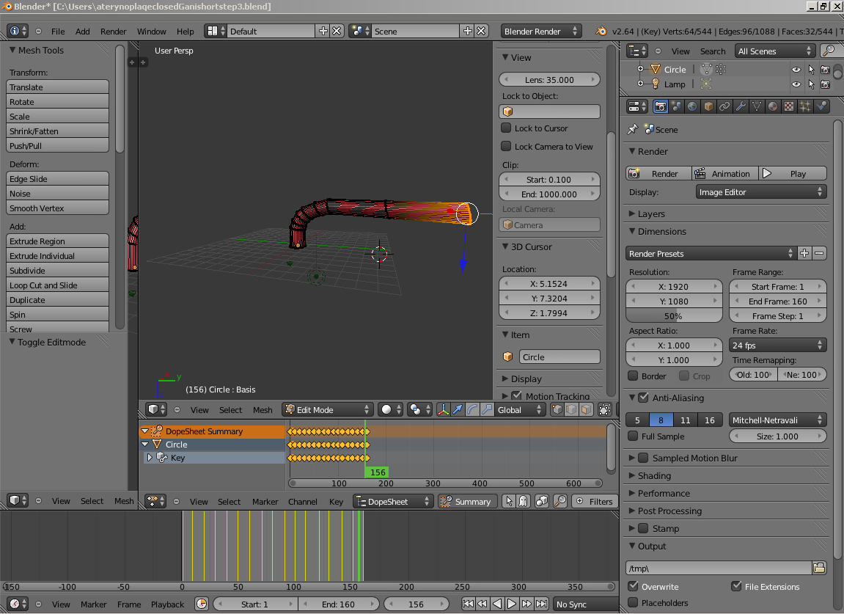

Screen capture 2: zoom into a finished artery
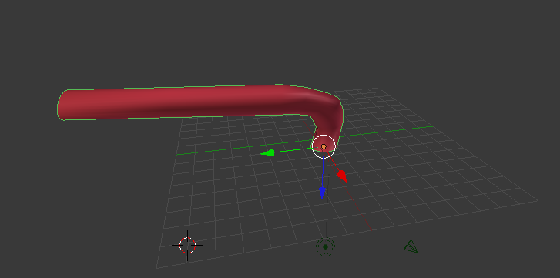
Screen capture 3: zoom into the inside of an artery without plaque
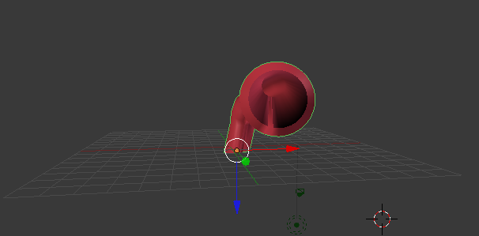

Screen capture 4: close up of plaque inside an artery
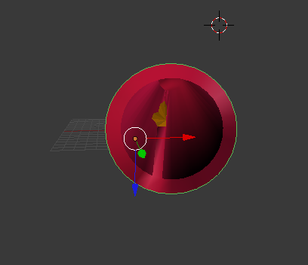
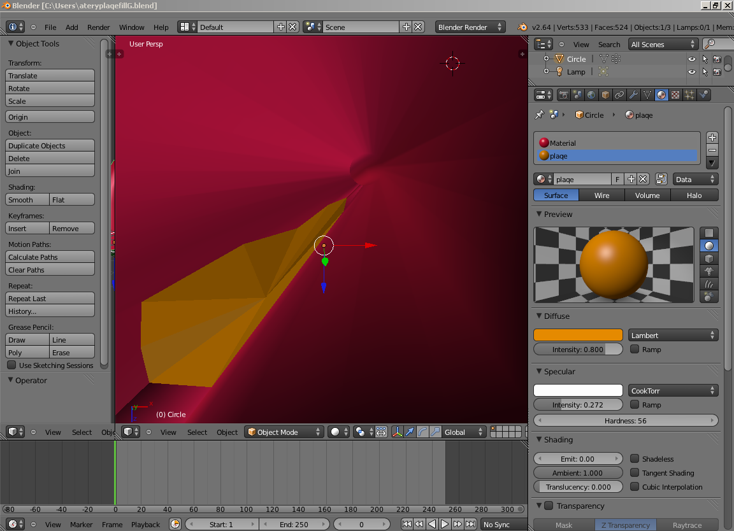
Screen capture 5: zoom into the inside of an artery with plaque

blender animation of the pulsing artery as a movie in a file or a link in github.....

unity fluid dynamics

APPENDIX B
Insert samples of program code here (if applicable)

fluid dynamics programming in c#

