The green arrow will change size below 33% and above 66% pass through / clicked through

The extension takes 2 x measures

1. Top of Funnel
2. Bottom of Funnel

The measure names will be displayed in the visualization

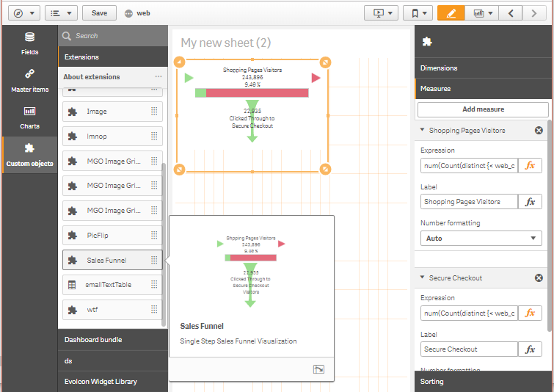

It is possible to set Custom Font Size and change the words, “Clicked Through” to “Passed Through” or whatever is required

