Holly - A Gift Idea Chatbot

Oksana Necio

Dec 14, 2020

Every year during the holidays, many people have difficulty deciding what kind of gift to get for their friends, families, coworkers, etc. Holly is a chatbot that was created to help people decide what to get. It can be used year-round for birthdays and other occasions but was designed mainly with Christmas in mind.

# Instructions

To use Holly, users must use The GNU Prolog console. Before talking to Holly, users must consult both the chat.pl file and the Holly.pl file. After doing that, users must type ‘holly.’ This is shown in the screenshot below.

If users want to see some information about Holly before talking to Holly. They can type ‘info.’ Instead.

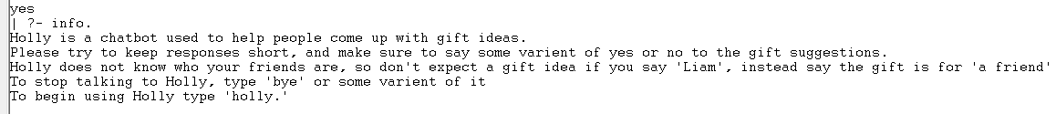

# Examples

Here are some examples of Holly being used. These are included to give a clearer idea of Holly’s capabilities.

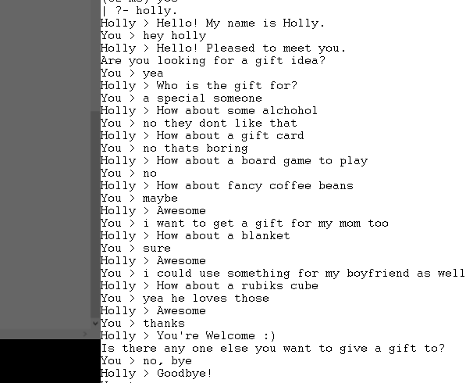

If the user does not want a gift, the following interaction occurs.

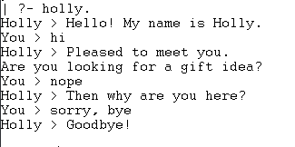

The next example showcases two different things. It shows both what happens when the user tells Holly the gift is for her, and what happens when she does not understand the Input.

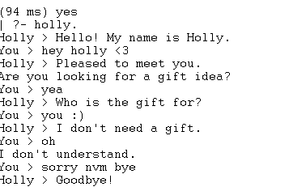

Lastly, if the user asks Holly what something is, Holly will tell them to Google it, since that is not her purpose.

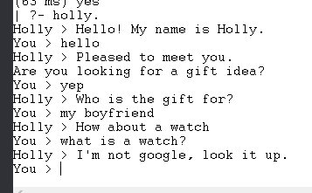

# How It Works

Holly works by finding keywords in the user’s input. Holly can understand many different people keywords such as coworker, teacher, daughter, husband, etc. These keywords are sorted by whether they are masculine, feminine, or neutral. There are three different suggestion lists for these three categories. Once Holly knows who the gift is for, she can go through the appropriate list and suggest items. The lists loop around once the end is reached. There is also a list of responses for when Holly does not understand the users input. Other keywords that Holly recognizes are positive and negative ones such as ‘yes’ and ‘no’ and ‘hello’, ‘thanks’, and ‘bye’ These specific keywords lead to specific responses from Holly.