# Whitepaper: A Comprehensive Guide to Hair Drying Solutions

#### By ChatGPT Haircare Solutions

Contents

Whitepaper: A Comprehensive Guide to Hair Drying Solutions 1

Introduction: The Quest for the Perfect Blowout 2

Traditional Hairdryers: The Old Faithfuls 2

Ionic Hairdryers: Charging Up Your Style 2

Ceramic Hairdryers: Heating Things Up 2

Tourmaline Hairdryers: Bringing Out the Shine 2

Infrared Hairdryers: A Light Touch for Your Locks 2

Titanium Hairdryers: Strength and Style Combined 2

Dual Voltage Hairdryers: Power on the Go 3

Professional Hairdryers: Salon-Quality Style at Home 3

Compact Hairdryers: Big Performance, Small Package 3

Wall-Mounted Hairdryers: Saving Space in Style 3

Conclusion: Finding Your Perfect Match 3

## Introduction: The Quest for the Perfect Blowout

In the eternal quest for the perfect blowout, finding the right hair dryer is half the battle. With so many options on the market, it's easy to feel overwhelmed by the sheer variety of hair drying solutions available. Fear not, dear reader, for we are here to guide you through the tangled web of hairdryer technology and help you find the perfect solution for your styling needs.

## Traditional Hairdryers: The Old Faithfuls

Let's start with the classics. Traditional hairdryers have been a staple of bathrooms around the world for decades, and for good reason. With their simple design and reliable performance, these no-frills dryers get the job done without any fuss or fanfare.

## Ionic Hairdryers: Charging Up Your Style

For those looking to take their blowout to the next level, ionic hairdryers offer a revolutionary solution. By emitting negative ions, these high-tech dryers break down water molecules faster, resulting in faster drying times and smoother, shinier hair.

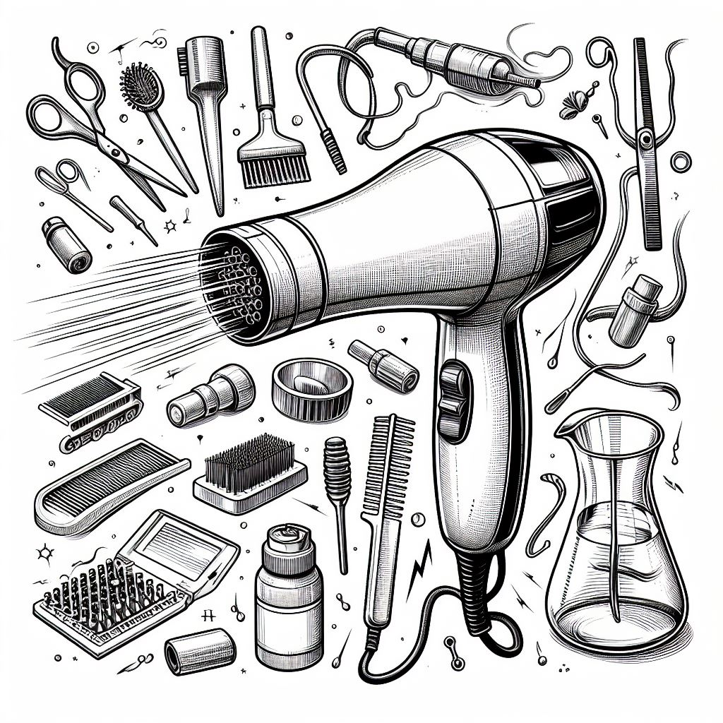

## Ceramic Hairdryers: Heating Things Up

If you're tired of dealing with frizz and flyaways, a ceramic hairdryer might be the solution you've been looking for. By evenly distributing heat and reducing hot spots, these innovative dryers help to seal the hair cuticle, resulting in smoother, more manageable hair.

## Tourmaline Hairdryers: Bringing Out the Shine

For the ultimate in shine and smoothness, look no further than a tourmaline hairdryer. These advanced dryers are infused with tourmaline, a semi-precious gemstone that emits negative ions when heated. This helps to neutralize static and frizz, leaving your hair looking glossy and beautiful.

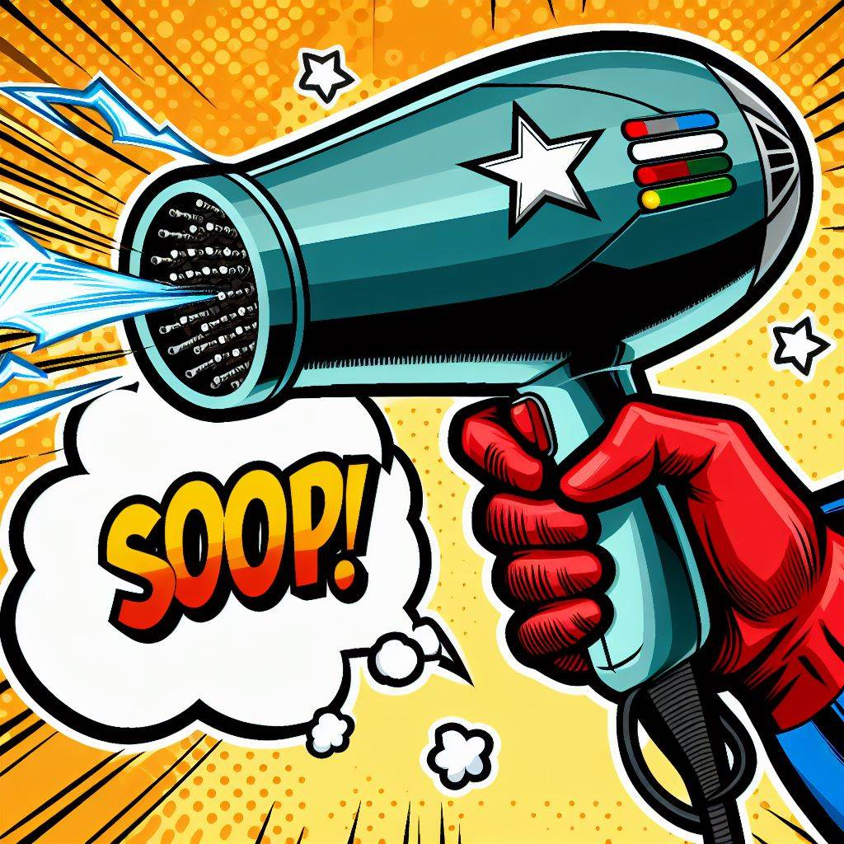

## Infrared Hairdryers: A Light Touch for Your Locks

For those with fine or damaged hair, infrared hairdryers offer a gentle yet effective drying solution. By using infrared heat technology, these dryers penetrate the hair shaft without damaging the outer layer, resulting in faster drying times and healthier-looking hair.

## Titanium Hairdryers: Strength and Style Combined

If you're looking for a hairdryer that's as tough as you are, look no further than a titanium hairdryer. With its ultra-durable construction and powerful performance, this high-tech dryer is perfect for even the thickest, most unruly hair.

## Dual Voltage Hairdryers: Power on the Go

For frequent travelers, a dual voltage hairdryer is an essential accessory. These versatile dryers can be used with both 110-volt and 220-volt electrical systems, making them perfect for use both at home and abroad.

## Professional Hairdryers: Salon-Quality Style at Home

Who says you need to visit the salon to get a professional blowout? With a professional hairdryer, you can achieve salon-quality results from the comfort of your own home. With their powerful motors and advanced features, these high-performance dryers are a cut above the rest.

## Compact Hairdryers: Big Performance, Small Package

Short on space? Not to worry! Compact hairdryers offer all the performance of a full-sized dryer in a smaller, more portable package. Perfect for travel or for use in small bathrooms, these space-saving dryers are a must-have for anyone on the go.

## Wall-Mounted Hairdryers: Saving Space in Style

For the ultimate in convenience and style, consider a wall-mounted hairdryer. These sleek, space-saving dryers mount directly to the wall, freeing up valuable counter space and keeping your bathroom clutter-free.

Conclusion  
  
Finding Your Perfect Match

In conclusion, the perfect hairdryer is out there—you just need to know where to look. Whether you're looking for a basic dryer or a high-tech styling tool, there's a hair drying solution to suit every need and budget. So go ahead, take the plunge, and invest in a hairdryer that will leave you looking and feeling fabulous, every single day.

Note to self: Hairdryer 3000 is purple. Hairdryer 2999 was available in orange, blue and white.