# Overview

In this lab, you will create your first IBM® Bluemix® application by using a boilerplate from the catalog.

## Prerequisites

You need the following account and software:

* An [IBM Bluemix account](https://developer.ibm.com/sso/bmregistration?lang=en_US&ca=dw-_-python-_-watson_-course)
* An Internet Explorer, Firefox, or Chrome web browser

See the prerequisite installation videos at the start of this course for more information.

# Step 1. Create an application on Bluemix

This lab will show you how to deploy a simple application from the Bluemix web interface.

1. In a browser, navigate to one of the following regions:

* <https://bluemix.net>: This link should take you to your default location.
  + [https://console.ng.bluemix.net](https://console.ng.bluemix.net/) (Region: US South)
  + [https://console.eu-gb.bluemix.net](https://console.eu-gb.bluemix.net/) (Region: United Kingdom)
  + https://console.au-syd.bluemix.net (Region: Sydney)

1. Click **Log In** and then enter your login information on the IBM id page and click **Sign in**. You should see your dashboard view:

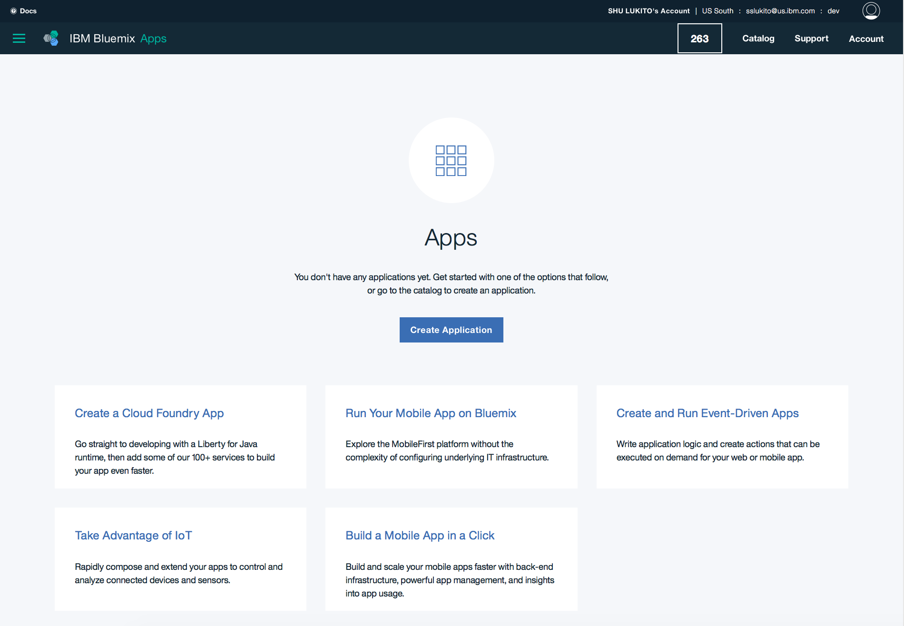

1. Click **Catalog**.

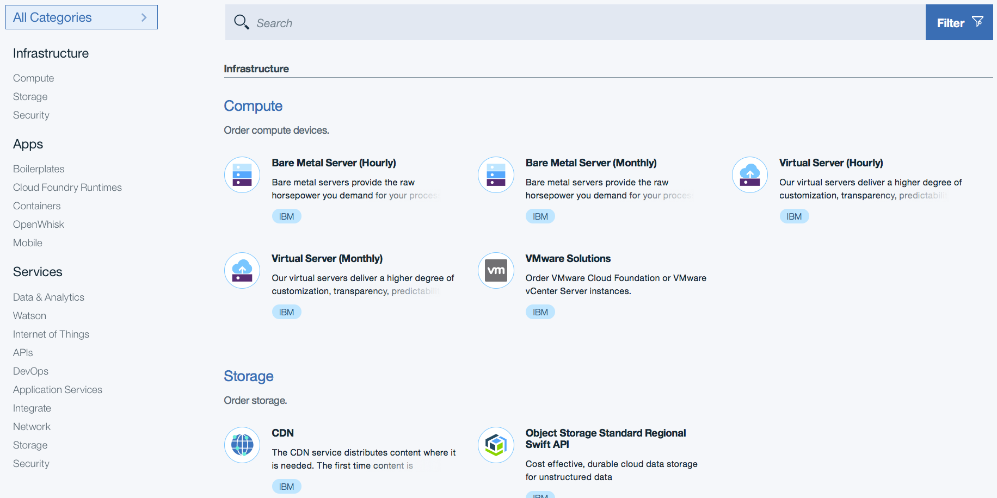

1. Click **Boilerplates >** **Node.js Cloudant DB Web Starter**.

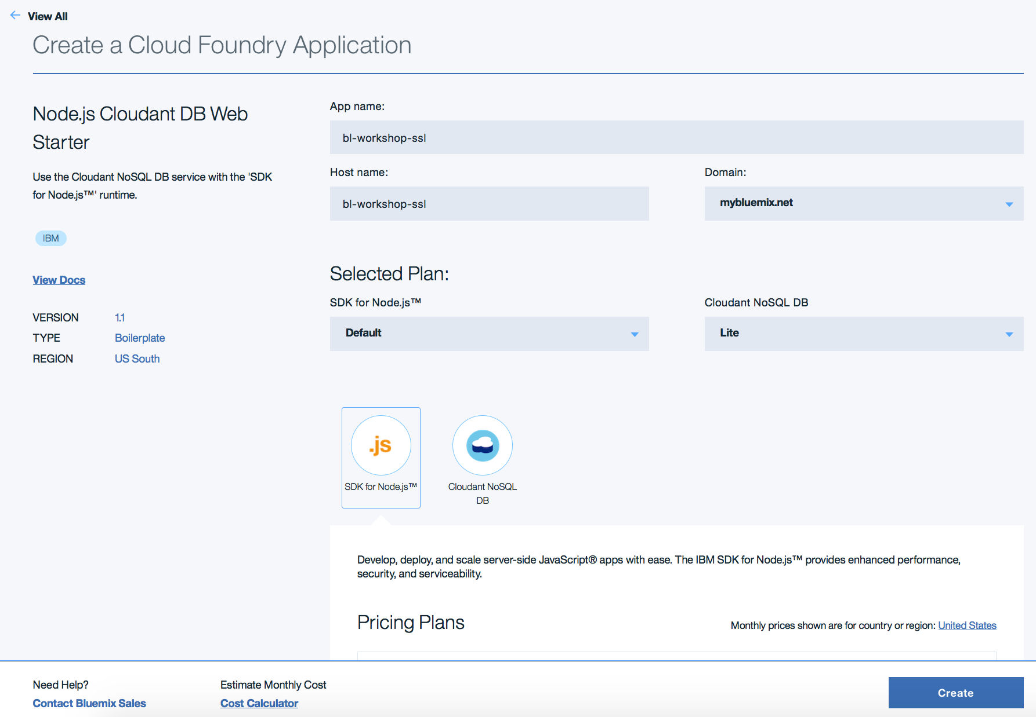

1. Enter a name for your application. The host name information is automatically entered. The host name must be unique on Bluemix, so enter a name with your company name or initials to make the name unique.
2. Click **Create**.

After a short while, your application will start running. Click **View App** to access the application through your browser.

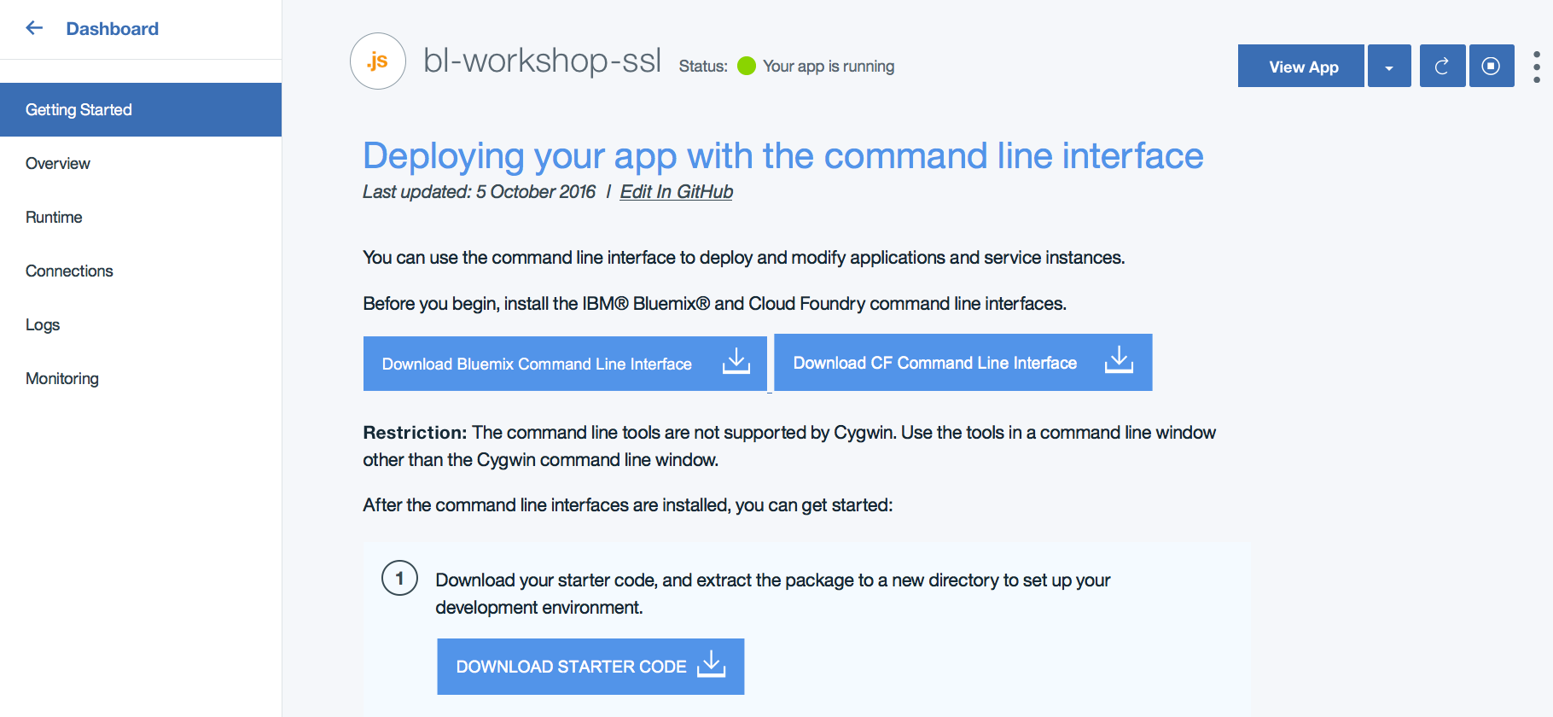

## Summary

You've now added an application to IBM Bluemix. In the following labs, you will learn how to work with this same application from the command-line and Eclipse environments.