Lab: deploy and update the application by using the cf CLI

# Overview

In this lab, you use the cf command-line interface (CLI) to work with IBM Bluemix. The cf CLI is a tool that you will use in a terminal or command window on your workstation.

This lab uses the same sample application that was used in the previous lab “Deploy your first application.”

## Prerequisites

You need the following accounts and software:

* An [IBM Bluemix account](https://developer.ibm.com/sso/bmregistration?lang=en_US&ca=dw-_-python-_-watson_-course)
* Cloud Foundry Command Line Interface (CLI) installed version 6.15 or later
* An Internet Explorer, Firefox, or Chrome web browser

See the prerequisite installation videos at the start of this course for more information.

# Step 1. Obtain the application code and deploy to Bluemix

Starting from the Bluemix boilerplate application that you deployed in the first lab, you will download the application code. Then, you will remove the current application from Bluemix and re-create it by deploying with the Cloud Foundry CLI tool.

1. Click **Getting Started** and then click **DOWNLOAD STARTER CODE**.

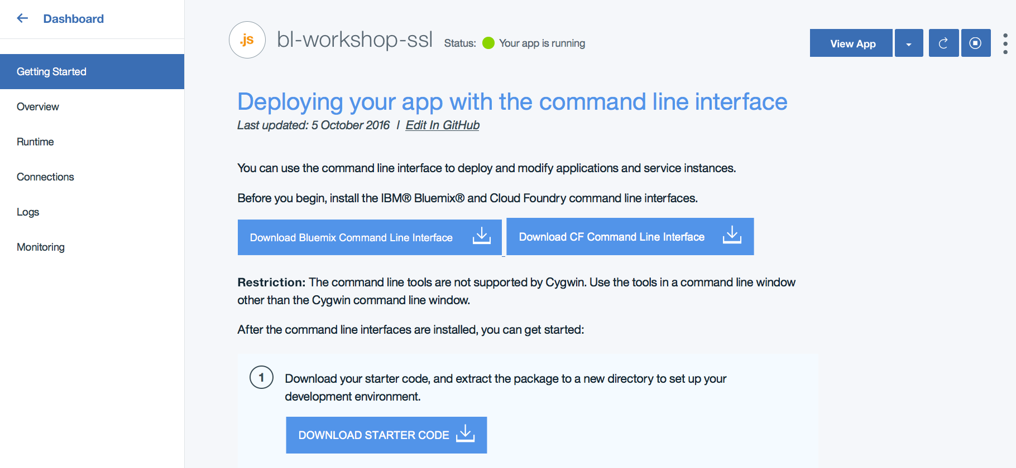

1. After the starter package is downloaded, move it to a directory on your workstation where you want to work, such as the Bluemix directory in your Documents folder.
2. Extract the package by double-clicking or right-clicking and click **Extract All** or **Unarchive** or use a command line tool. Do *not* delete the ZIP file: you will need it in the next lab “Working with Eclipse.”
3. Delete the deployed application so that you can deploy it from the command line. Click the **Overview** page for the application, click the gear wheel in the application, and then click **Delete App**.

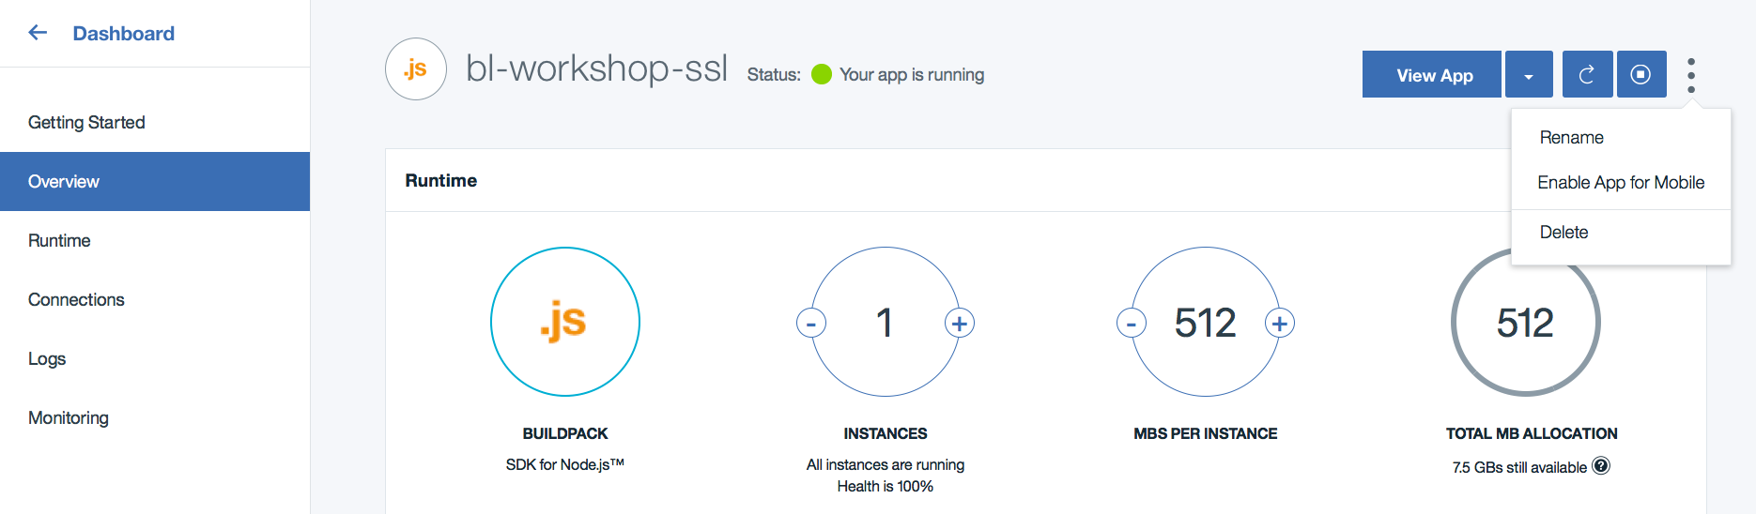

1. Confirm that the service or services and the route for the application will be deleted in the **Services** tab and the **Routes** tab. By default, these check boxes are selected:

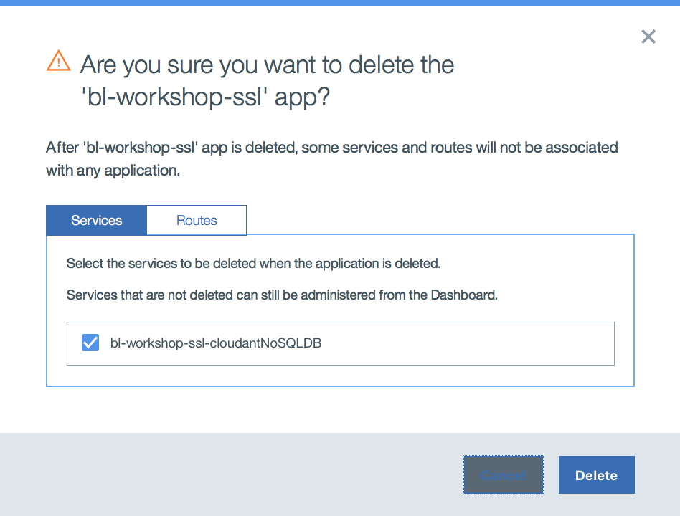 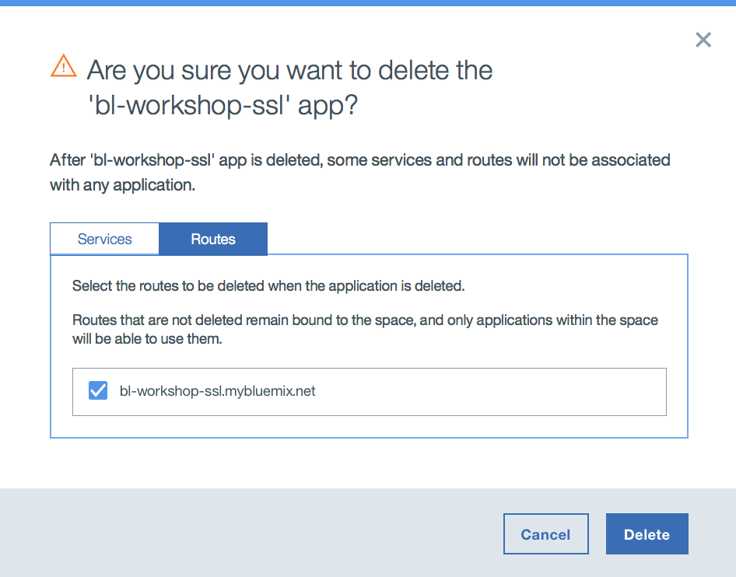

1. Click **Delete** to delete the application.
2. Open a command or terminal window and change the directory to the location where you extracted the downloaded sample application. (The file package.json should be in your current directory.) Note that the cf CLI tool is not supported in a Cygwin bash shell on Windows.
3. Log in to Bluemix by issuing one of the following commands. Use the same region that you used in the Bluemix web UI:

cf l -a <https://api.ng.bluemix.net> *(Region: US South)*

cf l -a <https://api.eu-gb.bluemix.net> *(Region: United Kingdom)*cf l -a https://api.au-syd.bluemix.net *(Region: Sydney)*

1. Enter the email and password that you used to log in to the Bluemix web UI. If prompted, select the organization and space that you want to work in.
2. Before you deploy the application, create a Cloudant database service instance. View the available services by running the following command. This command will take a little while to run because it collects all catalog entries:

cf marketplace

1. In the list of services, find the cloudantNoSQLDB service.

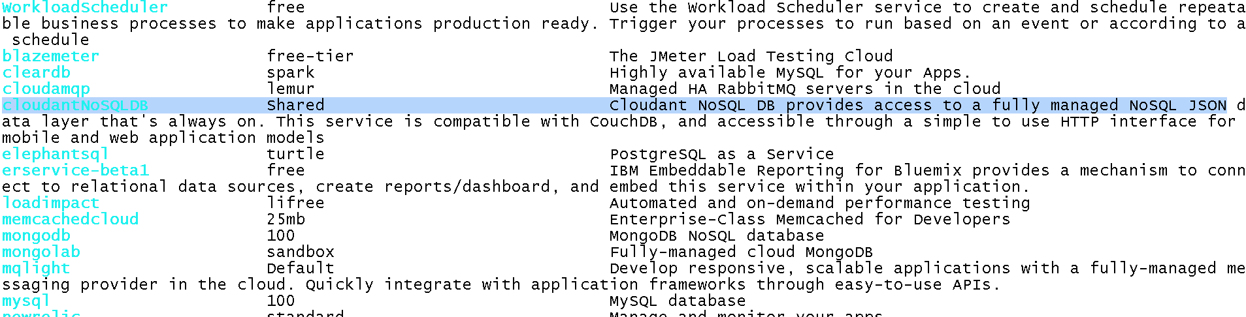

1. Create the service by running this command:

cf cs cloudantNoSQLDB Lite BICloudant

* CloudantNoSQLDB is the name of the service from the cf marketplace command.
* Lite is the name of the service plan that you want to use from the cf marketplace command.
* BICloudant is the name of the service instance that you want to use. Enter your own name rather than BICloudant. You will use this new name when connecting (binding) the service to the application.

1. Refresh your web UI to you see the deployed service.

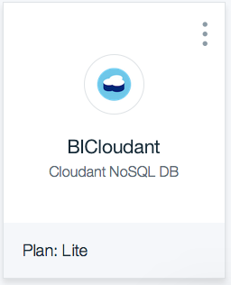

1. Deploy the application.

Push the application to Bluemix by entering the following command. Change the application name to your unique name:

cf push bl-workshop-ssl -c "node app.js" -m 128M --no-manifest --no-start

* bl-workshop-ssl is your unique application name and host name.
* -c specifies the command to start the application.
* -m specifies the amount of memory to allocate to each application instance. The default is 1 GB.
* --no-manifest instructs to CLI tool to ignore the supplied manifest file. This will allow the Cloudant database instance that you just created to be linked to the application.
* --no-start instructs to CLI tool not to automatically start the application.

You don't automatically start the application because it needs a database to run. You must link the Cloudant database instance to the application before you start the application. In Cloud Foundry, the action of linking is described as binding the service instance.

1. Link the database and application by using the following command. Substitute the application name and service instance names that you used previously:

cf bs bl-workshop-ssl BICloudant

* bl-workshop-ssl is the unique application name used to deploy.
* BICloudant is the service instance name used when the service is deployed.

If you refresh the web UI, you see that the application and service are linked, but the application is still stopped.

1. Start the application by running the following command. Substitute the name of your application:

cf start bl-workshop-ssl

* bl-workshop-ssl is the application that you want to start.

If you refresh the web UI, you should see the application running. If not, you can start the application from the Bluemix Dashboard.

1. 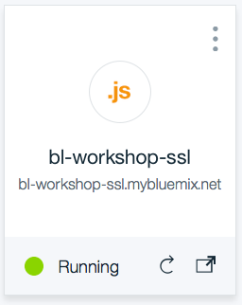Launch the application by clicking the route in the web UI. In this image, the route is bl-workshop-ssl.mybluemix.net.

# Step 2. Modify the application and republish to Bluemix

With the application deployed from your development workstation, you will now make a simple change to the application and then republish it to Bluemix.

1. In a text editor, open the file app.js and modify the name of the file, the file description, and the value (lines 344, 345, and 348):

* Line 344: Change the docName from 'sample_doc' to 'test_doc'
* Line 345: Change the docDesc from 'A sample Document' to 'A test Document'
* Line 348: Change the value from 'A sample Document' to 'A test Document'

Save the file when you’re finished editing.

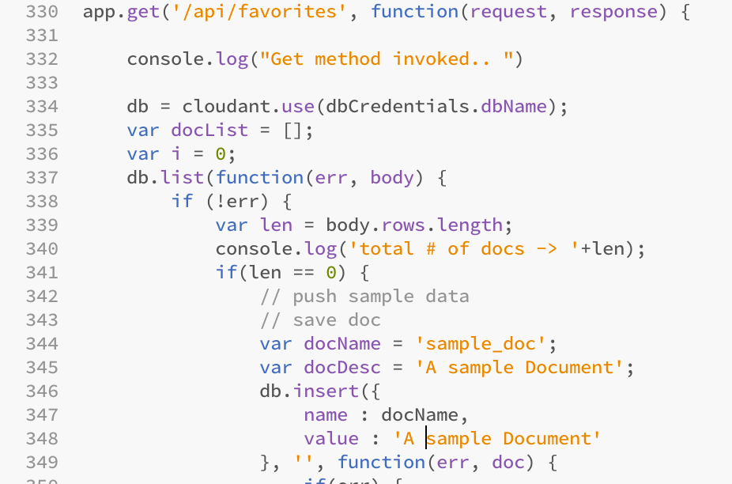

When the application starts for the first time, it creates a sample document in the database.

You just modified the code that creates the sample document in the database. Now, you will delete the document from the database and then restart the application to allow the database to be populated with the modified document.

1. In the Bluemix web UI, select the Cloudant Service instance.

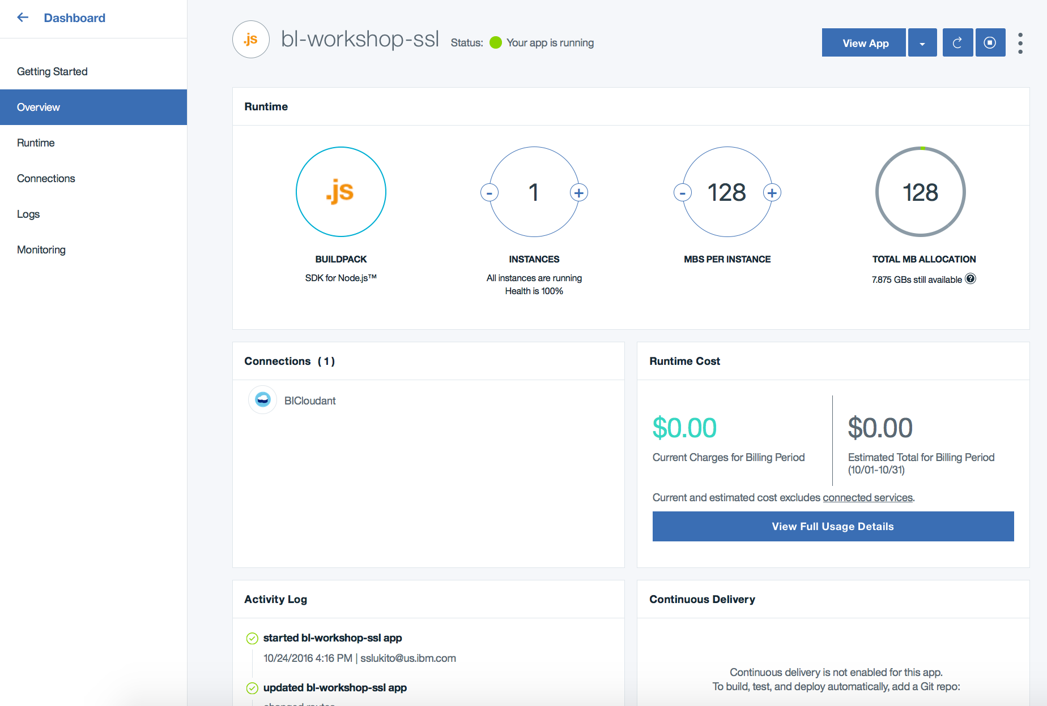

1. Launch the Cloudant console.

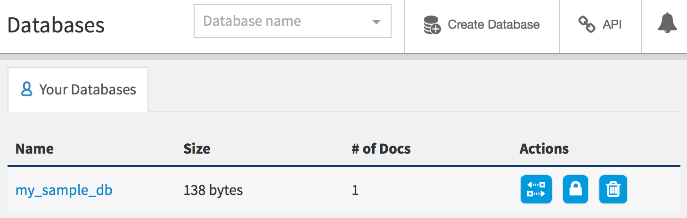You now see a single database. Select the database by clicking on the name:

1. Edit the database document by clicking the pencil icon:

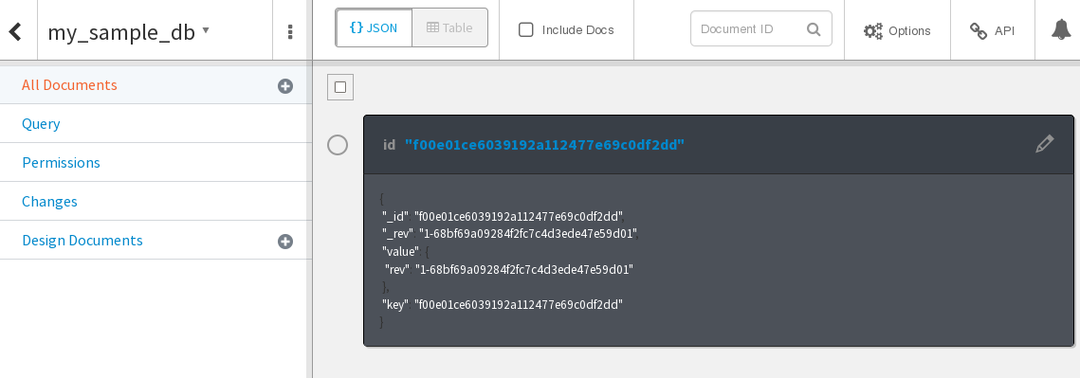

1. 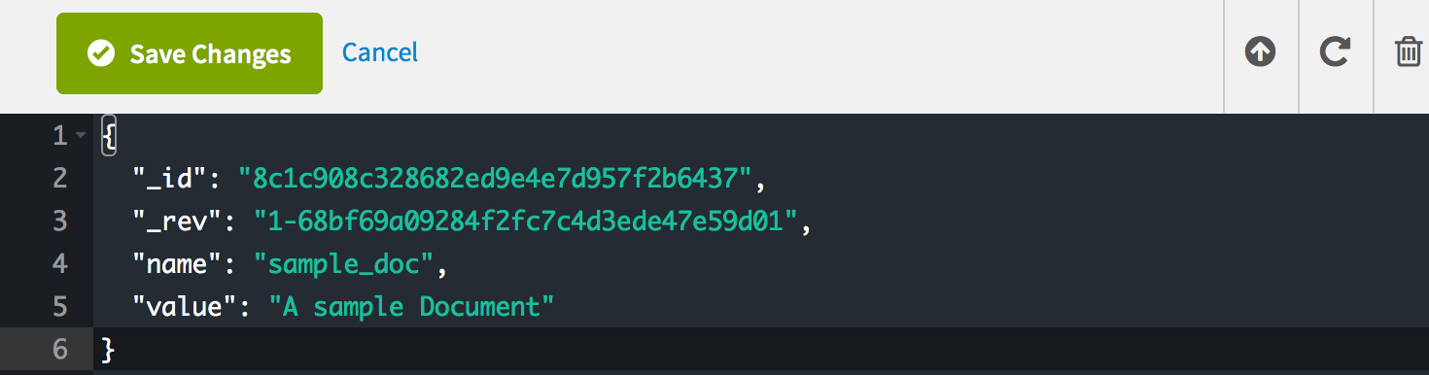Delete the document by clicking trash icon.
2. 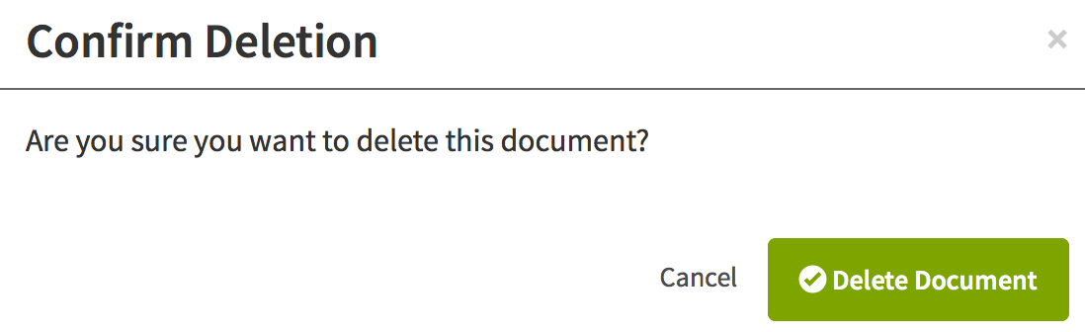Confirm the deletion when prompted.
3. Redeploy the updated application with the push command. This time, you don’t need to include the --no-start or -m parameters.

cf push bl-workshop-ssl -c "node app.js" --no-manifest

1. After the application is restarted, test it to ensure that your changes are now running.

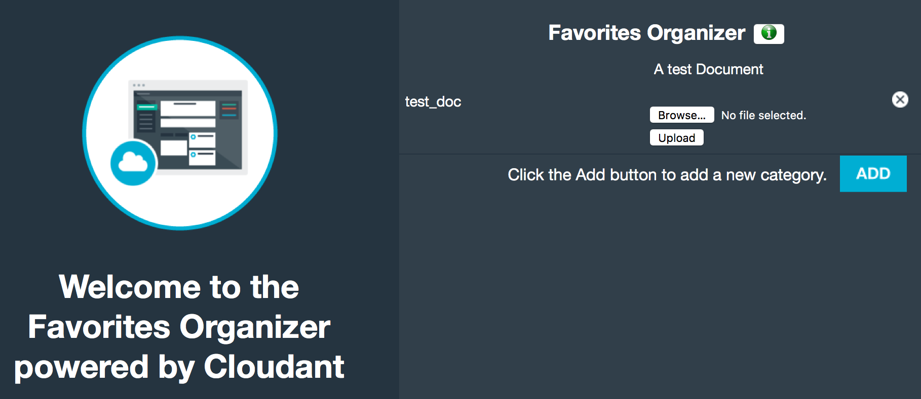

After the application is tested to confirm that the modified code is running, you can delete the application to release resources for the next lab.

1. Delete the application and service and confirm the deletion by running the following two commands:

Delete the application: cf d bl-workshop-ssl –r

* + bl-workshop-ssl is the application name to be deleted.
  + -r instructs Bluemix to also delete the routes attached to the application.

Delete the service: cf ds BICloudant

* BICloudant is the name of the service instance to be deleted.

Confirm that the application and service were deleted by checking the dashboard in the Bluemix web UI.

## Summary

In this lab, you learned how to use the Cloud Foundry CLI tool to manage an application including deployment, binding application services, and deleting the application.