

Central Management System

**Executive Summary**

The CMS will be the central storehouse for all our content, including but not limited to audio, video, images, text etc. with complete metadata. It will be the single point repository for secure content disbursement through multiple levels of security, key locking systems etc, which can be accessed only by key personnel with the right authorization and administrative access.

This will provide a workflow for secure content ingestion, editing and deployments to various partner destinations like Nokia, iTunes, various telcos, YouTube etc. with a **recorded audit trail**.

The CMS will also host Calendar of Events, and will facilitate alerts for timely deployments for any event.

It will provide a dashboard to the senior management about our content and activities undertaken by all the CMS users.

**CMS Features**

The CMS has a dashboard from where one can navigate across the repository.

The CMS is organised hierarchically with branches. There is the core content, which includes Audio, Video, Image and Text. These then are part of albums. An album can contain more than one type of medium. For example, an album can contain only songs, only videos, only images, or a combination of these media. The albums then are part of a catalogue. Examples of catalogue include Devotional (South), Non-Film (Gujarati) etc.

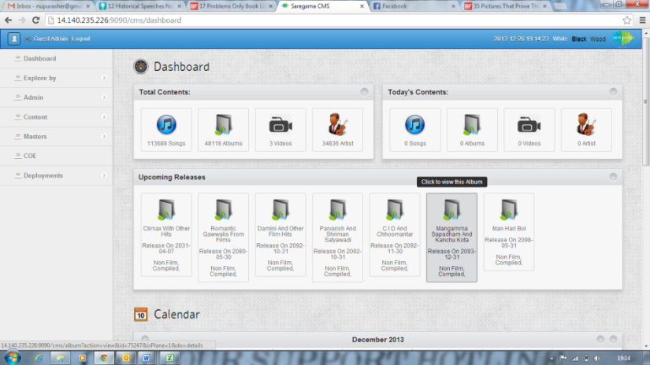**Dashboard**

After logging in, the user is taken to the dashboard, which gives a summary of the content present on the CMS. When you scroll down, you are taken to a calendar which shows the event on the days in the current month

The left navigation contains a Dashboard, Explore by, Admin, Content, Masters, COE and Deployments icons.

1 Dashboard

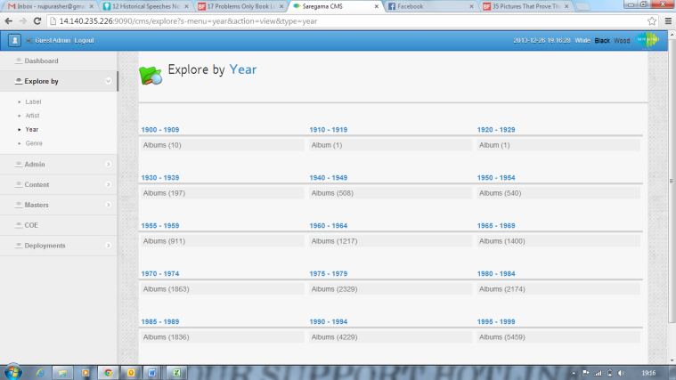**Explore By**

When one goes to explore by, one gets the options of exploring by Label, Artist, Year and Genre.

2 Explore by: Year

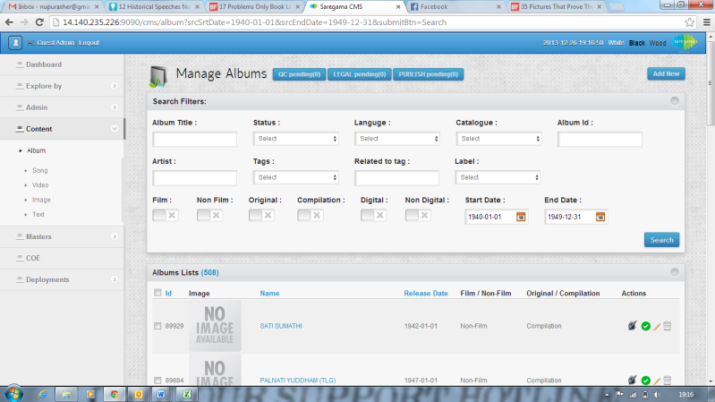

When one makes a selection from the explore by tab, one is taken to the relevant content tag. The Explore by tab functions like a filter to the content tab.

A selection from explore by genre takes you to the relevant songs in the selected genre.

3 Redirect from Explore by: Year to Album

**Admin**

In the Admin tab, one sees Manage editor, manage role, User Activities and Clean-up.

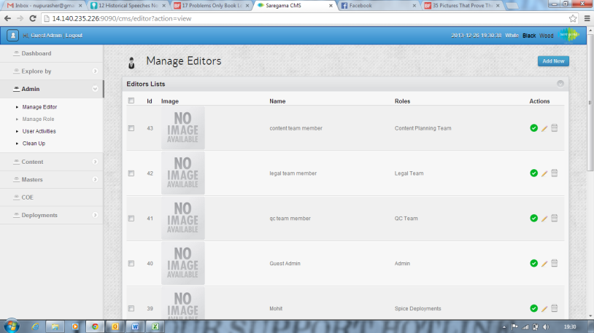

The manage editor tab shows the details of the different users/editors using the CMS.

4 Manage Editors

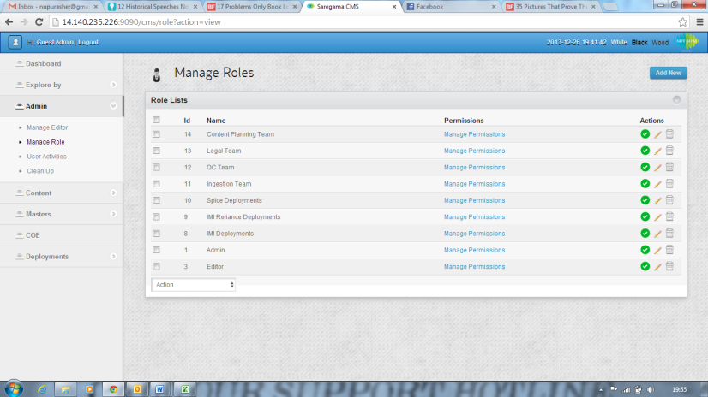

The Manage Role tab shows what sort of permissions the different classes of users have, and persons with admin rights can also make changes to the permissions.

5 Manage Roles

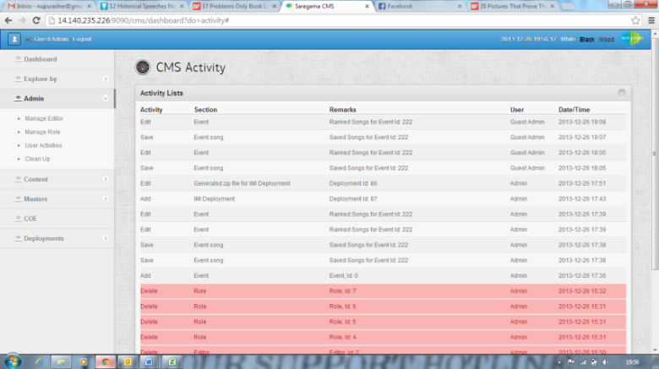

The User Activity page shows all the activity on the CMS.

6 CMS Activity

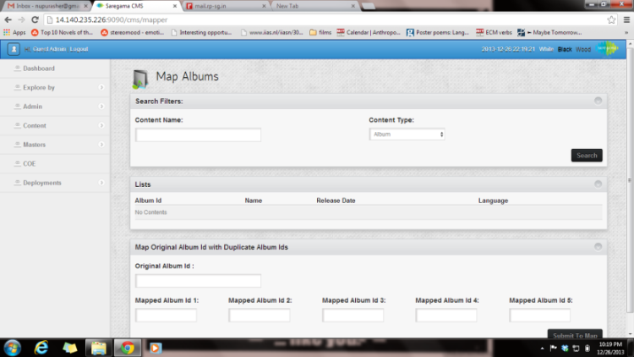

The Clean Up page takes the user to a page called Map Albums, where one can catch the duplicates etc.

**Content**

7 Clean Up

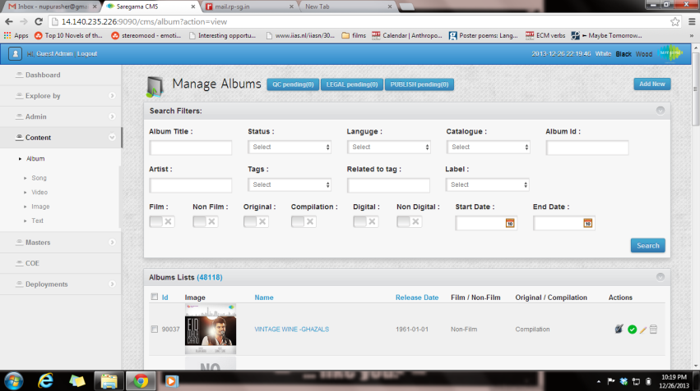

The Content navigation contains Album, Song, Video, Image and Text.

8 Album

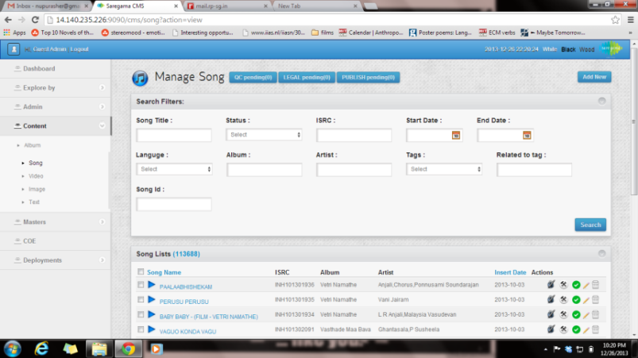One can view the core content through this navigation system. On the top of each of these types of content, there is a search bar, and some additional filters to make the searches better and more specific.

When one selects an Album, one further finds its components which are Songs, Videos, Images, Text or a combination of the given media.

9 Songs

**Masters**

The Master tag includes the fields that remain more or less the same. These fields don’t change with the addition or deletion of content. It includes tags like Artist, Banner, Catalogue, Language, Label, Region, and Tags.

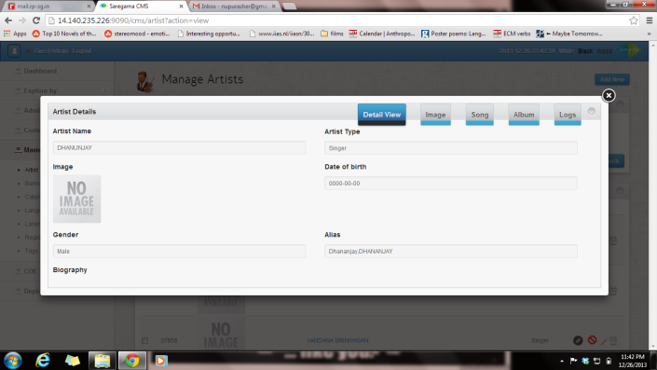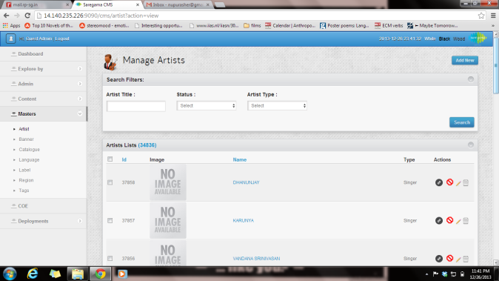

10 Artist

11 Artist Detail View

When you go to the Artist field, you get a list of all the artists, and when you select an artist, you get a list of all the content they are tagged in.

Right now, the rest of the tags seem to be lists, but eventually there will be content convergence for everything.

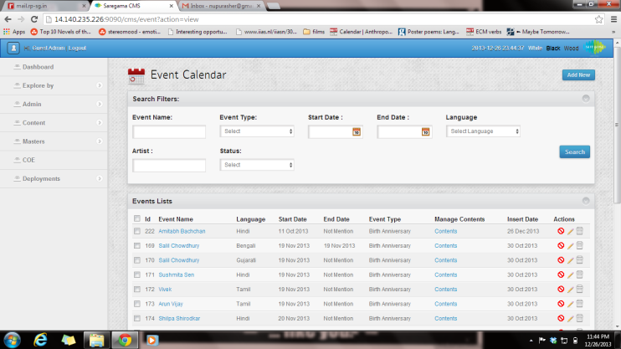**COE**

The Calendar of Events tab contains a list of the events, where one can select a particular event, and then add content for the event. There is also a short description of the event. Further there are tags like event type and language.

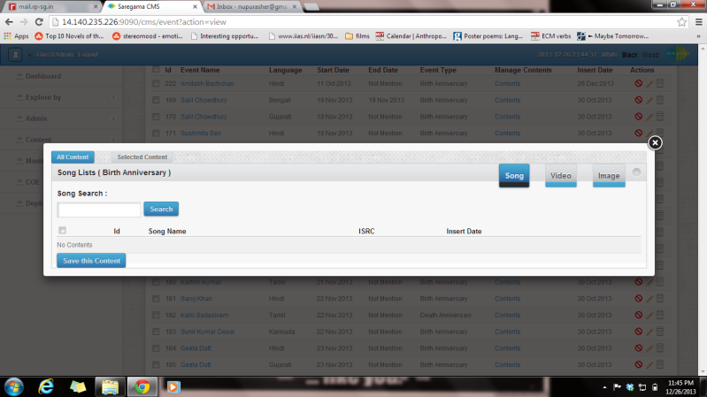

When one clicks on the contents in the COE page, one gets a toolbar where one can add content relevant to the event.

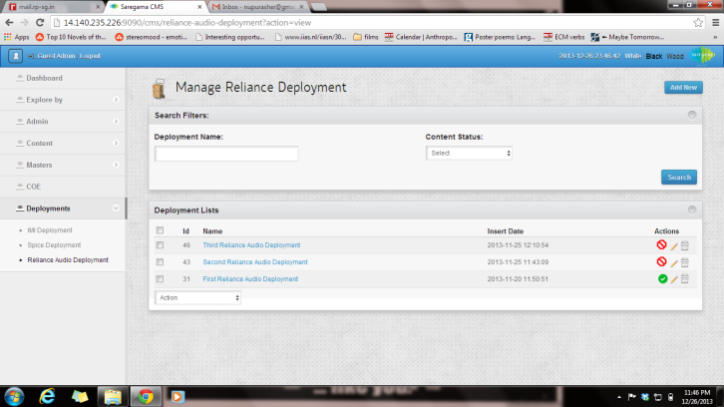

**Deployments**

The deployments page contains a few examples of the deployments that take place to third party partners. The interface selects content and deployment platform, and creates zip file containing the binary (content) and the metadata.

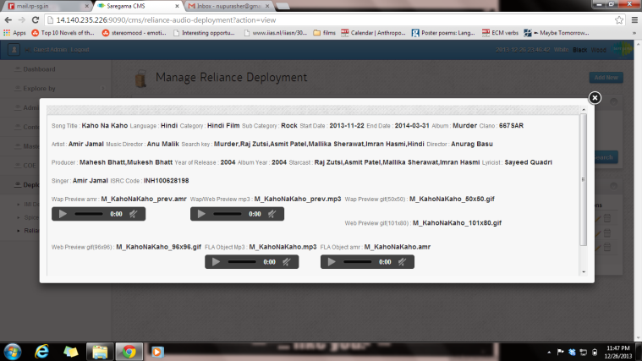

**FEEDBACK: CMS NAVIGATION**

Having gone through all the functions of the CMS, below is a feedback and review on the navigation experience, along with a few proposed additions that can enhance content planning and deployment.

**CHANGES suggested to be made in the backend.**

1. Download reports from all the clients need to be incorporated under a REPORTS section. The revenue part could remain undisclosed if confidential. This needs to be refreshed at regular intervals. This would help in planning top songs, popular songs, and bestselling songs as per the consumption trend. A combined, aggregated count should also feature in the CONTENT and COE sections.

**CHANGES UNDER – CONTENT & COE**

1. Firstly there isn’t much of a difference in the CONTENT and the COE section. The only difference is that one can select the songs and rank them (manually) to create a playlists. However, this can also be done under the content tab with the help of the download reports mentioned earlier. The download report has to be integrated with the metadata details. Thereby allowing the planner to sort the selected tracks as per the consumption.
2. Similarly a deployment report should also be incorporated for all the clients along with the unique codes that get generated post-deployment, i.e every content piece should be tagged with the client name, live statuses and content id or CRBT code. This will help while planning for particular services like WAP/CRBT/WEB/YOUTUBE and operators like VODAFONE/AIRTEL/IDEA etc.
3. The COE section **must** be linked with reports and consumption trends. Once an event is created under this section, any content that has been ingested under the CONTENT section must get populated under the event depending upon the tags and keywords. Thus, creating an auto-playlist for that particular event.
4. Additional search tag “CLIENT” to be added, with a dropdown featuring AIRTEL, VODAFONE, IDEA, MTS, RELIANCE, etc.
5. Additional search tag “SERVICES” to be added, with a dropdown featuring WAP, IVR,CRBT, WEB, YOUTUBE, VOD, etc. The existing filter “Song id” could then be used to search with ids pertaining to a particular service, viz. VODAFONE – CRBT - <CRBT Code>
6. A preview player needs to be added to play each content.
7. A provision to export selected tracks into an excel format will help in sharing playlist with internal or external clients. This could also be useful for content research and analysis. While doing this, it would be great if there is an intermediate page which will help in picking the meta headers/format in which the export is required.
8. A provision to select the number of tracks shown on the page will help in picking the desired number contents and then exporting it if required.
9. Currently, the search under COE – (New event) has only artist tab. It needs to be enhanced with other events and festivals too. In fact, the COE section could be called SPECIAL PLAYLISTS which could feature unique playlists that may include not only celebrity birthdays and events and festivals but also playlists created on special requests like a romantic special, top duets, hits of 90’s, wedding songs special, monsoon special, etc. The search could be flexible and not limited to artists. As mentioned earlier, the COE tab will only hold importance if it is backed with download counts. The playlist once created should get shuffled automatically depending on the consumption trends and also newly ingested contents.

## Work Flow:

* **The CMS will store:**
* **Albums**
* **Songs**
* **Artists**
* **Videos**
* **Wallpapers**
* **Animations**
* **Text Contents**

## Album:

* Album Type: Film/Non-Film, Original/Compilation, Digital/Non-digital.
* Mandatory Fields: Album Name, Language, Coupling IDs, Music Release Date, Description, Excerpt, Grade, Film Rating.
* Artists (Starcast, Director, Producer, Writer) are tagged with Album.
* Album Rights (legal) Information.

## Song:

* Mandatory Fields: Song Name, ISRC, Song Duration, Audio File, Artists (Singer), Version, Genre, Mood, Region.
* File Upload: Browse on local machine or browse on Server.

## Artist:

* Mandatory Fields: Artist Name, Artist Role
* Artist Roles ( Starcast, Music Director, Lyricist, Singer, Director, Producer, Writer, Mimicked Star, Poet)
* One Artist can have multiple Roles.

## Video:

* Mandatory Fields: Video Name.
* File Upload: Browse on local machine or browse on Server.
* Video can be tagged to album/Song.

## Image:

* Image can be Wallpaper, Animation, Content Art
* Tagged with Artist, Albums.
* File Upload: Browse on local machine or browse on Server.

# Text:

* Text Type: sms, trivia.
* Tagged with Artist, Albums.

# Content Migration:

* Video Files
* Song Files
* Image Files

# Editing and Conversions:

* Video/Song/Image: Editing will be done manually
* Video/Song/Image: System can create different file format.

# Legal Information:

* Content (Songs, Videos, Images, Text, Album) will follow work flow and Legal Approval part is mandatory for this.

# Quality Check (Publishing Right):

* After verifying all details the user with Quality Check rights can publish/unpublish Records.

# Calendar of Events:

* All Content (Songs, Videos, Images, Text, Albums) can be tagged with event.

# Deployments:

* We deploy our content to around 40 different platforms.
* Deployment Methods:
* APIs Based ( e.g.: YouTube )
  + We may deploy all published content (Videos, Songs) automatically or we can provide interface to deploy selected contents.
* FTP Deployment:
  + Current process:
  + Interface to select Content and deployment platform.
  + System will create zip file containing binary and metadata.
  + Do FTP this to client location.
  + Send e-mail confirmations.
* Manual Deployment:
  + Interface to select Contents
  + System will create zip file containing binary and metadata.

## Proposed Timeline for CMS:

**Current Challenges**

* Currently, all our metadata is stored on excel sheets, and anyone can access it.
* Deployment is a completely manual process, which is time consuming and the margin of error remains high.
* Information tends to go back and forth through emails, and keeping a track of all the changes becomes very difficult.
* Deployments take place without any audit trails or automations. In such cases, accountability remains low, and it becomes increasingly difficult to make timely and error free deliveries.

**Mitigation of Current Challenges**

* Currently, all our metadata is stored on excel sheets, and anyone can access it. Once the CMS is in place, the metadata will all be stored centrally, and access will be restricted
* Deployment is a completely manual process, which is time consuming and the margin of error remains high. The CMS will resolve this because then deployments will be done through the CMS, and duplications will be avoided. Errors will become fewer, and their source of origin will be traced easily.
* Information tends to go back and forth through emails, and keeping a track of all the changes becomes very difficult. There will be a record of all changes made, along with a record of the personnel making the updates.
* Deployments take place without any audit trails or automations. In such cases, accountability remains low, and it becomes increasingly difficult to make timely and error free deliveries. The CMS will ensure audit trails and automations. This will lead to an increase in accountability. Deliveries will become much easier, because manual inputs will be much lower, and be on time.

**Enhancement of Current Ops**

The high points of the CMS are:

* It is User Friendly, and navigation is intuitive
* It will be the centralised repository where one can access all content in different specifications and formats from one place- making compilations, COE deliveries, and third party deployments easy, error free and fast.
* It will make the deployment process more automated than it currently is.
* One can tracks changes made by different persons at different points of time.
* One can also keep track of when a deployment is done, and by whom.
* It will give limited rights to people only in the fields they are responsible for. This will keep processes streamlined and organized. It will avoid inadvertent errors.

**Conclusion**

The CMS is a much needed intervention. It will resolve many issues and clear out a lot of bottlenecks that have been affecting deliveries.

It will also ensure that metadata remains clean, and any corrections/clean-ups made are visible to all concerned personnel.

File transfers will become much more secure, and performance of all parties concerned will be enhanced.