1) go to this site: "https://discord.com/developers/applications" and make a bot and name it however you want and click create

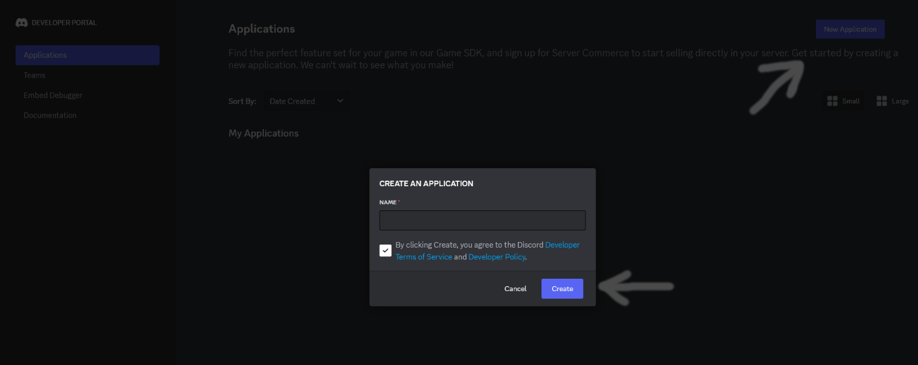

2) then click the “Bot” button and click reset token

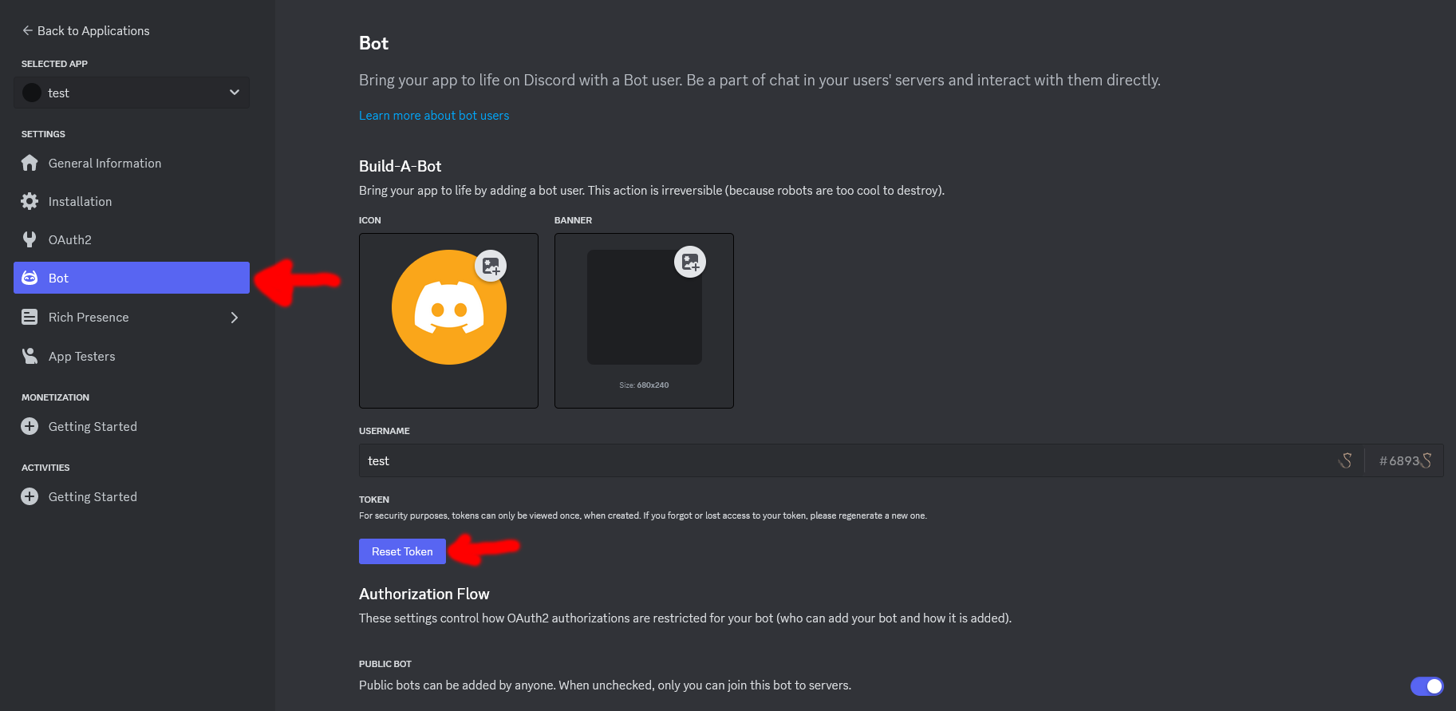

3)copy the token and paste it in the “BOT_TOKEN” area of the code

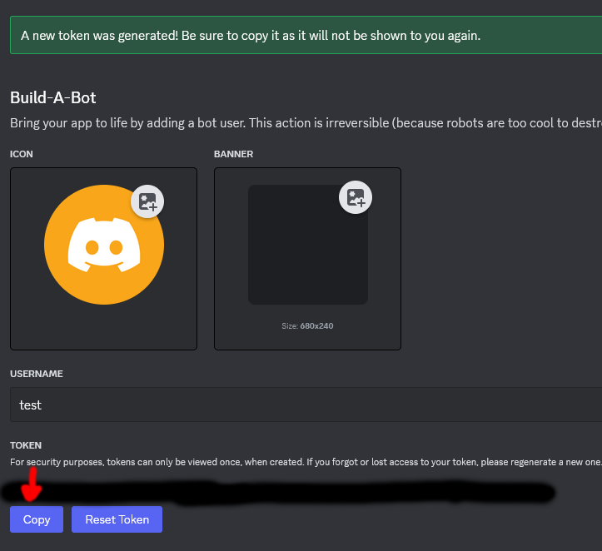

4)then go to your channel that you want the bot to be active in and right click it and select copy channel id And paste the channel id into “TARGET_CHANNEL_ID” part of the code

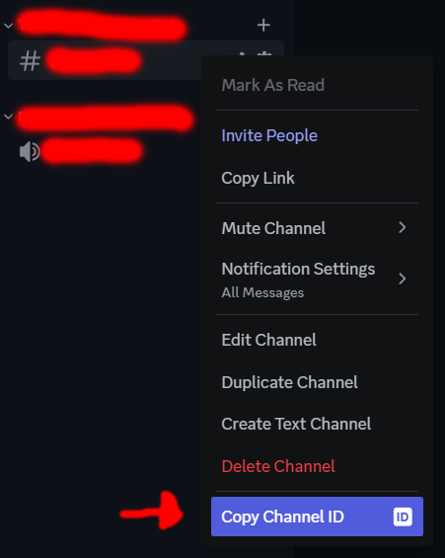

5) (OPTIONAL) then select the channel id of the channel that you want all tik Tok links to go and paste The channel id into the “DELETE_CHANNEL_ID” part of the code

## 6)add the bot into your server via OAuth2 in that site which you used to create the bot Just go to that tab and click add redirect and add your server link in the text input thingy there

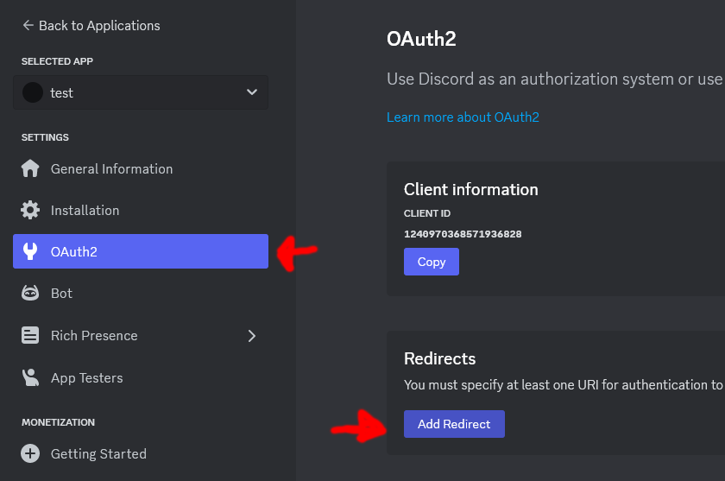

Then press all of the buttons as showed in the photo below

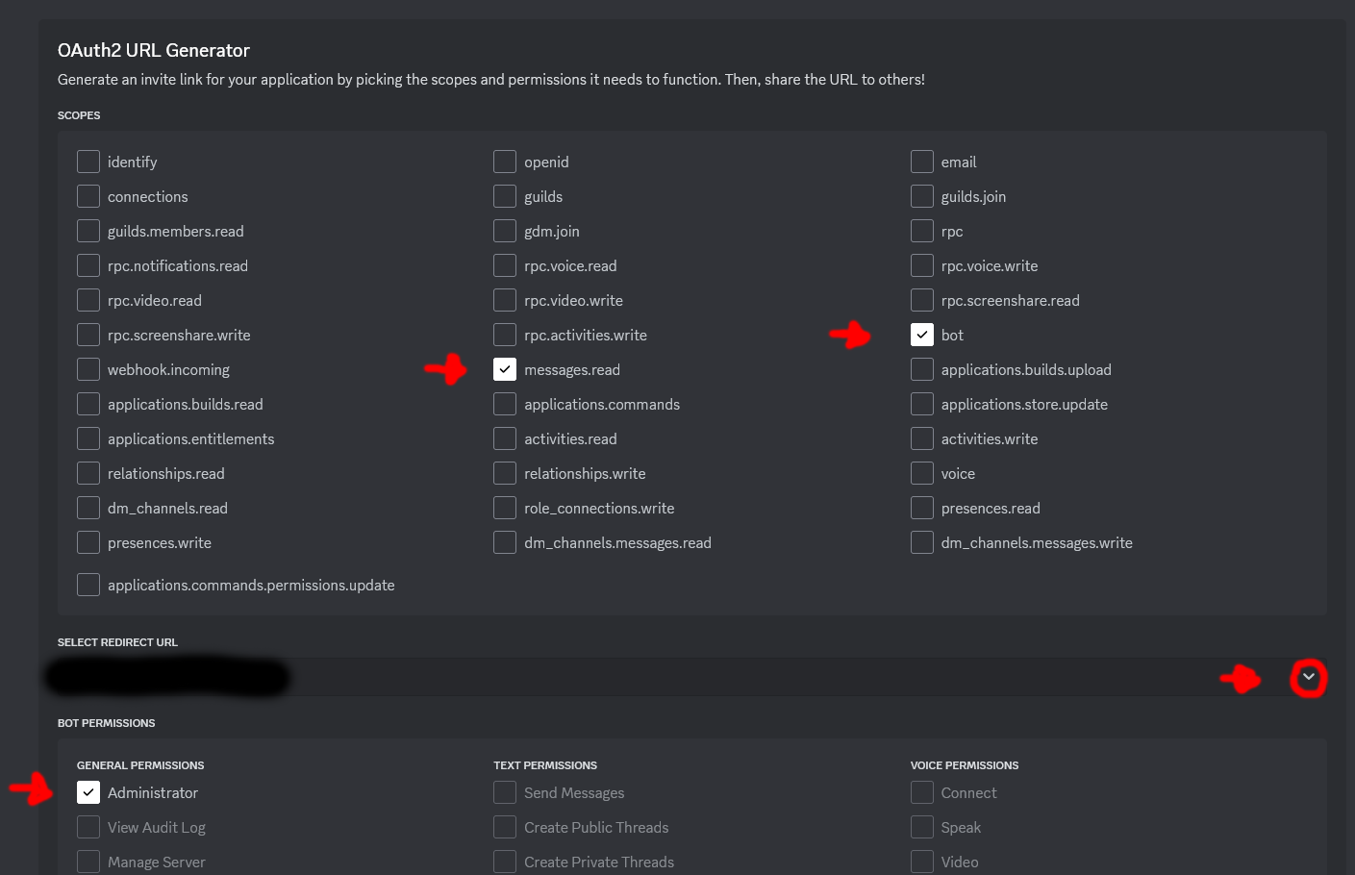

Then press copy link and enter it from a browser and connect the bot to your server

Now the bot should display as a member of your server

7)now run the python script and watch these tik Tok messages disappear*. Just make sure that the bot is online after the start of the scipt

*only those messages that are sent after the start of python script will disappear

made by plaui