**Computer Communications and Networks (COMN)**

**2022/23, Semester 1**

**Assignment 2 Worksheet**

|  |  |
| --- | --- |
| **Forename and Surname:** | Nikita Peleshatyi |
| **Matriculation Number:** | 2150635 |

**Question 1** – Number of retransmissions and throughput with different retransmission timeout values with stop-and-wait protocol. For each value of retransmission timeout, run the experiments for **5 times** and write down the **average number of retransmissions** and the **average throughput**.

|  |  |  |
| --- | --- | --- |
| **Retransmission timeout (ms)** | **Average number of**  **retransmissions** | **Average throughput**  **(Kilobytes per second)** |
| 5 | 867.20 | 35.75 |
| 10 | 416.00 | 37.67 |
| 15 | 255.20 | 37.01 |
| 20 | 233.00 | 35.45 |
| 25 | 141.60 | 35.00 |
| 30 | 146.60 | 33.53 |
| 40 | 109.20 | 30.23 |
| 50 | 106.20 | 28.67 |
| 75 | 102.80 | 24.09 |
| 100 | 100.20 | 21.49 |

**Question 2** – Discuss the impact of retransmission timeout value on the number of retransmissions and throughput. Indicate the optimal timeout value from a communication efficiency viewpoint (i.e., the timeout that minimizes the number of retransmissions while ensuring a high throughput).

10[5]ms seems to be the optimal timeout value as the pattern seems to reverse past it, that is, higher timeout values begin to cause the throughput to decrease as timeout delay for a missing packet takes significantly more time than RTT slowing down the entire application and bringing throughput down.

**Question 3** – Experimentation with Go-Back-N. For each value of window size, run the experiments for **5 times** and write down the **average throughput**.

|  |  |  |  |
| --- | --- | --- | --- |
|  | **Average throughput (Kilobytes per second)** | | |
| **Window** **Size** | **Delay = 5ms** | **Delay = 25ms** | **Delay = 100ms** |
| 1 |  |  |  |
| 2 |  |  |  |
| 4 |  |  |  |
| 8 |  |  |  |
| 16 |  |  |  |
| 32 |  |  |  |
| 64 |  |  |  |
| 128 |  |  |  |
| 256 |  |  |  |

Create a graph using the results from the above table (empty example graph shown below):

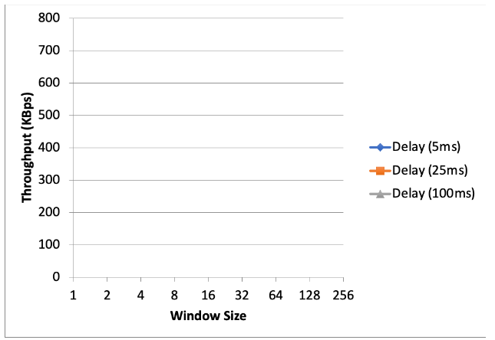

**Question 4** – Discuss your results from Question 3.

**Question 5** – Experimentation with Selective Repeat. For each value of window size, run the experiments for **5 times** and write down the **average throughput**.

|  |  |
| --- | --- |
|  | **Average throughput (Kilobytes per second)** |
| **Window Size** | **Delay = 25ms** |
| 1 |  |
| 2 |  |
| 4 |  |
| 8 |  |
| 16 |  |
| 32 |  |

**Question 6** - Compare the throughput obtained when using “Selective Repeat” with the corresponding results you got from the “Go Back N” experiment and explain the reasons behind any differences.

**Question 7** – Experimentation with *iperf*. For each value of window size, run the experiments for **5 times** and write down the **average throughput**.

|  |  |
| --- | --- |
|  | **Average throughput (Kilobytes per second)** |
| **Window Size (KB)** | **Delay = 25ms** |
| 1 |  |
| 2 |  |
| 4 |  |
| 8 |  |
| 16 |  |
| 32 |  |

**Question 8** - Compare the throughput obtained when using “Selective Repeat” and “Go Back N” with the corresponding results you got from the *iperf* experiment and explain the reasons behind any differences.