**ScreenInfo v1.5**

##### **一.Features**

1. Compare screen resolution information.
2. Compare Displaylink Chip name.

##### **二.Program Architecture**

1. Open the program.
2. Obtain all screen information from the system.
3. List the obtained information as comparison items.
4. Compare the system screen information with the comparison items to see if they match.
5. Display in green if they match, otherwise display in black.
6. If all comparison items match successfully, the result box on the right displays "PASS."

##### **三.** **Program Flowchart and Function Introduction**

1. Program Initial Screen

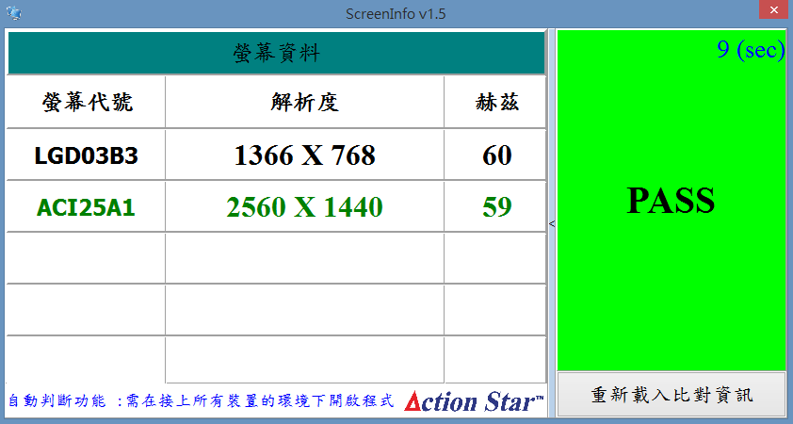

**⑥**

**⑤**

**④**

**③**

**②**

**①**

1. 螢幕資料 : Screen Information.
2. 螢幕代號 : Screen Name.
3. 解析度 : Screen Resolution.
4. 赫茲 : Screen frequency.
5. Test Result.
6. Reload comparison item button.  
   *The test result only confirms if all comparison items match successfully. If there is any additional screen information, it is ignored.