**USBMonitor v3.0**

##### **一.Features**

1. Compare the USB device's protocol interface, VPID, and REV.
2. Disk read/write test. (The disk name must be customized as DEVICE01~DEVICE16).
3. Obtain the firmware version of IC 9510.

##### **二.Program Architecture**

**USB device information comparison & PD version comparison.**

1. Open the program (The status of the product when not connected to a computer).
2. The product is connected to computer.
3. The program obtains newly appearing USB devices in the system.
4. Get the PD version of 9510 IC if the USB device contains it..

"

**USB Disk Read/WRIte Test**

1. Open the program (The status of the Disk when not connected to a computer).
2. The disk is connected to a computer.
3. If the disk name is DEVICEXX, perform a Reading/Writing test.
4. If the Reading/Writing test fails, the field will display red.

##### **三.** **Program Flowchart and Function Introduction**

Program Initial Screen

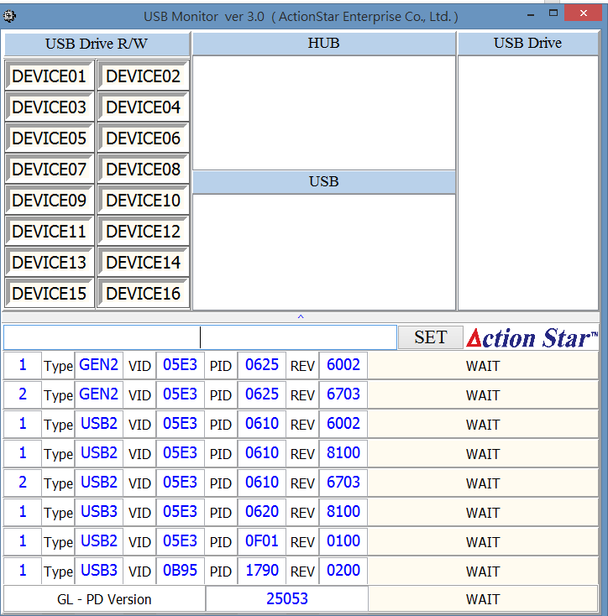

**⑦**

**⑥**

**⑤**

**④**

**③**

**②**

**①**

1. USB disk Reading/Writing field.
2. HUB field.
3. USB field.
4. List of disks in the system.
5. Password input field.   
   The password is "set", and the password is set to prevent personnel from mistakenly changing parameters.
6. Comparison items will compare with ➁ and ➂. If the comparison is successful, it will display PASS.
7. After obtaining the USB device, if there is a IC 9510, obtain its PD version.

##### **四.LOAD COMPARISON ITEMS**

1. Open the program (The status of the product when not connected to a computer).

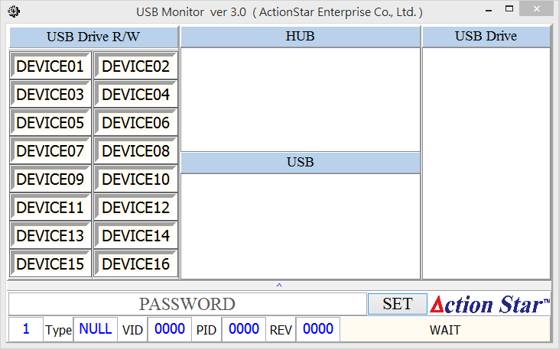

1. The product is connected to a computer.

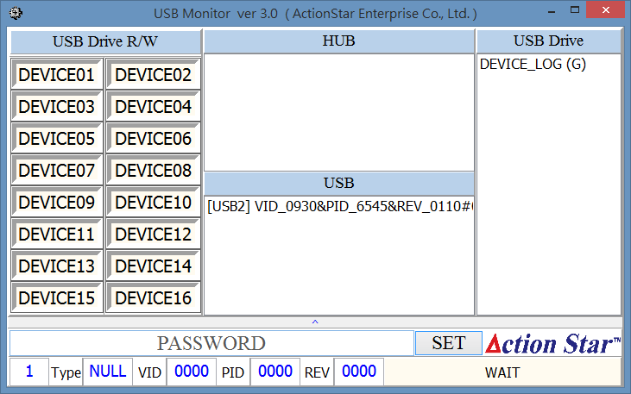

1. Enter the password and press the SET button.

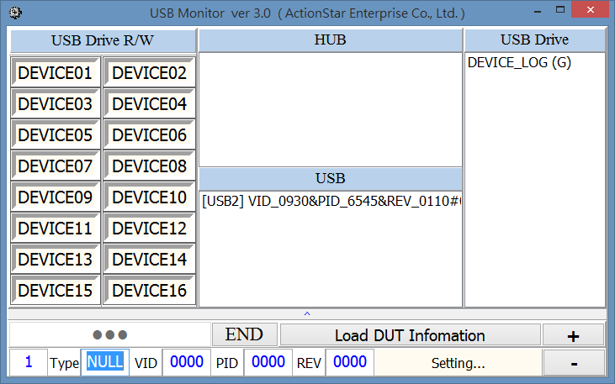

1. Press the Load DUT Information button( A "Confirm Again" window will pop up).

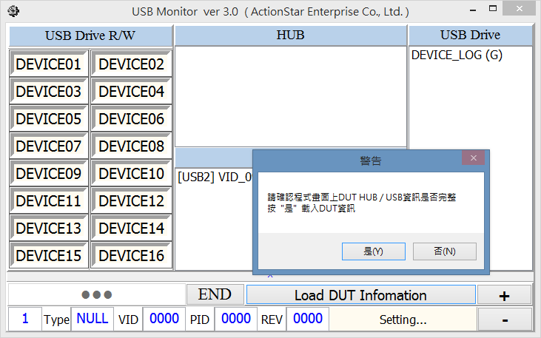

1. After confirming, this will load the information from the HUB and USB fields into the comparison items.  
   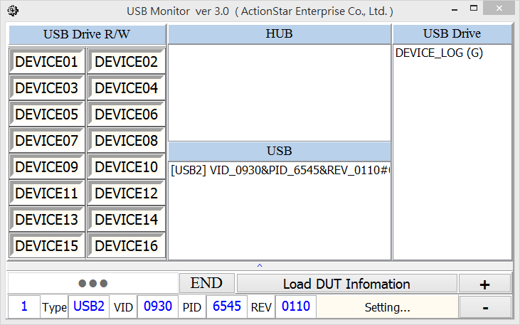
2. Press END to end the loading.