Title: Big Data Analysis and Visualization using Hadoop

1. Project Overview
The goal of this project was to build a small-scale data warehouse pipeline using Hadoop, Hive, and Sqoop, followed by interactive data visualization on a web dashboard.
The dataset contained enterprise registration information and regional statistics in China.
The analysis focused on enterprise distribution, risk indicators, and ownership structure (state-owned vs. private companies).
2. Technology Stack
Layer | Tools / Components | Description
Data Storage | HDFS (Hadoop Distributed File System) | Used to store raw CSV files of company and risk data
Data Processing | Hive (SQL-on-Hadoop) | Data querying, aggregation, and cleaning
Data Transfer | Sqoop | Export of processed Hive tables into MySQL
Data Visualization | HTML, JavaScript, ECharts | Web dashboard with charts and interactive analysis
Environment | Ubuntu (UTM on macOS) | Virtualized environment for big data development

3. Implementation Steps
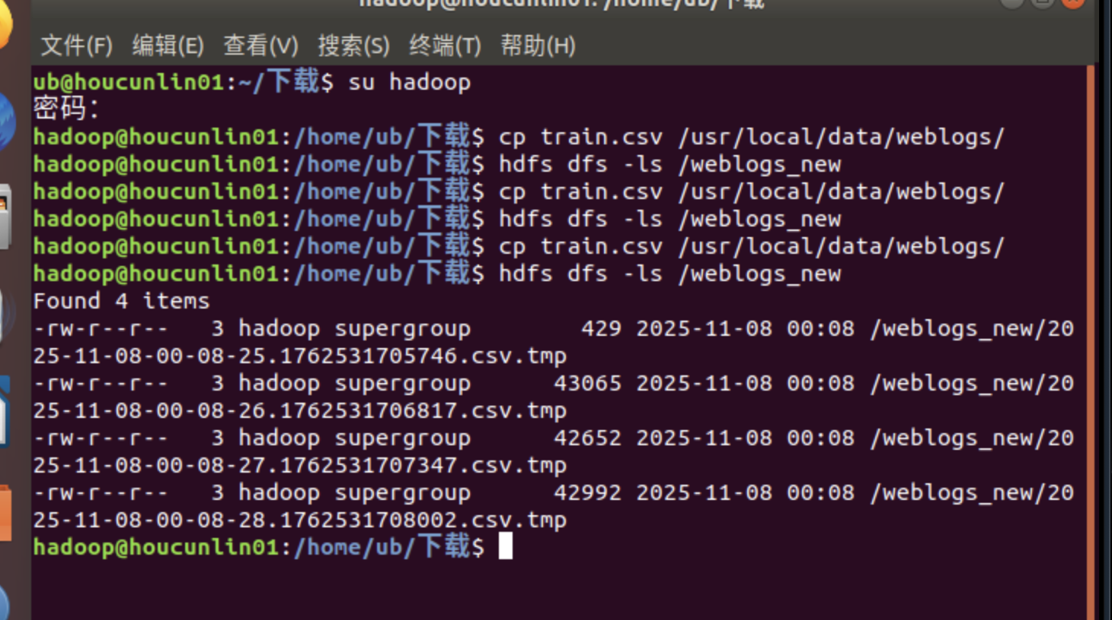

The next step – using flume to convert data

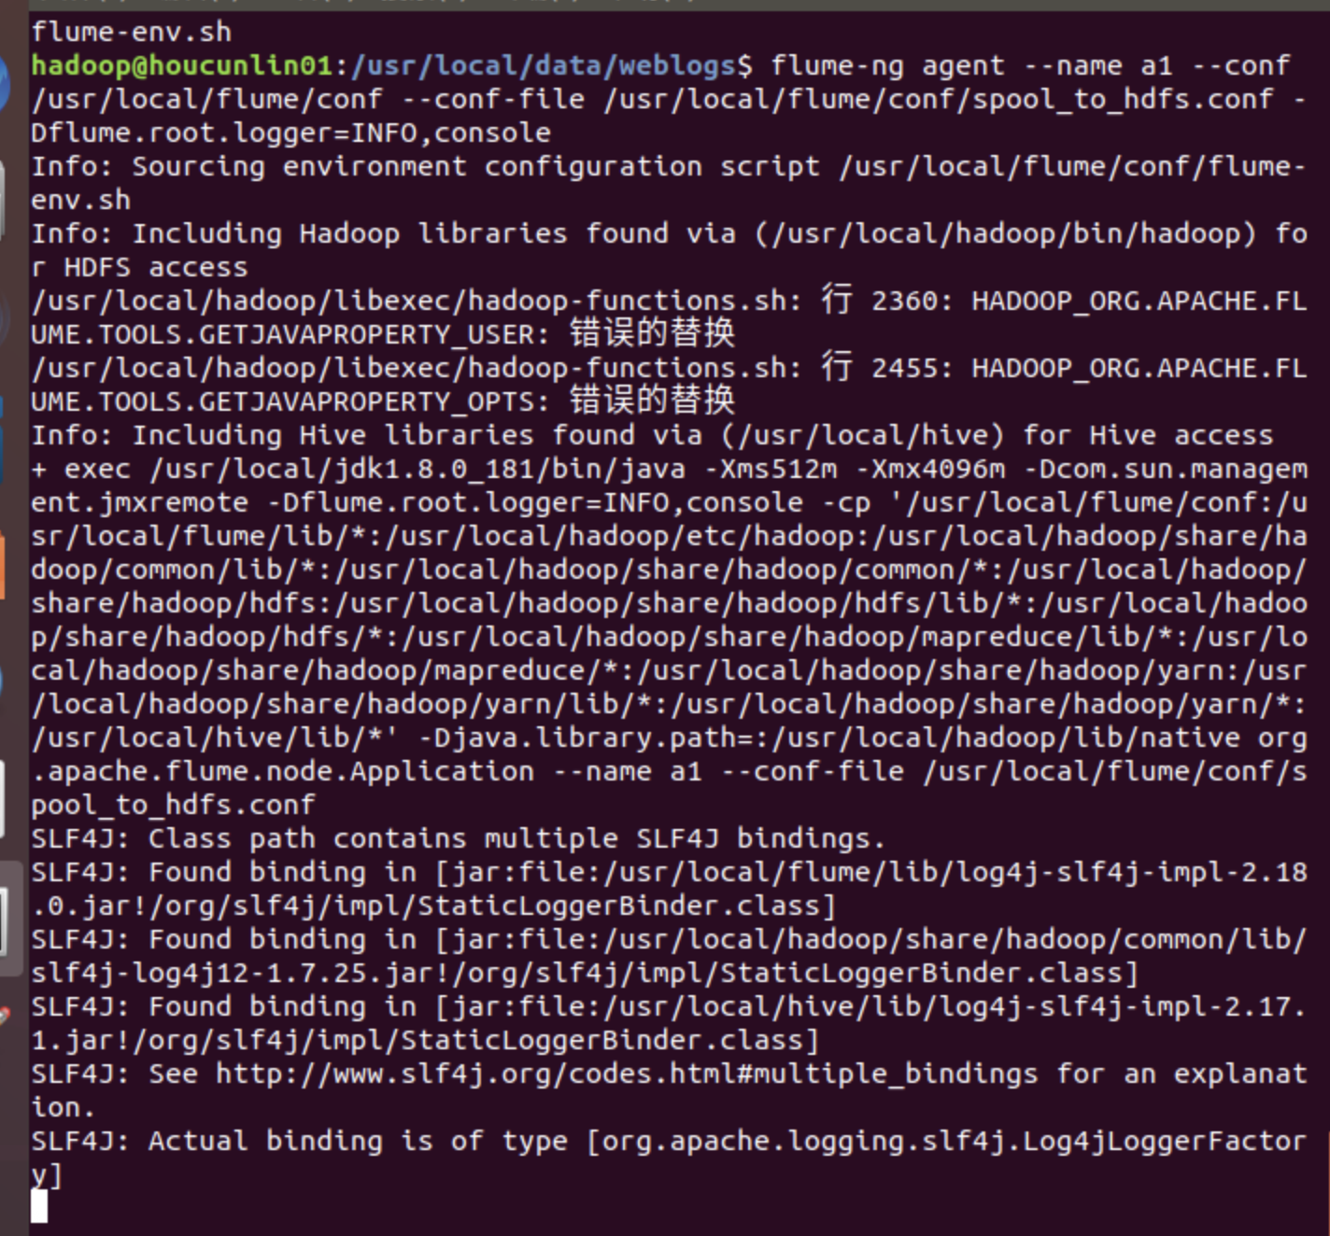
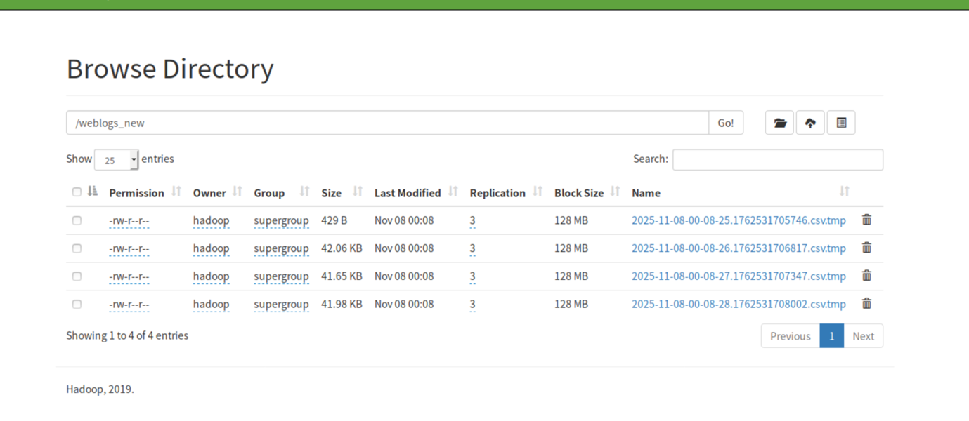
So after we got data in hdfs, we need to transfer it to hive
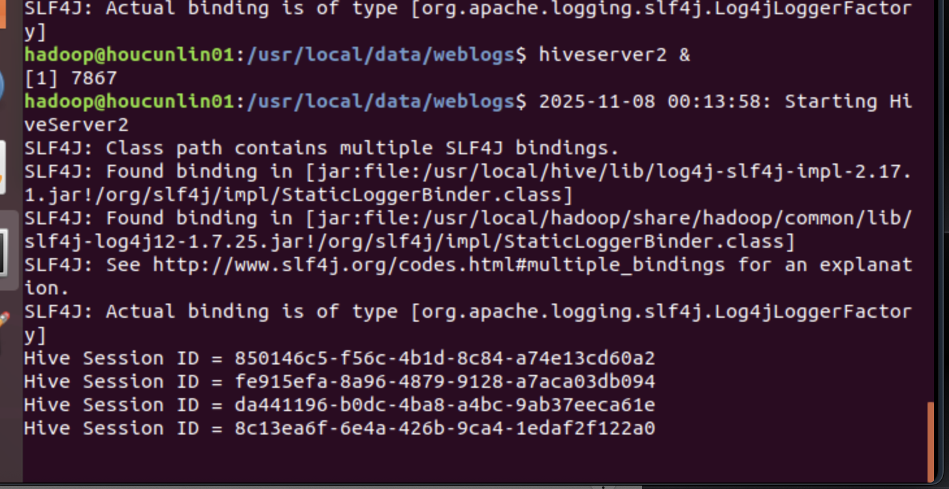
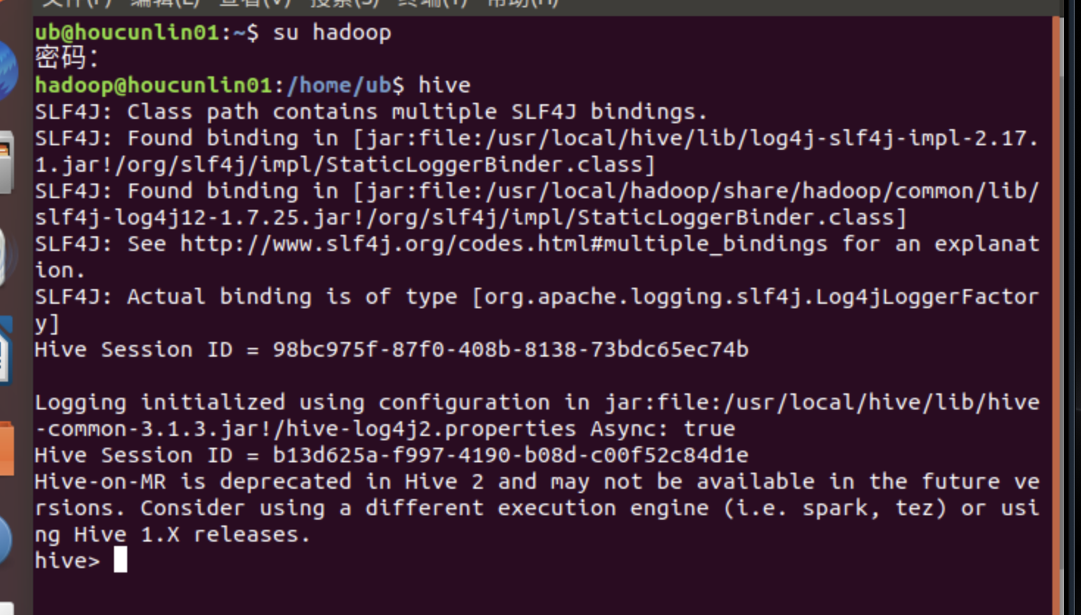
Creating database with 5 tables, that 5 tables – analysis tables
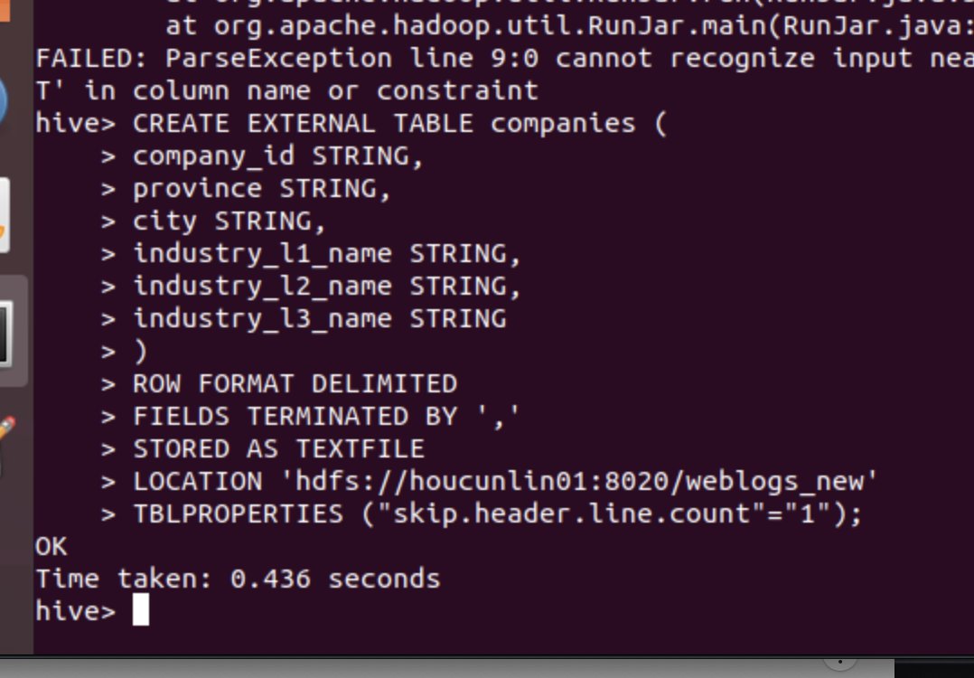
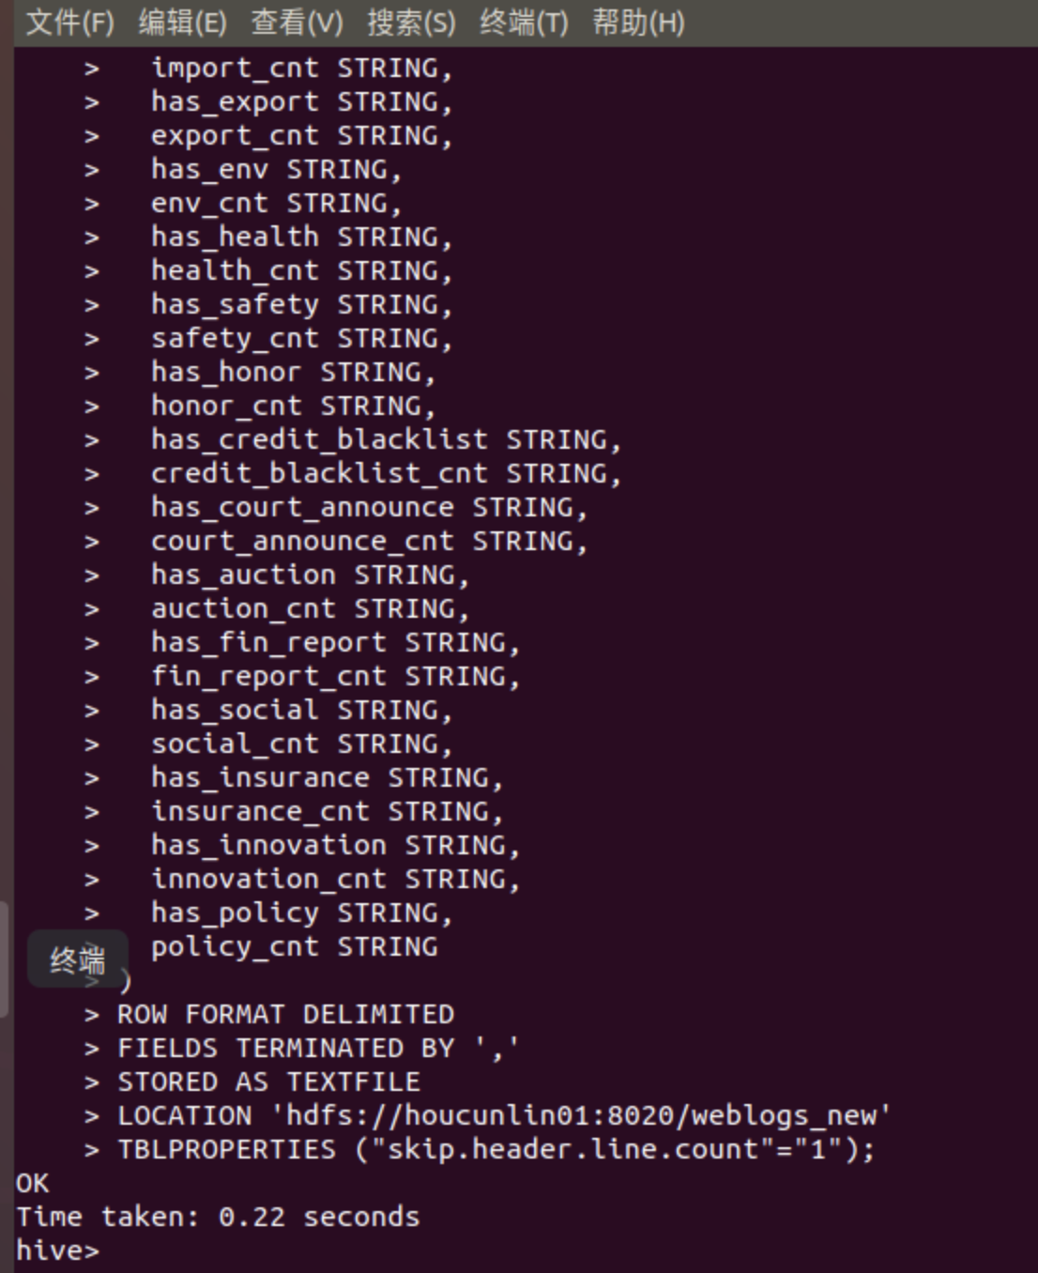

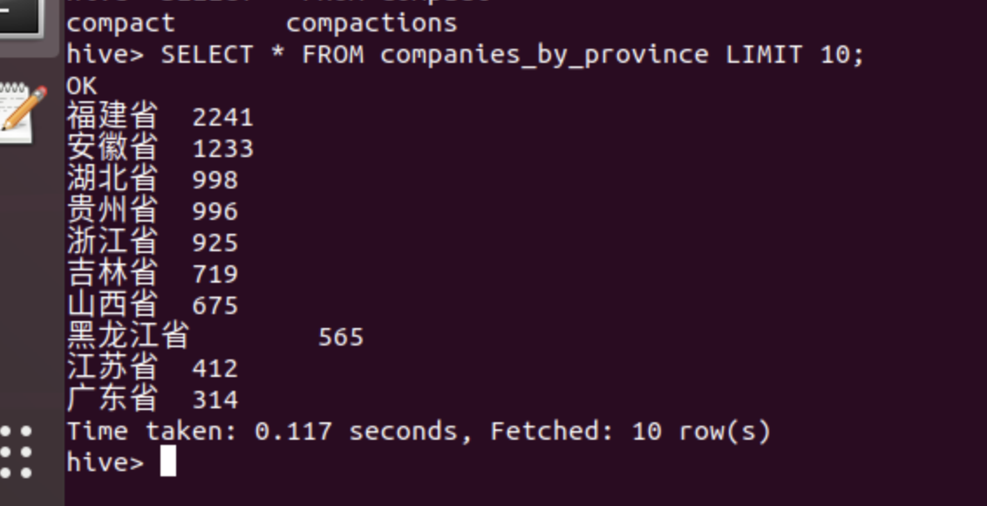
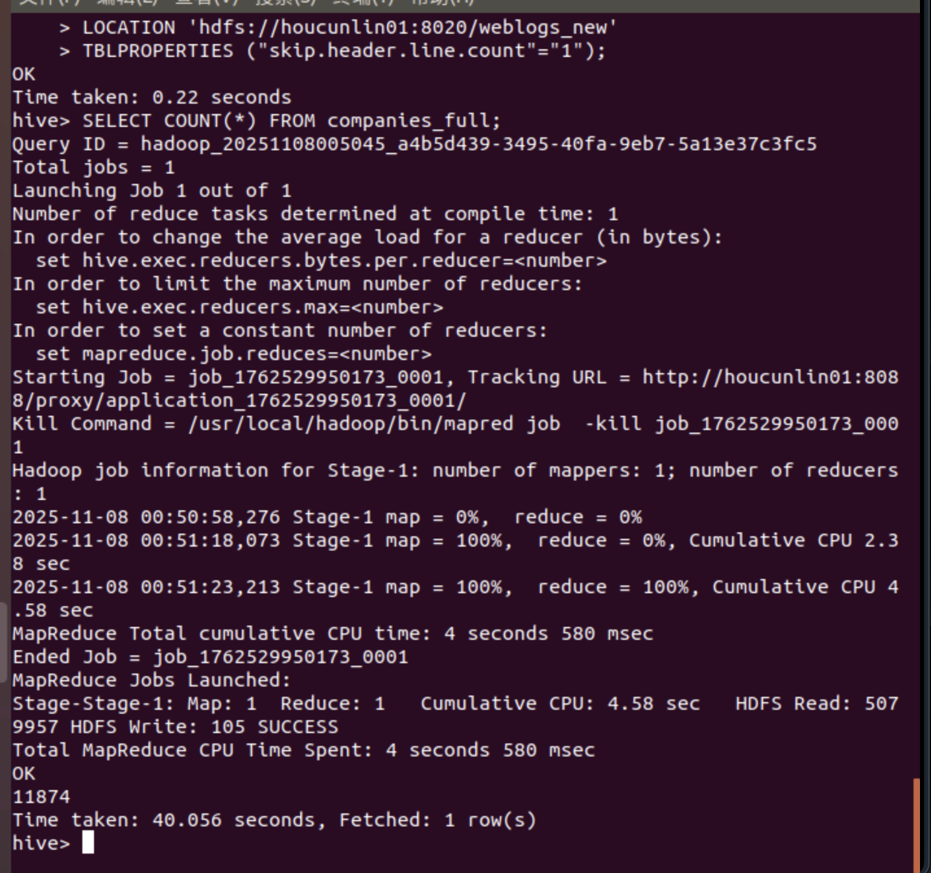

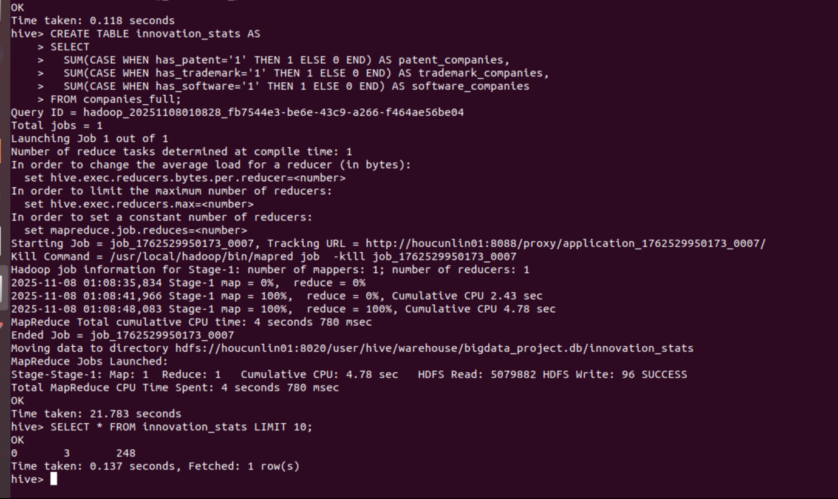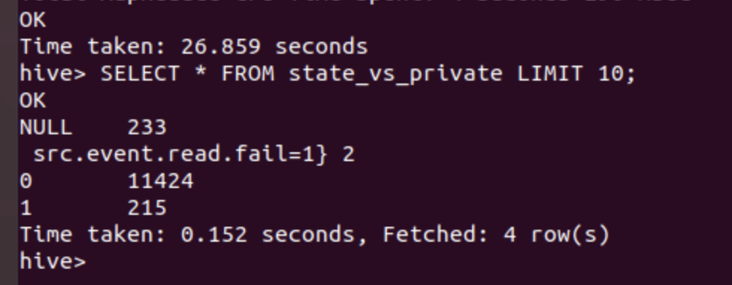
So, the final step is to transfer that 5 tabels to mysql through sqoop
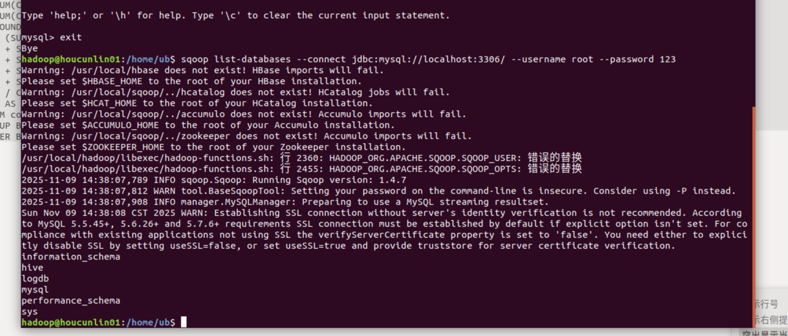

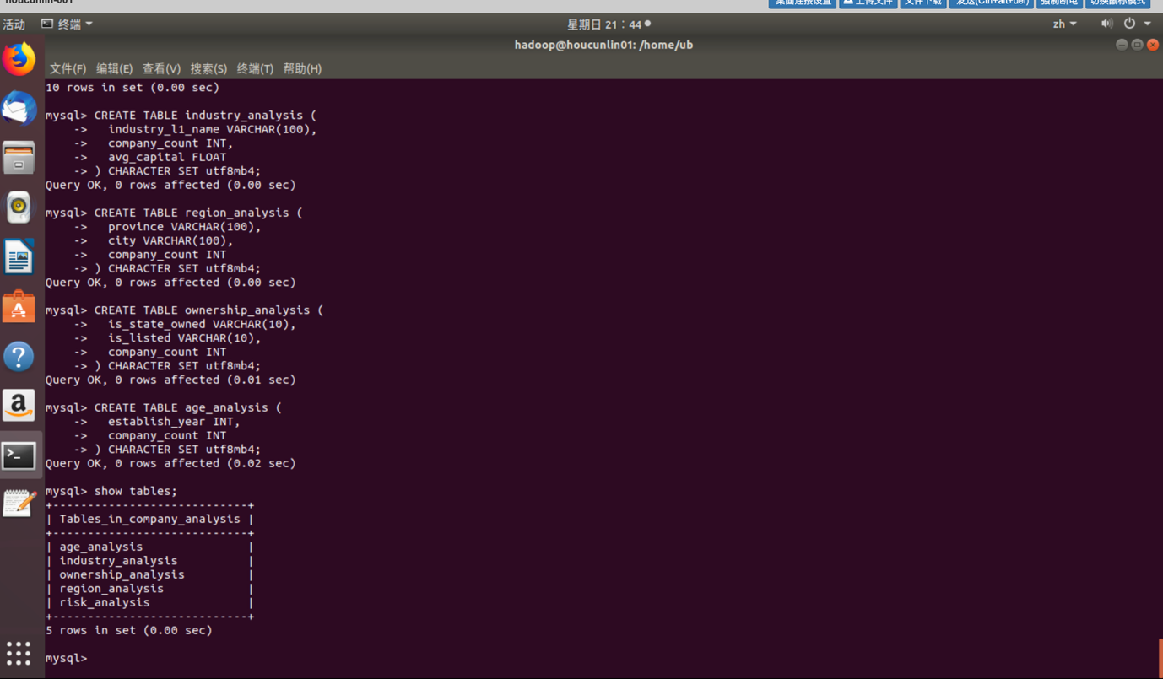

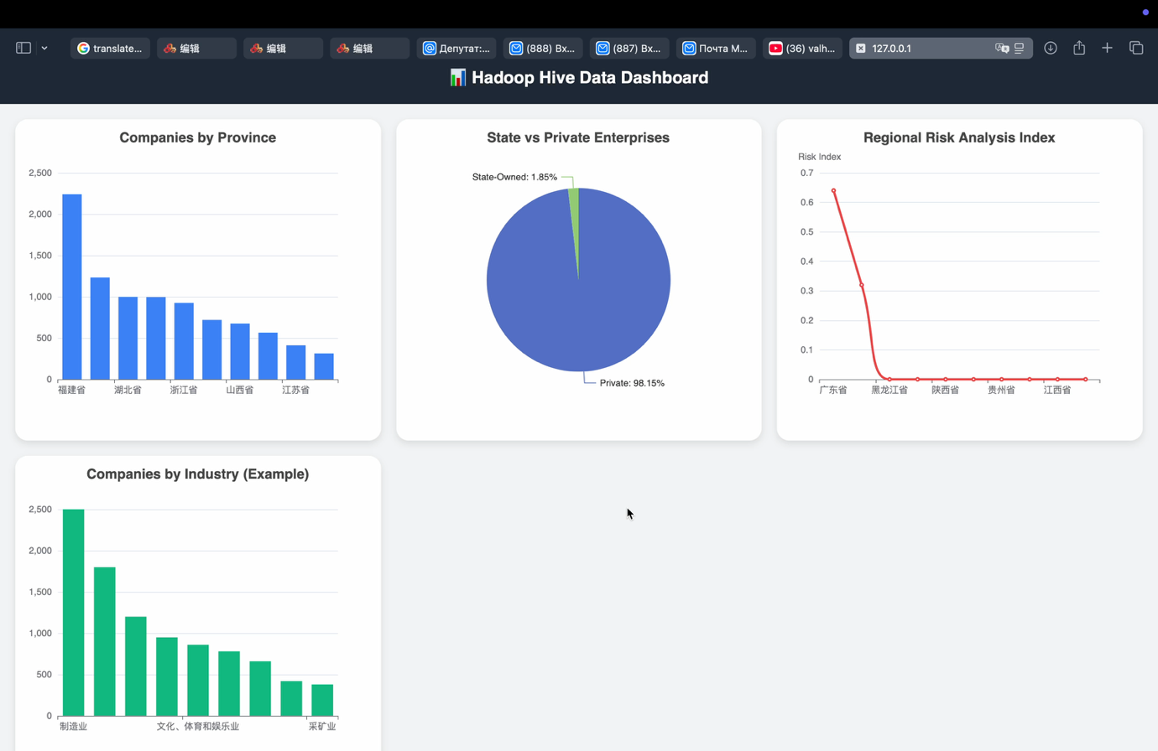
Step 5 — Data Visualization Dashboard
A web dashboard was built using HTML and ECharts, presenting insights from Hive tables.
Charts implemented:
- Bar Chart: Companies by Province
- Pie Chart: State vs. Private Enterprises
- Line Chart: Regional Risk Index
- Bar Chart (Interactive): Companies by Industry
Interactivity: Clicking on a province dynamically updates industry data.
Smooth animations and responsive layout were added for modern browser compatibility.

6. Results and Insights
- Fujian, Anhui, and Hubei provinces have the highest number of registered enterprises.
- Private enterprises dominate the dataset (over 98%).
- Risk index values are generally low, but Guangdong and Zhejiang show slightly higher values (0.64 and 0.32).
- Industry analysis reveals that most companies are concentrated in manufacturing, agriculture, and technology-related services.

7. Conclusion
This project demonstrates a complete big data analysis workflow:
data ingestion → transformation → export → visualization.
The integration of Hadoop, Hive, Sqoop, and ECharts successfully enabled the creation of an end-to-end analytical system.
This workflow can serve as a foundation for larger-scale regional or economic studies.

