***Chess Rocks! UCI GUI V1.2***

There have been a few bug fixes and a few new features added since the previous versions of the program. New features are the engine logo display, the ability to save and recall your own engine settings, a traditional menu bar at the top of the window and a new set of chess pieces.

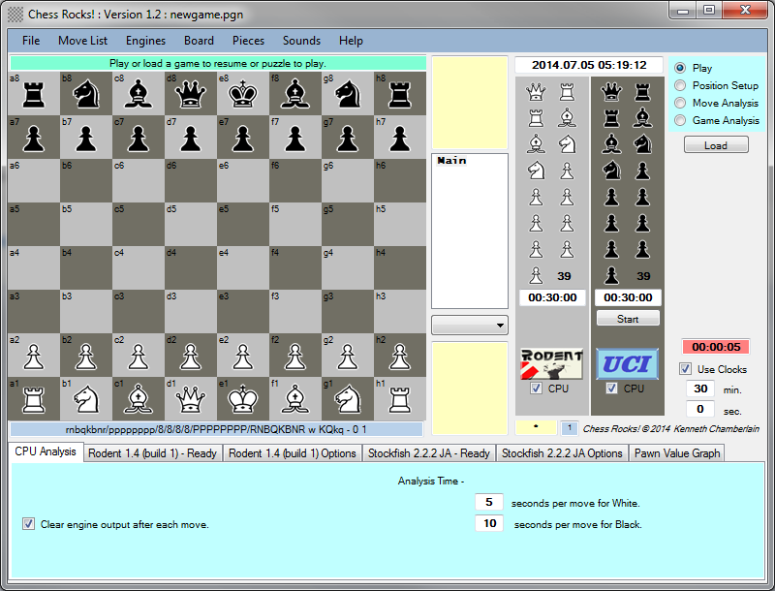

Main mode selections...

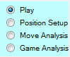

Play Mode:

This Mode allows human or computer players. Select the CPU checkbox for the players that you wish to be a chess engine. The engine that is started will be the last engine used for that color in any previous running of the Chess Rocks program. If this is a first time run or the chess.ini file is missing you will be prompted to find an engine executable.

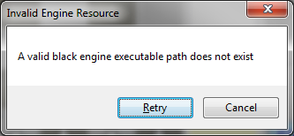

Select "Retry" and you will get a dialog to select the engine executable that you want.

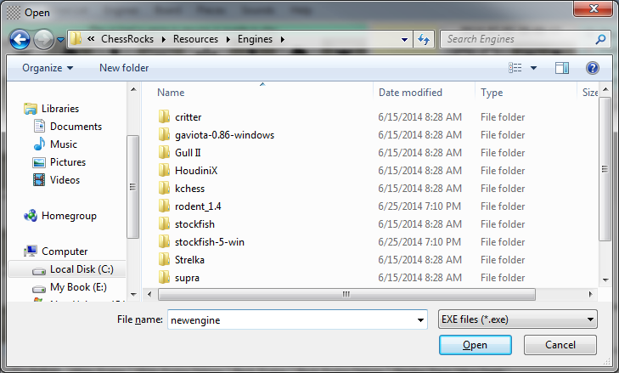

You also can choose two engines to play against each other if desired. There are all kinds of engines that can be downloaded from the net to use, they have not been provided with the Chess Rocks GUI.

If you want your game timed select the "Use Clocks" checkbox has been checked you want to make sure the clocks are set up the way that you want them to be. The total time and Bronstein times will be applied to both players clocks once the game is started. Each engine can have its own analysis time defined before a move will be forced.

To start a new game press the "Start" button that is displayed in the Black Information display area. If you wish to continue an adjourned game use the "Load" button to load the pgn before pressing start. Depending on when the incomplete game was adjourned (saved) the 'Start' button may appear in the White Information display area. The original timing setting will be loaded along with the piece positions of the incomplete game.

If it is a timed game the appropriate clock will now start counting down. A 'Pause' button is available to temporarily pause the clock.

For human players you can either pick up the piece and drop it on its destination position or just touch the piece to be moved and then touch the destination square.

An 'Offer' button is available to offer a draw, when pressed 'Accept' and 'Decline' buttons are made available on the opposite color Information area. If timed the 'Offer' button will pause the clocks until the 'Decline' button is pressed.

When a game is completed you will be given the option to save the gave to a PGN file with this dialog...

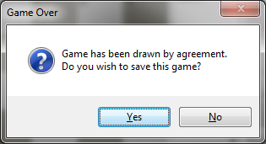

If you answer yes to the previous query you will get a dialog like this to fill in any additional or required information for a PGN file. If this game was loaded from a file produced by another program and special tags created by that program will be listed in the unknown tag section and saved back to the file as they are unless edited in the dialog shown below.

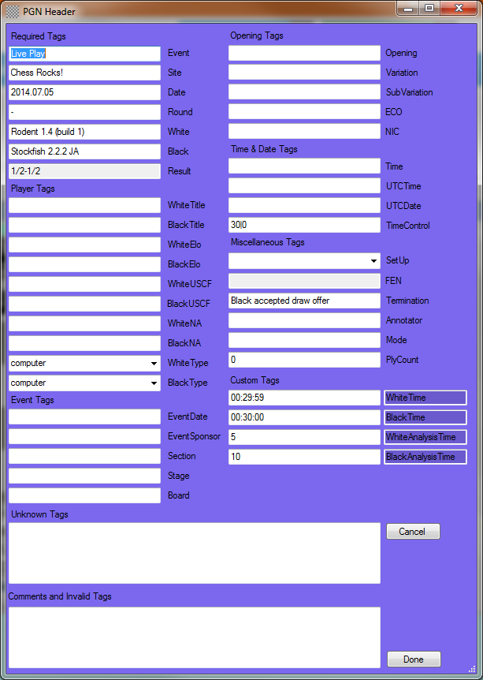

Position Setup Mode:

In this mode you can move pieces without being subject to normal piece move rules. You can load a starting position from a PGN file, in this case only the header is read and if there is a FEN tag the position will be changed to it. You can also manually edit the FEN string at the base of the board ( or paste a FEN string into it) and press the 'Update' button to set the pieces according to what was entered. The reason it does not automatically update while entering manually is to avoid error popups messages that invalid FEN sequences have be encountered before completing all the desired edits.

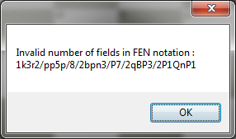

There are also menu selections to clear and reset the board positions and context menu selections to add or remove pieces on specific positions.

Once your position is as you want and the correct color for the first move is set you can now start making a puzzle by selecting "Make Puzzle". The moves will be recorded and can be saved to a PGN file. When 'Make Puzzle' is checked that turns back on the move checking in this mode. When this type of PGN is reloaded under Play mode the color to make the first move will be treated as the computer and make the first move automatically. All other moves will be hidden from the user and unless they make the next move that is identical to what is in the PGN list. Before each move you can edit the move comment and it will show up to the user while playing the puzzle, hints can be entered. Since the computer moves are done automatically any comments added before them will not immediately be seen but the user can back up and review each move including the computer moves.

Move Analysis Mode:

In this mode you will only be analyzing a particular move. First you must load a game to and select the move that you want to analyze. If you are going to have an engine do the analysis you must select which engine to do the analysis and make sure that its options are set to your liking. By default the white engine is selected. By selecting the 'Analyze' button the engine will analyze the selected move and place the pawn value result into the comment for it. Press the 'Best' button to have the computer analyze for the best move. The analysis will continue until you press the 'Add RAV' button. This will stop the engine, add the RAV and put the pawn value in the comment of the best move (first move in the RAV).

Manual analysis may be done by manually editing the comment field of the move you are looking at. You can also manually add your own RAV sequences by starting to move the pieces manually prior to the move that you would want to replace. If you are actually on a 'RAV' node in the move list a 'Clear RAV' button appears and you can delete that RAV sequence.

Game Analysis Mode:

In this mode all analysis done by one of the engines. By default the white engine is selected but you may select the black engine before starting the game analysis. When a file is loaded for analysis the hours specified in the CPU Analysis window for the whole process is divided based on how many moves are in the file. The resulting seconds per move is approximated and displayed. The seconds value can be manually adjusted if desired. Press 'Start' to start the processing and it will work on its own until the end of the game is reached. You can start processing on any position except for the first move. Analysis thresholds are base on the listed pawn values for questionable move, poor move and very poor move. There is also a checkbox that will show engine RAV's between 0 and the questionable move threshold. There is also an option to abort engine processing on a certain move if the engine has not changed its best move value for a certain amount of time.

The resulting pawn values from the game analysis will be displayed in graph form on the Pawn value Graph Tab. The graph auto sizes but maximum values of +/- 10 will be used in the Y-Axis. Values beyond these will be shown as a different color, mate values in red and anything between +/-10 and mate will be blue.

Engine Control Tab Interface...

There are two tabs dedicated to each possible engine. One tab displays the commands sent to the engine and the engine output. In order to reduce the size of the engine output I have replaced certain keywords as shown below.

Replace("multipv", "mpv");

Replace("seldepth", "sdp");

Replace("depth", "dp");

Replace("lowerbound", "lb");

Replace("upperbound", "ub");

Replace("hashfull", "hf");

Replace("tbhits", "th");

Replace("nodes", "n");

During Analysis modes the engine output is cleared after each move that is processed. In Play mode there is an option to clear or not clear the engine output after each move. When the message buffer gets very full the program will not respond as well.

The other tab deals with the specific options that are available to the particular engine. All the options are listed and can be changed. The settings can be saved to the chess.ini configuration file. The first time an engine is loaded its default values are save under the [engine_exe__Default]. The values in this section can be overwritten but I would suggest creating a new name for your settings and leaving the default section as is so that it can be returned to if ever needed. Pressing the 'Save Settings' button will allow you to save a new unique set of values and add the new section to the list. The last section loaded will be remembered and used as the default the next time that the engine is started.

All the option value changes are sent immediately to the engine except of the string values. The button to the left needs to be pressed to initiate the engine change, this is to avoid invalid test strings being sent to the engine to try and process. The is also another option for the text values, tow buttons to the left is a browse button so that if the text string needs to specify a file it can be selected in that manner instead of typing in the path.

If the engine logo is not in the same folder as the engine executable a default UCI logo will be used. This can be replaced by manually moving the logo bmp into the exe folder. There is a menu search selection that will let you find it and then it will copy the file to the expected directory.