Последовательно отметить числа от 1 до 32

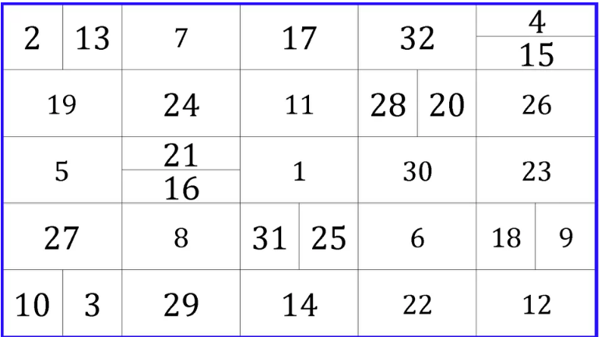

Составьте слова:

|  |  |  |  |
| --- | --- | --- | --- |
| У | Т | М | О |
| 3 | 4 | 2 | 1 |

|  |  |  |  |
| --- | --- | --- | --- |
| Е | Р | А | К |
| 2 | 1 | 4 | 3 |

|  |  |  |  |
| --- | --- | --- | --- |
| В | К | О | Л |
| 1 | 4 | 2 | 3 |

|  |  |  |  |  |
| --- | --- | --- | --- | --- |
| Д | Р | Ь | В | Е |
| 1 | 4 | 5 | 2 | 3 |

|  |  |  |  |  |
| --- | --- | --- | --- | --- |
| В | Т | О | Л | С |
| 3 | 2 | 4 | 5 | 1 |

|  |  |  |  |  |  |
| --- | --- | --- | --- | --- | --- |
| А | Д | Г | Р | У | А |
| 6 | 3 | 5 | 1 | 4 | 2 |

Напишите названия 10 фильмов: