Написать названия 16 стран:

|  |  |  |  |
| --- | --- | --- | --- |
|  |  |  |  |
|  |  |  |  |
|  |  |  |  |
|  |  |  |  |

Расшифровать текст

Образец:

|  |  |  |  |  |  |  |  |  |
| --- | --- | --- | --- | --- | --- | --- | --- | --- |
| * | @ | # | $ | % | ^ | & | + | ! |
| 1 | 2 | 3 | 4 | 5 | 6 | 7 | 8 | 9 |

1)

|  |  |  |  |  |  |  |  |  |  |
| --- | --- | --- | --- | --- | --- | --- | --- | --- | --- |
| * | + | * | @ | * | ! | ! | + | @ | $ |
|  |  |  |  |  |  |  |  |  |  |

2)

|  |  |  |  |  |  |  |  |  |  |
| --- | --- | --- | --- | --- | --- | --- | --- | --- | --- |
| @ | ^ | * | @ | * | ! | ^ | # | % | + |
|  |  |  |  |  |  |  |  |  |  |

Вычеркнуть выделенную букву в каждом ряду

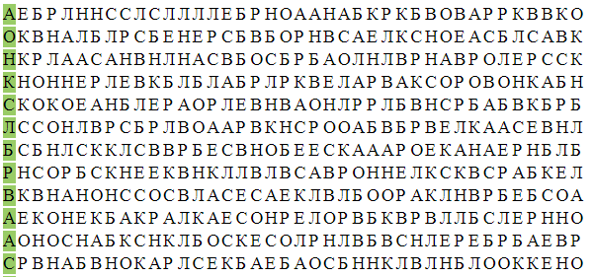

Найти слова в тексте:

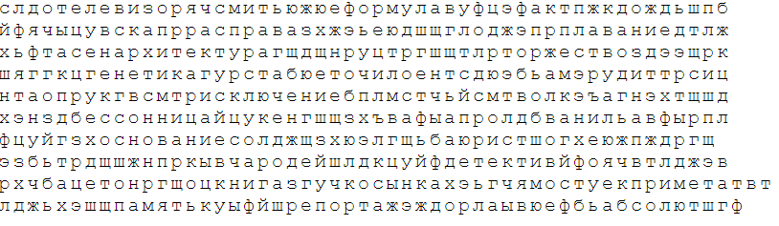

Сосчитать бобы:

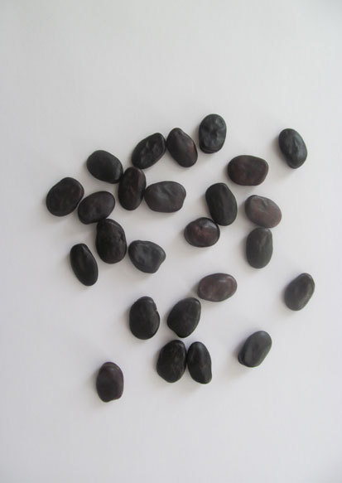

Нарисовать квадрат 3 раза правой рукой, 3 раза левой рукой: