Вычеркнуть выделенную букву

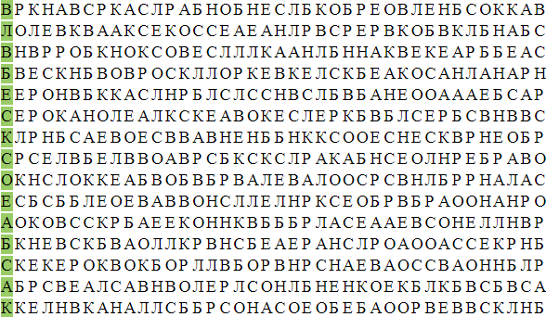

Собрать слова:

|  |  |  |  |  |
| --- | --- | --- | --- | --- |
| Б | Ь | Ш | О | Р |
| 1 | 5 | 4 | 3 | 2 |

|  |  |  |  |  |  |  |
| --- | --- | --- | --- | --- | --- | --- |
| Н | С | П | О | А | Е | Р |
| 6 | 4 | 1 | 5 | 7 | 2 | 3 |

|  |  |  |  |  |  |  |  |
| --- | --- | --- | --- | --- | --- | --- | --- |
| К | И | О | Л | К | О | Д | Р |
| 1 | 7 | 3 | 8 | 4 | 5 | 6 | 2 |

Заполнить таблицу:

Образец:

|  |  |  |  |  |  |  |  |  |
| --- | --- | --- | --- | --- | --- | --- | --- | --- |
| # | % | @ | & | + | ^ | ~ | ! | Q |
| 1 | 2 | 3 | 4 | 5 | 6 | 7 | 8 | 9 |

Задание:

|  |  |  |  |  |  |  |  |  |  |  |  |  |  |  |
| --- | --- | --- | --- | --- | --- | --- | --- | --- | --- | --- | --- | --- | --- | --- |
| # | ! | % | ~ | Q | ! | ^ | @ | # | @ | & | ^ | + | ~ | % |
|  |  |  |  |  |  |  |  |  |  |  |  |  |  |  |

Написать названия 10 органов/частей тела