Отметить числа от 1 до 34 последовательно

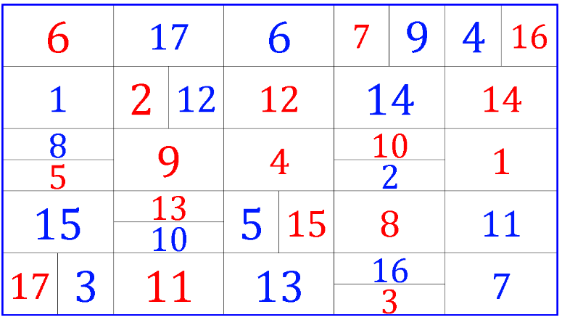

Нарисовать фигуры:



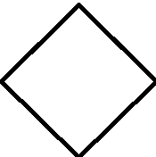

Расшифровать таблицу:

Образец:

|  |  |  |  |  |  |  |  |  |  |
| --- | --- | --- | --- | --- | --- | --- | --- | --- | --- |
| @ | * | & | % | $ | # | ! | П | + | ? |
| 1 | 2 | 3 | 4 | 5 | 6 | 7 | 8 | 9 | 0 |

Задание:

|  |  |  |  |  |  |  |  |  |  |  |  |  |  |  |
| --- | --- | --- | --- | --- | --- | --- | --- | --- | --- | --- | --- | --- | --- | --- |
| ? | @ | * | % | ! | + | П | * | ? | ! | $ | П | % | + | @ |
|  |  |  |  |  |  |  |  |  |  |  |  |  |  |  |

Написать 10 имен известных писателей или поэтов