- a. Statically typed languages – Programming languages which check the data types at compile-time are statically typed languages

b. Dynamically typed languages – Programming languages which check the data types at run-time are dynamically typed languages

c. Strongly Typed Languages – Programming languages of which the data types limit the values that a variable can hold or that an expression can produce and limit the operations supported on those values, and determine the meaning of the operations are called strongly typed languages.

d. Loosely Typed Languages – Programming languages of which that do not check the data types strictly, or languages that makes it simple to define variables with various data types and that does not hold limits of values that the data types can hold are called loosely typed languages.

- Case Sensitive – If a programming language has the ability to distinguish between upper and lower case versions of a letter in the language's character set, that is a case sensitive programming language.
Eg:- numberOne and numberone are idenfied as two different idenfifiers.

Case Insensitive – If a programming language has the ability to ignore the difference between upper and lower case versions of a letter in the language's character set or if they are identified as the same character, that is a case insensitive programming language.
Eg:- numberOne and numberone are idenfied as the same idenfifier.

Case sensitive-insensitive – Programming languages which act as case sensitive in some instances and as case insensitive in some instances

Java is a case sensitive programming language.

- Identity Conversion is the conversion from a data type to that same data type, which is permitted for any data type.
Eg:- int num1 = 10;
long num2 = 558673932L;

- Widening Primitive Conversion – Generally, data types with lower bit size will be automatically converted to higher bit sized data types. That is widening primitive conversion.

byte —> short —> int —> long
float —> double

Furthermore, widening primitive conversion will occur from int to float and double, long to float and double also. These conversions do not depend on bit size. Because the the bit structures of these converting types are different.
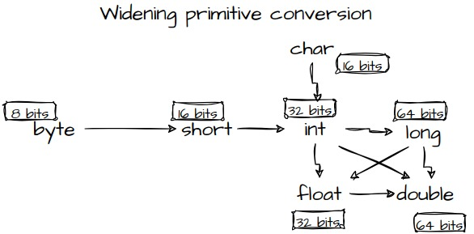

- Compile-time constant – Constants which the compiler can identify at compile-time.

Eg:- final int MY_CONST = 10;

Run-time constant – Constants which the JVM identifies only at run-time.

Eg:- final int MY_CONST2 = 10 * (int)Math.random();

- Conversion of higher bit sized data type to the lower bit sized data type is called Narrowing Primitive conversions. There are two types of Narrowing Primitive Conversions, explicit and implicit. Explicit conversion is also called casting which do nor occur automatically at compile time.

Implicit or automatic Narrowing Primitive Conversion occur automatically if four conditions fulfilled.

    - Conversion should be in a assignment context

    - It occur only among byte, short, char, int data types from higher bit size to a lower bit size data type.

    - Assigning value should be a compile-time constant

    - The assigning value should be in the range of the type

- Conversions from long data type to float data type do not depend on bit size. Because the bit structures of these converting types are different.
Long type which is a integer type represent the value by 2’s complement method while float type which is a floating point type represent the value by 32-bit IEEE 754 method. In IEEE 754 method, the number is taken as fraction and exponent and represent in 31 bits. Therefore in that method more large numbers can be hold in 31 bits than in 64 bit 2’s complement method. But the accuracy will be less.

