

Data Technician

Name: Jordan Playil
Course Date: 16/12/24
Table of contents
Day 1: Task 1 2
Day 2: Task 1 2
Day 2: Task 2 3
Day 2: Task 3 4
Day 3: Task 1 4
Day 3: Task 2 5
Dataset: 5
Step 1: Create a Pivot Table 5
Step 2: Use the SWITCH Function 5
Submission: 6
Day 3: Task 3 6
Day 4: Task 1 7
Course Notes 9
Additional Information 10

Day 1: Task 1

Please complete the below boxes on commons laws and regulations that must be followed when working with customers data, use the below bulleted list to support your answers.

- What is it
- Why is it important
- Provide a real-world example of how you can follow it
- How does it impact working with data
- What could happen if you breached it

Data Protection Act | What is it  A UK law that sets rules on how personal data must be collected, stored, and used.  Why is it important?  It protects people’s privacy and ensures their data is handled safely and legally.  Real-world example of following it  A retail company keeps customer information, like email addresses and phone numbers, in an encrypted database. I only access the records I need for my work, and never share them with anyone unauthorised.  Impact on working with data  I must use only the data required for a task, keep it accurate, and process it for legitimate business purposes only.  What could happen if breached?  The organisation could be fined by the Information Commissioner’s Office (ICO), suffer reputational damage, and I could face disciplinary action.  Example: If a staff member accidentally emails a customer list to the wrong people, the company could get fined and lose customer trust.
GDPR | What is it  A law that protects people’s personal information and tells organisations how they must use it safely.  Why is it important  It keeps people’s private details safe and ensures businesses are transparent about how they use data.  Real-world example of following it  A YouTube creator collects emails for a newsletter. To follow GDPR, they must ask permission first, clearly explain what the emails will be used for, and keep the list secure.  Impact on working with data  I must only use data for the reason it was collected, keep it safe, and record how and why I use it.  What could happen if breached  The organisation could get big fines, lose people’s trust, and I could get in trouble for mishandling data.
Freedom of Information Act | What is it  A UK law that allows the public to request information from public organisations.  Why is it important  It helps keep public organisations open and honest.  Real-world example  If someone asks a council for information about an author they paid to run a workshop, the council can share the payment details, but must remove the author’s personal information, like their home address or phone number.  Impact on working with data  I must check the data carefully and only share information that is allowed to be made public.  What could happen if breached  Private information could be shared by mistake, leading to complaints, investigations, and damage to the organisation’s reputation.
Computer Misuse Act | What is it  A UK law that makes hacking, unauthorised access, and misuse of computer systems illegal.  Why is it important  It protects systems and data from being stolen or damaged.  Real-world example (phishing)  A criminal sends a fake bank email to trick someone into entering their login details and then uses these details to access the victim’s account. This is unauthorised access, which breaks the CMA.  Impact on working with data  I must keep passwords secure, use authorised systems only, and never access data I don’t have permission for.  What could happen if breached  Criminal charges, losing my job, and serious reputational damage.

Day 2: Task 1

Please research and complete the following tasks within the retail-sales_dataset.xlsx document, paste a print screen into the provided boxes below:

- In the sheet ‘retail_sales_dataset’ add all available data between columns A –J into a ‘table’
- Using the ‘sort’ function, sort ‘Age’ to ‘largest to smallest’
- Using the ‘SUM’ function, show me the commission total in cell ‘L10’
- Using the ‘AVERAGE’ function, show me the average commission in cell ‘L11’

Print screen 1 | Data Between A-J into a Table Format  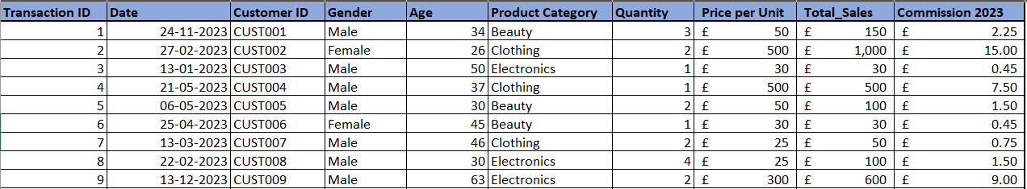
Print screen 2 | Sort “AGE” (Largest to Smallest)  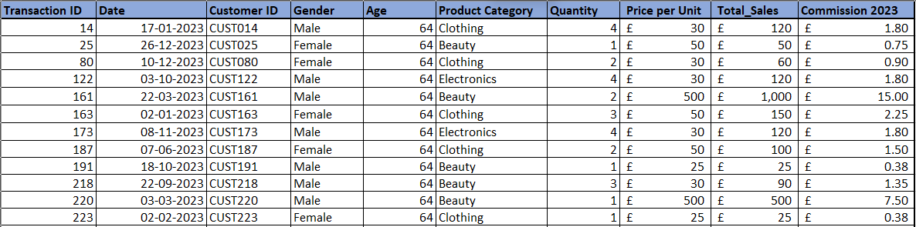
Print screen 3 | Commission Total  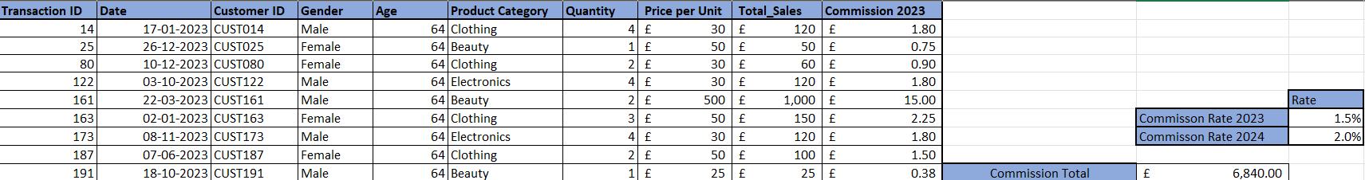
Print screen 4 | Commission Average  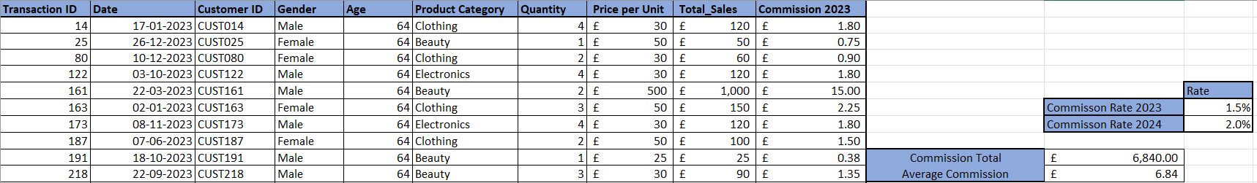
Day 2: Task 2

Please research and complete the following tasks within the retail-sales_dataset.xlsx document, paste print screens into the provided box below:



Print screen 1 | English Highest Score (Filtering)  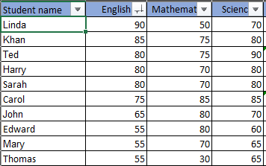  Maths Highest Score (Filtering)  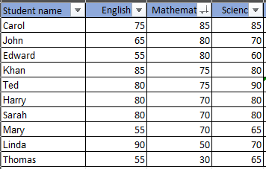  Science Highest Score (Filtering)  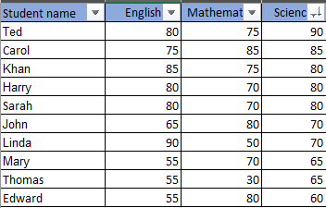  Average for All Students (Average)  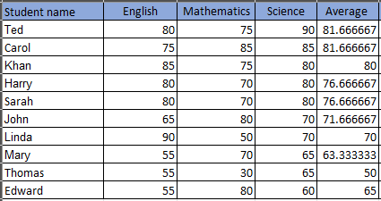  Student Highest Score (MAX)  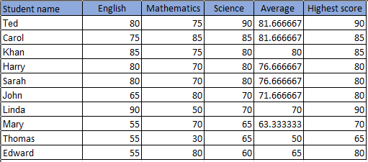  Best Student by Average (Filtering)  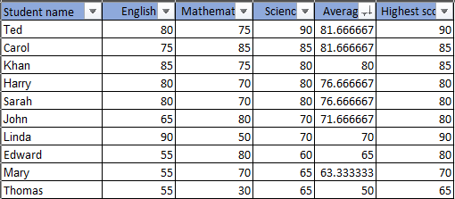  Best Student by Highest Score (Filtering)  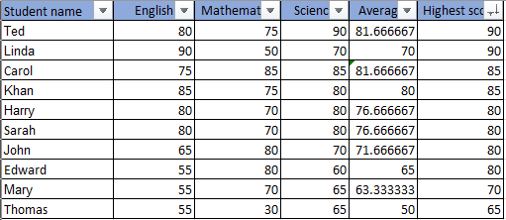  Highest and Lowest Average Scores (Conditional Formatting)  Highest-Green  Lowest-Red  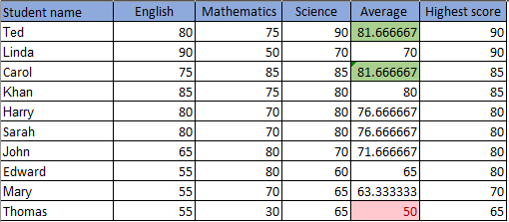

Day 2: Task 3

Using the skills developed today, have some fun with the data set you have imported. Paste your work below and enjoy!

Print screen 1 | 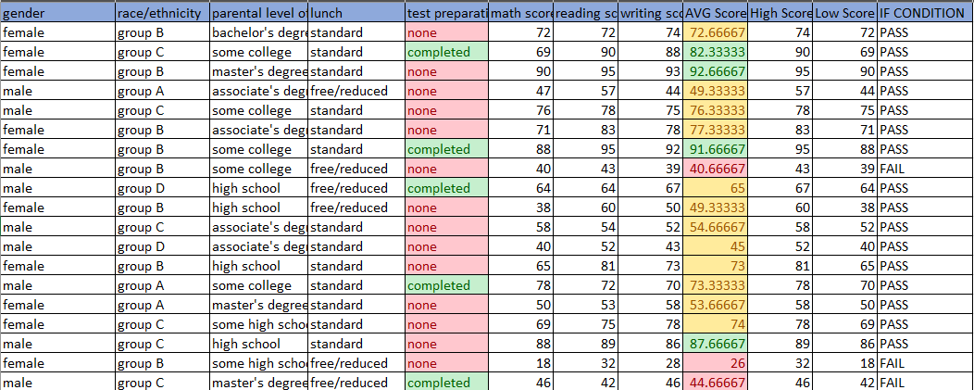

Day 3: Task 1

Please download the dataset ‘Day_3_Task_1_Bike_Sales_Pivot_Lab.xlsx’ and the lab instructions.

Do not worry if you do not complete the lab, just working with data and playing with the pivot table will be good experience.

Please paste your final pivot table below and complete the reflection questions:

Print screen 1 | PIVOT TABLE  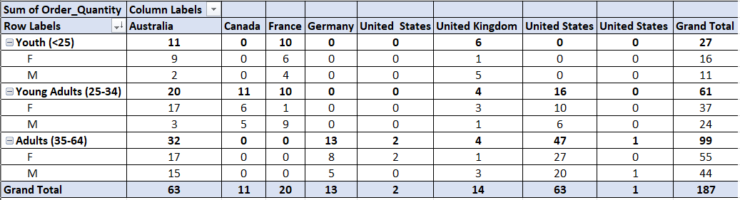  PIVOT CHART  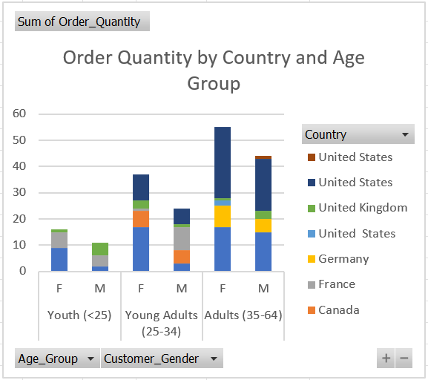
In which markets does Germany have customers? | Germany has customers only in the Adults (35-64) market.
What country has sales in all markets? | Australia and the United Kingdom
What are the most profitable markets by country, age group, and gender? | By Country- Australia (Adults), Canada (Young Adults), France (Youth), Germany (Adults), United States (Adults), United Kingdom (Youth).  By Age Group-Adults-51, Young Adults-45, Youth-27  By Gender-Female-71, Male-52
Any other findings? | Females purchase more than males in every age segment except Youth in the UK, where males slightly exceed females.  Adults (35–64) are the most active buyers overall  Only Australia and the U.K. have broad appeal across all age groups.  Canada, Germany, and the U.S. have very narrow market segments.

Day 3: Task 2

The dataset below tracks the sales performance of different products in various counties in England. Please paste the dataset into a blank Excel workbook. Your task is to:
- Create a Pivot Table to summarise the data by county and product.
- Use the SWITCH function to categorise products based on their sales volume.

Dataset:
County | Product | Sales Volume
Yorkshire | Laptops | 500
Yorkshire | Smartphones | 200
Cornwall | Laptops | 700
Cornwall | Printers | 400
Lancashire | Smartphones | 150
Lancashire | Laptops | 600
Essex | Printers | 800
Essex | Smartphones | 300
Durham | Laptops | 250
Durham | Printers | 300
Greater Manchester | Smartphones | 600
Greater Manchester | Laptops | 400

Step 1: Create a Pivot Table
- Select the dataset (columns A to C).
- Insert a Pivot Table to summarise the data by County in the rows and Products in the columns. Use Sales Volume as the value to be summarised.

Step 2: Use the SWITCH Function
In a new column next to your data, use the SWITCH function to categorise products based on Sales Volume as follows:
  - For sales greater than 600: "High"
  - For sales between 300 and 600: "Medium"
  - For sales less than 300: "Low"
SWITCH Function Example:
=SWITCH(TRUE, C2 > 600, "High", C2 >= 300, "Medium", "Low")
- Apply this formula to each row, and check if the products are categorised correctly.

Submission:
- A completed Pivot Table summarising sales by county and product.
- A new column in the dataset categorising products by sales volume using the SWITCH function.
  - Please paste your completed work below

Print screen 1 | SWITCH FUNCTION (NEW COLUMN)  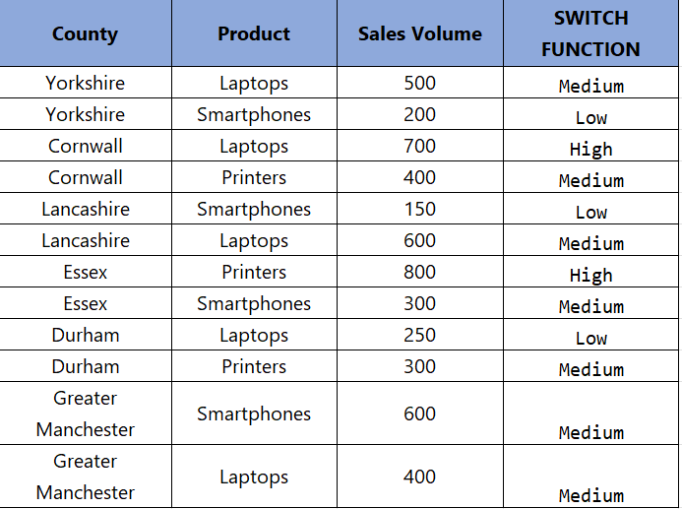  PIVOT TABLE  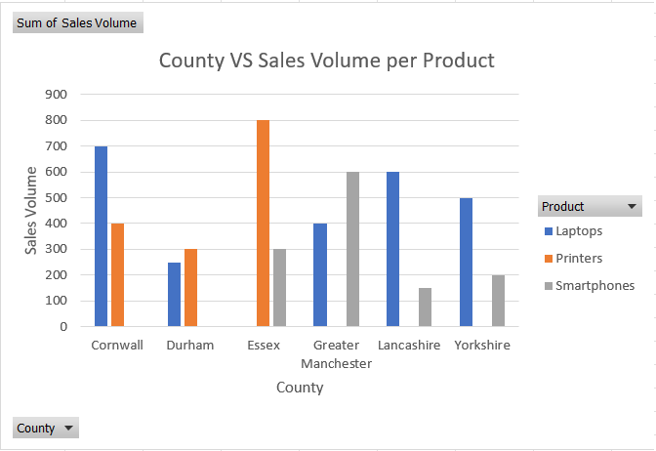

Day 3: Task 3

Please download the dataset ‘Day_3_Task_3_Bike_Sales_Visualisations_Lab.xlsx’ and the the lab instructions. Do not worry if you do not complete the lab, just working with data and playing with the charts will be good experience.

Please paste your results below:

Print screen 1 | DATASET  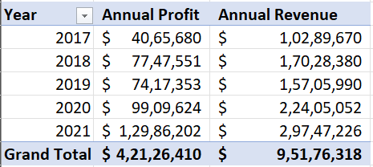  LINE CHART  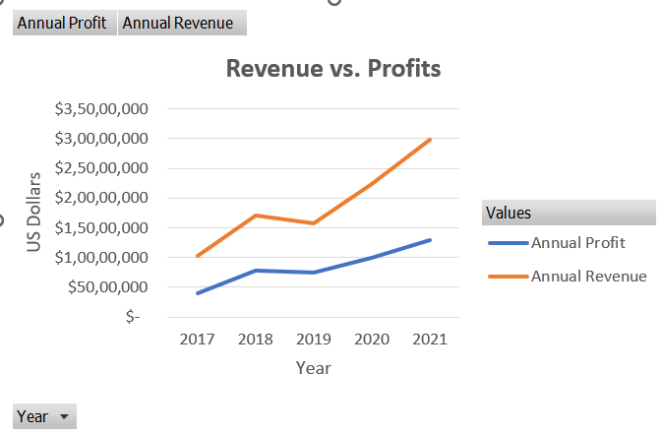  DATASET  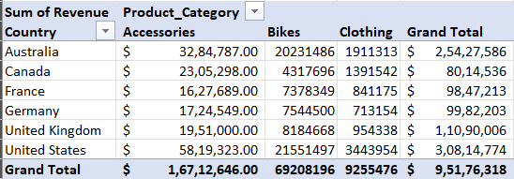  BAR CHART  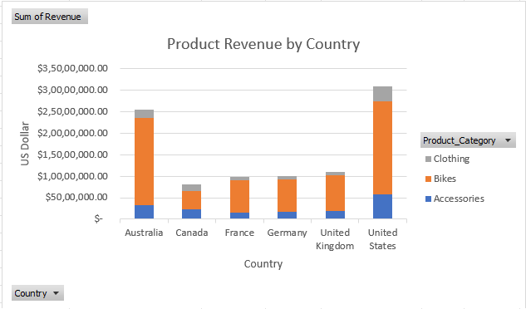  DATASET  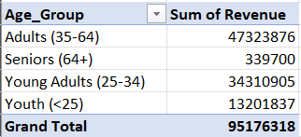  PIE CHART  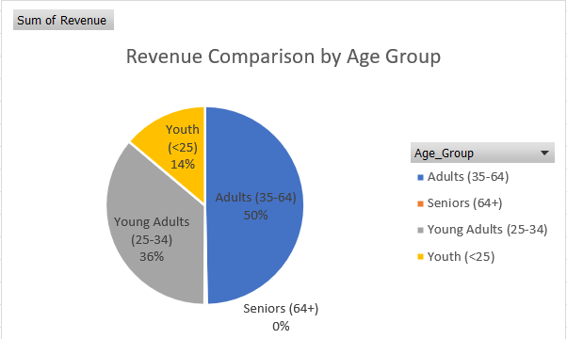

Day 4: Task 1

You have been asked to deliver your analysis findings to the board of directors, with your analysis you have identified that customers are leaving your company at the 12-month point, this is typically when they receive their renewal price.

Conduct research and complete the below questions:

How would you prepare for the delivery? | - Research board members backgrounds and their familiarity with the data.  - Keep in mind the key message “customers are leaving at the 12-month renewal point”, do not get driven by unnecessary information.  - Structure your presentation (Problem-Insight-recommendation-action plan-)  - Double-check all metrics, sources and calculations.  - Consider rehearsing beforehand
What tools would you use for the delivery? | - Presentation software (PowerPoint, Google Slides)  - Data visualisation tools (Tableau, Power BI, Excel)  - Supporting documents  - If remote delivery- Be prepared with up-to-date tools
What is prospecting and why would you complete this before your delivery? | Prospecting is understanding your audience before engaging  Why?  - Tailor your message/answers to their priorities.  - Builds credibility by addressing their concerns proactively
Tell me best practices for public speaking and providing updates to senior leaders | - Focus on high-impact insights  - Present your analysis, like a story  - Highlight trends and patterns rather than raw data.  - Engage the audience.  - Confident Body Language  - Active Listening
What will you show the board in your delivery? | - Analysis  - Trends and Patterns  - Financial impact on the company  - Proposed solutions
How will you articulate the changes that are needed? | - Be solution-oriented  - Use data to justify  - Prioritise actions
Provide a list of online resources and videos that will support your preparation for public speaking | - TED’s Collection on Public Speaking  - YouTube Videos on Presentation Skills
Evaluate tools that provide visualisation.  Tell me what they are.  Tell me what you would choose when delivering your presentation and why | Tableau, Power BI, Excel, and PowerPoint Charts  Data-visualisation tools are software that help you transform raw data into visual formats such as graphs, charts, and dashboards  For presentation, I would choose PowerPoint because it is the standard format for presentations. You can embed high-quality charts from Excel and Power BI  Power BI and Tableau can be used for deeper insights if requested by the authorities.

Course Notes

It is recommended to take notes from the course, use the space below to do so, or use the revision guide shared with the class:
Taken down in my personal notebook (handwritten)

Additional Information

We have included a range of additional links to further resources and information that you may find useful, these can be found within your revision guide.

END OF WORKBOOK

Please check through your work thoroughly before submitting and update the table of contents if required.

Please send your completed work booklet to your trainer.

