

Data Technician

Name: Jordan Playil
Course Date: Week 3
Table of contents
Day 1: Task 1 3
Day 1: Task 2 3
Day 3: Task 1 4
Day 4: Task 1: Written 6
Day 4: Task 2: SQL Practical 9
Course Notes 19
Additional Information 19

Day 1: Task 1

Please research and complete the below questions relating to key concepts of databases.

What is a primary key? | A primary key is a field (or combination of fields) in a database table that uniquely identifies each record in that table  Example: StudentID
How does this differ from a secondary key? | A secondary key is any field that can be used to retrieve data but does not uniquely identify records in the same strict way a primary key does.  Example: LastName
How are primary and foreign keys related? | A foreign key is a field in one table that references the primary key in another table.  Example: Student ID-primary key  Enrollment.Student ID- foreign Key
Provide a real-world example of a one-to-one relationship | Each person has one phone number  Each phone number belongs to a person
Provide a real-world example of a one-to-many relationship | One customer places many orders  Each order belongs to a customer
Provide a real-world example of a many-to-many relationship | A student can enrol in many courses.  A course can have many students.

Day 1: Task 2

Please research and complete the below questions relating to key concepts of databases.

What is the difference between a relational and non-relational database?
  Features | RDBMS | NoSQL
  Data Structure | Tables with rows and columns | Documents, key-value pairs, wide column
  Schema | Fixed | Flexible/Dynamic
  Relationship | Strong, enforced via keys | None
  Query Language | SQL | Varies with Database (eg, MongoDB)
  Scaling | Vertical | Horizontal
  Flexibility | Less Flexible due to the schema | Highly Flexible
  Storage | Stored in rows and columns | Stored based on key-space and partitions
  Example | MySQL, PostgreSQL | MongoDB, Cassandra
What type of data would benefit off the non-relational model?  Why? | Non-relational databases are ideal for unstructured or semi-structured data—data that does not fit neatly into rows and columns. Examples include social media posts, chat messages, logs, product catalogues, images, videos, IoT sensor readings, and rapidly changing or unpredictable data formats. These types of data benefit from the NoSQL model because it allows flexible schemas, fast read/write performance, and easy scaling across many servers, making it suitable for modern applications that handle massive or variable-shaped data

Day 3: Task 1

Please research the below ‘JOIN’ types, explain what they are and provide an example of the types of data it would be used on.

Self-join | What it is  A join where a table is joined with itself. Useful for comparing rows within the same table.  Use case  Finding relationships within the same dataset, e.g., employees and their managers stored in the same employees table.  Example  SELECT e1.employee_id, e1.name AS employee, e2.name AS manager  FROM employees e1  JOIN employees e2 ON e1.manager_id = e2.employee_id;  Data: Employees table where manager_id references another employee_id.
Right join | What it is  Returns all rows from the right table, and matching rows from the left table. If no match, left table columns are NULL.  Use case  Find all orders, even if the customer info is missing.  Example  SELECT c.customer_id, o.order_id  FROM customer c  RIGHT JOIN orders o ON c.customer_id = o.customer_id;  Data: Customers and orders tables, show all orders even if customer info is missing
Full join | What it is  Returns all rows from both tables, with NULLs where there is no match.  Use case  Combine two datasets and include unmatched data from both sides.  Example  SELECT a.id, a.value, b.id, b.value  FROM table_a a  FULL OUTER JOIN table_b b ON a.id = b.id;  Data: Two datasets where you want to see all records, matched or unmatched.
Inner join | What it is  Returns only the rows that have matching values in both tables.  Use case  Get orders that have valid customer information.  Example  SELECT c.customer_id, o.order_id  FROM customer c  INNER JOIN orders o ON c.customer_id = o.customer_id;  Data: Customers and orders tables; only customers who have orders appear.
Cross join | What it is  Returns the Cartesian product of the two tables (every row in the first table paired with every row in the second table).  Use case  Generate all possible combinations, e.g., pairing all products with all promotions.  Example  SELECT p.product_name, d.discount  FROM products p  CROSS JOIN discounts d;  Data: Products and discount tables; generates every product-discount combination.
Left join | What it is  Returns all rows from the left table, and matching rows from the right table. If no match, right table columns are NULL.  Use case  List all customers and any orders they may have, including customers with no orders.  Example  SELECT c.customer_id, o.order_id  FROM customer c  LEFT JOIN orders o ON c.customer_id = o.customer_id;  Data: Customers and orders tables; includes all customers, even those without orders.

Day 4: Task 1: Written

In your groups, discuss and complete the below activity. You can either nominate one writer or split the elements between you. Everyone however must have the completed work below:

Imagine you have been hired by a small retail business that wants to streamline its operations by creating a new database system. This database will be used to manage inventory, sales, and customer information. The business is a small corner shop that sells a range of groceries and domestic products. It might help to picture your local convenience store and think of what they sell. They also have a loyalty program, which you will need to consider when deciding what tables to create.

Write a 500-word essay explaining the steps you would take to set up and create this database. Your essay should cover the following points:
- Understanding the Business Requirements:
  - What kind of data will the database need to store?
  - Who will be the users of the database, and what will they need to accomplish?
- Designing the Database Schema:
  - How would you structure the database tables to efficiently store inventory, sales, and customer information?
  - What relationships between tables are necessary (e.g., how sales relate to inventory and customers)?
- Implementing the Database:
  - What SQL commands would you use to create the database and its tables?
  - Provide examples of SQL statements for creating tables and defining relationships between them.
- Populating the Database:
  - How would you input initial data into the database? Give examples of SQL INSERT statements.
- Maintaining the Database:
  - What measures would you take to ensure the database remains accurate and up to date?
  - How would you handle backups and data security?

Your essay should include specific examples of SQL commands and explain why each step is necessary for creating a functional and efficient database for the retail business.

Please write your 500-word essay here | To create a database for a small corner shop is a very crucial job because it helps the business manage stock, customers, and sales more efficiently.  The first thing I would do is try to understand what the business needs. The shop will need to store data such as product names, prices, quantity in stock, and categories, like for example dairy or cleaning products. It will also need to store customer information for the loyalty scheme, such as names, emails, and loyalty points. Sales data also needs to be recorded, including what products were sold, when they were sold, and which customer bought them. The people using the database will mainly be shop staff and possibly the owner. Staff will enter sales and update stock levels, while the owner will need to look at stock levels and customer information  The second step is designing how the database will look. The database will need several tables, and each table will store different types of data. For example, one table called Products will hold information about all items sold in the shop. Another table called Customers will store customer details and loyalty points. There will also be a Sales table for recording each sale and a SalesItems table for the individual items within a sale. The reason we need both tables for sales is because one receipt can include many products. To link these tables together, we use relationships/cardinality. The Customers table connects to the Sales table because each sale belongs to a customer. The Sales table connects to the SalesItems table because a sale has many items. The SalesItems table connects to Products, because each item is a product.  Next, I would create the database using SQL commands  CREATE DATABASE ShopDB;  USE ShopDB;  Then we create tables  CREATE TABLE Products (  ProductID INT PRIMARY KEY AUTO_INCREMENT,  ProductName VARCHAR(100),  Category VARCHAR(50),  Price DECIMAL(6,2),  Stock INT  );  Table 2  CREATE TABLE Customers (  CustomerID INT PRIMARY KEY AUTO_INCREMENT,  CustomerName VARCHAR(100),  Email VARCHAR(100),  LoyaltyPoints INT  );  Table 3 and 4  CREATE TABLE Sales (  SaleID INT PRIMARY KEY AUTO_INCREMENT,  CustomerID INT,  SaleDate DATE,  FOREIGN KEY (CustomerID) REFERENCES Customers(CustomerID)  );  CREATE TABLE SalesItems (  SaleItemID INT PRIMARY KEY AUTO_INCREMENT,  SaleID INT,  ProductID INT,  Quantity INT,  FOREIGN KEY (SaleID) REFERENCES Sales(SaleID),  FOREIGN KEY (ProductID) REFERENCES Products(ProductID)  );  After the tables are created we start inserting the values for each specific columns using insert statement  Example  INSERT INTO Products (ProductName, Category, Price, Stock)  VALUES ('Bread', 'Bakery', 1.00, 25);  To keep the database up to date, I would make sure staff enter sales every day so stock stays accurate. I would also update loyalty points after each sale. Backups would be taken regularly so nothing is lost if something goes wrong. Passwords and restricted permissions should be used so only trusted people can change important data.

Day 4: Task 2: SQL Practical

In your groups, work together to answer the below questions. It may be of benefit if one of you shares your screen with the group and as a team answer / take screen shots from there.

Setting up the database:

- Download world_db(1)
- Follow each step to create your database

For each question I would like to see both the syntax used and the output.

- Count Cities in USA: Scenario: You've been tasked with conducting a demographic analysis of cities in the United States. Your first step is to determine the total number of cities within the country to provide a baseline for further analysis.

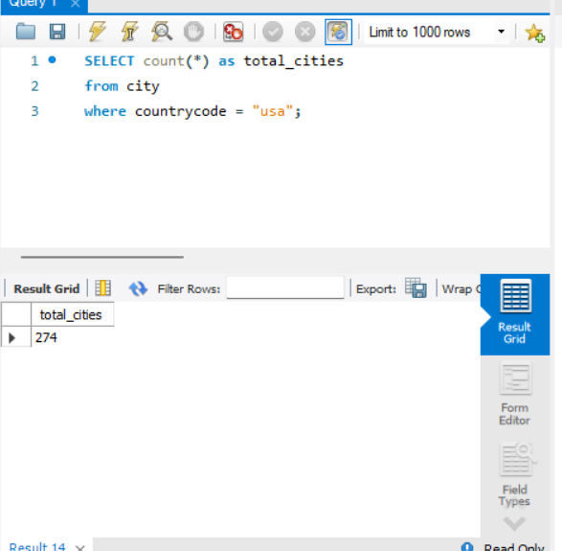

- Country with Highest Life Expectancy: Scenario: As part of a global health initiative, you've been assigned to identify the country with the highest life expectancy. This information will be crucial for prioritising healthcare resources and interventions.

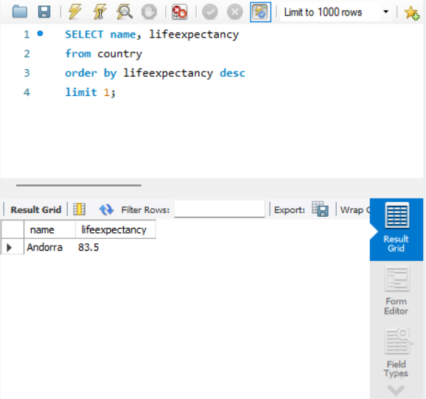

- "New Year Promotion: Featuring Cities with 'New : Scenario: In anticipation of the upcoming New Year, your travel agency is gearing up for a special promotion featuring cities with names including the word 'New'. You're tasked with swiftly compiling a list of all cities from around the world. This curated selection will be essential in creating promotional materials and enticing travellers with exciting destinations to kick off the New Year in style.

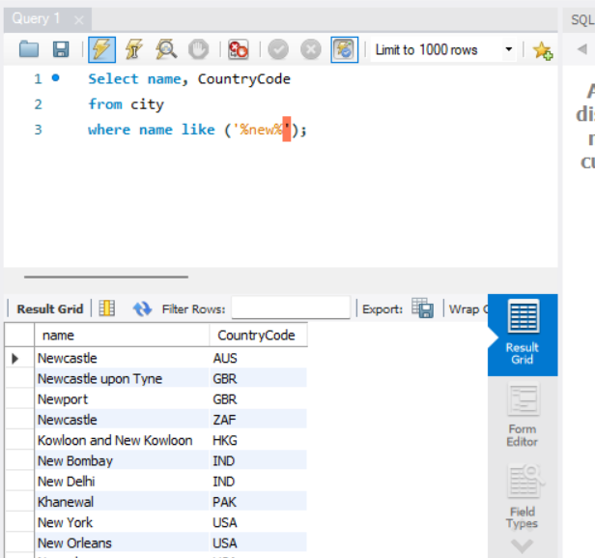

- Display Columns with Limit (First 10 Rows): Scenario: You're tasked with providing a brief overview of the most populous cities in the world. To keep the report concise, you're instructed to list only the first 10 cities by population from the database.

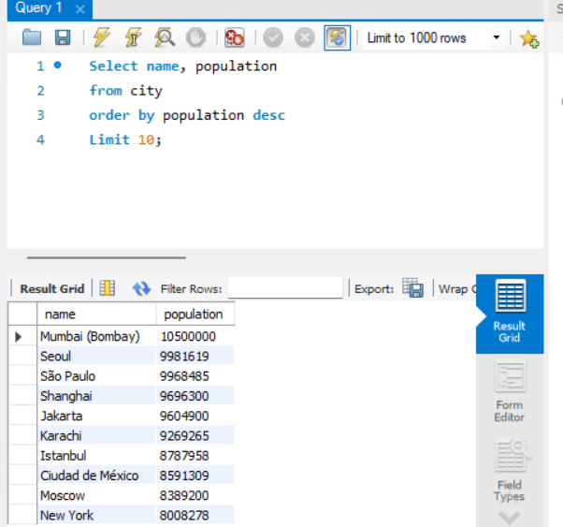

- Cities with Population Larger than 2,000,000: Scenario: A real estate developer is interested in cities with substantial population sizes for potential investment opportunities. You're tasked with identifying cities from the database with populations exceeding 2 million to focus their research efforts.

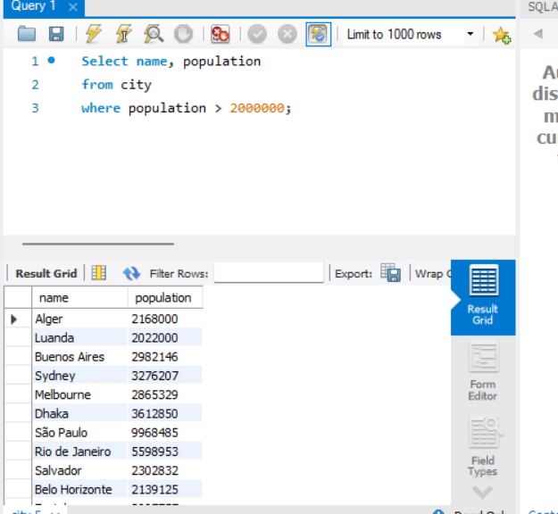

- Cities Beginning with 'Be' Prefix: Scenario: A travel blogger is planning a series of articles featuring cities with unique names. You're tasked with compiling a list of cities from the database that start with the prefix 'Be' to assist in the blogger's content creation process.

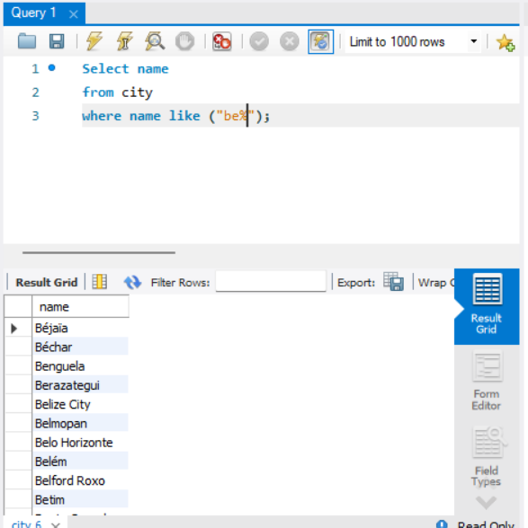

- Cities with Population Between 500,000-1,000,000: Scenario: An urban planning committee needs to identify mid-sized cities suitable for infrastructure development projects. You're tasked with identifying cities with populations ranging between 500,000 and 1 million to inform their decision-making process.

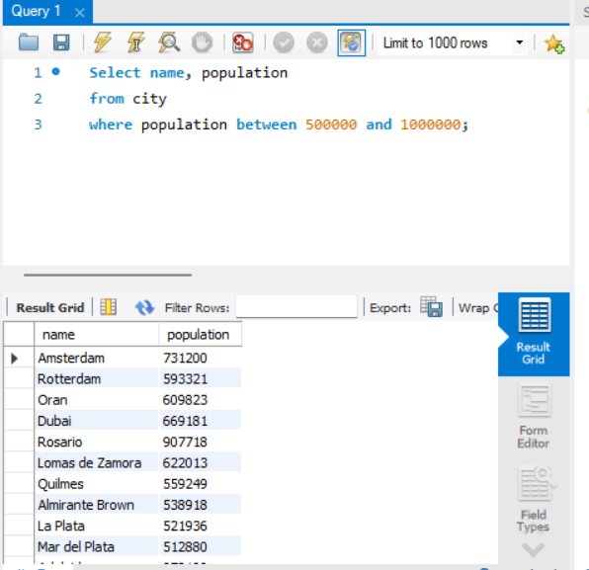

- Display Cities Sorted by Name in Ascending Order: Scenario: A geography teacher is preparing a lesson on alphabetical order using city names. You're tasked with providing a sorted list of cities from the database in ascending order by name to support the lesson plan.

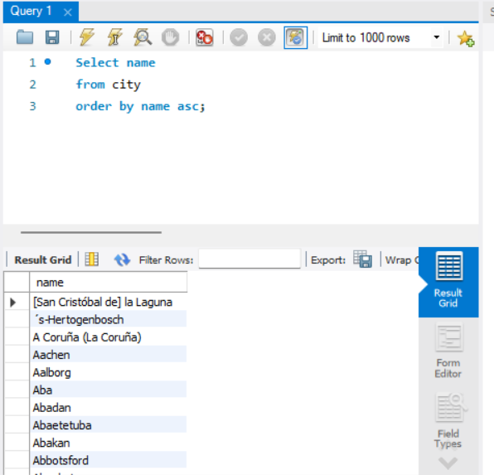

- Most Populated City: Scenario: A real estate investment firm is interested in cities with significant population densities for potential development projects. You're tasked with identifying the most populated city from the database to guide their investment decisions and strategic planning.

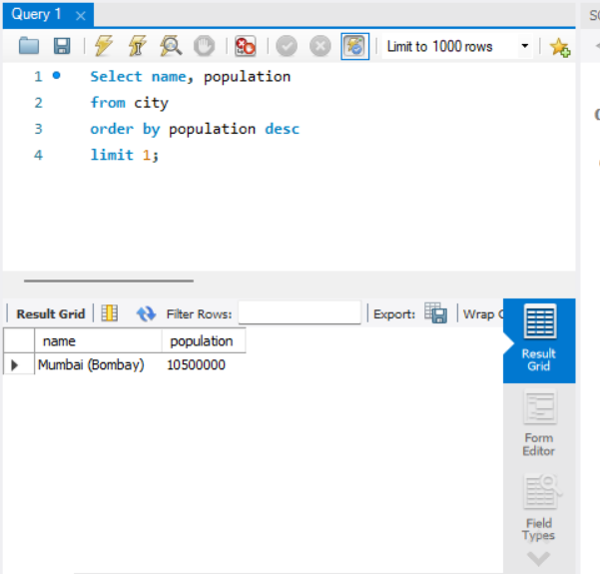

- City Name Frequency Analysis: Supporting Geography Education Scenario: In a geography class, students are learning about the distribution of city names around the world. The teacher, in preparation for a lesson on city name frequencies, wants to provide students with a list of unique city names sorted alphabetically, along with their respective counts of occurrences in the database. You're tasked with this sorted list to support the geography teacher.

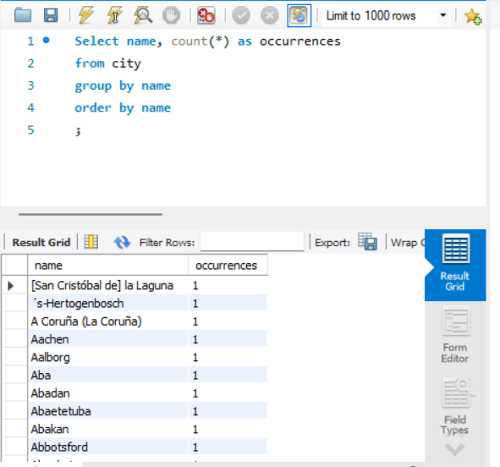

- City with the Lowest Population: Scenario: A census bureau is conducting an analysis of urban population distribution. You're tasked with identifying the city with the lowest population from the database to provide a comprehensive overview of demographic trends.

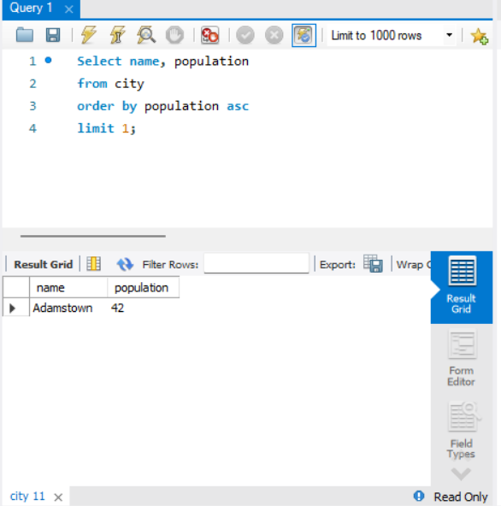

- Country with Largest Population: Scenario: A global economic research institute requires data on countries with the largest populations for a comprehensive analysis. You're tasked with identifying the country with the highest population from the database to provide valuable insights into demographic trends.

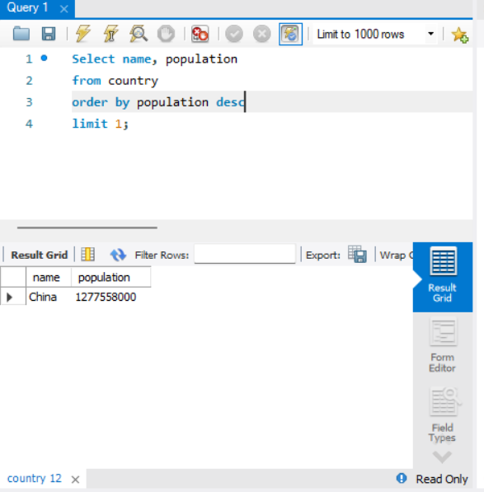

- Capital of Spain: Scenario: A travel agency is organising tours across Europe and needs accurate information on capital cities. You're tasked with identifying the capital of Spain from the database to ensure itinerary accuracy and provide travellers with essential destination information.

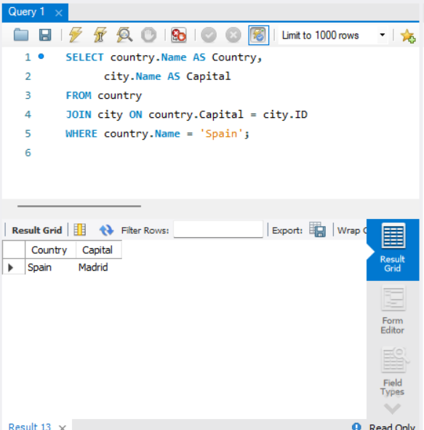

- Country with Shortest Life Expectancy: Scenario: A healthcare foundation is conducting research on global health indicators. You're tasked with identifying the country with the highest life expectancy from the database to inform their efforts in improving healthcare systems and policies.

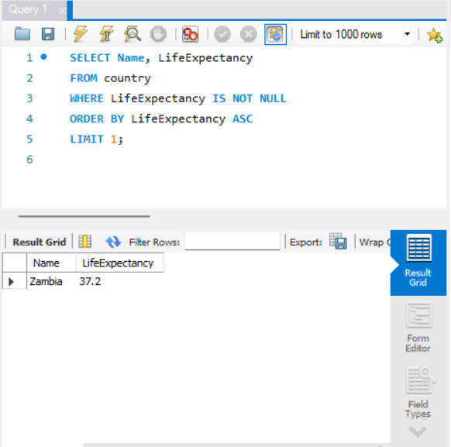

- Cities in Europe: Scenario: A European cultural exchange program is seeking to connect students with cities across the continent. You're tasked with compiling a list of cities located in Europe from the database to facilitate program planning and student engagement.
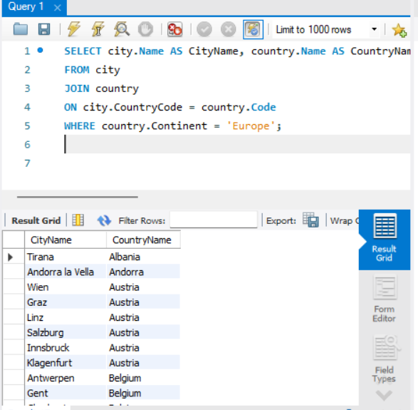

- Average Population by Country: Scenario: A demographic research team is conducting a comparative analysis of population distributions across countries. You're tasked with calculating the average population for each country from the database to provide valuable insights into global population trends.

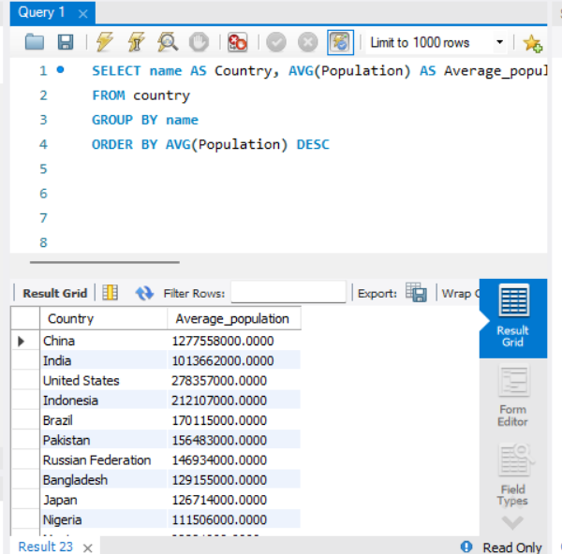

- Capital Cities Population Comparison: Scenario: A statistical analysis firm is examining population distributions between capital cities worldwide. You're tasked with comparing the populations of capital cities from different countries to identify trends and patterns in urban demographics.

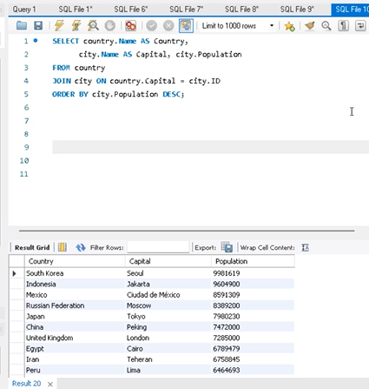

- Countries with Low Population Density: Scenario: An agricultural research institute is studying countries with low population densities for potential agricultural development projects. You're tasked with identifying countries with sparse populations from the database to support the institute's research efforts.

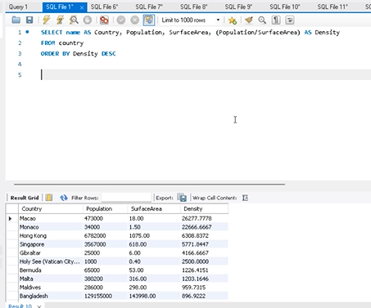

- Cities with High GDP per Capita: Scenario: An economic consulting firm is analysing cities with high GDP per capita for investment opportunities. You're tasked with identifying cities with above-average GDP per capita from the database to assist the firm in identifying potential investment destinations.

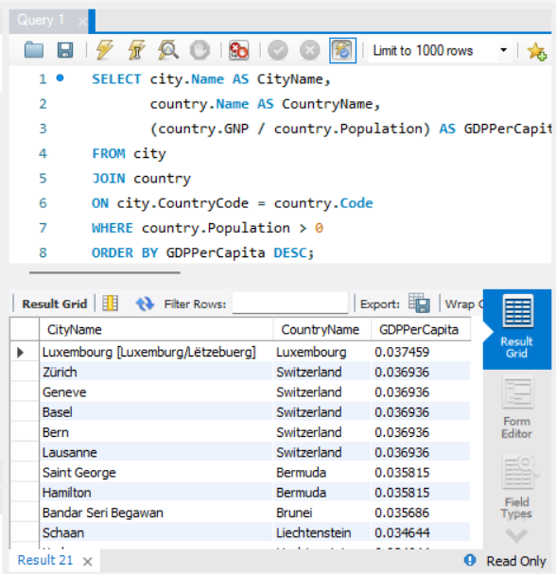

- Display Columns with Limit (Rows 31-40): Scenario: A market research firm requires detailed information on cities beyond the top rankings for a comprehensive analysis. You're tasked with providing data on cities ranked between 31st and 40th by population to ensure a thorough understanding of urban demographics.

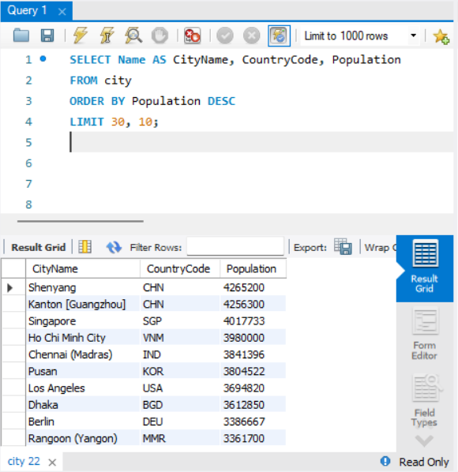

Course Notes

It is recommended to take notes from the course, use the space below to do so, or use the revision guide shared with the class:

Additional Information

We have included a range of additional links to further resources and information that you may find useful, these can be found within your revision guide.

END OF WORKBOOK

Please check through your work thoroughly before submitting and update the table of contents if required.

Please send your completed work booklet to your trainer.

