

Data Technician

Name:
Course Date:
Table of contents
Day 1: Task 1 3
Day 1: Task 2 3
Day 1: Task 3 4
Day 2: Task 1 5
Day 3: Task 1 9
Day 3: Task 2 10
Day 3: Task 3 11
Day 4: Task 1 12
Day 4: Task 2 13
1. Scenario Background 13
2. Data Laws and Regulations 14
3. Azure Service Recommendations 14
4. Data Types and Data Modelling 14
5. Data Storage Formats and Structures in Azure 14
6. Additional Considerations 15
Submission Guidelines: 15
Course Notes 17
Additional Information 17

Day 1: Task 1

Please research and complete the below questions relating to key concepts of cloud.

Be prepared to discuss the below in the group following this task.

What can cloud computing do for us in the real-world? | Cloud computing allows individuals and organisations to access computing resources (servers, storage, databases, software, and networking) over the internet, instead of owning physical hardware.  An example of cloud computing in real life for me is online storage. I use cloud storage to save my files, such as documents, photos, and videos. For example, I might start with 15GB of free storage, and as I save more files and my storage usage increases, I then have to pay for additional space. If I need 100GB or more, I upgrade my plan and pay a bit extra each month. The benefit of this is that I don’t need to worry about running out of physical storage or buying new hardware. My data is backed up automatically, so there is less risk of losing important files if my device is damaged, lost, or crashes. I can also access my files from anywhere and on different devices, which makes cloud storage convenient, secure, and reliable.
How can it benefit a business? | Cloud computing provides businesses with operational and financial benefits by reducing costs, as companies do not need to buy or maintain physical servers. It allows businesses to scale resources up or down depending on demand, making it flexible during busy periods. Employees can access systems remotely, supporting remote work. Cloud services also offer strong security, reliable data backups, and quick recovery in case of failure. Overall, cloud computing helps businesses deploy applications faster and operate more efficiently. For example, a retail business can manage increased traffic during events like Black Friday without investing in permanent infrastructure.
What’s the alternative to cloud computing? | The main alternative to cloud computing is on-premises computing, where servers and hardware are physically located within the business. The company is responsible for buying and maintaining the hardware, handling security, and managing power and cooling. This approach gives full control over systems but is usually more expensive and less flexible than cloud computing.
What cloud providers can we use, what are their features and functions?
  Features | AWS | Azure | GCP
  Owned by | Amazon | Microsoft | Google
  Known for | Vast range of services | Microsoft integration | Data & AI strengths
  Ease of use | Powerful but complex | Easy for windows user | Clean and simple
  Pricing style | Pay-as-you-go | Pay-as-you-go with enterprise plans | Competitive and flexible pricing
  Common users | Startups and large enterprises | Businesses using Microsoft tools | Data-driven & AI-focused companies

Day 1: Task 2

Please research the below cloud offerings, explain what they are and examples of use cases.

Cloud Offerings | Explain what it is | When / how might you use this service in the real-world?
IaaS (Infrastructure as a service) | IaaS provides virtualised computing resources such as servers, storage, and networking over the internet. The cloud provider manages the physical hardware, while I manage the operating system, applications, and data. | I want to host my website on the cloud, so I use AWS EC2, which provides virtual servers that I can control over the internet. First, I rent a virtual server and choose an operating system, like Linux, to run on it. Then, I install web server software such as Apache, which allows my website to be accessible online. After that, I upload my website files to the server so people can visit my site. I also manage backups and security, making sure my data is safe and the server runs smoothly. This way, I don’t need to buy physical hardware, and I can scale my website easily if more people visit
PaaS (Platform as a service) | PaaS provides a cloud-based platform that allows me to develop, run, and manage applications without dealing with the underlying infrastructure. The provider handles servers, storage, networking, and the runtime environment | I want to develop a web application, so I use Google App Engine, which is a Platform as a Service (PaaS). This means I can focus on writing my application code without worrying about servers, storage, or networking. I choose a programming language supported by the platform and write features like user login, forms, and payment processing. When I deploy my app, the platform automatically handles scaling, ensuring it can handle more users if traffic increases. It also takes care of updates and server maintenance, so I can focus entirely on building and improving my app rather than managing hardware or software infrastructure
SaaS (Software as a service) | SaaS delivers ready-to-use software over the internet. I access the software via a web browser or app, while the provider manages everything behind the scenes, including servers, storage, and updates | I want to manage my emails and communicate with my team, so I use Gmail, which is a Software as a Service (SaaS). This means the software is ready to use over the internet, and I don’t need to install anything or manage servers. I can send and receive emails, organise my inbox, and access it from any device with an internet connection. The provider takes care of maintenance, updates, storage, and security, so I don’t have to worry about technical details. This allows me to focus on my work while using powerful software without any setup or infrastructure management

Day 1: Task 3

Please research the below terms and explain what they are, when they would be appropriate and a real-world example of where it could be implemented (i.e. what type of organisation).

Public Cloud | A public cloud is provided by third-party companies such as AWS, Azure, or Google Cloud, where resources are shared between multiple users. It is appropriate for organisations that want a cost-effective and scalable solution without managing physical hardware. For example, a startup or small business can use a public cloud to host its website or applications because it is affordable and easy to scale as the business grows.
Private Cloud | A private cloud is used by a single organisation and offers greater control and security over data and systems. It is suitable for organisations that handle sensitive information or must meet strict compliance requirements. For example, banks or healthcare organisations often use private clouds to securely store customer or patient data.
Hybrid Cloud | A hybrid cloud combines public and private cloud environments, allowing data and applications to be shared between them. It is appropriate when an organisation needs both security and flexibility. For example, a large company may store sensitive data in a private cloud while using a public cloud to handle increased website traffic during busy periods
Community Cloud | A community cloud is shared by multiple organisations that have similar requirements, such as security, compliance, or operational goals. It is appropriate when organisations want to share infrastructure while meeting common standards. For example, several hospitals and medical research institutions could use a community cloud to securely share research data and patient information while following the same healthcare regulations.

Day 2: Task 1

Describe, with examples, the three major areas that the Computer Misuse Act deals with.

Area | Description | Example
Unauthorised Access | Accessing a computer without permission | Using someone else's password to view files
Unauthorised access with intent to commit further offences | Accessing a system to commit a crime | Hacking a bank to steal money.
Unauthorised modification | Changing, deleting, or damaging data without permission. | Introducing a virus that deletes files.

The computer misuse act 1990 is an act where an individual can be criminalised because of computer related offense. Describe three extra powers that the Police and Justice Act 2006 (Computer Misuse) has added.

Description
Making denial-of-service (DoS) attacks illegal - Police can criminalise deliberate attacks that overload or disrupt a computer/network, making it unavailable to users.

Targeting attacks on data rather than just systems - Police can act against offences that damage, delete, or impair data, even if the system itself isn’t hacked.

Penalties for malware creation and distribution - Police can prosecute individuals who create, supply, or obtain malware intending to cause harm.

Look at the below website to answer the questions:
https://www.gov.uk/personal-data-my-employer-can-keep-about-me

Write down three items of data which a company can store about an employee.
Name, Address, Date of Birth, Sex

Education, Qualification, Work Experience

National Insurance Number, Tax code

Give three more examples of data that an employer can only store if they first get the employee’s permission.
Race, Religion

Biometrics

Disabilities

Conduct further research to answer the below questions.

Question | Answer
Provide one example of: Copyright infringement | If I download and share a movie or song online without permission, I am committing copyright infringement.
Provide one example of: Plagiarism | If I copy paragraphs from a website, books or any source of information into my essay/work and claim it as my own work, that is plagiarism.
What are two consequences of copyright infringement and software piracy? | 1. I could get fined or taken to court for breaking the law.  2. My reputation could be damaged if people find out I used illegal content.
Give three possible consequences for individuals when using pirated software | 1. My computer could get viruses or malware from the pirated software.  2. I wouldn’t get technical support or software updates if something goes wrong.  3. I could face legal action, including fines, for using unlicensed software

Listed below are some laws which we have covered today:

1. Computer Misuse Act 1990
2. Police and Justice Act 2006 (Computer Misuse)
3. Copyright, Designs and Patents Act 1988
4. Copyright (Computer Programs) Regulations 1992
5. The Health and Safety (Display Screen Equipment) Regulations 1992
6. Data Protection Act 2018
7. Consumer Rights Act 2015

- Insert a number in the first column of each row to match each of the statements with one of the above Acts.

- One of statements is incorrect and not illegal. For this statement, write ‘Not illegal’.

Act number | Clause
4 | With some exceptions, it is illegal to use unlicensed software
7 | Any product, digital or otherwise, must be fit for the purpose it is supplied for
1 | Unauthorised modification of computer material is illegal
2 | It is illegal to create or use a hacking tool for penetration testing
6 | Personal data may only be used for specified, explicit purposes
5 | Employers must provide their computer users with adequate health and safety training for any workstation they work at
2 | It is illegal to distribute hacking tools for criminal purposes
3 | It is illegal to distribute an illicit recording
6 | Personal data may not be kept longer than necessary
1 | Gaining unauthorised access to a computer system is illegal
5 | Employers must ensure that employees take regular and adequate breaks from looking at their screens
2 | It is illegal to prevent or hinder access (e.g. by a denial-of-service attack) to any program or data held in any computer
6 | Personal data must be accurate and where necessary kept up to date

Day 3: Task 1

Please complete the below lab (3) ‘Explore relational data in Azure’ and paste evidence of the completed lab in the box provided.



Completed lab | 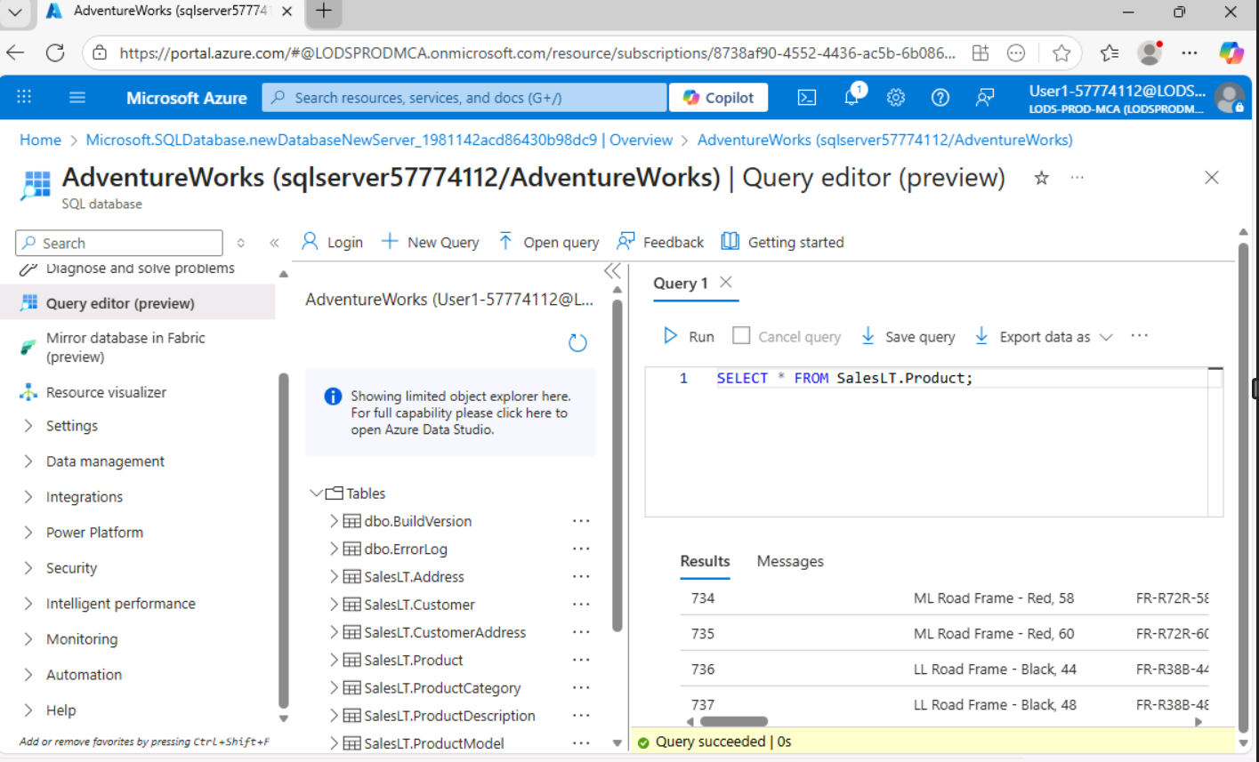  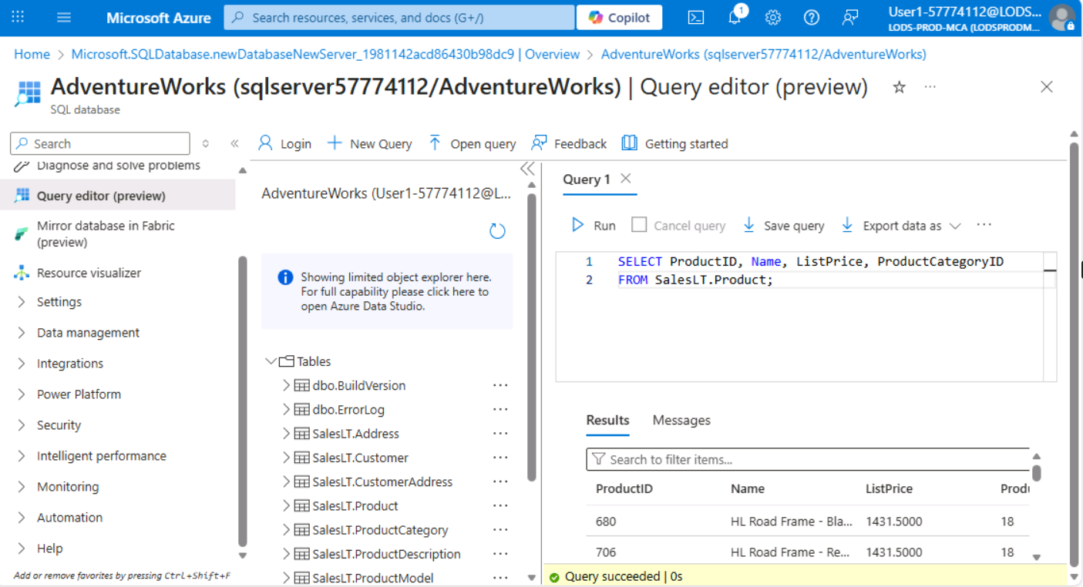  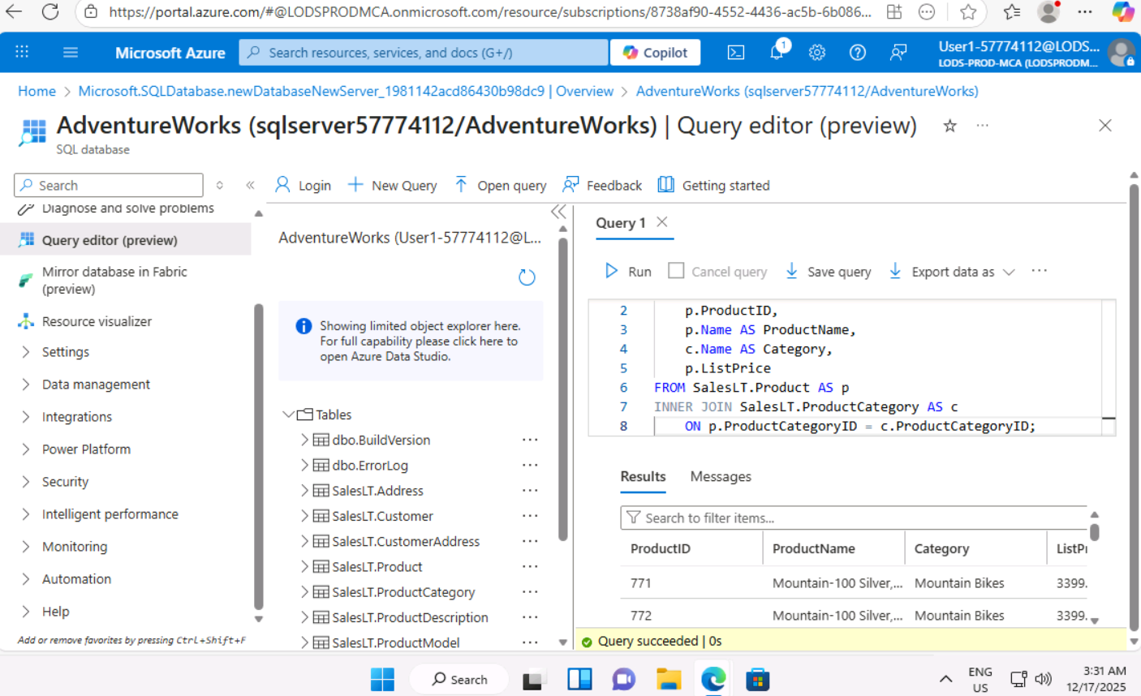

Day 3: Task 2

Please complete the below lab (4) ‘Explore non-relational data in Azure’ and paste evidence of the completed lab in the box provided.



Completed lab | 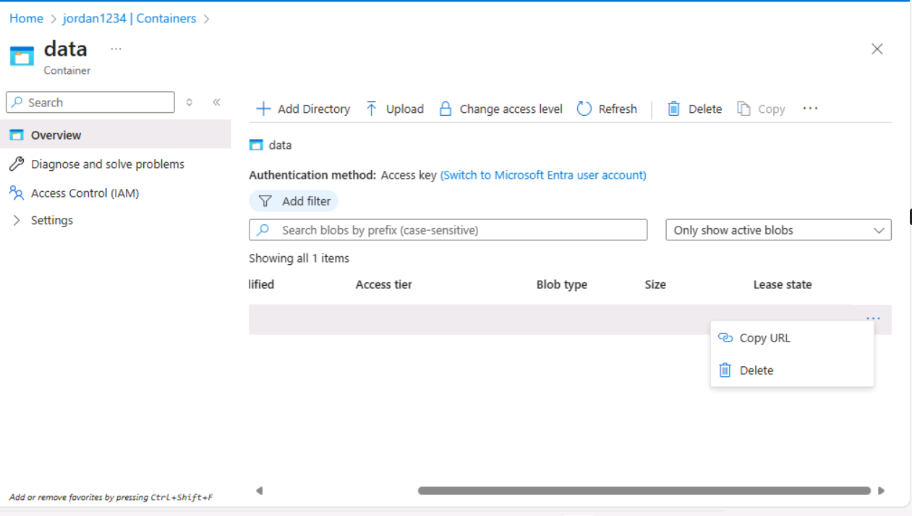  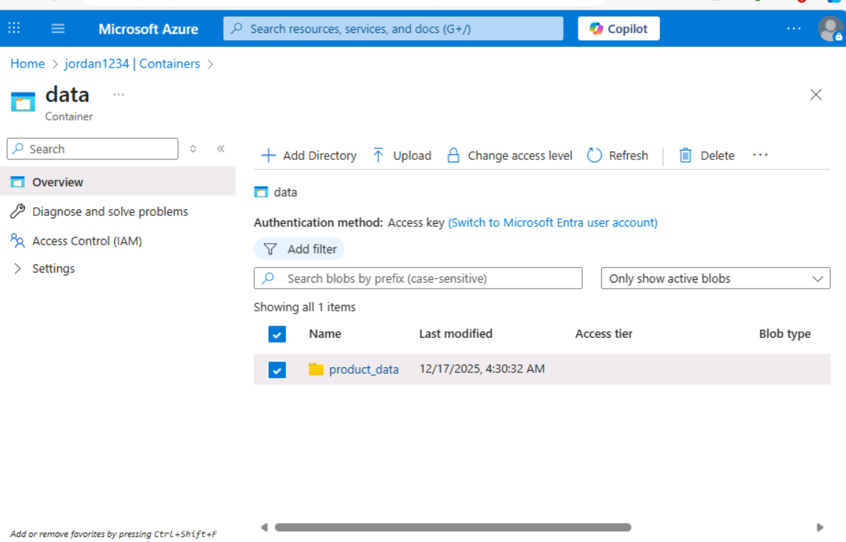  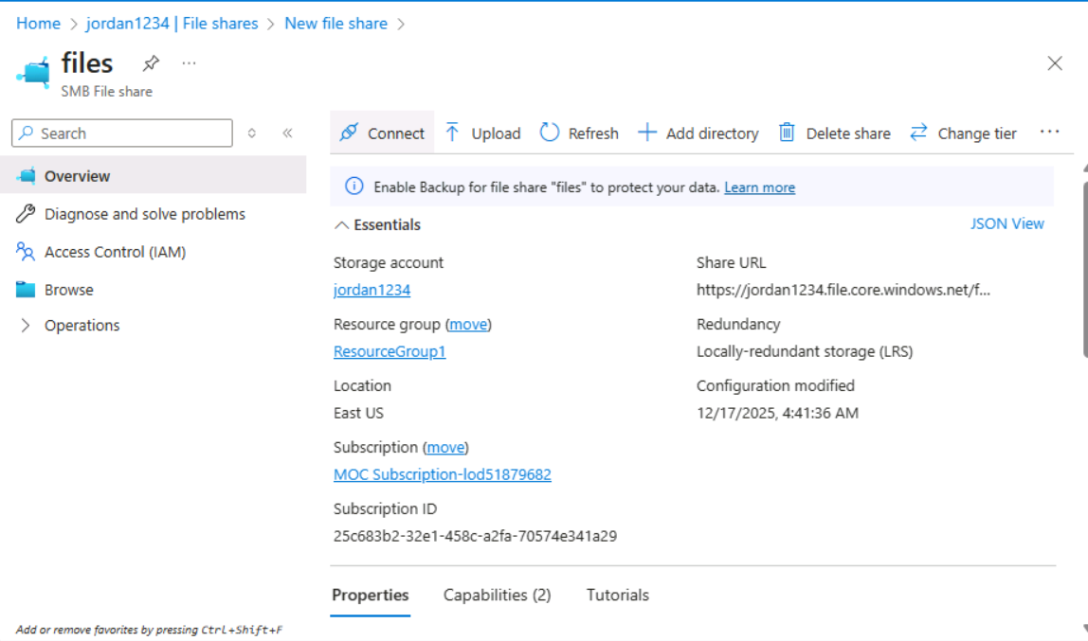  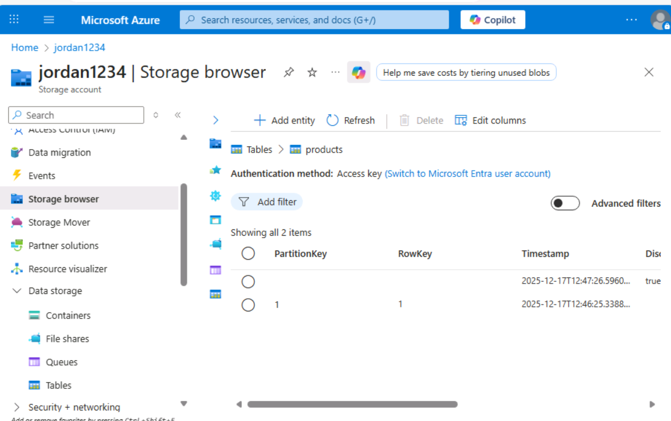  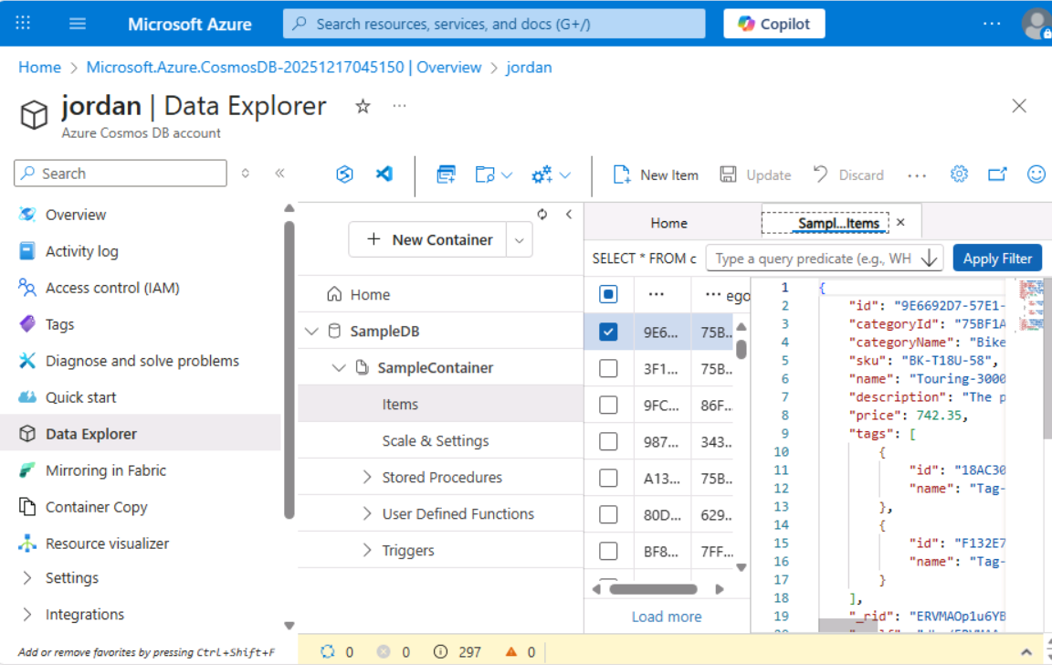  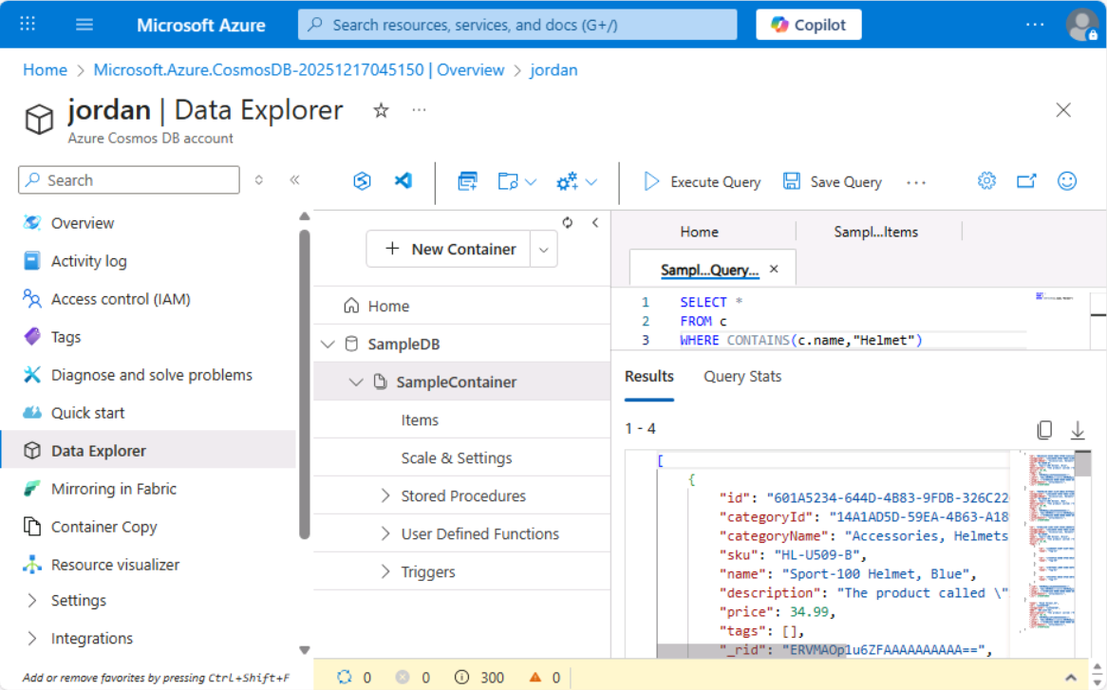

Day 3: Task 3

Please complete the below lab (5) ‘Explore data analytics in Azure’ and paste evidence of the completed lab in the box provided.

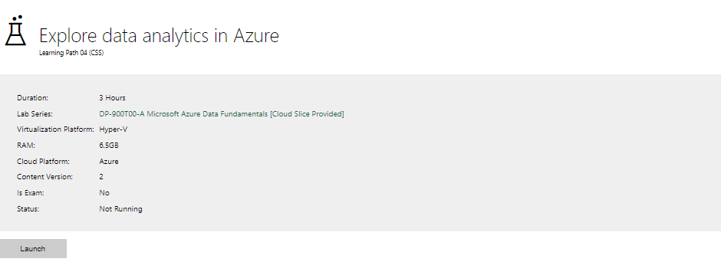

Completed lab | 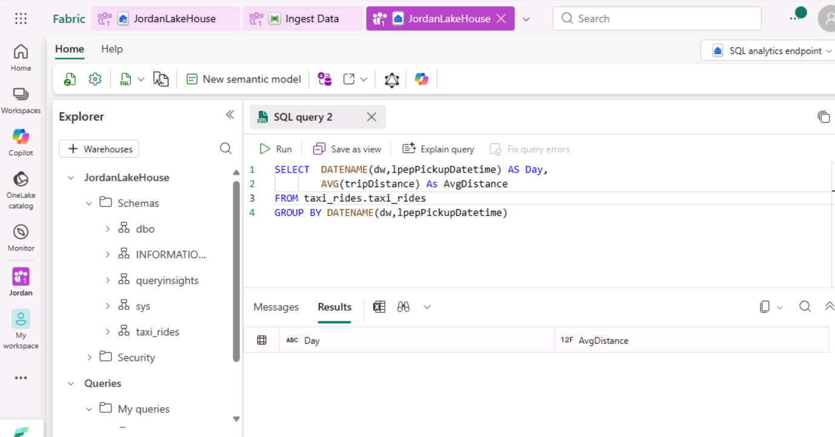  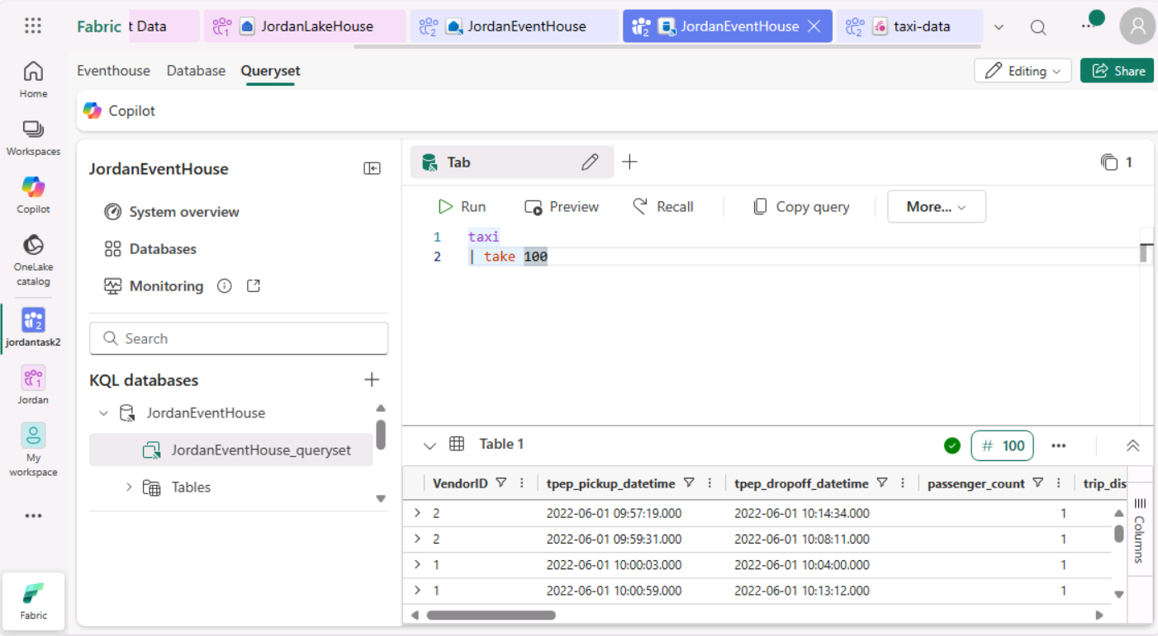  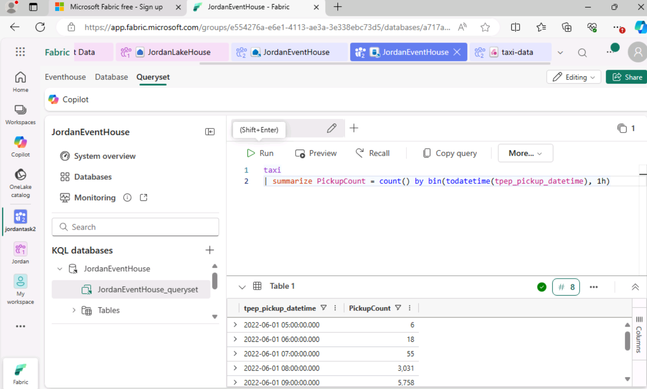  The map visual is not loading, it says to enable the map and filled map visual, which is already enabled in the security, but it’s the same.  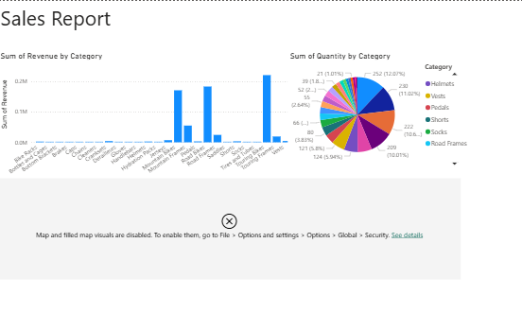

Day 4: Task 1

In your teams, complete the Azure DP-900 practice exam and paste your result below – this is open book and please research and discuss your answers as a team.


Result | 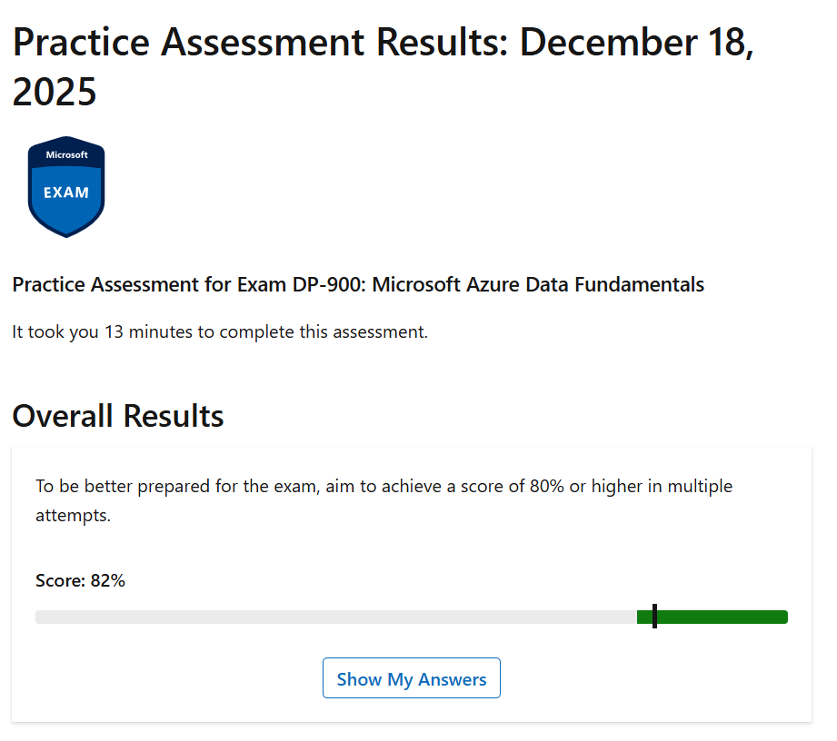

Day 4: Task 2

1. Scenario Background
"Paws & Whiskers" is a growing pet shop that aims to improve its business by analysing sales, customer information, and inventory data. Currently, the data is collected manually or stored in spreadsheets. Management is interested in transitioning to Microsoft Azure to streamline data storage, analysis, and reporting, enabling them to make data-driven decisions.

2. Data Laws and Regulations
Identify and explain the data laws and regulations relevant to handling customer data within the proposal. Ensure you cover the following points:
- GDPR Compliance: Highlight the importance of adhering to the General Data Protection Regulation (GDPR), particularly as it relates to storing and processing customer information.
- Data Protection Act (DPA) 2018: Outline how the DPA 2018 may affect the way "Paws & Whiskers" collects and stores data, ensuring compliance with UK laws on data privacy.
- Other Industry Standards: Research any additional data protection standards or regulations that may apply to pet shop data, particularly if they involve sensitive or payment information.

3. Azure Service Recommendations
Recommend Microsoft Azure services that would suit the company’s data analysis needs and explain why these services are suitable. Your recommendations should include:
- Data Storage: Identify suitable storage options, such as Azure Blob Storage or Azure SQL Database, and discuss the benefits of each for storing large datasets, including inventory, sales transactions, and customer details.
- Data Analysis Tools: Recommend tools such as Azure Machine Learning for customer behaviour analysis or Azure Synapse Analytics for analysing sales trends.
- Data Integration and Automation: Explain how services like Azure Data Factory could automate data collection and integration processes, improving efficiency.

4. Data Types and Data Modelling
Define the types of data "Paws & Whiskers" will need to work with and describe your approach to data modelling:
- Data Categories: Identify key data types, such as customer demographics, transaction history, pet inventory, and product categories.
- Data Modelling Approach: Outline how you would structure this data using a relational model or a data warehouse approach, considering factors like tables, entities, relationships, and primary keys.

5. Data Storage Formats and Structures in Azure
Discuss how you would store data within Azure and the formats you would recommend:
- Data Formats: Specify recommended formats (e.g., CSV for raw data imports, JSON for structured data, Parquet for analytics) and explain why these formats are suitable for specific data types.
- Data Security and Encryption: Include recommendations for securing data using Azure’s built-in encryption features and access controls to ensure compliance with data privacy regulations.

6. Additional Considerations
Provide any other considerations that might enhance data handling and efficiency in Azure, such as:
- Backup and Disaster Recovery: Outline a backup plan using Azure Backup or Azure Site Recovery to safeguard against data loss.
- Data Visualisation: Discuss potential use of Power BI within Azure for creating dashboards that provide management with real-time insights into sales and customer trends.
- Future Scalability: Comment on how Azure services can scale as the business grows, accommodating larger datasets and more complex analyses.

Submission Guidelines:
- Structure: Ensure your report is well-organised, with sections for each task (e.g., Data Laws, Azure Services, Data Types, etc.).
- Formatting: Include headings, bullet points where appropriate, and any visuals or diagrams that support your explanations.
- References: Cite any resources or regulations referenced in the report.
- Length: Aim for 1500-2000 words.

1. Scenario Background
My first step is to understand the business and its current challenges. “Paws & Whiskers” is a growing pet shop that currently relies on manual data collection and spreadsheet-based storage for managing sales, customer information, and inventory records. While spreadsheets are useful for basic record-keeping, they become difficult to manage as the business grows and operations become more complex. Manual handling of data often results in duplicated records, missing information, inconsistent formatting, and limited analytical capabilities. This makes identifying best-selling products, tracking loyal customers, or forecasting inventory demand both time-consuming and prone to error.
To overcome these challenges, management is interested in transitioning to Microsoft Azure. Azure provides a cloud-based platform that allows businesses to store data securely, analyse it efficiently, and generate meaningful reports. By moving to Azure, the company can centralise data, reduce manual effort, improve operational efficiency, and make informed, data-driven decisions. From my experience, this type of transition is crucial for small businesses seeking to scale in a controlled and secure manner.

2. Data Laws and Regulations (Data Protection Act, GDPR)
Handling customer and transaction data carries legal responsibilities. Ensuring compliance with data protection laws is essential to avoid legal penalties, reputational damage, and loss of customer trust. The General Data Protection Regulation (GDPR) is a key regulation for “Paws & Whiskers.” GDPR applies to organisations that collect or process personal data of individuals in the UK and EU. Personal data includes names, addresses, emails, phone numbers, and payment information. Under GDPR, data must be collected for a specific, lawful purpose, stored securely, and only retained as long as necessary. Customers have the right to access their data, request corrections, and ask for deletion where applicable. Microsoft Azure supports GDPR compliance through encryption, secure access controls, and audit logging.
The Data Protection Act (DPA) 2018 complements GDPR and governs data protection within the UK. For “Paws & Whiskers,” it dictates how customer data is collected, stored, and accessed. Compliance requires clearly defined user roles and access permissions, ensuring that only authorised staff can handle sensitive information. Other standards, such as the Payment Card Industry Data Security Standard (PCI DSS), may apply if card payments are processed. Azure is compliant with PCI DSS, providing a secure environment for payment data without the need for complex in-house systems.

3. Azure Service Recommendations (Microsoft Azure)
Selecting the right Azure services is crucial for building a reliable and scalable data solution. For raw and unprocessed data, such as spreadsheet uploads or historical files, Azure Blob Storage is ideal. It is scalable, cost-effective, and suited for large volumes of unstructured or semi-structured data. Structured data, such as customer records, sales transactions, and inventory details, is best stored in Azure SQL Database. This service supports table-based storage, complex queries, automated backups, and strong security features, ensuring business-critical data is protected and easy to manage.
For data analysis, Azure Synapse Analytics allows fast querying of large datasets, enabling analysis of sales trends, popular products, and seasonal purchasing patterns. Azure Machine Learning can be introduced to predict customer behaviour and forecast product demand, providing insights for future planning. To reduce manual effort, Azure Data Factory automates the extraction, transformation, and loading of data from spreadsheets or other systems. Automation ensures data remains consistent, accurate, and up to date, supporting better decision-making.

4. Data Types and Data Modelling (LucidChart)
“Paws & Whiskers” works with several key types of data that are central to understanding business performance and customer behaviour. Customer data includes information such as names, contact details, loyalty programme membership, and purchase history. This data allows the business to identify repeat customers, understand purchasing patterns, and improve customer engagement. Managing customer data accurately is also essential for maintaining trust and ensuring compliance with data protection regulations.
Sales data is the core transactional data used by the business. It captures details such as sales identifiers, transaction dates, products sold, quantities purchased, and total sales values. Analysing sales data enables “Paws & Whiskers” to monitor revenue performance, identify best-selling products, and understand seasonal sales trends. Sales data also supports financial reporting and helps management make informed decisions regarding pricing and promotions.
Product data contains information about the items sold by the business, including product names, categories such as food, toys, grooming products, and accessories, pricing details, and supplier information. Organising products into categories allows for more meaningful analysis of sales trends across different product types and supports better stock planning and marketing strategies.
Date data plays a critical role in enabling time-based analysis. It includes attributes such as day, month, quarter, and year, allowing sales performance to be analysed over different time periods. By using a dedicated date table, the business can easily identify trends such as peak sales days, monthly growth, or seasonal variations.
Store data represents information about the physical or operational locations of the business, such as store names, locations, and management details. This data supports analysis of sales performance across different stores, enabling comparisons and helping identify high-performing or underperforming locations.
To manage these data types effectively, a relational data model is recommended. In this approach, data is organised into tables representing real-world entities such as customers, products, stores, dates, and sales transactions. Each table contains a primary key that uniquely identifies records, ensuring data accuracy and consistency. Relationships between tables are created using foreign keys, allowing sales data to be linked logically to customers, products, stores, and dates.
This structured approach reduces data duplication, improves data quality, and simplifies querying and reporting. It also supports the use of a star schema, where the sales table acts as the central fact table connected to surrounding dimension tables. A well-designed relational data model provides a strong foundation for reporting, analytics, and business intelligence. The diagrammatic representation below illustrates the data model and the relationships between the date, sales, store, product, and customer tables.

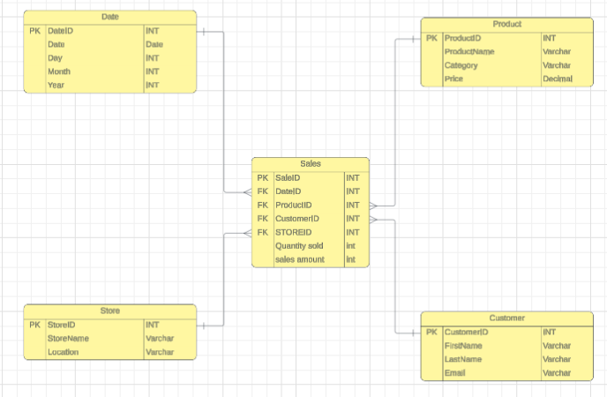
Data Modelling and its relationship

5. Data Storage Formats and Structures in Azure (Microsoft Azure, Data Protection Act )
Choosing the correct data storage formats and structures is essential for ensuring efficient data handling, reliable analysis, and long-term scalability. For “Paws & Whiskers,” different types of data are collected from spreadsheets, sales systems, and customer records, and each requires an appropriate format when stored in Microsoft Azure.
CSV (Comma-Separated Values) files are particularly suitable for raw data imports, especially when migrating existing spreadsheet-based data into Azure. CSV files are simple, lightweight, and widely supported, making them ideal for initial data ingestion using services such as Azure Data Factory. They allow data to be quickly transferred into Azure storage or databases for further processing. However, CSV files offer limited support for data validation and complex structures, which means they are best used as a temporary or staging format rather than for long-term analytical storage.
JSON (JavaScript Object Notation) is recommended for structured and semi-structured data, particularly where flexibility is required. JSON supports hierarchical data structures, making it useful for customer or transaction data that may vary over time. Within Azure, JSON is commonly used for data integration with applications, APIs, or cloud-based services. For “Paws & Whiskers,” JSON provides a flexible option that can support future system integrations, such as online ordering or customer engagement platforms.
Parquet format is most suitable for analytical workloads involving large datasets. As a column-based storage format, Parquet improves query performance and reduces storage costs by allowing analytical tools to read only the required columns. This makes it particularly effective when analysing sales trends, inventory movement, or customer behaviour using services such as Azure Synapse Analytics. As the business grows and data volumes increase, Parquet helps ensure analytics remain fast and cost-efficient.
Data security is a critical consideration when storing data in Azure. Microsoft Azure provides encryption at rest and in transit, ensuring that data is protected both when stored and during transfer between systems. In addition, Azure role-based access control restricts access to sensitive data based on user roles, ensuring that only authorised staff can view or modify customer information. These measures support compliance with GDPR and the Data Protection Act 2018 while helping to maintain customer trust and data integrity.

6. Additional Considerations (Microsoft Azure, PowerBI)
A robust backup and recovery strategy is essential. Azure Backup allows automated backups of databases and storage accounts, while Azure Site Recovery provides quick recovery options in the event of system failure, cyber incidents, or natural disasters. These measures ensure business continuity and protect against data loss.
For reporting and insight generation, Power BI integrates seamlessly with Azure, enabling interactive dashboards that show real-time sales performance, inventory levels, and customer trends. Management can make informed decisions quickly, without requiring advanced technical knowledge.
Scalability is another significant advantage of Azure. As “Paws & Whiskers” grows, Azure services can scale to accommodate larger datasets, more users, and increasingly complex analyses. This flexibility ensures the data infrastructure remains effective and cost-efficient over time, supporting both current operations and future expansion.

Conclusion
Transitioning “Paws & Whiskers” to Microsoft Azure provides a secure, scalable, and efficient solution for managing and analysing business data. By adhering to data protection laws, selecting suitable Azure services, and implementing a structured data model, the business can improve operational efficiency, gain valuable insights, and support long-term growth. This approach reflects best practices developed through years of professional data analysis experience and establishes a strong foundation for data-driven decision-making.

References

- UK Government. (2018). Data Protection Act 2018. Available at: https://www.legislation.gov.uk/ukpga/2018/12/contents (Accessed: 18 December 2025).
- European Union. (2016). General Data Protection Regulation (GDPR). Official Journal of the European Union. Available at: https://gdpr.eu/what-is-gdpr/ (Accessed: 18 December 2025).
- Microsoft Azure. Available at: Home - Microsoft Azure (Accessed: 18 December 2025).
- Power BI Available at: PowerBI (Accessed: 18 December 2025).
- LucidChart Available at: LucidChart (Accessed: 18 December 2025).

Course Notes

It is recommended to take notes from the course, use the space below to do so, or use the revision guide shared with the class:

Additional Information

We have included a range of additional links to further resources and information that you may find useful, these can be found within your revision guide.

END OF WORKBOOK

Please check through your work thoroughly before submitting and update the table of contents if required.

Please send your completed work booklet to your trainer.

